Preschool P.A.L.
Parkview At-Home Learning

Parkview At-Home Learning is as easy as 1, 2, 3! Thank you for your support at home as we work to retain and strengthen the skills learned in preschool this year.

Week 1 | 3-23 to 3-27 | Online Resources | Teacher Tips
Language Arts | 1.Fundations: Practice writing lowercase a and g. (We are sending home a Fundations letter mat--Have your child say each letter, the picture, and the sound.) | 1.https://www.education.com/games/play/#choosePlayer  Start with the first ELA Pre-K lesson | 1. Remind your child to hold it using pinching fingers to correctly hold writing utensils.
 | 2.Read 6 books this week with your child.(Lending library books for the week will be included if you would like to use them) | 2. | 2. If your student is recognizing letter sounds have them sound out a few words each book while reading.
 | 3. Complete the Alpha friend books for letters a (Andy Apple) and g (Gertie Goose) (Included) | 3. | 3. Find the letters Aa and Gg throughout the book and complete the back page activities.
Math | 1.Write Numbers 0-10 | 1. | Use rectangle writing page
 | 2.Sensory Writing -- Shapes | 2.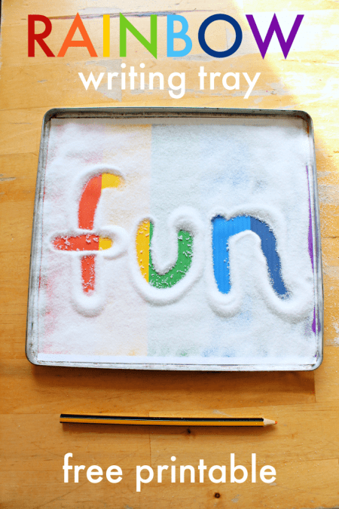 | 2. Use paint, soap, salt, rice, corn, shaving cream, toothpaste, flour, sugar, sprinkles, etc.
 | 3.Walk to your mailbox, count your steps. How many did it take? | 3. | 3.
Gross Motor | 1. Jump like a frog | 1.Cosmic Kids Yoga | 1.
 | 2. Take a walk outside playing “I spy” walking, running, or galloping to the object | 2. | 2.
Fine Motor | 1.Trace lined paper with finger/pencil/crayon | 1. | 1.Depending on student level, have students use writing materials or just fingers to trace.
 | 2. Tear paper into small pieces. What can you create with it? | 2. | 2.Ideas: self portrait , picture from a book, pet, favorite toy.

Week 2 | 3/30 - 4/3 | Online Resources | Teacher Tips
Language Arts | 1.Fundations: Practice writing lowercase d and s | 1.https://classroommagazines.scholastic.com/support/learnathome/grades-prek-k.html | 1.
 | 2. Practice Writing your name. (Try to identify all the letters in your name) | 2. | 2. If your child is not yet correctly forming letters, have them trace. To extend this activity you could practice writing your family's names as well.
 | 3.Find IT! (find and color the pictures that rhyme) (Worksheet included in printables). | 3. | 3. We are including materials like crayons, scissors, or markers in your child’s bag.
Math | 1.Write Numbers 0-20 | 1. | 1.
 | 2.Sensory Writing  (paint, soap, salt, rice, corn, shaving cream, toothpaste, flour, sugar, sprinkles, etc.) -- Shapes | 2. | 2.
 | 3. Patterns-- Use items to make yellow/green patterns. | 3. | 3.
Gross Motor | 1.Find lines on sidewalk/driveway and jump over them. Make sure to land softly on two feet. | 1. | 1.
 | 2.Hop like a bunny around the house | 2. | 2.
Fine Motor | 1. Draw and color a picture. Cut it apart into 6 pieces to create a fun puzzle. See if your family can put the picture back together . | 1. | 1.
 | 2.Write a shopping list before going to the store. Younger kids may use pictures or scribbles which is still appropriate. | 2. | 2.

Week 3 | 4/6-4/10 | Online Resources | Teacher Tips
Language Arts | 1. Fundations: Practice writing lowercase e and r | 1.https://www.abcya.com/grades/prek/letters | 1.
 | 2.Letter Hunt! Hide letters on sticky notes or small pieces of paper. Have your child match them to a piece of paper with the same letters written on them . | 2. | 2.
 | 3.Blending is putting syllables and sounds together. Blend these together and practice taking them apart.  Air- Plane  Rain-Coat  Pan-cake  Ear-ing | 3. | 3. When blending the words together, use one hand for the first part of the word and the other hand for the second. Clap your hands together and say the whole word.
Math | 1. Numbers: Numbers to sets 1-10 | 1. | 1. Find objects around the house or outside. Rocks, cotton balls, beads, buttons, beans, legos, blocks, etc. 3 - 3 rocks above the number 3
 | 2. Shapes-- Build shapes with cotton balls, q-tips or other items (toothpicks) | 2. | 2.
 | 3. Sorting- sort laundry into groups such as shirts, jeans, socks, etc | 3. | 3.
Gross Motor | - Walk backwards one day. Move from room to room backwards. Try going fast and slow. | 1. | 1.
 | - Balance on two body parts (hand and foot) Now try three (2 feet, and one hand). Be careful. How long can you stay upright? | 2. | 2.
Fine Motor | 1. Practice cutting the worksheet. Start at the doghouse and cut on the dotted line to the dog | 1. | 1.
 | 2.Find small objects like beads, macaroni , cereal , legos, toys, etc. Use fingers to manipulate like putting legos together, placing clothes on barbies , stringing ceral / beads. | 2. | 1.

