The Louisiana School Boards Association’s Team

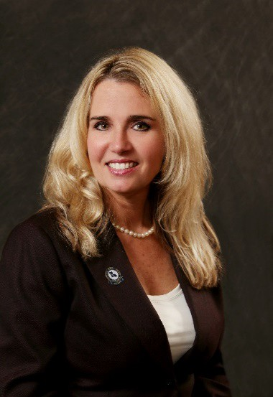
Dr. Janet Pope was selected by the Louisiana School Boards Association (LSBA) as their Executive Director in July 2018 after serving five years as their Board Development/Legislative Specialist. Pope’s appointment marked a notable milestone in both the association’s and the state’s history as she is the first and only woman to be selected to serve as the full-time Executive Director of one of the major associations representing Louisiana local government.

Prior to joining LSBA, Dr. Pope, a Lafayette native, served nineteen years in a large, traditional public school system in south Louisiana where she held various teaching and administrative positions.

Dr. Pope is an advocate of continuing education and professional development who believes in leading by example. She is National Board for Professional Teaching Standards certified and has passed the School Superintendent Assessment. Pope was awarded a Doctorate in Educational Leadership from the University of Louisiana at Lafayette in 2015. After serving with the GEAR UP College Readiness Grant, Janet continues to mentor students towards completing their post-secondary degree and into the workforce. She is a product of public-school education along with her husband and daughter Jolie.

Anita M. Tillman is a strategist, speaker, and executive coach. She is the founder and CEO of AMCorp International, where she helps clients - primarily municipal government and affiliated associations - find their voices and clearly speak to their audiences. The firm provides strategic communication and project management services as well as training for elected and appointed officials. For over 20 years - including many years in consulting and in governmental leadership positions - Anita has demonstrated expertise in communications, planning, governmental affairs, and policy. She is a former engineer and true to her problem-solving background, Anita is often referred to as "The Fixer."
Anita’s superpower is in helping people elevate their view and value of themselves. She is constantly coaching clients through transitions and helping them build the bridge from right now to what's next – ultimately leading to a greater quality of life.

Anita holds a B.S. in Electrical Engineering as a cum laude graduate of Southern University and A&M College in Baton Rouge. She sits on the Board of Directors of the Research Park Corporation and serves on the Executive Committee of the Krewe of Athena Carnival Club, Inc. Anita is a member of Delta Sigma Theta Sorority, Inc. and is her daughter, Sydnie’s biggest cheerleader.
Service, Leadership and Support for School Boards
Advocating for over 700,000 Louisiana Public School Students Page 2 of 2

