Hello seventh graders,

I know we don’t have an art class together right now, but I feel it’s only fair that you all have the same resources as the rest of junior high. Scroll down to find some materials you may take advantage of to keep your minds active, calm, and creative while we are away from school. These are all optional, and I encourage you to create however you please during this time. If you would like to share any of your artwork, you may E-mail me a picture of your work and I will share it on the CO-U live feed and on Artsonia! Hope to see you all soon!

Miss Hopp
ahopp@co-u.net

Lunch Doodles with Mo Willems! Go online any weekday at noon to draw along with author and illustrator, Mo Willems.
https://www.kennedy-center.org/education/mo-willems/

Go on a virtual field trip to the Metropolitan museum of art in New York City! Explore the map, hop in the time machine, or watch videos!
https://www.metmuseum.org/art/online-features/metkids/

Calm your mind while you explore color and symmetry by creating your own digital artwork using the Silk program at http://weavesilk.com/

Love classic video games? You may find an interest in making pixel art! Check it out at https://www.pixilart.com/draw

Watch some live webcams from the Georgia or Monterey Bay aquariums. Draw what you see!
https://www.georgiaaquarium.org/webcam/ocean-voyager/
https://www.montereybayaquarium.org/animals/live-cams

DOODLE AND DESTRESS
Try this: Put on some relaxing music, grab some paper or your art journal, a gel pen, Sharpie, pencil, or ball point pen, and try one of the doodle ideas below. --Trace a cup or a bowl to create a large circle in the middle of your page – this will be your drawing space.-- Experiment with keeping your lines close together so that you have to work carefully. --Remember that anything repeated looks much more interesting, even if the lines aren’t “perfect.” Look closely, you’ll find imperfections in my art here.--I find that stepping back gives me a better perspective and helps me stop perseverating on small imperfections. I do this often as I work. (Funny how that’s like life)

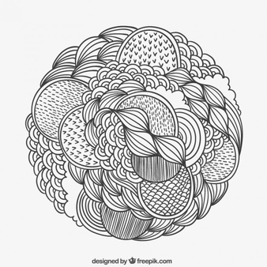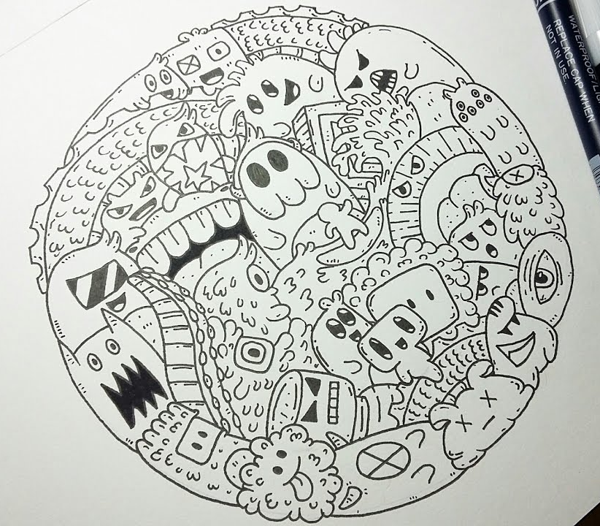

Here’s some shapes you might try doodling with:
1. Bubbles or Spirals
2. Triangles or Squares
3. Waves (drawn really close together – this looks cool)
4. Tiny leaf shapes – you can turn these into leaves, or make a small dot for a fish eye
5. Horizontal lines, overlapped with vertical lines
6. Simple flowers with 3 – 5 petals
7. Short lines, long lines, curvy lines, wavy lines
8. Dots – SO MANY DOTS!
9. Overlapping ovals to create a “chain”
10. Repeated “V” shapes, “C” shapes, “L” shapes, “U” shapes
11. Skinny ovals or fat ovals
12. “Checkerboard” patterns – make a grid and color in every other square

