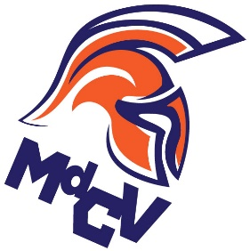

Marais des Cygnes Valley High School
National Honor Society Application

Please complete all sections. Do not be modest. Every bit of information can be used by the faculty council to assist with the selection process. Information MUST be legible; please type or use black or blue ink pen. If you would like this form emailed to you, please ask Mrs. McCullough.

- Name

- Clubs, Teams, Organizations
List all activities in which you have participated during high school. Include clubs, teams, musical groups, etc., and major accomplishments.

- Leadership Positions
List all elected or appointed leadership positions held in school, the community, or work activities. Only those positions in which you were directly responsible for directing or motivating others should be included.

- Community Service Activities
List community service activities in which you have participated and note any major accomplishment in each. List number of hours involved and date of activity.

- Work Experience, Recognition, and Awards
List below any job experiences, honors, or recognitions, that you have received which support your bit to be selected for membership. Work experience may be paid or volunteer.

- Importance To You
Write at least a paragraph explaining what it would mean to you to be selected for membership in the National Honor Society.

Return this form to Mrs. McCullough by Wednesday, March 18th.
No late applications will be accepted!

National Honor Society Application

Name _____________________________________________ Date ________________

- Clubs, Teams, and Organizations

Name of Club, Team, or Organization | 9th | 10th | 11th | 12th | Accomplishments

- Leadership Positions

Name of Activity, Service, Organization | 9th | 10th | 11th | 12th | Position Held

- Community Service Activities

Community Service Performed | 9th | 10th | 11th | 12th | Hours

- Work Experience, Recognition, Awards

Job, Volunteering, Recognition, Awards | 9th | 10th | 11th | 12th | Hours

- Important To You
Write at least a paragraph explaining what it would mean to you to be selected for membership in the National Honor Society.

I understand that completion of this form does not guarantee membership, but that I am being considered for membership in MdCV National Honor Society. I will accept the final decision of the faculty committee responsible for selecting members.

____________________________________________________________________________________
Student Signature
Return this form to Mrs. McCullough by Wednesday, March 18th.
No late applications will be accepted!

