Virtual School Counseling Guidance Lesson
Area: Social Development
Goal: To explore the definition of Honesty (Character Trait for March) and to help students understand that it is very important to tell the truth at all times even if it gets you into trouble
Standard: Students will understand and appreciate self and others
Objective/Competency: Students should be able to:
- No the difference between a lie and the truth;
- Identify and model skills of honesty and integrity in school and in their community

Strategy: Virtual Guidance Lessons
Key Material and Resources:
- Youtube video: “The Berenstain Bears and the Truth”
- Berenstain Bears Coloring Sheet
Evaluation Method:
- Students can answer the questions about the video

3K- 2nd Grade Guidance Lessons:
- Students will learn that trust is something that can’t be easily put back together once it is broken”.

Berenstein Bears Post Evaluation Questions:

Name_________________________

- What sport did Brother like to play?

- What was one of momma’s house rules for Brother and Sister?

- What happened when Brother and Sister decided not to follow the house rules?

- What did Brother and Sister decide to tell their mother?

- What valuable lesson did Brother and Sister learn from all of this?

NAME________________________________________________________
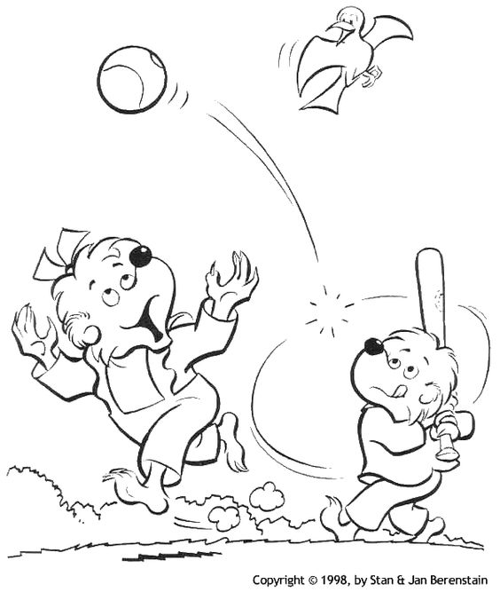
Answers: to Evaluation Questions:
1.Soccer 2.No playing ball in the house 3.Brother and Sister broke the lamp playing ball in the house 4.That a bird flew in the window and broke the lamp 5.To always tell the truth no matter what happens (consequences).

