The Teacher Will

- Provide high quality curriculum and instruction using TN standards in reading and math so students will meet the state’s academic achievement standards as well as both district and school goals
- Provide instruction in the subject/grade level for which I am responsible
- Provide a safe and pleasant learning environment
- Explain assignments and deadlines clearly to students
- Provide clear assessments of student progress and achievement to both the student and parent/guardian on a timely basis

The Parent Will
- Stay informed of my child’s education- check school website, Skyward, read all school communication
- Review homework assignments and offer assistance when needed
- Encourage my child to read 20 minutes each day outside of school
- Review assessments on a regular basis, sign report cards, and make every effort to attend parent-teacher conferences
- Ensure that the student gets to school each day, on time, and ready to learn

The Student Will

- Do my best in all I do
- Respect the rights of others so learning is not distracted or disrupted
- Come to class prepared and on time with necessary materials
- Give my parent/guardian and teachers all notices and information received by me
- Read 20 minutes each day outside of school

Communication about Student Learning/Progress

Gordonsville Elementary School is committed to frequent two-way communication with families about children’s learning. Some of the ways you can expect us to communicate are:

- Updates on the school website and grades in Skyward
- Progress reports and report cards
- Parent-teacher conferences
- Phone calls
- Remind App
- Email

Do you have questions about your child’s progress?
Parents can contact their child’s teacher by phone.
Phone: (615) 683-8252

School-Parent Compact for Achievement
2019-2020
Gordonsville Elementary School
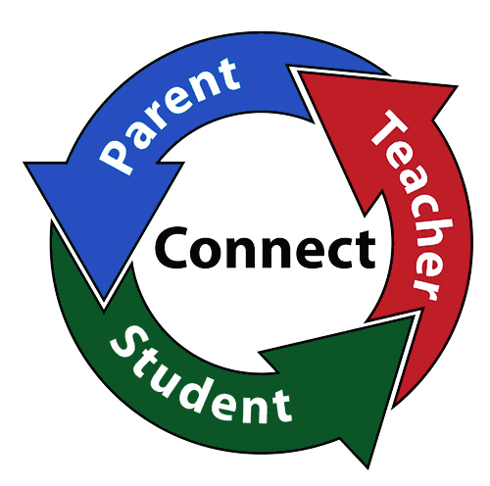
100 Main Street E
Gordonsville, TN 38563
(615)683-8252, fax (615)683-8253
https://gordonsville.smithcoedu.com
Principal- Rachel Kelley
Assistant Principal- Scott Clemons

Signature Page
Thank you for your support and involvement in working together for success in student education.

Please review the entire School-Parent Compact and your responsibility as a partner.

Please sign and date below to acknowledge that you have received and read your commitment to this partnership. Please send signed pamphlet to school.

Student:

Signature _______________________________

Date: _______________

Parent/Guardian:

Signature _______________________________

Date: _______________

Teacher:

Signature _______________________________

Date: _______________

Please contact us if you have any questions about school activities.
Mrs. Rachel Kelley- rkelley2@smithcoedu.net
Mr. Scott Clemons- sclemons@smithcoedu.net

Our Goals for Student Achievement
Smith County Schools
- 90% of all students reading on grade level
- Meet all ACT College and Career Readiness benchmarks
- Meet or exceed state attendance requirements

Gordonsville Elementary School
- 90% of GES students reading on grade level
- Increase the number of students scoring proficient or advanced on state testing in both Reading and Math
- Meet or exceed state attendance requirements

School-Parent Compact
A school-parent compact for achievement is an agreement for parents, students, and teachers. It explains how parents and teachers will work together to make sure all students get the individual support they need to reach and exceed grade level standards.

- Link to goals of the district and school improvement plans
- Begin with standards
- Focus on student learning
- Respond to school/student data
- Define everyone’s responsibilities

This compact is distributed to all parents, students, and teachers. It is on file at the school and is used throughout the year.

Jointly Developed
The parents, students, and staff of Gordonsville Elementary School work collaboratively to annually assess and revise the School-Parent Compact for achievement.

Parents are welcome to participate and/or contribute comments at any time.

For information of GES compact annual review, please contact the GES Literacy Leader.
Lesa Manning - manningl@smithcoedu.net

Student:

My personal learning goal is: ______________________________________________________________________________
My teacher can help by: ______________________________________________________________________________
My parents can help by:
______________________________________________________________________________

