 Bureau Valley Wyanet Elementary Storm Report
Issue 12 Volume 1 March 6, 2020
Unity, Excellence and Pride!
We are what we believe. What we believe unifies us.
We promise to our students and communities to provide a positive learning environment which promotes both academic and social success

Website-- www.bv340.org

March Student of the Month



Meysen is a sweet boy who loves to please the adults at school. He follows classroom and school rules and procedures right away. He has enthusiastic stories to share, and is excited for school. Meysen is a friend to all students in his class, and is respectful to others. Congratulations to Meysen Watson for being named March Student of the Month!

Additional Clothing

Please send with your child an additional set of clothing to be kept at school in case of spills, mud puddles, or accidents. Please put items in a Ziploc or plastic bag labeled with your child’s name.

PE Classes Enjoyed Using the Parachute

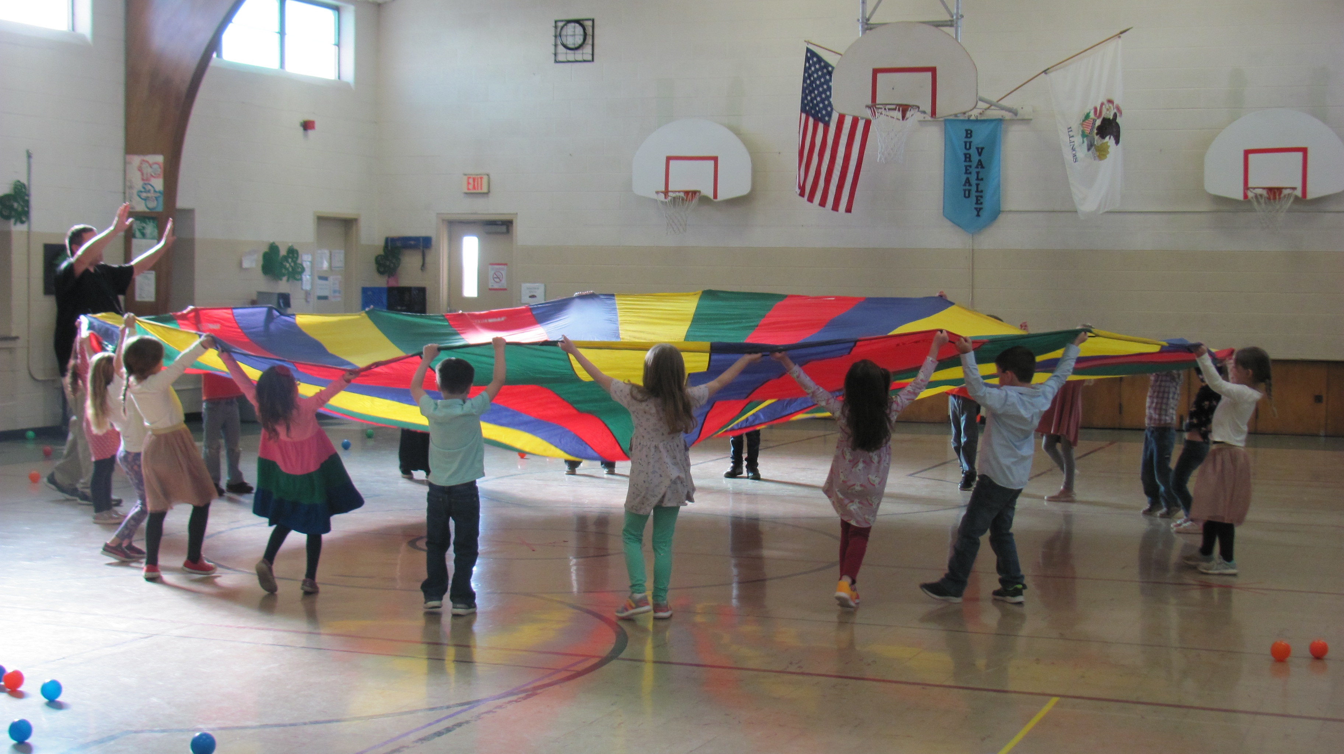
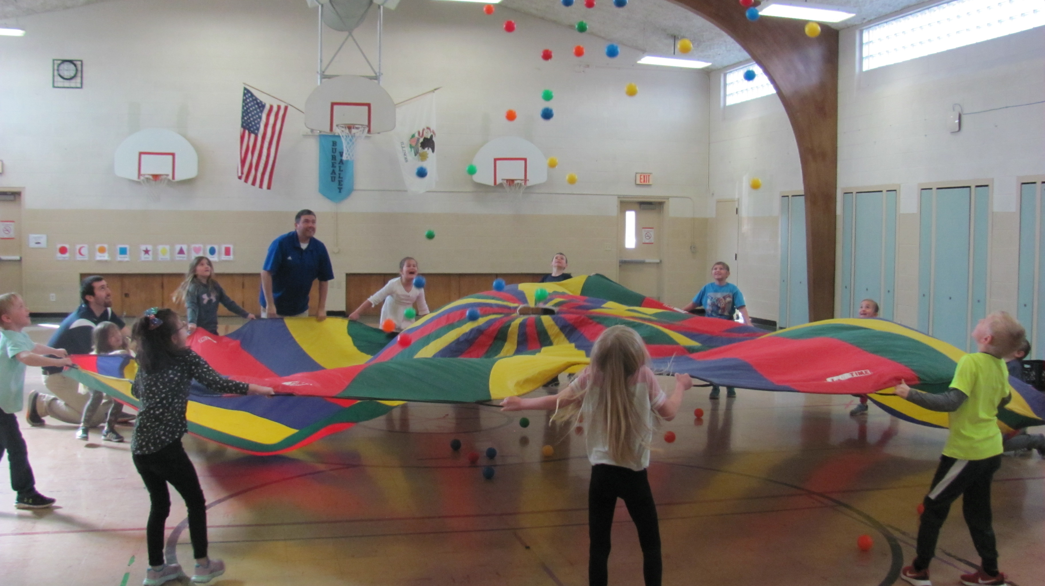
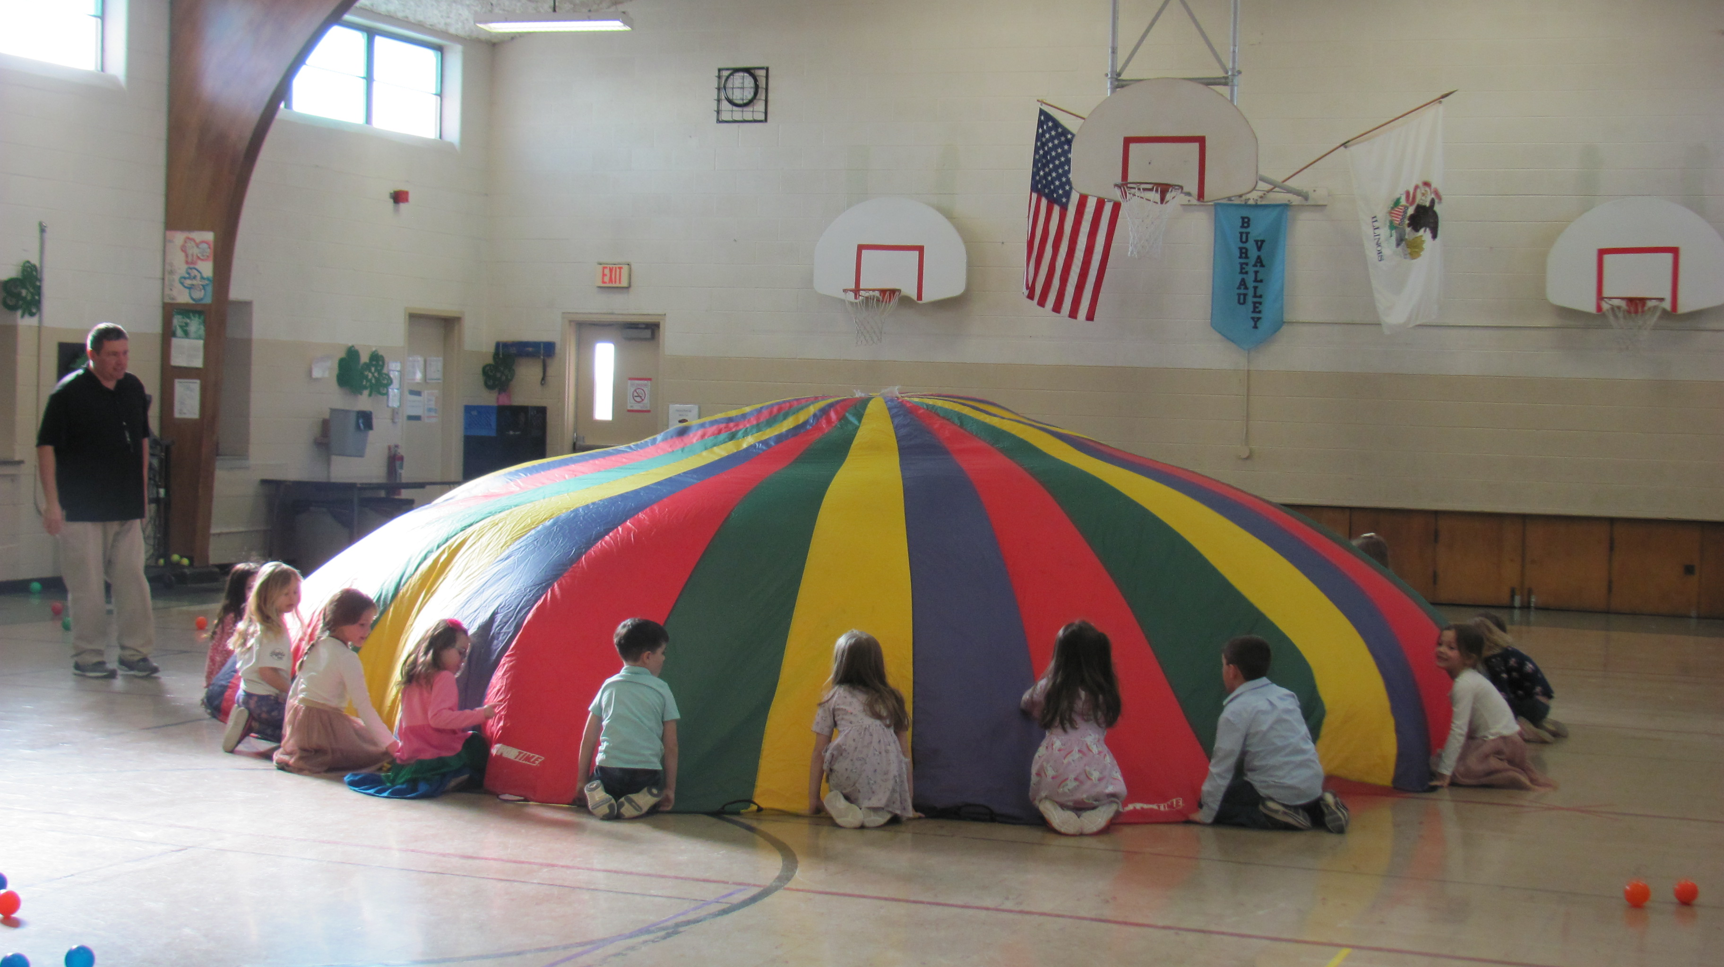

The K-2 students learned how to work together as a team during physical education class to make the parachute ripple, make big waves, and look like a mushroom. They also had some goldfish that rode the waves. Be sure to ask your child how the goldfish did. The parachute is a great way to gain muscular endurance for arms, creative play for the mind, and teamwork.
Iditarod Visitors in First Grade

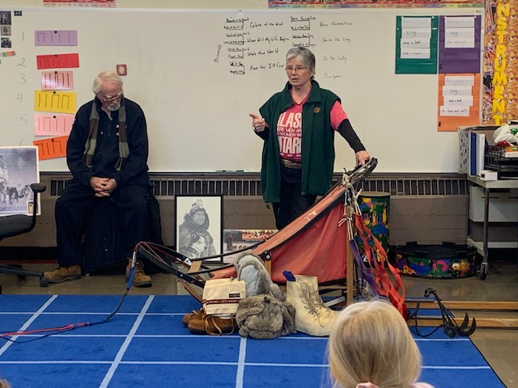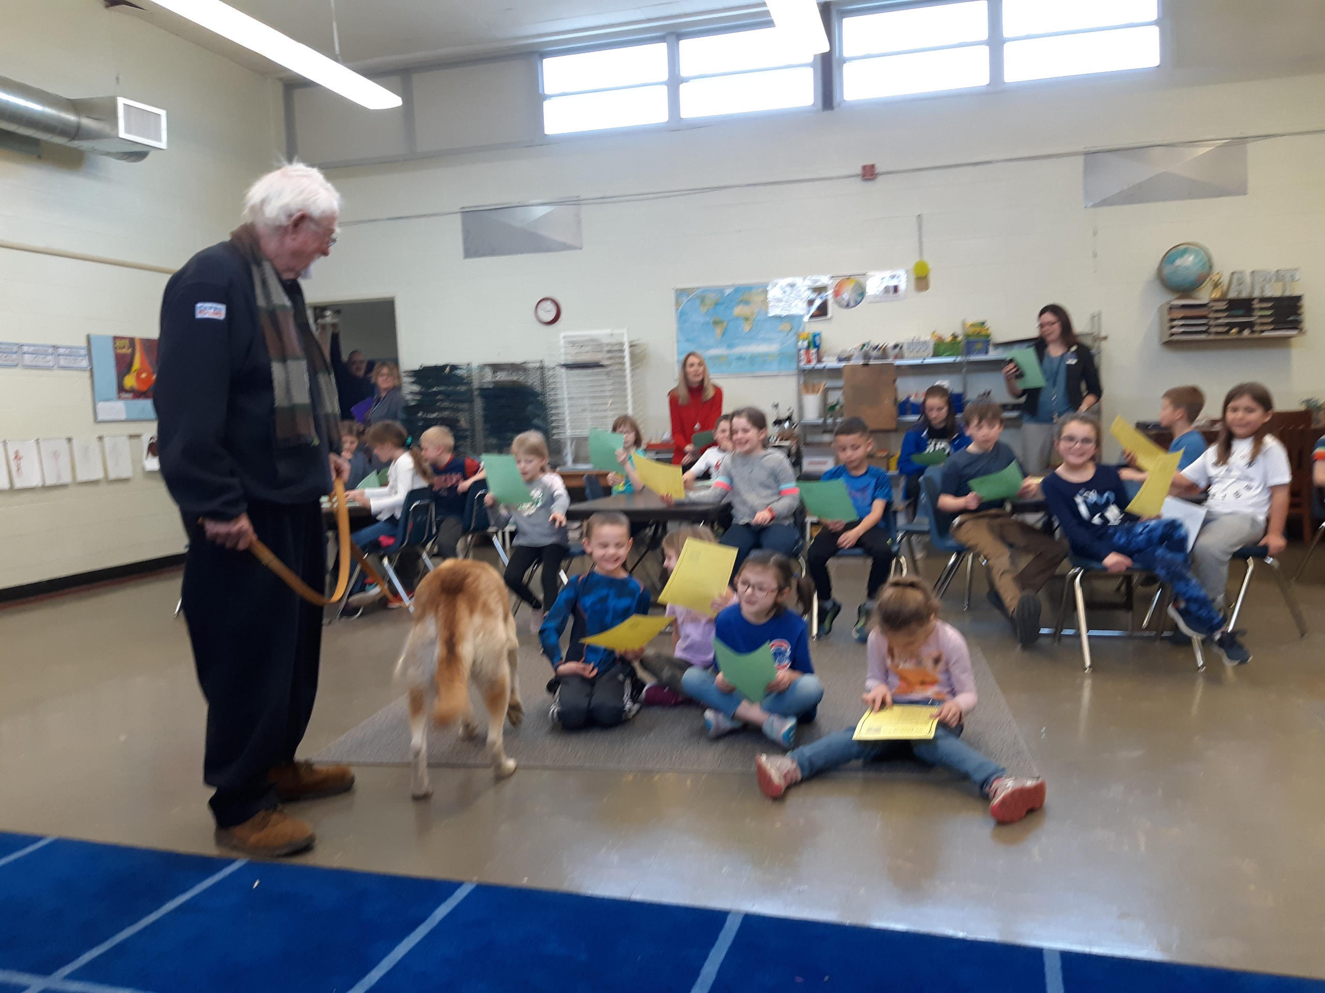
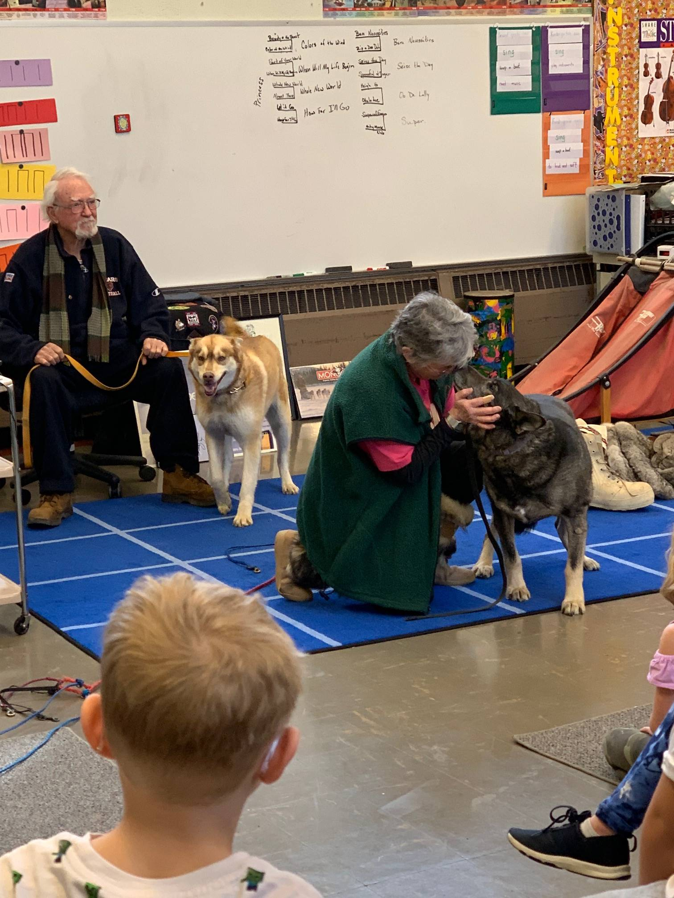

The 1st graders have been following the Iditarod, a 1049 mile dog sled race across Alaska. They were honored to have Lori Windows visit and tell about the Iditarod and the times she has spent volunteering as a vet tech at the Iditarod. She brought a sled and other equipment. She also brought two sled dogs, Zirkle and Brutus. Zirkle is named after musher Aliy Zirkle. The students enjoyed their time with Ms. Lori.

First Grade’s Special Visitor

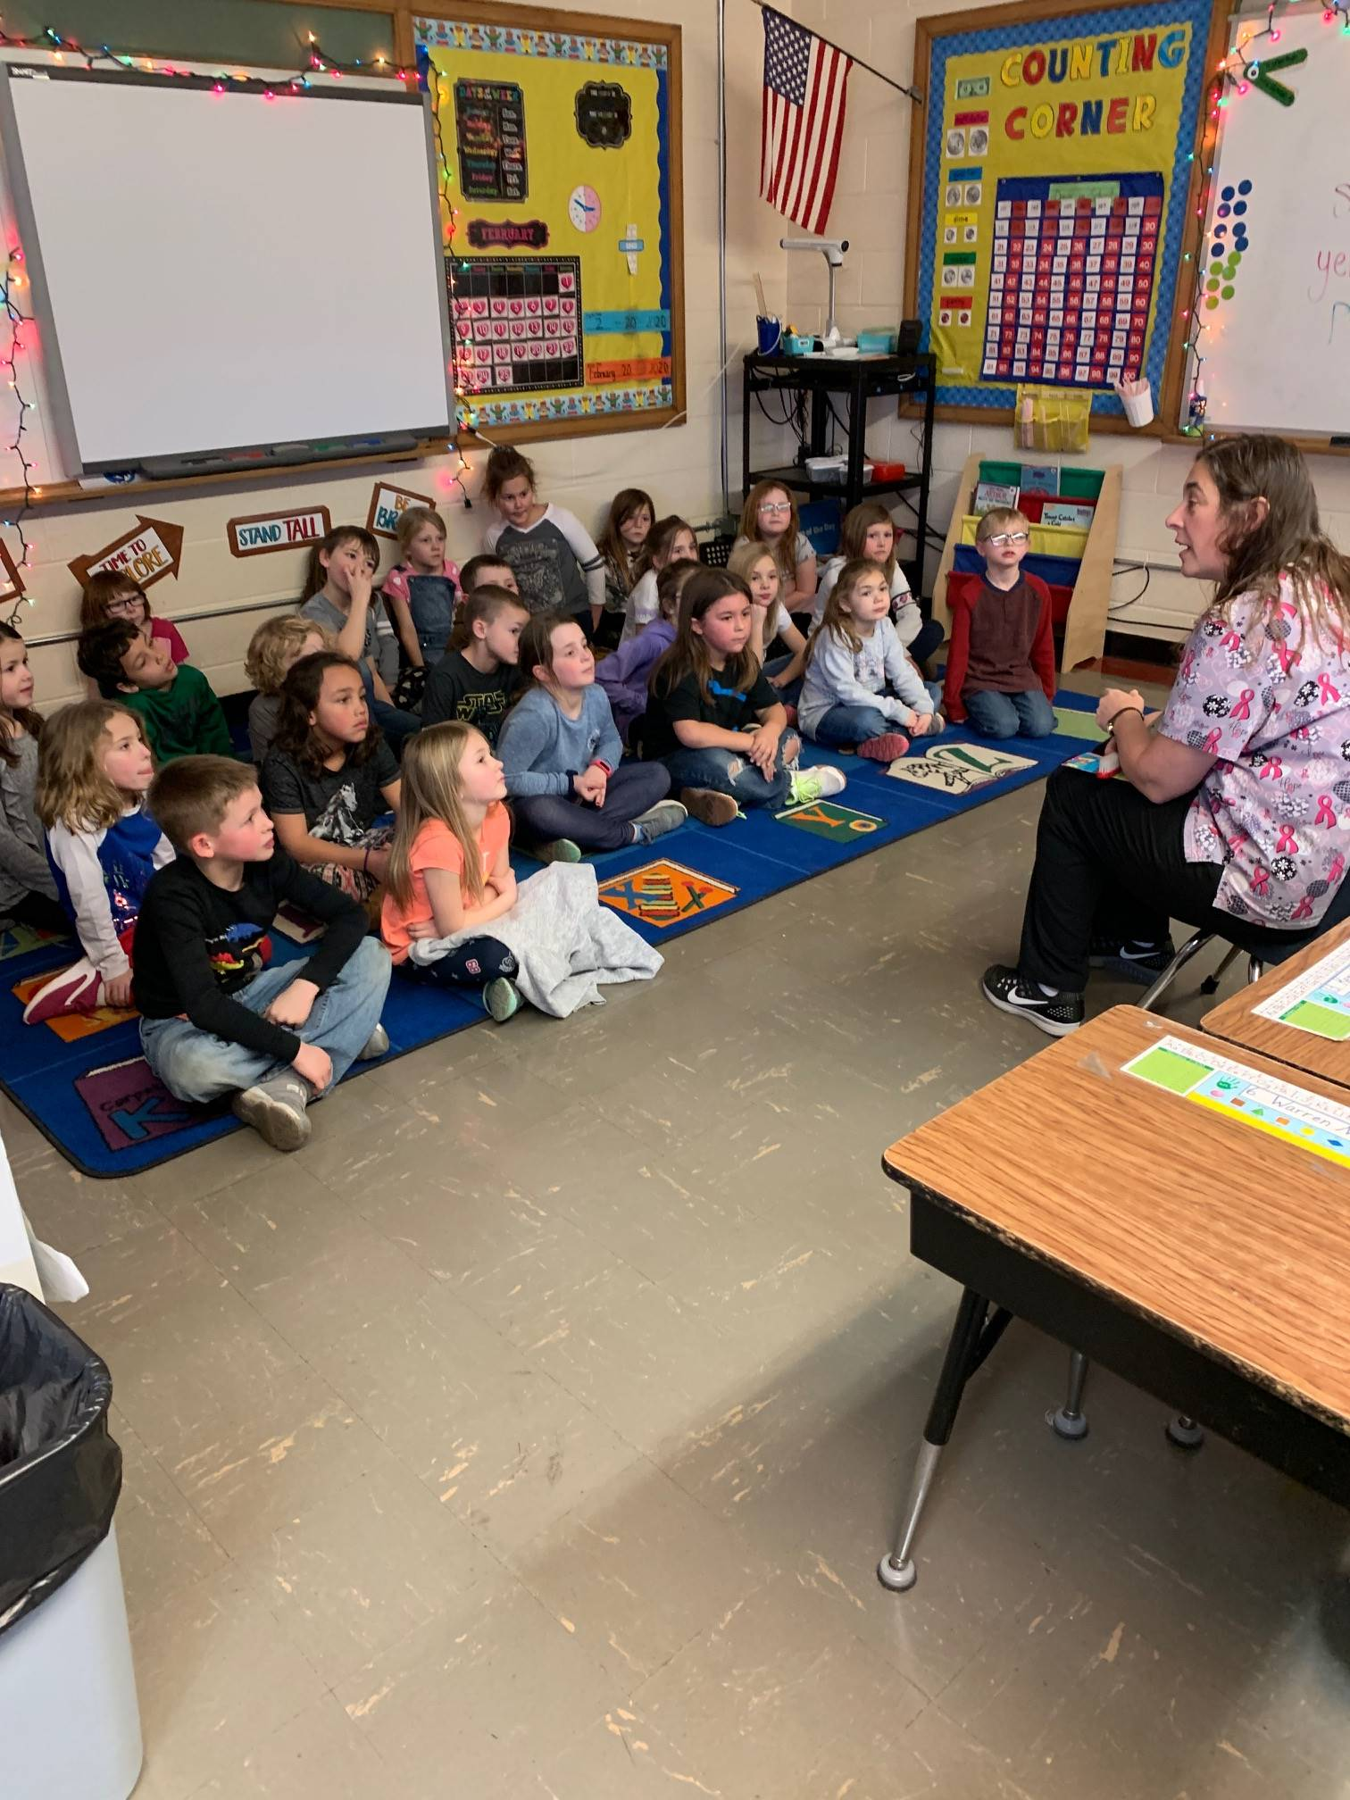
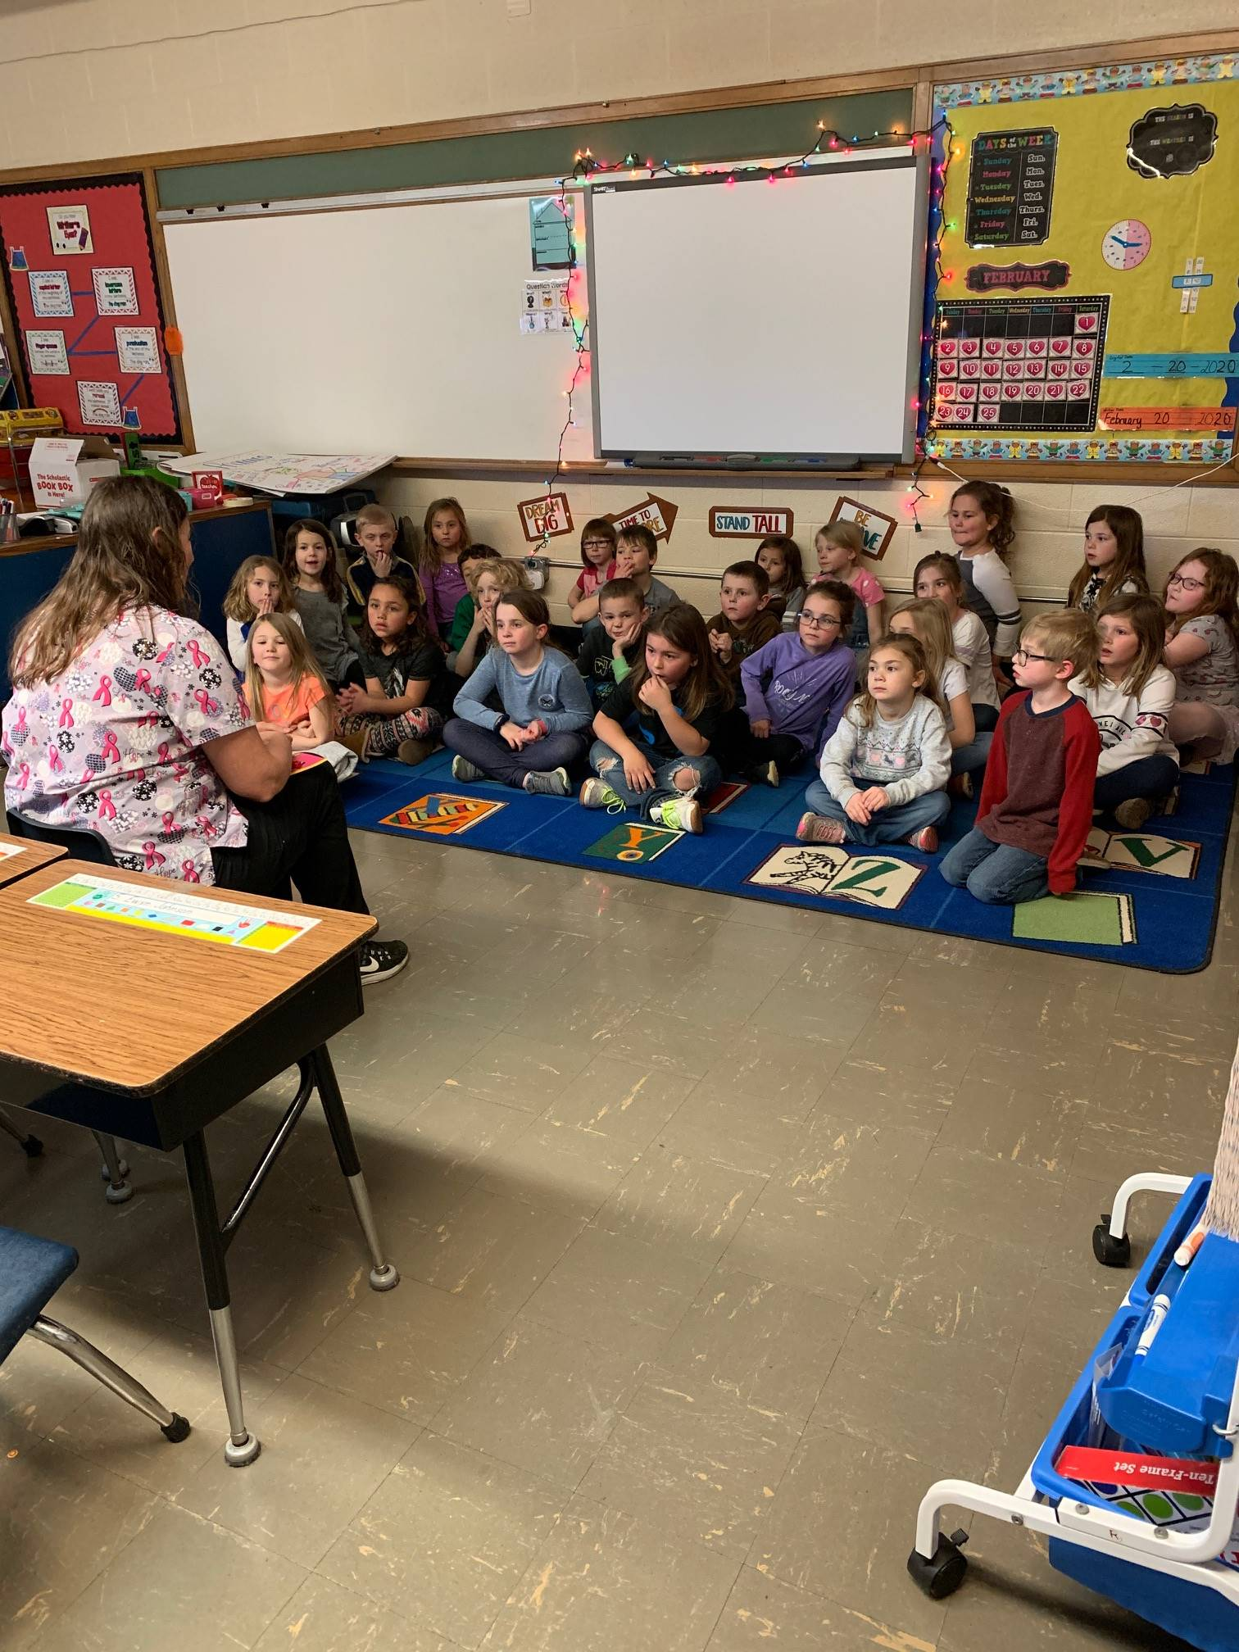

First grade had a guest speaker this week. Mrs. Ledergerber came to talk to both first grade classes about dental hygiene. She talked about proper ways to help us take care of our teeth and even brought in props to give us a visual!

Kindergarten Packets for 2020-2021

Please remember that if you have a student going into Kindergarten for 2020-21 school year, kindergarten packets were due in February. If you have not turned yours in, please do so as soon as possible.
Pre-K Visits Pizza Hut

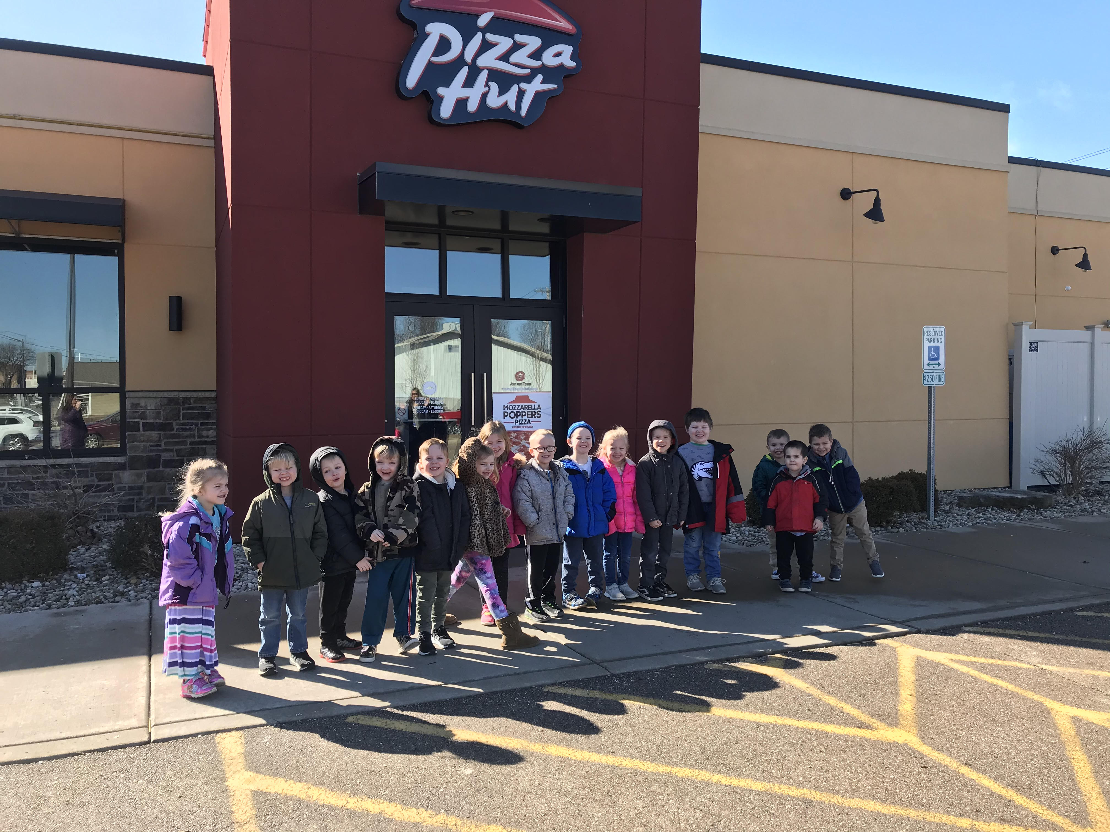
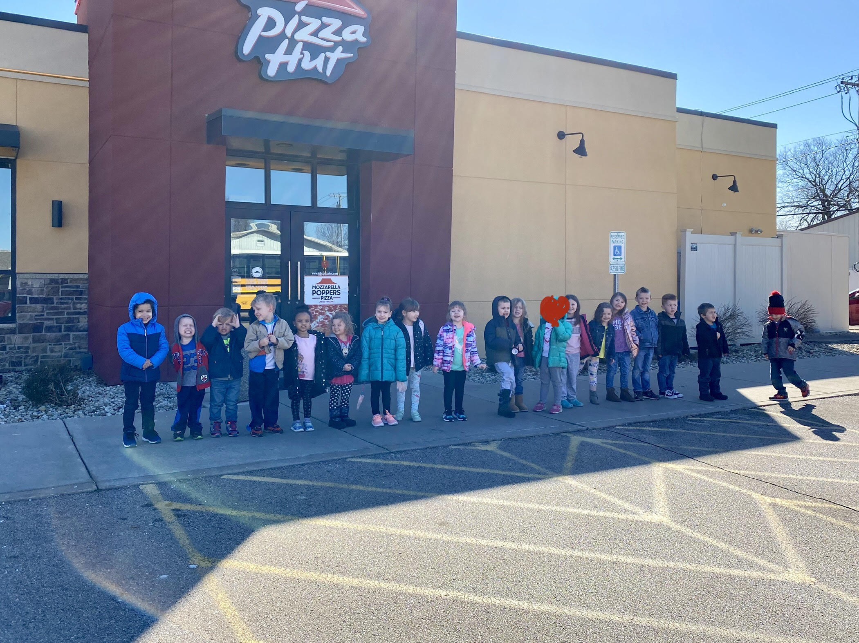

The BV Wyanet Pre-K worked up quite an appetite while learning about community helpers this week. We have learned what it is to be a community helper and how they help in our daily lives. On Wednesday, March 4th we were able to take a field trip to the local Pizza Hut and see the different materials and utensils that are used to make pizza. After a long day of learning, the students got to enjoy eating yummy Pizza Hut pizza. Everyone gave it two BIG thumbs up!! If you plan to visit Pizza Hut soon, be sure to check out the wall of coloring pages around the entrance. You may see a few BV Pre-K students work of art!

 Salad Bar

Due to Spring break, there will be no salad bar on Monday, March 30th and Tuesday, March 31st. Students will only be able to receive hot lunch for these two days or bring a lunch from home.

 Dates to Remember
  - Monday, March 9th -4th quarter milk/juice starts
  - Tuesday, March 10th-Pre-K to Sheffield Fire Station (AM 8:30-10:00 and PM 12:40-2:10)
  - Thursday, March 12th 5:30pm Blast off Pre-K Science Night
  - Friday, March 13th End of 3rd quarter
  - Monday, March 16th -Ag in the Classroom
  - Monday, March 16th 6pm Board of Education meeting at District Office
  - Tuesday, March 17th – 6pm PTO meeting in the gym
  - Friday, March 20th – 3rd quarter Report Cards sent home and 2pm Dismissal for
Spring Break
Saturday, March 21st – BV Foundation Draw Down (5:30pm Doors Open/6:00pm Dinner)
  - Monday, March 23-Friday, March 27- No School Spring Break
  - Monday, March 30th School Resumes
  - Wednesday, April 1st-Character Counts for students
  - Thursday, April 9th -4th quarter mid-term and 2pm Dismissal for Easter break
  - Friday, April 10th- No school –Easter break
  - Monday, April 13th- School Resumes

Next newsletter will be sent home on Friday, March 20th.

