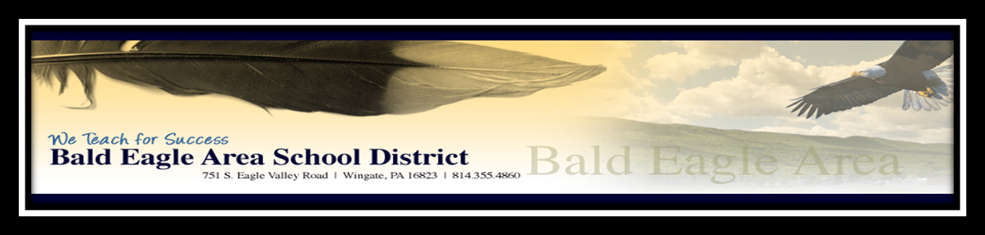

Dear Parents of Bald Eagle Area School District Students:
Throughout the last few weeks the Coronavirus has received significant coverage within national and international news reports. The Centers for Disease Control & Prevention (CDC) is closely monitoring the outbreak – including the number of confirmed cases within the United States – which remains considerably low.
As this outbreak is a virus, the best defense is to follow the same precautions recommended to prevent the spread of the cold and flu. The Centers for Disease Control and Prevention offers the following practical advice:
- Wash your hands often with soap and water for at least 20 seconds, especially after going to the bathroom; before eating; and after blowing your nose, coughing, or sneezing.
- If soap and water are not readily available, use an alcohol-based hand sanitizer with at least 60% alcohol. Always wash hands with soap and water if hands are visibly dirty.
- Avoid touching your eyes, nose, and mouth with unwashed hands.
- Avoid close contact with people who are sick.
- Stay home when you are sick.
- Cover your cough or sneeze with a tissue, then throw the tissue in the trash.
- Clean and disinfect frequently touched objects and surfaces using a regular household cleaning spray or wipe.
- The CDC does not recommend the use of face masks as a way to prevent the virus’ spread.
If necessary and appropriate, we will provide further updates. In the meantime, information is available online from the Centers for Disease Control and Prevention and the Pennsylvania Department of Health.
As a reminder, students should be kept home from school if they are experiencing any of the following symptoms:
- Vomiting or diarrhea
- Temperature of 100 degrees or higher
- Continuous coughing or sneezing
- Unexplained and/or contagious rash
- Thick dark yellow or yellow-greenish drainage from the nose
- Yellowish drainage from the eye (contagious conjunctivitis—Pink Eye)
Symptoms should be resolved for 24 hours before returning to school.
Should you have any concerns regarding your child’s health and safety, please contact your health care provider, school nurse and/or building principal. Thank you for helping to keep our schools and, most importantly, our students safe and healthy.

Resource Links
- About Human Coronaviruses
- Coronavirus in the U.S.
- Frequently Asked Questions about the Coronavirus
- What to do if you are sick with 2019 Novel Coronavirus (2019-nCoV)
- Pennsylvania Department of Health - Coronavirus
- Fact Sheet provided by the Pennsylvania Department of Health

