Your Menus Have Gone Online!

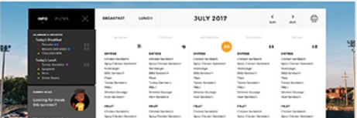
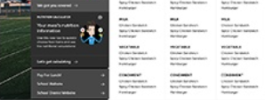
The Rich Hill school district along with Thrive Nutrition Services are excited to announce our partnership with MealViewer. MealViewer is an online menu viewing system that allows users to look up their school district’s monthly breakfast/lunch menus and much more!

Information at Your Fingertips!
- View and Print Menus
- Create User Profiles
- Filter Menus by Specific Food Allergen
- Access Nutritional Information
- Provide Instant Feedback

How to View Menus
- Type in the direct link below
http://schools.mealviewer.com/school/RichHills
- Visit schools.mealviewer.com & type in “Rich Hill School District”
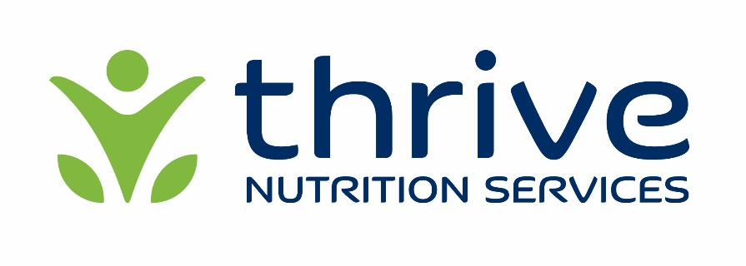
- Download the “MealViewer To Go” App for iOS and Andriod

