On Tuesday, Feb. 25th, Maryetta is hosting a FREE Car Seat Check Up for
Expectant mothers & caregivers with children birth to age 8.

A limited number of car seats will be available for $10 (cash only)
- Child must be present or expectant mother within 2 months of delivery
- Show proof of government assistance (WIC, Food Stamps, SoonerCare, etc)
- Maximum of 1 seat per child and 2 seats per family
- Car Seats / Boosters available on a FIRST COME FIRST SERVE BASIS

Tuesday, February 25th, 2020
TIME: 1:30 p.m. – 3:30 p.m.
LOCATION: Maryetta Preschool parking lot
100 Maryetta Road | Stilwell, OK 74960
Sponsored by:
Safe Kids Tulsa Area
Oklahoma Highway Safety Office
The Children’s Hospital at Saint Francis
Maryetta Schools

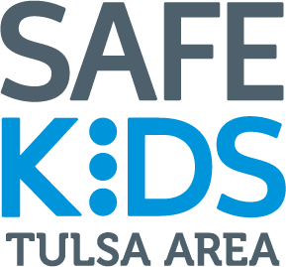
10$ Car Seats available to legal guardians
or parents only

