**THE STANLEY ROAR**



Stanley Elementary School

Volume 6, Issue 4

November 2019

Ms. Suzanne Dupuis-Principal

Ms. Anita Webb-Assistant Principal

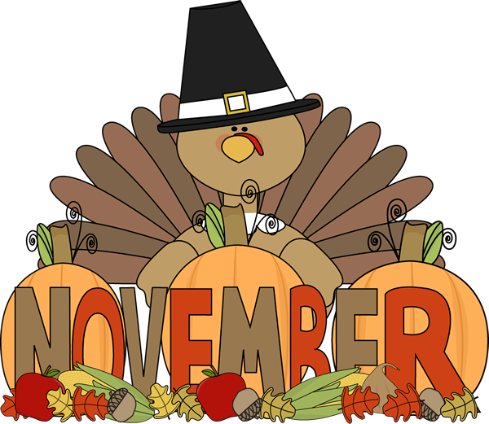

**Important Dates:**

* November 5: Parent Teacher Conf. 12:30-7 pm
* November 11: No school – PD Day
* November 12: Veteran’s Day Assembly – 1 pm
* November 27-29: Thanksgiving Holiday Break
* December 6: Night with Santa – 5 pm

**\*\*\*\*\*Reminder\*\*\*\*\*\***

**Parents & Guardians: Please remember to call into the office by 2:00 pm for transportation changes. This allows the office time to get notes to students before being released.**

**Exciting Ways to Keep in the Loop at Stanley Elementary!**



**Stanley Elementary** now has its own Facebook page. Please like and follow Stanley Elementary School on Facebook for updated information, pictures of exciting things happening at school, and other important messages.

Another way to see and hear what is going on at Stanley Elementary is to watch

**Tiger Time** each morning. We post a live video M-F on our Facebook page.

NOVEMBER CHARACTER TRAIT

**CITIZENSHIP**

* Stay informed and vote
* Are good neighbors
* Obey laws and rules
* Respect authority
* Protect the environment
* Make their school and communities better



**Counselor’s Corner:**

Mr. Harlow will be holding classroom guidance lessons during the first and fourth weeks of the month of November.   
  
November 5 – November 8: Students will sharpen their senses by learning to mindfully listen.   
  
November 26 – November 29: Students will sharpen their senses by learning to mindfully see.

Veteran’s Day Assembly: November 12 at 1:00 pm in the gym. Students please invite a parent/guardian and a veteran to attend. Choir performance, America’s White Table Ceremony, and recognition of past and present veterans of the United States of America to be held.

Words of Wisdom to Students: Be kind, for everyone you meet is having a hard battle.

**Nurse’s Corner:**

**Wellness Tips**



**How to Prevent Colds and the Flu:**

* Wash your hands often
* Cover your mouth when you cough or sneeze
* Eat a Healthy diet & get regular exercise
* Don’t share cups, glasses, or eating utensils
* Flu Vaccination

**Symptoms of the Flu include:**

* Fever, chills, fatigue, sore throat, muscle/body aches, headaches and nasal congestion.

**Students should remain at home if they exhibit any of the following conditions:**

* Temperature of 100 degrees or higher orally with other symptoms
* Strep throat until 24 hours after the start of antibiotics
* Vomiting and/or diarrhea two or more times during the night or morning and until your child is eating and drinking fluids again
* A cough that would interfere with learning
* Bacterial conjunctivitis (pink eye) until 24 hours after the start of antibiotics.



