THE STANLEY ROAR

Stanley Elementary School
Volume 6, Issue 6
January 2020
Ms. Suzanne Dupuis, Principal
Ms. Anita Webb, Assistant Principal

January Character Trait
Fairness
The student displaying
fairness treats people and ideas with justice and impartiality.

IMPORTANT DATES
- Jan. 13 – No School – Teacher Workday
- Jan. 16 – Report Cards go home
- Jan. 19 – MLK Celebration 2 pm @ LHS
- Jan. 20 – No School – Prof. Development

Have you downloaded our app yet? Be sure you do, so you can follow what’s taking place at our schools and get alerts instantly. Just search Page County Public Schools in the Apple store or Google Play Store today!!!

ATTENDANCE MATTERS!
*Attendance incentives at Stanley*
- The class with the best attendance will earn Stanley Jr. as the class mascot for the week.
- Each student that has perfect attendance will have their name added to a drawing. Every morning on Tiger Time, a name will be drawn and the student will be live on the next day’s morning announcements.
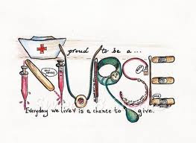
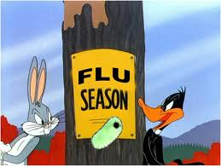
Stay warm, wash hands, and get good rest! We want you at school happy and healthy!
Wellness Tips:

When to keep your child home from school:
We stress good attendance, however in order to promote the health and safety of all of our children at Stanley Elementary, and assure your child’s comfort, students with the following conditions should remain at home:

*Temperature of 100 degrees or higher orally with other symptoms
*Strep throat until 24 hours after the start of antibiotics
*Bacterial Conjunctivitis (Pink Eye) until 24 hours after the start of antibiotics
*Impetigo (Staph skin infection) until 24 hours after the start of antibiotics
*Vomiting and/or diarrhea two or more times during the night or morning and until your child is eating and drinking fluids again
*A cough that would interfere with learning

Counselor’s Corner:

The Six Pillars of Character are the core ethical values of CHARACTER COUNTS! The Six Pillars of Character are: Trustworthiness, Respect, Responsibility, Fairness, Caring and Citizenship. Each of The Six Pillars of Character are used within the CHARACTER COUNTS! program to help instill a positive school climate and a culture of kindness, making schools a safe environment for students to learn.

Mr. Harlow will be holding classroom guidance lessons during the second and fourth weeks of January.
January 13 –January 17 students will develop their character and use trustworthiness in order to be honest in their communications and actions, not deceive by cheating or stealing, being reliable by doing what they say you will do, finding the courage to do the right thing, building a good reputation for themselves, being loyal by standing by their family, friends, and country, and keeping their promises.

January 27 – January 31 students will develop their character and use respect in order to ensure that they follow the golden rule, become tolerant and accepting of others’ differences, use good manners, not bad language, be considerate of the feelings of others, not threatening to hit or hurt anyone, and learning to deal peacefully with anger, insults, and disagreements.
PBIS Celebration: Friday, January 17, 2019. Party Like a Rock Star theme.

Words of Wisdom to Students: Do one act of kindness each day of the year, and change 365 lives.

