Performance and Financial Reports

[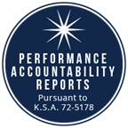](https://datacentral.ksde.org/acct_rpt.aspx)

[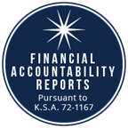](https://datacentral.ksde.org/dist_funding_rpt.aspx)

[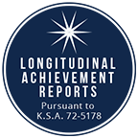](http://ksreportcard.ksde.org/2015_2019_Assessment_Full_File.xlsx)