Transferring Google Drive Files: Students
Your district Google account will be deleted several weeks after you leave the district. If you would like to retain the files you created, you will need to export them out of your district Google account. Sharing them with a non-district account will not work, because you are unable to transfer the ownership of those documents and once your account is disabled, you will no longer have access.
1. Download documents from Google Drive: Do this on a regular computer, not a Chromebook.
a. Select all of the items you would like to export. You can type Ctrl/A to select all of your documents, or hold down the Ctrl key and click on just the items you want to keep.
b. Expand the More Actions drop-down menu (three dots), and select Download. 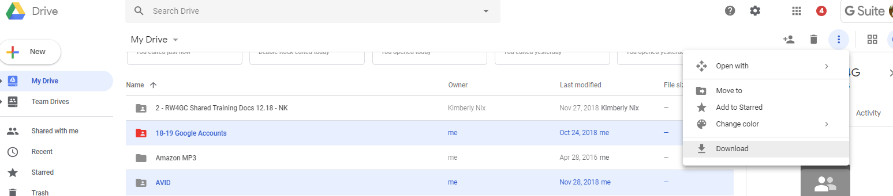

c. Select a file format to which you'd like to convert and download your item, such as Microsoft Word. If you select multiple items, they'll be compressed into a .zip file.
d. Click Download.
e. You can now transfer the documents to another computer using a jump drive or transfer them to another Google account.
2. Extract documents from downloaded ZIP
a. Windows: Right click the ZIP file, click Extract all files.
b. Mac OS X: Double click the ZIP file.
3. Upload documents to another Google Drive Account
a. Use the Google Chrome web browser in order to upload an entire folder to Google Drive.
b. Click the New button.
c. Click Folder Upload.
d. Browse to the folder with your extracted Google Drive files.
e. Click OK.

