Transferring Google Drive Files: Staff
Your district Google account will be deleted several weeks after you leave the district. If you would like to retain the files you created, you will need to export them out of your district Google account. Sharing them with a non-district account will not work, because you are unable to transfer the ownership of those documents, and once your account is disabled, you will no longer have access.
1. Download documents from Google Drive (Do this on a computer and not a Chromebook)
a. Select all of the items you would like to export. You can type Ctrl/A to select all of your documents, or hold down the Ctrl key and click on just the items you want to keep.
b. Expand the More Actions drop-down menu (three dots), and select Download. 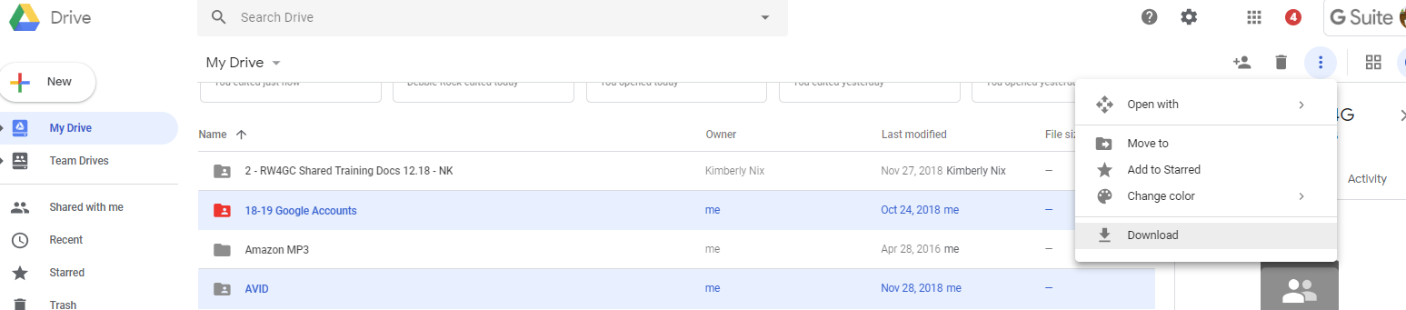

c. Select a file format to which you'd like to convert and download your item, such as Microsoft Word. If you select multiple items, they'll be compressed into a .zip file.
d. Click Download.
e. You can now transfer the documents to another computer using a jump drive or transfer them to another Google account.
2. To Extract documents from downloaded ZIP
a. Windows: Right click the ZIP file, click Extract all files.
b. Mac OS X: Double click the ZIP file.
3. Upload documents to another Google Drive Account
a. Use the Google Chrome web browser in order to upload an entire folder to Google Drive.
b. Click the New (Plus) button.
c. Click Folder Upload.
d. Browse to the folder with your extracted Google Drive files.Click OK.
Google Transfer: Allows you to transfer Drive files and mail from one account to another https://takeout.google.com/transfer
Here’s a video that shows you how: https://www.youtube.com/watch?v=B-eGHN6vo2M&index=60&list=PL3FMVFVAvQFTgYw5LPtGXJQ6LlvRfyp0O

Transferring Ownership of Documents to Other District Staff
If you have shared documents with other district staff members and would like them to retain access to those documents, you can transfer ownership to another staff member. If there are multiple documents, you can put them in a folder and transfer ownership of the entire folder. You can also transfer the documents to a TEAM drive if there is one that is used by your colleagues. Check with Brenda Sargent about this if you are unsure.
- Transferring ownership of a single document
  - Open the document
  - Click on the blue Share button
  - Click on advanced at the bottom of the Share window

  - In the window that comes up, click on the dropdown menu next to the name of the person you would like to make the new owner of the document. Select “Is owner”.

  - Click Done

When we delete your Google account, we have the option of transferring all of your documents to another staff member. If you would like us to do this, please email Brenda.sargent@kelsosd.org

