Project B.A.S.I.C. Newsletter
January 2020
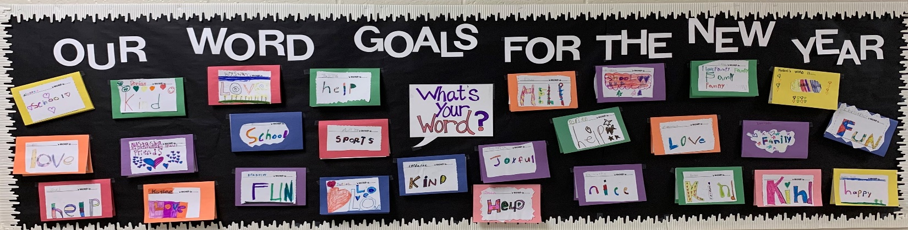

Happy New Year!
I hope everyone had a wonderful holiday season and I hope the new year will be a joyous one for all!
As we think about the new year, many of us will spend time reflecting and setting goals for the year ahead. One of my goals for the new year is to begin an informative newsletter for families of Ripley Primary School. This is the first of those newsletters and I plan to include helpful information on topics that I think will be important to you, shed some light on mental health awareness, provide helpful hints and tips on relevant issues that you may face as parents, upcoming community events, and updates on what kids are learning in Project B.A.S.I.C. If there is ever a topic you’d like to learn more about, just ask!
What are kids learning?
The past couple of months we have spent time reviewing rules and why they are important. We’ve talked about traits that make someone a good friend and ways to show someone that you care. We’ve talked about setting goals for ourselves and developing a plan to succeed! You may sometimes see work that comes home that we did together in BASIC. Sometimes we aren’t able to finish, so I encourage the children to work on it at home if they’d like. This would be a good opportunity for them to share with you what they are learning, and it opens the door for you as parents to further the lesson being taught at home!
BASIC Spotlight: Effects of TV in Children
For this newsletter, I want to share a little information that I have come across regarding screen time, content and television usage by young children. This includes regular TV programming, movies and YouTube videos. This is an area that I know we all struggle with as parents, but it is important to set limits and monitor the content that your children are seeing. Here are some facts:
- TV can be a powerful influence in shaping behavior. Unfortunately, much of today's television programming is violent. Studies show that children exposed to TV violence may:
- become "immune" or numb to the horror of violence
- begin to accept violence as a way to solve problems
- imitate the violence they observe on television; and
- identify with certain characters, victims and/or victimizers
- Children with emotional, behavioral, learning or impulse control problems may be more easily influenced by TV violence.

- Young people can be affected even when their home life shows no tendency toward violence.

- Federal Communications Commission (FCC) & Surgeon General agree that there is “strong evidence” that exposure to media violence can increase aggressive behavior in children.

- Most programming contains some form of violence. Surprisingly, the highest proportion of violence is found in shows that are intended for children. Of all animated feature films produced in the United States between 1937 and 1999, 100% portrayed violence.

- The strength of the association between media violence and aggressive behavior is nearly as strong as the association between cigarette smoking and lung cancer.

- The average amount of time spent in front of a screen for children age 8-18 is over 6 hours per day. By the age of 18, the average child will have viewed 200,000 acts of violence on TV alone.
Concerns about the impact of television on children is not a new thing. In fact, studies have been conducted as far back as the 1950’s. In addition to concerns about promoting violence, too much time in front of the screen also takes away time that can be spent doing other beneficial activities such as reading, playing with friends, and developing hobbies.
What can parents do? While it isn’t always easy, here are some steps that you can take:
- Pay attention to what your kids are watching.
- Limit the amount of time spent in front of the screen.
- Explain the difference between violence seen on TV and violence in real life (on TV it is acting, in real life people will be hurt, etc.).
- Don’t let children have TV’s in their bedrooms.
- If you come across something that is inappropriate, turn it off and explain why it won’t be watched.
- Don’t let your child have access to tablets or phones where inappropriate content is easily viewable. If they do, set up parental controls to limit exposure to violent or adult content.
All information has been compiled from the American Academy of Pediatrics and The American Academy of Child & Adolescent Psychiatry. If you have any questions or need support on setting limits for your child, please don’t hesitate to reach out.
BASIC Referrals
In addition to teaching classroom lessons, I can also meet with children individually to provide counseling and guidance for a variety of concerns. If this is something you think would benefit your child, please ask your child’s teacher for a referral or contact me directly.
Talking to Your Child About Mental Health
As parents, we often second guess ourselves and wonder if we are “reading into” something that isn’t there. Always take your concerns seriously and talk to your child about them. Make sure you actively listen to what your child is telling you. Here are some ideas to help get the conversation started:
- Can you tell me more about what is happening? How you are feeling?
- Have you had feelings like this in the past?
- Sometimes it helps to talk to an adult about your feelings. I'm here to listen. How can I help you feel better? Or, do you feel like you might want to talk to someone else about it?
When talking about mental health with your child you should:
- Be straightforward; use language they will understand
- Discuss the topic when your child feels safe and comfortable
- Watch for reactions during the discussion and slow down or back up if your child becomes confused or looks upset
- Listen openly and let your child tell you about his or her feelings and worries
Talking to your child about mental health doesn’t have to be something you do only when you have a concern. It is healthy to discuss it in regard to things they are facing in everyday life. Whether it be a death of a loved one, a separation or divorce, a loss of a pet, problems with other kids at school, behavior issues, etc.; talking with your children about how they are feeling and helping them find ways to cope will help them know just what to do when they encounter the same or similar situations in the future.
Important Dates & Community Happenings
No School – President’s Day, February 17th

Black History Month Art Exhibit
Thursday, February 27, 3pm – 5pm
Alex Haley Museum and Interpretive Center
200 Church St, Henning, TN 38041
*Bring Artwork between Feb. 1st - Feb. 21st

No School – Spring Break, March 16-20th

*Copies of this newsletter may also be found on the RPS website. Thank you!

Contact Info:
Tonya Wood, Child Development Specialist
Project B.A.S.I.C
Ripley Primary School
(731) 635-0691
tonya.wood@pcswtn.org

