Itinerary
9:00 AM – 10:00 AM Staff Meeting
Please complete this short survey before Oct. 19: Microsoft Forms
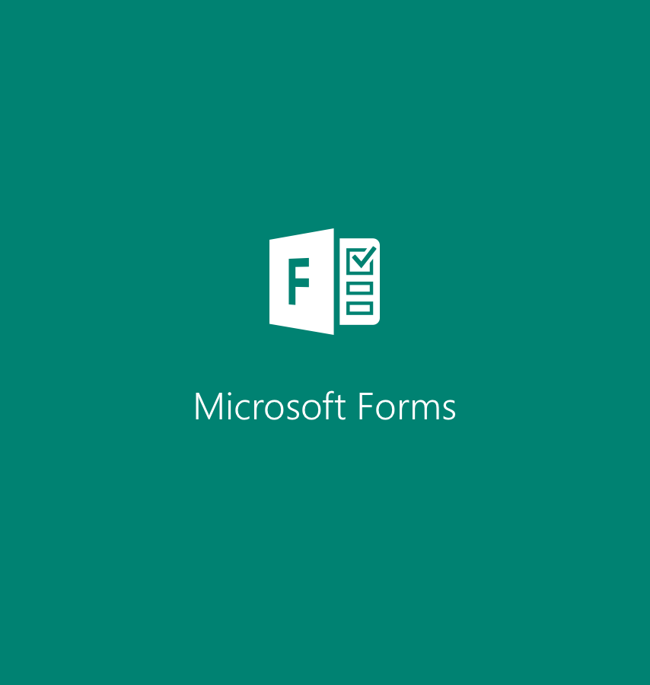

10:00 AM – 12:00 PM P/T Prep & Lunch (on your own)
12:00 PM –6:00 PM P/T Conferences

