Community Resource Manual

Table of Contents

Categorized Resource Lists……………………………………………...……...…2-14
Clothing Services……………………………………………...……...………...2
Crisis Management……………………………………………...……...………3
Counseling Services……………………………………………...……...……..4
Educational Opportunities……………………………………………...……....5
Employment Services……………………………………………...……...……6
Food Services……………………………………………...……...…………….7
Housing Services……………………………………………...……...………...8
Legal Services……………………………………………...……...……………9
Medical Services……………………………………………...……...………..10
Mentoring Services……………………………………………...……...……..11
Parenting Services……………………………………………...……...……..12
Rehabilitation Services……………………………………………...……...…13
Shelters/Missions……………………………………………...……...……….14
Utilities Assistance……………………………………………...……...……...15
Community Resources……………………………………………….……………16-35
American Red Cross…………………………...………………...…...………16
ARVAC…………………………...………………...…………………..………17
Big Brothers/Big Sisters…………………………...…………………..…...…18
ARV Boys and Girls Club…………………………...………………...…...…19
CASA- Court Appointed Special Advocates…………………………...…...20
Counseling Associates…………………………...……………...…...………21
Department of Human Services…………………………...………………...22
Friendship Community Care…………………………...……………......…...23
Help Network, Inc. …………………………...……………...…...…...………24
Main Street Mission…………………………...…………..……...…...………25
Manna House…………………………...………………………...…...………26
Perspectives Behavioral Health Management…………………………...…27
Pope County Health Department…………………………...………………..28
Pope County Literacy Council…………………………...………………......29
River Valley Shelter for Battered Women and Children…………………...30
River Valley Christian Clinic…………………………...………………...…...31
Salvation Army…………………………...………………..……...…...………32
Sharing and Caring…………………………...……………..…...…...………33
United Way…………………………...…………………………...…...………34
Victim Assistance Program…………………………...….……………...…...35
Reflection……………………………………………….………………………………36

Categorized Resource Lists
Clothing Services
Help Network, Inc.  312 S. Boulder Avenue  Russellville, AR 72801  479-967-7890  www.helpnetworkinc.net | Main Street Mission  1110 East 2nd Street  Russellville, AR 72801  479-968-8303  www.mainstreetmission.org
River Valley Shelter for Battered Women and Children  P.O. Box 2066  Russellville, AR 72811  www.rivervalleyshelter.org | River Valley United Way, Inc.  310 North Boston Place  Russellville, AR 72811-0636  479-968-5089  www.rivervalleyunitedway.org
The Salvation Army of Russellville, AR  1004 Weir Road  Russellville, AR 72801  479-968-4369  http://salvationarmyaok.org/russellville/ | Sharing and Caring  107 State Street  Dardanelle, AR 72834  https://www.facebook.com/SharingAndCaringFoodPantry

Crisis Management
American Red Cross  1311 East 16th Street  Russellville, AR 72802  479-968-3498  www.redcross.org | ARVAC  613 North 5th Street  Dardanelle, AR 72834  479-229-4861  www.arvacinc.org
Counseling Associates  110 Skyline Drive  Russellville, AR 72801  479-968-1298  http://www.caiinc.org/pope.htm | Freedom House  400 Lake Front Drive  Russellville, AR 72802  479-968-7225
Perspectives Behavioral Health Management  1305 East Main Street  Russellville, AR 72801  479-967-5656  www.pbhm.com | River Valley Shelter for Battered Women and Children  P.O. Box 2066  Russellville, AR 72811  www.rivervalleyshelter.org
River Valley United Way, Inc.  310 North Boston Place  Russellville, AR 72811-0636  479-968-5089  www.rivervalleyunitedway.org | Russellville Mental Health  1610 S Arkansas Ave  Russellville, AR 72801  479-967-4673  http://aoinc.org/locations/behavioral-health-russellville/
The Salvation Army of Russellville, AR  1004 Weir Road  Russellville, AR 72801  479-968-4369  http://salvationarmyaok.org/russellville/ | Teen Challenge Women’s Ministries  618 South Knoxville  Russellville, Arkansas 72801  1-866-567-7101  http://womenstc.com/
Victim Assistance Program
Pope County Courthouse
100 West Main Street
Russellville, AR 72811
479-968-8600
Counseling Services
American Red Cross  1311 East 16th Street  Russellville, AR 72802  479-968-3498  www.redcross.org | Arkansas Rehabilitation Services  1010 North Arkansas  Russellville, AR 72801  479-890-5751  http://ace.arkansas.gov/arRehabServices/Pages/default.aspx
Adullam Youth Awakening Center  111 North El Paso  Russellville, AR 72801  479-970-7748  http://adullamyouth.com/tablet/r-r-r.html | Choices Pregnancy Center  311 East 3rd Street  Russellville, AR 72801  479-967-2255  http://www.choicesprc.org/
Community Services, Inc.  1505 South Oswego Avenue  Russellville, AR 72801  479-967-3370  http://www.communityserviceinc.com/index.html | Counseling Associates  110 Skyline Drive  Russellville, AR 72801  479-968-1298  http://www.caiinc.org/pope.htm
Department of Workforce Services  104 South Rochester Avenue  Russellville, AR 72801  479-968-2784  www.dws.arkansas.gov | Freedom House  400 Lake Front Drive  Russellville, AR 72802  479-968-7225
Perspectives Behavioral Health Management  1305 East Main Street  Russellville, AR 72801  479-967-5656  www.pbhm.com | River Valley Shelter for Battered Women and Children  P.O. Box 2066  Russellville, AR 72811  www.rivervalleyshelter.org
River Valley United Way, Inc.  310 North Boston Place  Russellville, AR 72811-0636  479-968-5089  www.rivervalleyunitedway.org | Russellville Mental Health  1610 S Arkansas Ave  Russellville, AR 72801  479-967-4673  http://aoinc.org/locations/behavioral-health-russellville/
Teen Challenge Women’s Ministries  618 South Knoxville  Russellville, Arkansas 72801  1-866-567-7101  http://womenstc.com/ | Victim Assistance Program  Pope County Courthouse  100 West Main Street  Russellville, AR 72811  479-968-8600

Educational Opportunities
Adult Education Center- GED  1000 South Arkansas  Russellville, AR 72801  479-968-5244 | American Red Cross  1311 East 16th Street  Russellville, AR 72802  479-968-3498  www.redcross.org
Choices Pregnancy Center  311 East 3rd Street  Russellville, AR 72801  479-967-2255  http://www.choicesprc.org/ | Community Services, Inc.  1505 South Oswego Avenue  Russellville, AR 72801  479-967-3370  http://www.communityserviceinc.com/index.html
Counseling Associates  110 Skyline Drive  Russellville, AR 72801  479-968-1298  http://www.caiinc.org/pope.htm | Department of Workforce Services  104 South Rochester Avenue  Russellville, AR 72801  479-968-2784  www.dws.arkansas.gov
Friendship Community Care  920 North University  Russellville, AR 72802  479-967-2322  www.fccare.org | Help Network, Inc.  312 S. Boulder Avenue  Russellville, AR 72801  479-967-7890  www.helpnetworkinc.net
Perspectives Behavioral Health Management  1305 East Main Street  Russellville, AR 72801  479-967-5656  www.pbhm.com | Pope County Literacy Council  1000 South Arkansas  Russellville, AR 72801  479-967-7323  http://popecoliteracy.org/Home.html
River Valley United Way, Inc.  310 North Boston Place  Russellville, AR 72811-0636  479-968-5089  www.rivervalleyunitedway.org | Russellville Mental Health  1610 S Arkansas Ave  Russellville, AR 72801  479-967-4673  http://aoinc.org/locations/behavioral-health-russellville/
STAR Industries, Inc.
1200 South Elmira Avenue
Russellville, AR 72802
479-968-7118

Employment Services
Arkansas Rehabilitation Services  1010 North Arkansas  Russellville, AR 72801  479-890-5751  http://ace.arkansas.gov/arrehabservices/pages/default.aspx | Department of Human Services  701 South Denver Avenue  Russellville, AR 72801  479-968-5596  http://humanservices.arkansas.gov/Pages/DHSofficeDetail.aspx?show=Pope
Department of Workforce Services  104 South Rochester Avenue  Russellville, AR 72801  479-968-2784  www.dws.arkansas.gov | STAR Industries, Inc.  1200 South Elmira Avenue  Russellville, AR 72802  479-968-7118
Veteran’s Services
107 West B Street
Russellville, AR 72801
479-968-6049
www.veterans.arkansas.gov

Food Services
Arkansas Rice Depot  Local Food Banks  Participating Schools  501-565-8855  www.ricedepot.org | ARVAC  613 North 5th Street  Dardanelle, AR 72834  479-229-4861  www.arvacinc.org
Department of Human Services  701 South Denver Avenue  Russellville, AR 72801  479-968-5596  http://humanservices.arkansas.gov/Pages/DHSofficeDetail.aspx?show=Pope | Help Network, Inc.  312 S. Boulder Avenue  Russellville, AR 72801  479-967-7890  www.helpnetworkinc.net
Main Street Mission  1110 East 2nd Street  Russellville, AR 72801  479-968-8303  www.mainstreetmission.org | Manna House  304 South Commerce  Russellville, AR 72801  479-968-1232  http://www.fumcrsvl.org/ministries/mission_outreach/manna_house/
Pope County Health Department  203 Weir Road  Russellville, AR 72802  479-968-6400  http://www.healthy.arkansas.gov | River Valley Shelter for Battered Women and Children  P.O. Box 2066  Russellville, AR 72811  www.rivervalleyshelter.org
The Salvation Army of Russellville, AR  1004 Weir Road  Russellville, AR 72801  479-968-4369  http://salvationarmyaok.org/russellville/ | Sharing and Caring  107 State Street  Dardanelle, AR 72834  https://www.facebook.com/SharingAndCaringFoodPantry

Housing Services
ARVAC  613 North 5th Street  Dardanelle, AR 72834  479-229-4861  www.arvacinc.org | Help Network, Inc.  312 S. Boulder Avenue  Russellville, AR 72801  479-967-7890  www.helpnetworkinc.net
Main Street Mission  1110 East 2nd Street  Russellville, AR 72801  479-968-8303  www.mainstreetmission.org | River Valley United Way, Inc.  310 North Boston Place  Russellville, AR 72811-0636  479-968-5089  www.rivervalleyunitedway.org
Russellville Housing Authority  115 South Denver Avenue  Russellville, AR 72811  479-968-5440 | The Salvation Army of Russellville, AR  1004 Weir Road  Russellville, AR 72801  479-968-4369  http://salvationarmyaok.org/russellville/
Universal Housing Development
301 East 3rd Street
Russellville, AR 72801
479-968-5001
www.hud.gov

Legal Services
Arkansas Legal Services Partnership  101 East Main Street Suite C  Russellville, AR 72801  479-785-5211  http://www.arlegalservices.org/node/104 | Court Appointed Special Advocates  Pope County Courthouse  100 West Main Street  Russellville, AR 72811  479-880-1195  http://www.arkansascasa.net
Office of Child Support Enforcement  800 East Main Street Suite A  Russellville, AR 72801  479-968-7051  www.dfa.arkansas.gov | Juvenile Probation Office  Debbie Gobell  Pope County Courthouse  100 West Main Street  Russellville, AR 72811  479-967-1520
Victim Assistance Program
Pope County Courthouse
100 West Main Street
Russellville, AR 72811
479-968-8600

Medical Services
American Red Cross  1311 East 16th Street  Russellville, AR 72802  479-968-3498  www.redcross.org | Choices Pregnancy Center  311 East 3rd Street  Russellville, AR 72801  479-967-2255  http://www.choicesprc.org/
Department of Human Services  701 South Denver Avenue  Russellville, AR 72801  479-968-5596  http://humanservices.arkansas.gov/Pages/DHSofficeDetail.aspx?show=Pope | Equestrian Zone  PO Box 282  Russellville, AR, 72811  479-970-8351  http://www.equestrianzone.org/
Friendship Community Care  920 North University  Russellville, AR 72802  479-967-2322  www.fccare.org | Freedom House  400 Lake Front Drive  Russellville, AR 72802  479-968-7225
Pope County Health Department  203 Weir Road  Russellville, AR 72802  479-968-6400  http://www.healthy.arkansas.gov | River Valley Christian Clinic  1714 State Highway 22  Dardanelle, AR 72834  479-229-2566  http://www.rvchristianclinic.org/
River Valley Shelter for Battered Women and Children  P.O. Box 2066  Russellville, AR 72811  www.rivervalleyshelter.org | River Valley United Way, Inc.  310 North Boston Place  Russellville, AR 72811-0636  479-968-5089  www.rivervalleyunitedway.org

Mentoring Services
Big Brothers/Big Sisters  Crawford Elem  1116 N. Parker Rd  Russellville, AR 72811  479-968-5525  www.bbbs.org | Boys and Girls Club of America  600 East 16th Street  Russellville, AR 72801  479-968-7819  http://www.bgcarv.org/
Choices Pregnancy Center  311 East 3rd Street  Russellville, AR 72801  479-967-2255  http://www.choicesprc.org/ | Pope County Literacy Council  1000 South Arkansas  Russellville, AR 72801  479-967-7323  http://popecoliteracy.org/Home.html
River Valley United Way, Inc.  310 North Boston Place  Russellville, AR 72811-0636  479-968-5089  www.rivervalleyunitedway.org | STAR Industries, Inc.  1200 South Elmira Avenue  Russellville, AR 72802  479-968-7118

Parenting Services
Choices Pregnancy Center  311 East 3rd Street  Russellville, AR 72801  479-967-2255  http://www.choicesprc.org/ | Community Services, Inc.  1505 South Oswego Avenue  Russellville, AR 72801  479-967-3370  http://www.communityserviceinc.com/index.html
Counseling Associates  110 Skyline Drive  Russellville, AR 72801  479-968-1298  http://www.caiinc.org/pope.htm | Juvenile Probation Office  Debbie Gobell  Pope County Courthouse  100 West Main Street  Russellville, AR 72811  479-967-1520
Perspectives Behavioral Health Management  1305 East Main Street  Russellville, AR 72801  479-967-5656  www.pbhm.com | Pope County Health Department  203 Weir Road  Russellville, AR 72802  479-968-6400  http://www.healthy.arkansas.gov

Rehabilitation Services
Arkansas Rehabilitation Services  1010 North Arkansas  Russellville, AR 72801  479-890-5751  http://ace.arkansas.gov/arRehabServices/Pages/default.aspx | Community Services, Inc.  1505 South Oswego Avenue  Russellville, AR 72801  479-967-3370  http://www.communityserviceinc.com/index.html
Counseling Associates  110 Skyline Drive  Russellville, AR 72801  479-968-1298  http://www.caiinc.org/pope.htm | Department of Human Services  701 South Denver Avenue  Russellville, AR 72801  479-968-5596  http://humanservices.arkansas.gov/Pages/DHSofficeDetail.aspx?show=Pope
Equestrian Zone  PO Box 282  Russellville, AR, 72811  479-970-8351  http://www.equestrianzone.org/ | Freedom House  400 Lake Front Drive  Russellville, AR 72802  479-968-7225
Help Network, Inc.  312 S. Boulder Avenue  Russellville, AR 72801  479-967-7890  www.helpnetworkinc.net | Juvenile Probation Office  Debbie Gobell  Pope County Courthouse  100 West Main Street  Russellville, AR 72811  479-967-1520
Perspectives Behavioral Health Management  1305 East Main Street  Russellville, AR 72801  479-967-5656  www.pbhm.com | River Valley Christian Clinic  1714 State Highway 22  Dardanelle, AR 72834  479-229-2566  http://www.rvchristianclinic.org/
River Valley Shelter for Battered Women and Children  P.O. Box 2066  Russellville, AR 72811  www.rivervalleyshelter.org | River Valley United Way, Inc.  310 North Boston Place  Russellville, AR 72811-0636  479-968-5089  www.rivervalleyunitedway.org
Russellville Mental Health  1610 S Arkansas Ave  Russellville, AR 72801  479-967-4673  http://aoinc.org/locations/behavioral-health-russellville/ | STAR Industries, Inc.  1200 South Elmira Avenue  Russellville, AR 72802  479-968-7118
Teen Challenge Women’s Ministries  618 South Knoxville  Russellville, Arkansas 72801  1-866-567-7101  http://womenstc.com/ | Veteran’s Services  107 West B Street  Russellville, AR 72801  479-968-6049  www.veterans.arkansas.gov

Shelters/Missions
Adullam Youth Awakening Center  111 North El Paso  Russellville, AR 72801  479-970-7748  http://adullamyouth.com/tablet/r-r-r.html | Freedom House  400 Lake Front Drive  Russellville, AR 72802  479-968-7225
Main Street Mission  1110 East 2nd Street  Russellville, AR 72801  479-968-8303  www.mainstreetmission.org | River Valley Shelter for Battered Women and Children  P.O. Box 2066  Russellville, AR 72811  479-968-3110  www.rivervalleyshelter.org
Teen Challenge Women’s Ministries
618 South Knoxville
Russellville, Arkansas 72801
1-866-567-7101
http://womenstc.com/

Utilities Assistance
ARVAC  613 North 5th Street  Dardanelle, AR 72834  479-229-4861  www.arvacinc.org | Help Network, Inc.  312 S. Boulder Avenue  Russellville, AR 72801  479-967-7890  www.helpnetworkinc.net
River Valley United Way, Inc.  310 North Boston Place  Russellville, AR 72811-0636  479-968-5089  www.rivervalleyunitedway.org | Westside Church of Christ  2399 West C Street  Russellville, AR 72801  479-968-1121  www.wscocsrsvl.org

Name of Organization/Agency: American Red Cross
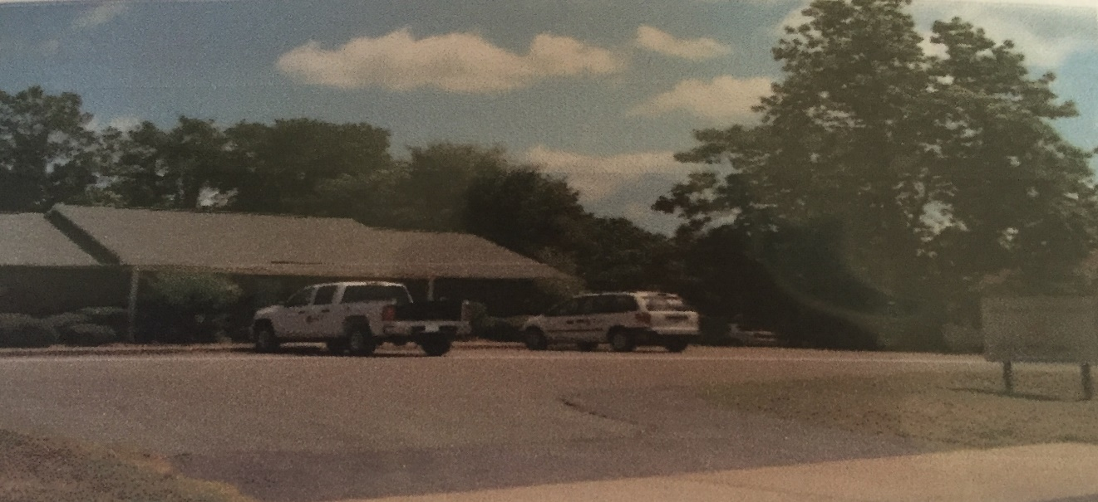
Address: 1311 East 16th Street  Russellville, AR 72802 | Hours: Monday- Friday 8:00-5:00
Phone: 479-968-3498 | Fax: 479-967-4688
Contact Person: Holly Odom | Email: hlodom@redcrossnwa.org
Website: www.redcross.org | Fees: Vary By Service
Services Provided:
- Military Outreach
- Disaster Response and Prevention
- CPR and First Aid Classes
- Health and Safety Precautions
- Disaster Mental Health Program
- Swimming Classes
- Babysitting Classes
- Youth Disaster Action Team
- Volunteer teams go out to emergency sites for disaster relief
- Preparing families to deal with potential disasters

Name of Organization/Agency: ARVAC
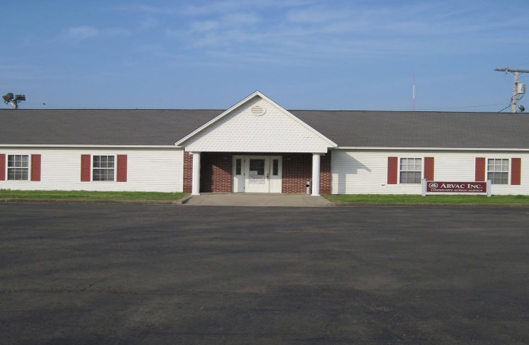
Address: 613 North 5th Street  Dardanelle, AR 72834 | Hours: Monday- Friday 8:00-4:30
Phone: 479-229-4861
Contact Person: Stephanie Ellis | Email: sellis@arvacinc.org
Website: www.arvacinc.org | Fees: Vary By Service
Services Provided:
- Home Energy Assistance (Utilities)
- Crisis Intervention Program
- Home to Own Program
- ARVAC Garden Project
- Emergency Food Assistance
- Social Security Representative Payee
- EF&A Programs- assist families who are threatened with foreclosure or may be evicted because of past due rent and/or utilities
- ARVAC Food Bank

Name of Organization/Agency: Big Brothers, Big Sisters
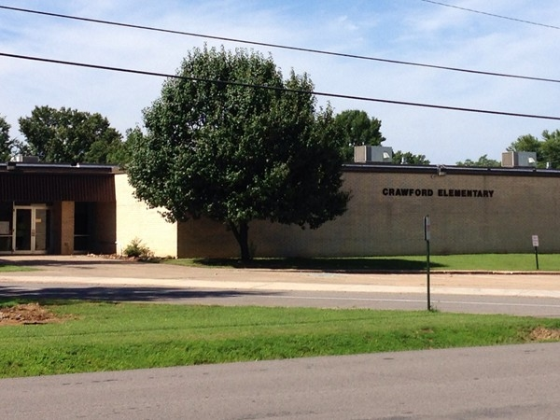
Address: Crawford Elem  1116 N. Parker Rd  Russellville, AR 72811 | Hours: Monday- Friday 9:00-5:00
Phone: 479-968-5525
Contact Person: C. Sain | Email: csain@bbbsca.org
Website: www.bbbs.org | Fees: None
Services Provided:
- One-on-One mentoring for at-risk children and teens
- Community and school based services
- Children matched with a caring adult volunteer who will serve as their mentor through professionally supported programs
- Accepts school counselor and teacher referrals

Name of Organization/Agency: Boys and Girls Club of America
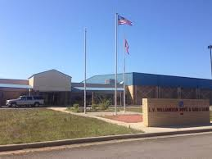
Address: 600 East 16th Street  Russellville, AR 72801 | Hours: Monday-Friday  During School: 3:00-7:00  Summer Day Camp: 7:00-55:30  Summer: 12:00-6:00
Phone: 479-968-7819 | Fax: 479-968-8176
Contact Person: Lyle Manning
Website: http://www.bgcarv.org/ | Fees: Summer Programs $10 or $70 every two weeks
Services Provided:
- Character and Leadership
- Sports and Fitness
- The Arts
- Health and Life Skills
- Education and Career
- Special Initiatives Program

Name of Organization/Agency: Counseling Associates
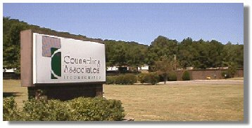
Address: 110 Skyline Drive  Russellville, AR 72801 | Hours: Monday-Friday 8:00-4:30 or by evening appointment
Phone: 479-968-1298  24-Hour Crisis Line: 800-844-2066 | Fax: 479-968-6053
Contact Person: Tessa Riffell
Website: http://www.caiinc.org/pope.htm | Fees: Vary by Service
Services Provided:
- Individual, Family, and Marital Counseling
- Psychiatric Services
- Medication Management
- CHOICE Children's Programs
- Case Management
- Substance Abuse Services
- Crisis Response
- School-Based Services
- DWI/DUI Educational Classes
- Therapeutic Foster Care Program
- Information Technology
- Information Systems

Name of Organization/Agency: Court Appointed Special Advocates (CASA) of the 5th Judicial District
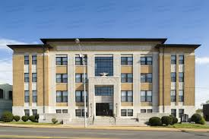
Address: PO Box 1213  Russellville, AR 72811 | Hours: Monday-Friday 8:00-5:00
Phone: 479-880 1195 | Fax: 479-880-0163
Contact Person: Genney Baker | Email: casa5gb@suddenlinkmail.com
Website: www.arkansascasa.net | Fees: Free
Services Provided:
- Monitor and care of abused and neglected children in the custody of the state
- Monitor court ordered services
- Appear in court at each hearing with a report of recommendations for the child’s welfare
- Research the background of children to help the court make informed decisions about placement
- Identify needed services and resources for children
- Make sure the child’s voice and opinion gets heard in court
- Explain to the child details of what is happening in the court setting
`

Name of Organization/Agency: Department of Human Services (DHS)
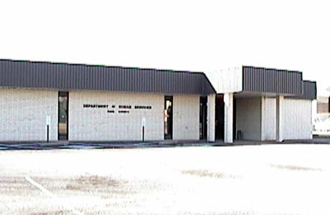
Address: 701 North Denver  Russellville, AR 72801 | Hours: Monday-Friday 8:00-4:30
Phone: 479-968-5596 | Fax: 479-968-2102
Contact Person: Jolayne Coffman | Email: jolayne.coffman@dhs.arkansas.gov
Website: http://humanservices.arkansas.gov/Pages/DHSofficeDetail.aspx?show=Pope | Fees: Vary by Service
Services Provided:
- SNAP- Supplemental nutrition assistance program
- AR Kids insurance
- TEFRA- children with disabilities
- Family planning program
- Earned income tax credit
- Medicaid/Medicare
- Daycare applications
- Welfare to Work Program
- TEA-Transitional Employment Assistance
- Arkansas Health Care Access
- Employment and Training Program
- Connect Care

Name of Organization/Agency: First United Methodist Church Manna House
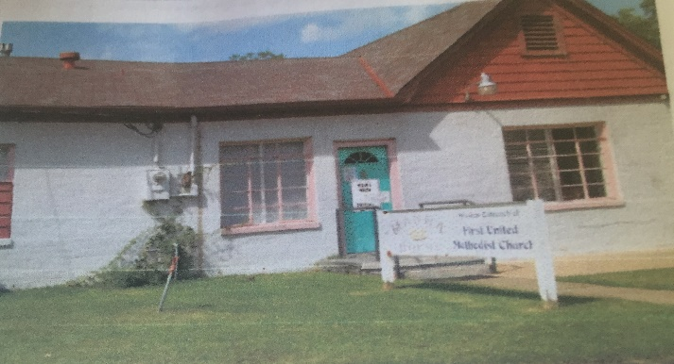
Address: 304 South Commerce  Russellville, AR 72801 | Hours:  Monday – Thursday  10:00– 12:00  Wednesday Evening  6:00 – 7:00
Phone: 479-968-1232
Contact Person: Terri Kulbeth | Email: tkulbeth@fumcrsvl.org
Website: http://www.fumcrsvl.org/ministries/mission_outreach/manna_house/ | Fees: None
Services Provided:
- Provides food and toiletries to approximately 3,000 people in Pope and Yell counties each month
- People are allowed to get food 1 time a week for up to 10 weeks.
- Mission was started as a temporary service to help people in need get back on their feet.
- No eligibility proof or proof of income necessary. Must show a photo I.D. and utility bill to prove residency in Pope or Yell county.
- Serves people in transit

Name of Organization/Agency: Friendship Community Care, Inc.
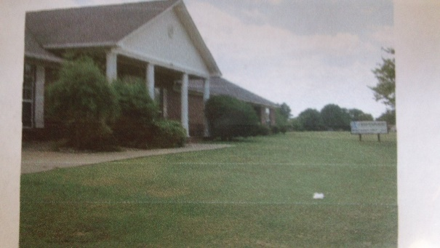
Address: 920 North University  Russellville, AR 72802 | Hours: Monday – Friday 8:00-5:00
Phone: 479-967-2322 | Fax: 479-967-2876
Contact Person: Angela Traweek
Website: www.fccare.org | Fees: Vary by Service
Services Provided:
- Adult systems of care
- Pediatric services
- Residential services
- Senior services
- Transportation services
- Vocational services
- Therapeutic services
- Behavioral intervention programs

Name of Organization/Agency: Help Network, Inc.
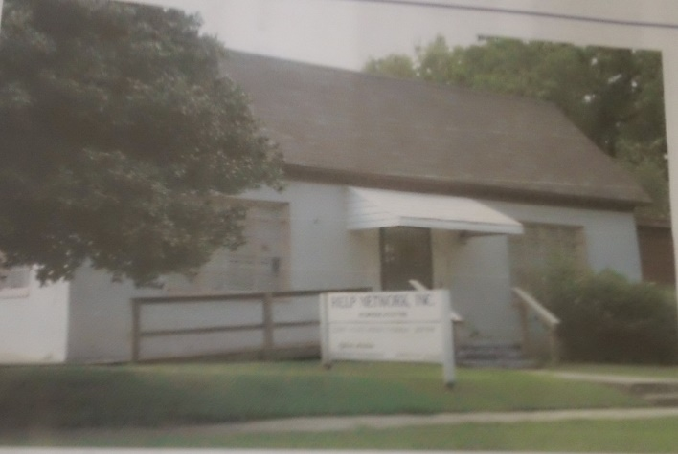
Address: 312 S. Boulder Avenue  Russellville, AR 72801 | Hours: Monday, Tuesday & Thursday  9:00-4:00  Lunch 1:15 – 2:15
Phone: 479-967-7890 | Fax: 479-967-9891
Contact Person: Ed Seay | Email: eseay@helpnetworkinc.net
Website: www.helpnetworkinc.net | Fees: None
Services Provided:
- Emergency Financial Assistance with: utilities, rent, lodging, prescriptions, gasoline
- Needs are met through vouchers
- Offer assistance and encourage clients to live with self-sufficiency
- Ask that clients pay portions of their own bills to keep accountable
- Not a service to enable clients to live in the same situations they have been in
- Each client is interviewed and needs are assessed. Assistance is given based on individual needs.

Name of Organization/Agency: Main Street Mission
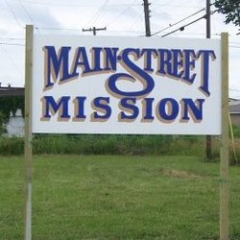
Address: 1110 East 2nd Street  Russellville, AR 72801 | Hours:  Office Hours  Monday-Friday  9:00 am – 1:30 pm  Meal Schedule  Monday – Friday  Breakfast 8:30 – 9:30 am  Lunch 11:00 am – 1:30 pm  Food Boxes Prepared and Distributed  Every other Wednesday  Summer Hours 8:00 am – 9:00am  Winter Hours 9:00am – 10:am
Phone: 479-968-8303 | Fax: 479-890-5468
Contact Person: Raul Torres
Website: www.mainstreetmission.org | Fees: Free
Services Provided:
- Food boxes every other Wednesday. Patrons must attend chapel service before getting food.
- Monday and Friday- clothing, household items, shoes, furniture- people can shop 1 time every 6 months
- 2 meals a day in kitchen
- Christmas Wish- parents write a letter and the community adopts families
- 3 families live in FEMA trailers. Preference given to people with children.

Name of Organization/Agency: Perspectives Behavioral Health Management
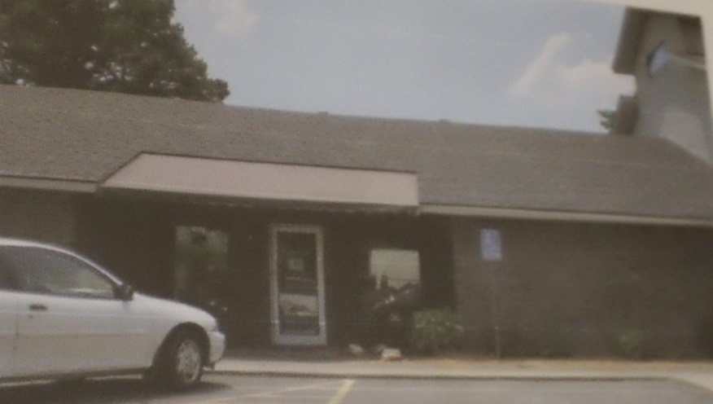
Address: 1305 East Main Street  Russellville, AR 72801 | Hours: Day Treatment 9:00-3:00  Office: Monday-Friday 8:00-5:00
Phone: 479-967-5656 | Fax: 479-967-5660
Contact Person: Hollie Clark | Email: info@pbhm.com
Website: www.pbhm.com | Fees: Medicaid or Self-Pay
Services Provided:
- Individual and Family Counseling for adults and children 5+
- Day Treatment K-12 grades. Students get 2 hours of school with a certified teacher and the rest counseling services
- MHP and MHPP for on-site interventions
- Psychiatrist for medications
- Intakes
- Collateral interventions
- Psychological testing
- Licensed Professional Counselors and Case Managers on staff

Name of Organization/Agency: Pope County Health Department
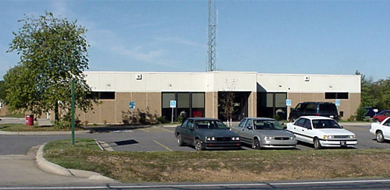
Address: 203 Weir Road  Russellville, AR 72802 | Hours: Monday-Friday 8:00-4:30
Phone: 479-968-6400 | Fax: 479-964-0928
Contact Person: Pam Sellers
Website: http://www.healthy.arkansas.gov | Fees: Vary by Service
Services Provided:
Community Services
Communicable Disease Investigation and Intervention
Hometown Health Improvement
Voter Registration
Environmental Health
Food Protection
General Sanitation
Private Well Water Sampling
Rabies
Septic Tanks
Swimming Pools
West-Nile Virus Surveillance
Family Planning
Pregnancy Testing
HIV/Sexually Transmitted Diseases
Counseling, testing and treatment
Immunizations
Adolescent 7-18 years
Adult Vaccines age 19 and up
Children: 0-6
Maternity
Breastfeeding
Prenatal Care
Private Option enrollment assistance
Public Health Preparedness
Public Health Preparedness
TB Program
Preventative Treatment
Treatment
Vital Records
Birth Certificates
Death Certificates
WIC
Breastfeeding Peer Counseling/ Breast Pumps
Nutrition Counseling
Women’s Health
BreastCare

Name of Organization/Agency: Pope County Literacy Council
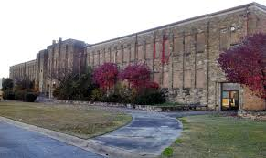
Address: 1000 South Arkansas  Russellville, AR 72801 | Hours: Monday-Friday 9:00-12:00 and 1:00-4:30
Phone: 479-967-7323 | Fax: 479-967-7323
Contact Person: Jennifer Merkey | Email: info@popecoliteracy.com
Website: http://popecoliteracy.org/Home.html | Fees: None
Services Provided:
- 1-1 basic literacy tutoring for students with minimal reading capabilities
- Computer and financial courses
- Small group study sessions
- English as a Second Language classes- reading, writing, speaking skills
- Refer to community services- AR Rehabilitations, Manna House, Counseling Associates, Main Street Mission
- Work with Adult Education Center and Russellville School District Alternative Learning to help students get their GED

Name of Organization/Agency: River Valley Christian Clinic
Address: 1714 State Highway 22  Dardanelle, AR 72834 | Hours: Office Hours: Monday-Friday 9:00-3:00  Clinic Hours: Begin at 6:00 P.M. on the 1st and 3rd Thursday of each month
Phone: 479-229-2566 | Fax: 479-229-1021
Contact Person: Dr. James Carter | Email: rvccadmin@gmail.com
Website: http://www.rvchristianclinic.org/ | Fees: None
Services Provided:
- Medical, dental, and optical care
- Prescriptions
- Physical Therapy
- Physician evaluation and treatment
- Routine lab and x-ray exams
- Diabetic clinic and counseling
- Education classes
- Weight loss and diet classes
- Smoking cessation classes
- Support groups
- Financial counseling
- Social service counseling
- Volunteers provide all services

Name of Organization/Agency: River Valley Shelter for Battered Women and Children
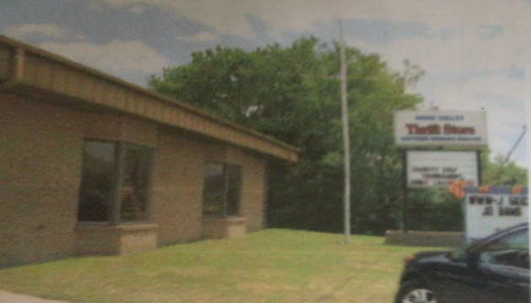
Address: P.O. Box 2066  Russellville, AR 72811 | Hours: 24/7
Phone: 479-968-3110 | Fax: 479-968-6320
Contact Person: Jannie Condley | Email: info@rivervalleyshelter.org
Website: www.rivervalleyshelter.org | Fees: None
Services Provided:
- Free emergency shelter (90 days)
- Food/medical care
- Clothing vouchers (thrift store)
- 24 hour crisis phone line
- Court advocacy
- Bilingual services
- Get clients on a housing list
- Financial assistance
- Food stamps
- Volunteers keep the center running
- Grants, thrift store, and donations fund the shelter
- Help with getting a GED
- Childcare vouchers
- Help obtain orders of protection
- Child support group
- Counseling and self-esteem classes
- Motivational instruction
- Classes on how to prepare a resume, parenting, financial management

Name of Organization/Agency: River Valley United Way
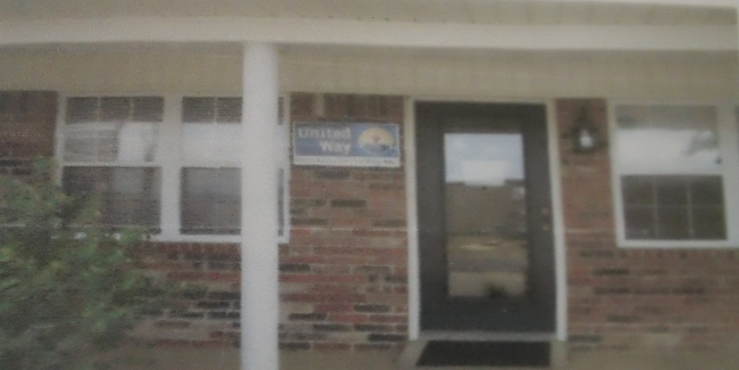
Address: 310 North Boston Place  Russellville, AR 72811-0636 | Hours: Monday-Friday 8:00-4:30
Phone: 479-968-5089 | Fax: 479-968-5089
Contact Person: Beth Latham | Email: blatham@rivervalleyunitedway.org
Website: www.rivervalleyunitedway.org | Fees: Vary by Service
Services Provided:
- Education helping children and youth achieve their potential
- Income: promoting financial stability and independence
- Health: improving health for all through education and preventative care
- Homeless prevention
- Rapid re-housing and relocating services for the homeless
- Rental and moving cost assistance
- Credit counseling
- After school mentoring for at-risk youth
- Case management services
- Rehabilitation training
- Job training
- Speech, occupational, and physical therapy
- Stuff the Bus school supplies
- Prevent high school dropouts
- Help with utility bills, security, and utility deposits
- Access to critical health services
- Advocates for children to enter school ready to succeed, read proficiently by grade 4, and graduate from high school on time

Name of Organization/Agency: Salvation Army
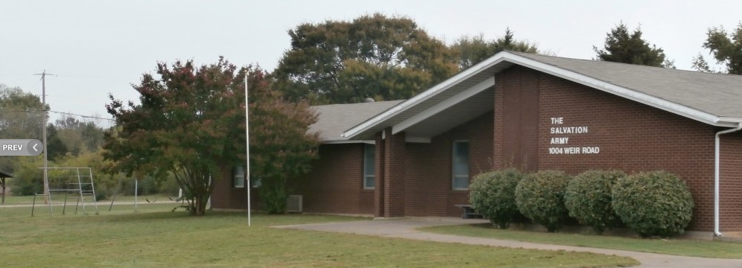
Address: 1004 Weir Road  Russellville, AR 72801 | Hours: Monday 1:00-3:00  Tuesday-Thursday 9:00-3:00  Friday 9:00-12:00
Phone: 479-968-4369 | Fax: 479-968-4122
Contact Person: Warren and Cynthia Jones | Email: rsvlss@yahoo.com
Website: http://salvationarmyaok.org/russellville/ | Fees: None
Services Provided:
- Clothing vouchers
- Food boxes
- Funding for lodging
- Children’s camp
- Christmas Angel Tree
- Summer Food for Kids
- Thanksgiving Baskets
- Furniture vouchers for those who have lost their home in a fire

Name of Organization/Agency: Sharing and Caring
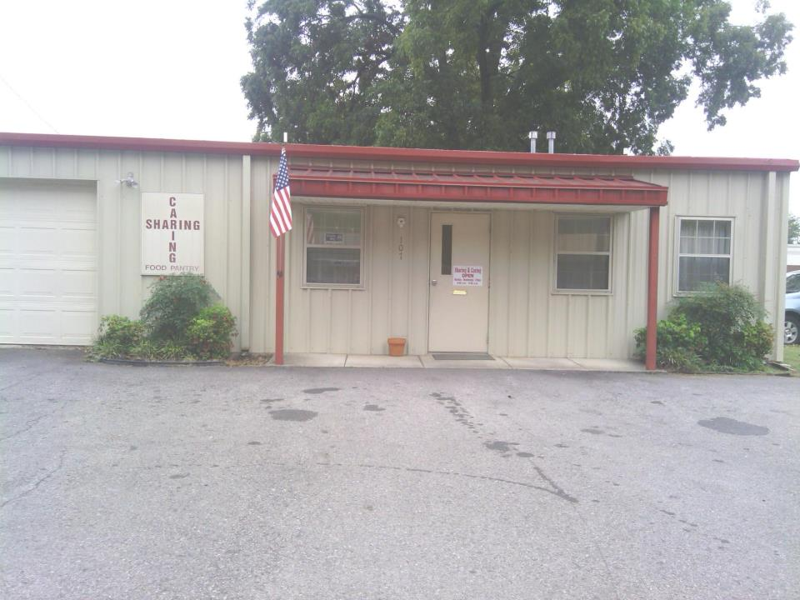
Address: 107 State Street  Dardanelle, AR 72834 | Hours: Monday, Wednesday, Friday 8:30-11:30 A.M.
Phone: 479-229-1220
Contact Person: Shirley and Lawrence Vaughn
Website: https://www.facebook.com/SharingAndCaringFoodPantry | Fees: Free for those who qualify
Services Provided:
- Food pantry
- Ensure- Nutritional supplement for cancer patients
- Household items and toiletries when available
- Clothing when available
- 1 visit per month and 3 visits per year

Name of Organization/Agency: Victim Assistance Program
Address: PO Box 3080  Russellville, AR 72811 | Hours: Monday-Friday 8:00-5:00
Phone: 479-968-8600 | Fax: 479-967-1086
Contact Person: Samantha Whitten
Fees: Vary by Service
Services Provided:
- Assisting crime victims to help them understand what is happening in court
- Assisting victims in applying for compensation from the Crime Victims Reparation Board
- Specialized approach for child victims
- Assisting victims in filing protection orders
- Making victims comfortable in court
- Keeping contact with the victim during the trial process
- Emotional and moral support to crime victims during court proceedings
- Referring victims to counseling services, mental or substance treatment, or support groups
- Transportation to court hearings
- Assistance with employer or school in getting excused absences to honor a subpoena

Reflection

While completing this assignment I was absolutely amazed that there are so many resources available to help the community of Russellville. As stated before, there is such a diverse socioeconomic population in Russellville. It warms my heart to know that those families and individuals who are considered “well off” are willing to bless others who may not be as fortunate. It is nice to know that I can have a solution at hand for my students whom need assistance.
This whole assignment allowed me to create a resource notebook that is very relevant to my role as a school counselor in Russellville. It is a relief that when a student or his/her family comes in for assistance that I won’t have to go searching for a resource. It will all be in one place. I also like the idea of posting these resources on the school website to accommodate those families who are too embarrassed to ask for assistance, but truly need it. All of this work ties directly to standard section 8 of the Arkansas School Counseling Standards. This resource notebook allows me to advocate for my students and their families through collaboration and consultation.

