Salary Reduction Agreement (SRA) steps to make a change to a current contribution or to set up a new contribution:

403(b) plans, often referred to a TSA, is a tax-sheltered retirement savings plan. Omni is our third-party administrator of this program.

These steps must be done on the OMNI website, not sent to the RAC offices to be completed, or the change/enrollment will not be initiated.

You must first have an account with an approved service provider (list is on the OMNI website, on the USD 489 Plan Detail Page).

For new accounts you must complete the Employer Match Form – please print off the Employer Match form (available on the USD 489 website), complete the top portion and send it to the Payroll Office. NOTE: DO NOT add the employer match amount on Omni as a Salary Reduction Agreement (SRA). Submit to Payroll a completed Match form and a copy of your account information only.

Our Organization Page on the website explains our Plan Details which includes Participating Service Providers and Forms.

No one at USD 489 can sign any form that is authorizing a disbursement or withdrawal of your 403B money. This request MUST go thru OMNI, to make sure all compliance issues are addressed properly.
OMNI’s Customer Service Number 1-877-544-6664
OMNI’s website www.omni403b.com
- First go to www.omni403b.com
Or use the direct link found on the USD 489 Web Site: usd489.com>Menu>Payroll Resources>403B Website Link

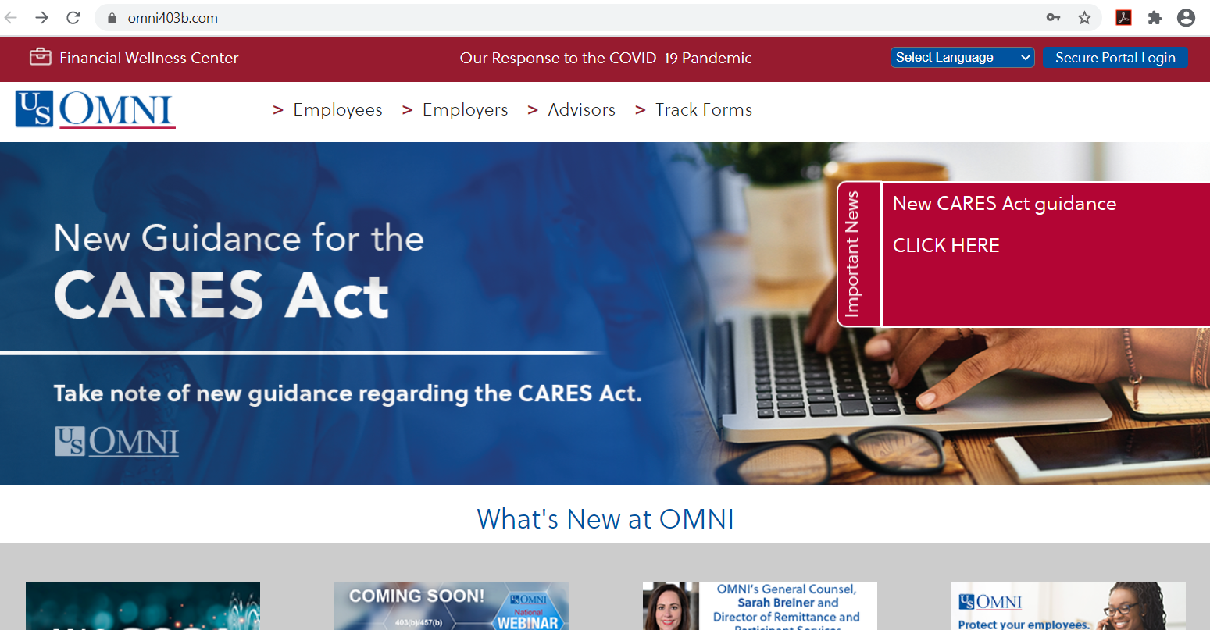

- Click on the Employees
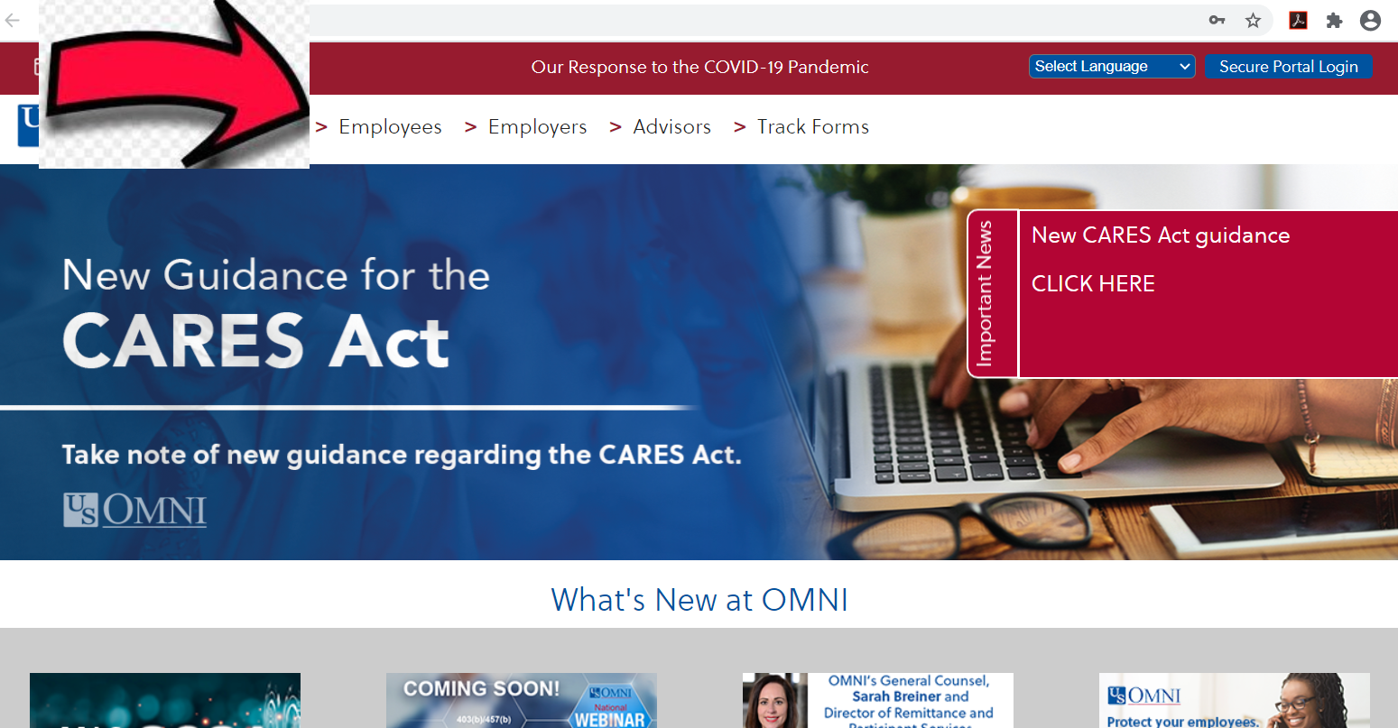
- Click on – “Your Plan Page” to find list of district approved providers.
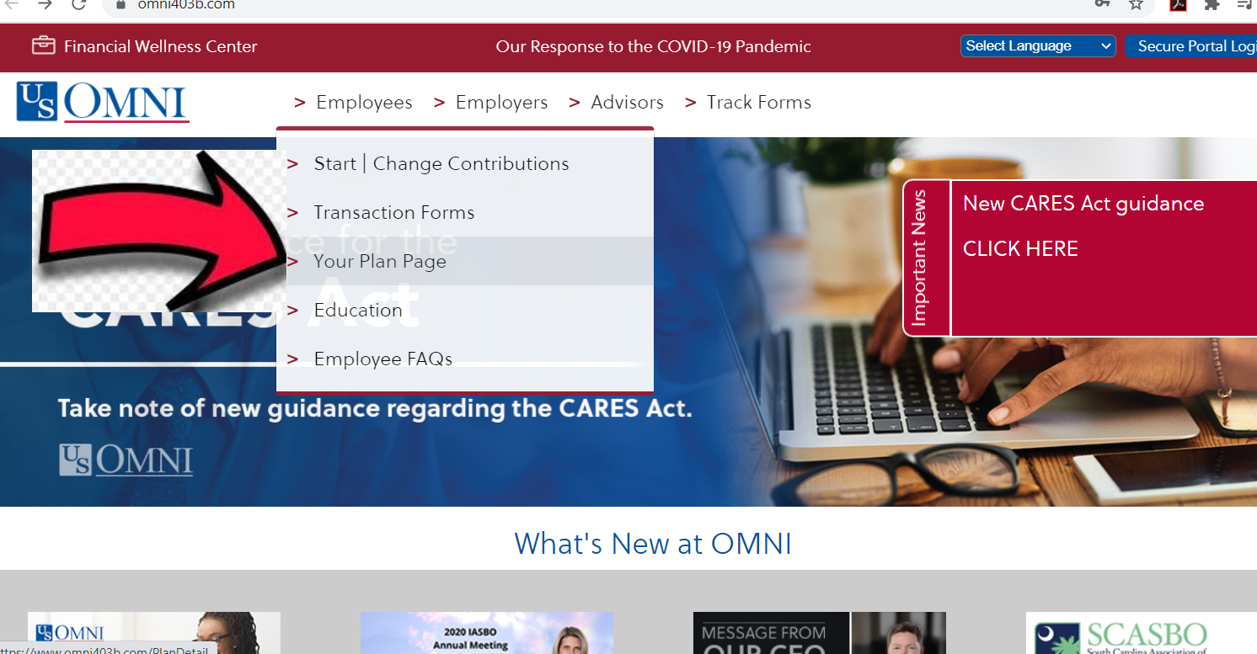

- Enter “KS” and “USD489 Hays School Dist.”
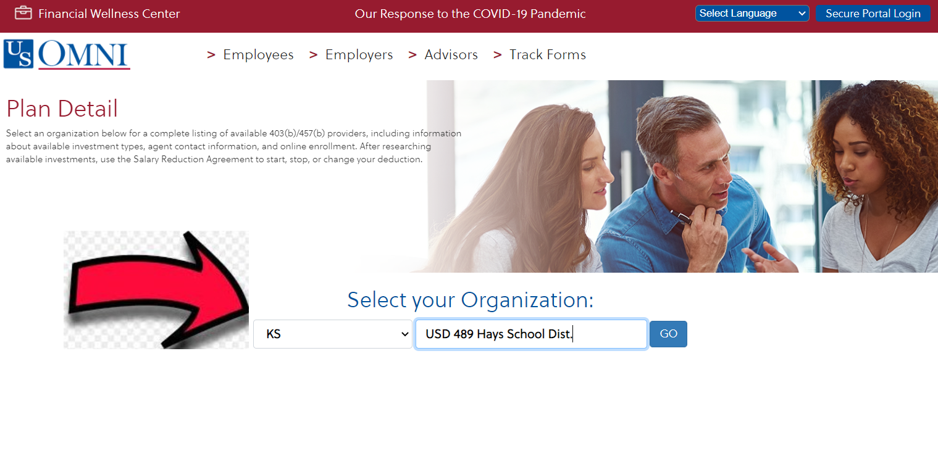

- This is the page where you will find a list all of approved district providers.

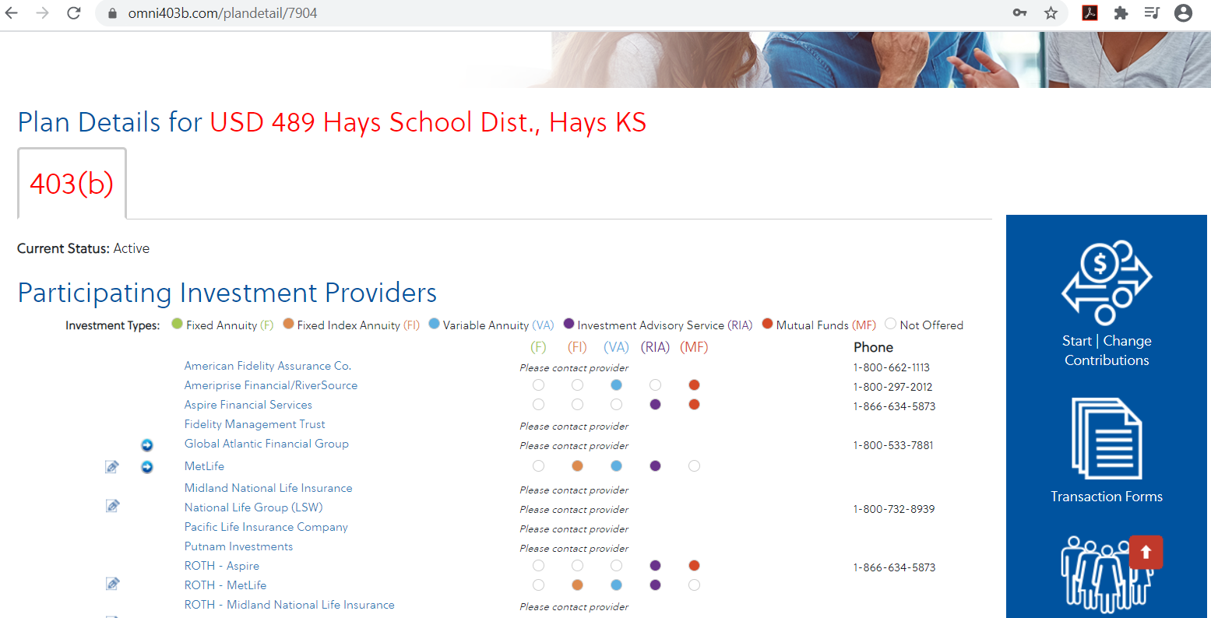

- You are now ready to start your enrollment.
- Click on – Start / Change Contributions

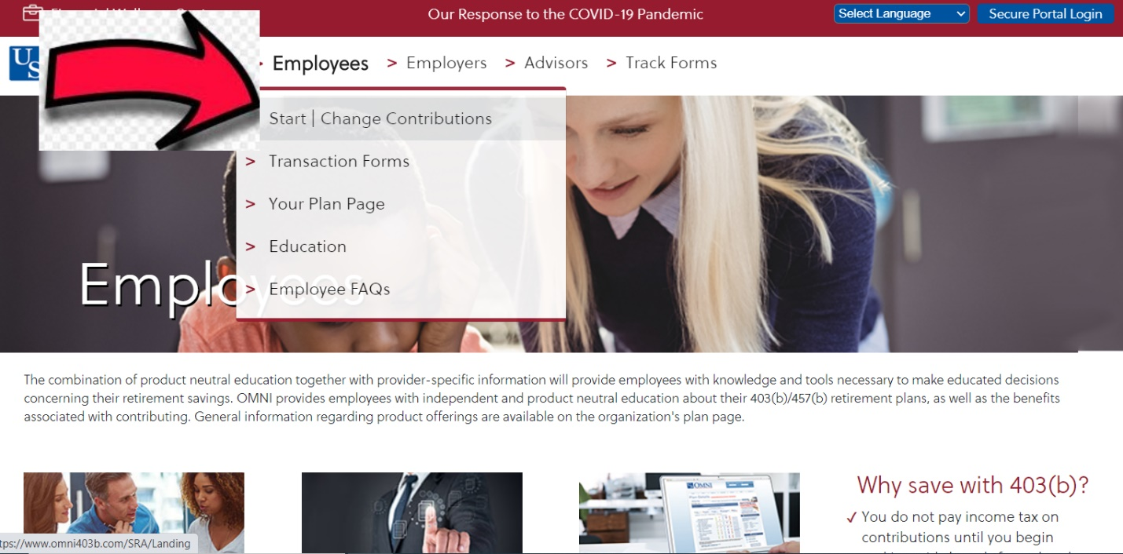
It will bring you to this screen:
- Select KS for our State
- Type USD 489 for Employer Name and then select USD 489 Hays School Dist.
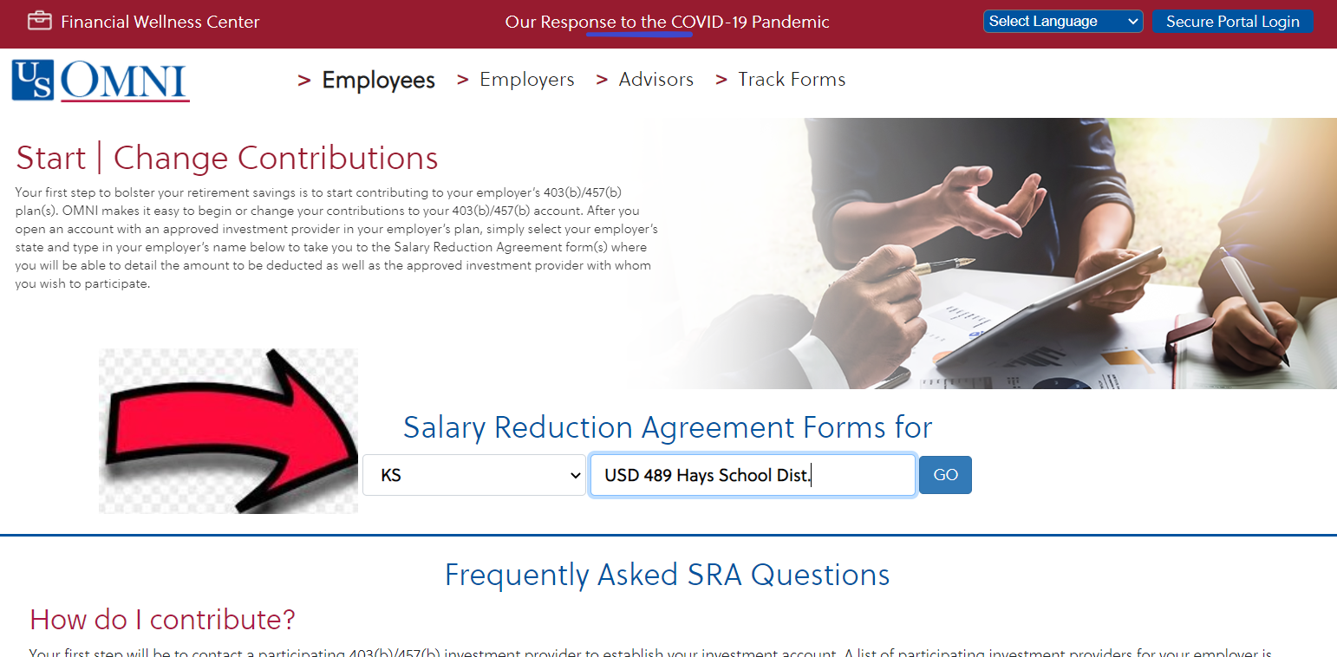

- Click GO and it will take you to the next screen.
- Pick the 2nd option and follow the directions. You will need to fill out each of the 4 sections – Employer Information, Employee Information and Agreements and Acknowledgements. The next section can’t be accessed until the previous one is completed.
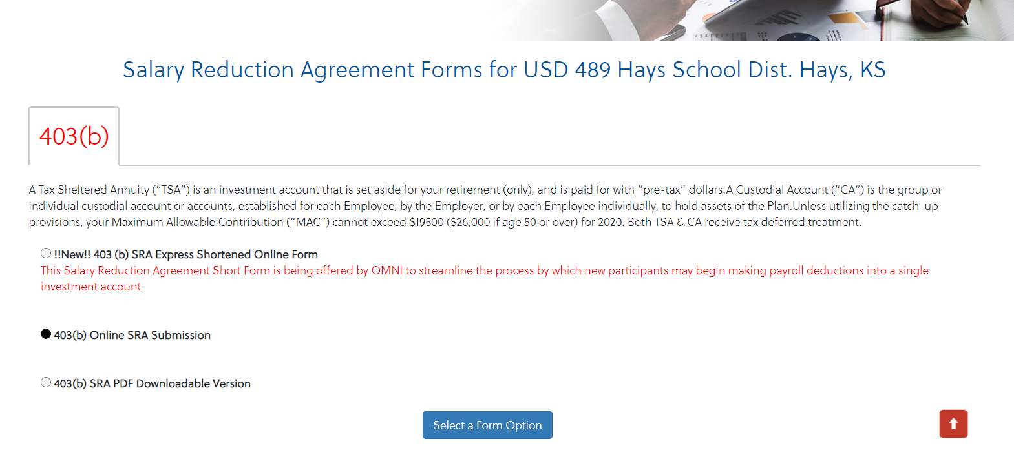
- Omni will then let Payroll know when your account has been verified or your requested change approved and the effective date.

