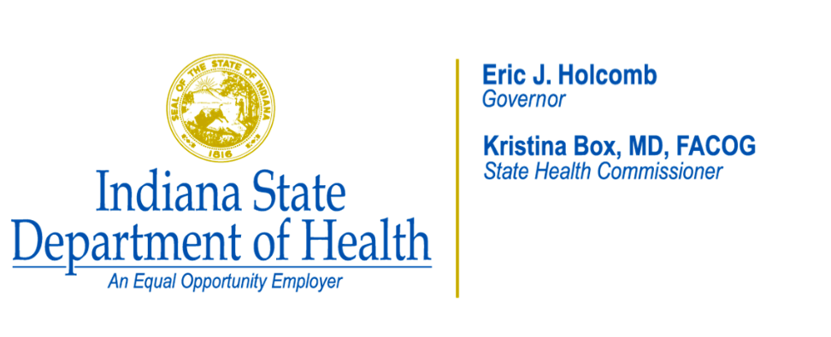[

The Indiana State Department of Health believes that protecting Indiana’s citizens from vaccinepreventable diseases is one of the most important roles of public health. Indiana is experiencing an increase in hepatitis A cases. To ensure that all of Indiana’s youth are properly protected against this disease, new school immunization requirements are being implemented for fall 2020. All students in kindergarten through 12th grade who attend an accredited school in Indiana will be required to have two doses of hepatitis A vaccine for the 2020-21 school year.

Records from the Indiana Children and Hoosiers Immunization Registry Program (CHIRP) indicate that your child has not completed the two-dose hepatitis A vaccine series. Hepatitis A vaccine is recommended by the Advisory Committee of Immunization Practices for all ages and is safe and effective at preventing hepatitis A, a highly contagious liver infection. The Hepatitis A vaccine series is a two dose series that requires six months between doses.

Please contact your healthcare provider to discuss options for vaccination and if your child is eligible to receive publicly-funded vaccine. Please make an appointment with your healthcare provider to complete the series and discuss any other adolescent vaccines that might be needed to protect your child from vaccine-preventable diseases and/or cancer, including human papillomavirus (HPV) and meningitis B.

If you have questions about your child’s immunization history, MyVaxIndiana is an online tool that allows individuals to access their immunization records after receiving a secure personal information number (PIN) from their healthcare providers. This tool enables individuals to view, print or electronically store their records since 2012. Please ask your healthcare provider how to access your child’s record.

Yours in health,

The Indiana Immunization Program

