Office of the Superintendent:
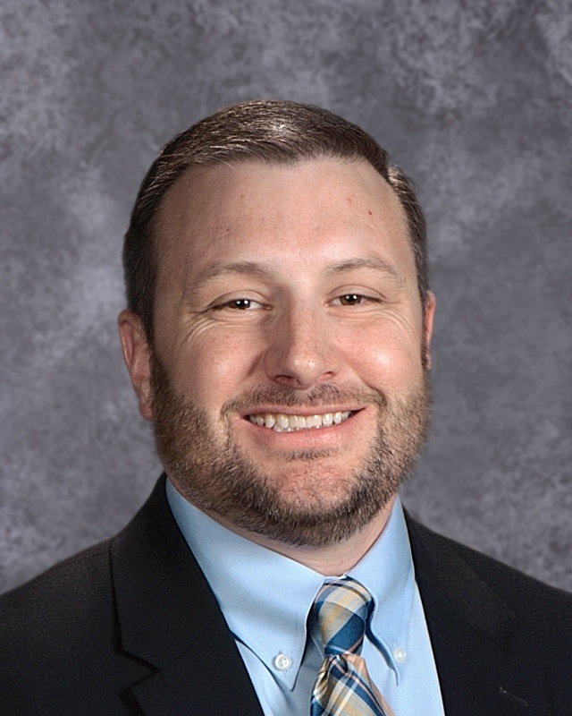
Dr. Brian Bibb
Superintendent of Schools
bbibb@petersburgisd.net
Brian earned his bachelor’s and Doctoral degrees from Texas Tech University. He earned his Master’s degree from Lamar University. He served as a high school principal prior to serving as superintendent.

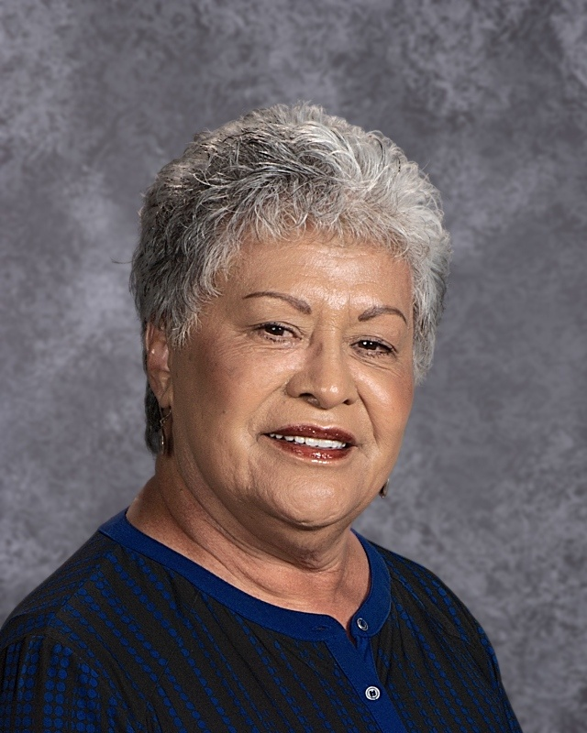
Bentura Navarro
Administrative Assistant and PEIMS Coordinator
bnavarro@petersburgisd.net
Bentura is serving her 51st year in Petersburg ISD. She is a graduate of Petersburg ISD and has served the district in multiple roles over the years. She has served as the administrative Assistant to the superintendent for the past 23 years.

Business Manager:
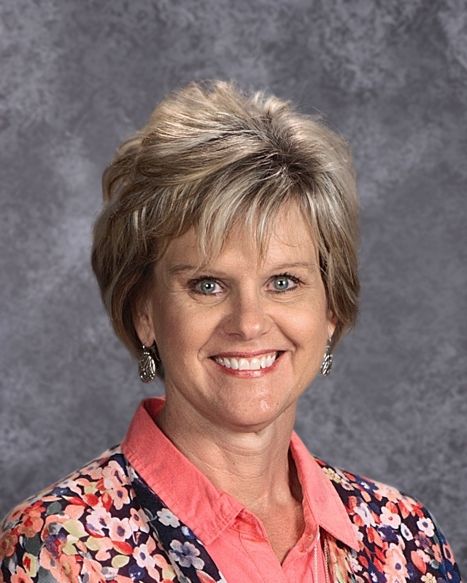
Darlenea Robertson, RTSBA
drobertson@petersburgisd.net

Darlenea Robertson is serving her 23rd year as an employee of Petersburg ISD. She served the first 3 years as elementary librarian, 3 years as high school secretary and the last 17 years as the business manager. Darlenea is a graduate of Canyon High School. She earned her Bachelor’s degree and Legal Assistant Certification from West Texas State University. She is certified as a Registered Texas School Business Administrator for the Texas Association of School Business Officials.

Major Job Responsibilities:

- Finance / Business Affairs
  - Budgeting
  - Accounts Receivable and Payable
  - Payroll
  - Purchasing
  - Risk management
  - Tax collection
  - Audits
  - EDGAR
  - State and Federal Title Funds
- Human Resources
  - Onboarding new employees
  - Employee benefits
- Operations
  - Purchasing of equipment/materials
  - Integrated Pest Management
  - Asbestos Management Plan
  - Policy and procedure management

Maintenance Director

Jesus Garcia
jgarcia@petersburgisd.net
Cafeteria Manager

Vickie Mclaughlin
vmclaughlin@petersburgisd.net
Custodial Director

Lupe Alvarez
lalvarez@petersburgisd.net

K-12 Principal:
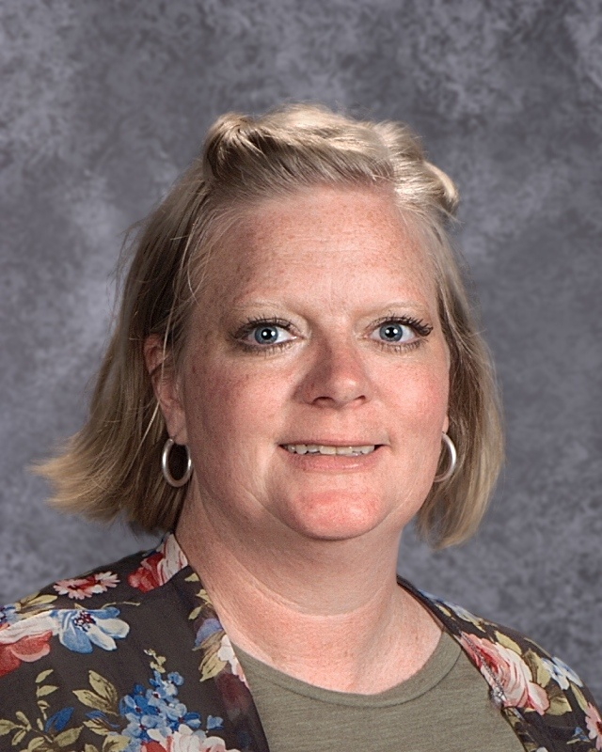
Melissa Galloway, M.Ed.
mgalloway@petersburgisd.net

Melissa Galloway has been in education for 17 years. In 2011, Melissa received her Superintendent certification and doctoral hours through the Bill Ratliff Academy for School Executives and Texas A&M Commerce, as well as a Masters in Educational Administration and Principal certification through Lamar University. She received her Bachelors of Science in Interdisciplinary Agriculture from Texas Tech University in 2001 and her Associate of Science in Agriculture from Howard College in 1999. Melissa is a 1997 graduate of Sands High School.

Major Job Responsibilities:

- Direct and supervise instructional and curricular services to meet the needs of the students and teachers of the district in order to raise student outcomes
- Facilitate the alignment and development of PK-12 curriculum based upon continuing systematic review and analysis
- Use information and insights provided through assessment instruments, the district appraisal process, evaluative feedback, and professional development programs to improve performance
- Review and analyze data, including student achievement data, to examine and improve the effective delivery of the instructional program
- Collaborate with instructional staff in evaluating and selecting instructional materials to meet student learning needs
- Order, secure, and provide instructional materials to support teaching staff in accomplishing instructional goals
- Define expectations for staff performance regarding instructional strategies, classroom management, and communication
- Observe employee performance, record observations, and conduct evaluations of all instructional staff
- Ensure that school rules are uniformly observed and that student discipline is appropriate and equitable in accordance with the Student Code of Conduct and Student Handbook
- Manage the use of school facilities
- Direct and manage extracurricular and cocurricular programs

K-12 Assistant Principal

Larry Lacey
llacey@petersburgisd.net
Athletic Director

Armando Solis
asolis@petersburgisd.net
Technology Assistant

Minerva Orozco
morozco@petersburgisd.net

Counselor:
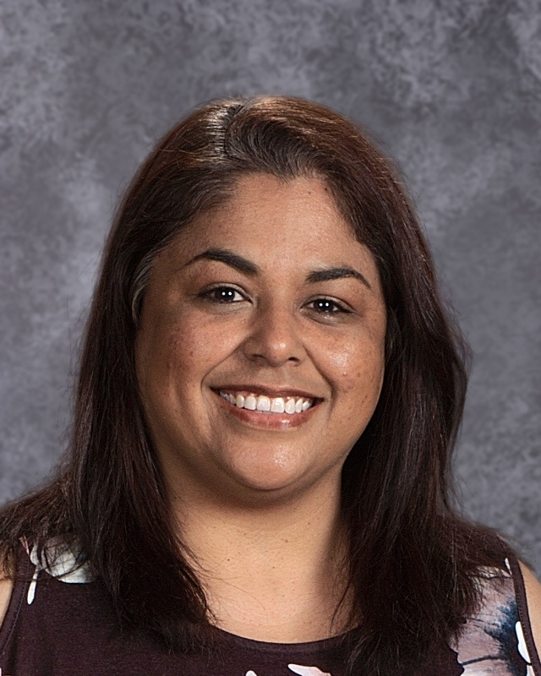
Corina Reyes, M.Ed.
creyes@petersburgisd.net

Corina Reyes is serving her 18th year in education, nine years as a classroom teacher and nine as school counselor. Corina has served Petersburg ISD as the district testing coordinator, college readiness coordinator and parent liaison. Corina is a 1993 Petersburg ISD graduate. She earned her Bachelor’s degree from Texas Tech University in Human Development and Family Studies in 1998 and her Master’s of Education in Counseling From Texas Tech in 2011.

Major Job Responsibilities:

- Guidance and Counseling
  - Character building guidance lessons K-12
  - Proactive interventions
  - Bully prevention
  - Conflict resolution
  - Individual and group counseling
  - Post-secondary counseling
- Monitors College, Career and Military Readiness
  - College admissions: FAFSA, ACT, TSI, PSAT, ASVAB, GT Testing
  - College and military recruiters
  - Scholarships
  - Mentor days
  - Dual credit courses and partnerships
- Student Registration
  - Student schedules
  - Student records
- Parent and Community Involvement
  - SHAC (Student Health Advisory Council)
  - Parent workshops
  - Community service
  - Community outreach

School Nurse

Penne Francis, RN
pfrancis@petersburgisd.net

Registrar

Susie Martinez
smartinez@petersburgisd.net
Director of Federal Programs:
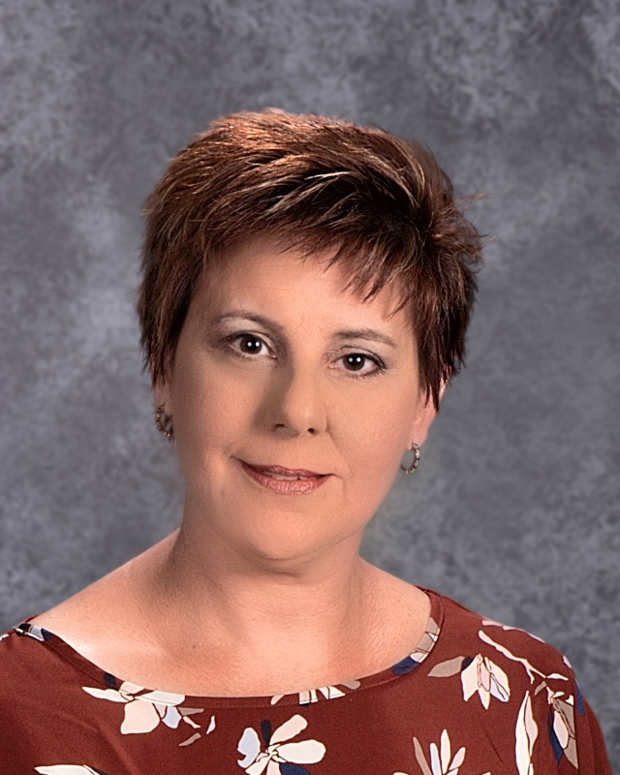
Donna Carnagey, M.Ed.
dcarnagey@petersburgisd.net

Donna Carnagey has been in education for 32 years. Donna earned her bachelor's degree from Southwestern Oklahoma State University and her Master’s from Lamar University. She is currently pursuing her Doctorate in Education. Donna started her teaching career in Pampa as a Special Education teacher. She served in Lubbock ISD as the 504 coordinator, Student Support Team leader, and campus testing coordinator. Donna became the Petersburg Elementary School Principal in 2015.

Major Job Responsibilities:

- Special Education: Responsible for all compliance with Special Education state and federal regulations governing the delivery of services to students with disabilities, Child Find, finances, planning, development, coordination, and management of all special education programs, and personnel

- English Learner / Title III: Responsible for programing, maintaining, completing, and submitting data required for state and federal requirements, coordinate screening for language support program eligibility, plan and chair LPAC meetings, recruit and train LPAC members, oversee TELPAS testing. Provide professional development to staff of best practices for English Learners.

- 504/Dyslexia Coordinator: Responsible for all compliance with 504 state and federal regulations governing the delivery of services to students, Child Find, personnel, planning, development, coordination, and management of accommodations for students in need of intervention and support. Provide professional development to staff on dyslexia characteristics, and identification, and the 504 guidelines, and best practices in intervention services.

- District Testing Coordinator: Responsible for ensuring the security and confidentiality of state-mandated testing programs. Direct and oversee test training, implementation and monitoring of testing activities to ensure that procedures are followed and deadlines are met. Consult with staff to provide appropriate testing accommodations for LEP, Special Education, Dyslexic, and 504 students. Identify, investigate, and address testing irregularities. Maintain integrity of testing data. Order, track, and monitor location of test materials throughout the distribution, return, and storage process. Develop a system for test groups, testing rooms, and scheduling test administrators.

Diagnostics
Rebecca Miller, LSSP
rmiller@petersburgisd.net

Speech Pathologist
Abilou Shirley
akirk@petersburgisd.net

Interventionist/Dyslexia
Angel Sidhu
asidhu@petersburgisd.net

