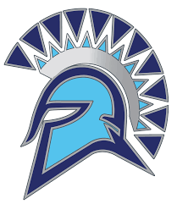

Letter Jackets are Back!

Pick up extra order forms in High School Office – (See Mrs. Logsdon)

Orders are due back in the High School Office. Please bring order form with payment. Bring award letters/patches earned - sewn on at no cost!
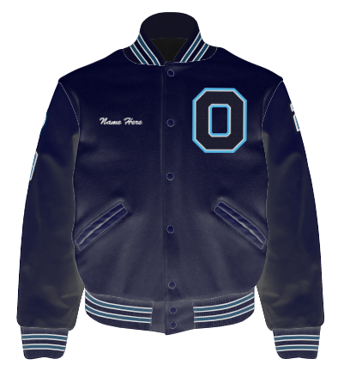
Starter Package All-Star Package Earned Letters Mascot Patch
Name + Earned Letters sewn on FREE Includes Olympia Spartans Back Patch Numerals / Awards sewn on Mascot Patch, Position, Jersey #
$159 $194 Included on Order Day $12 Each

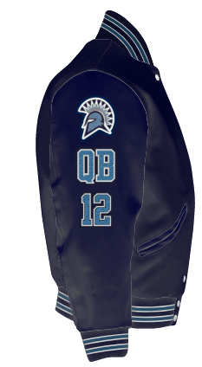
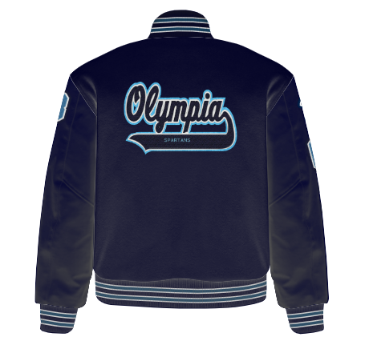

What to do:
- Print or pick up order form (see Mrs. Logsdon)
- Choose Starter or All-Star Package
- Choose Vinyl (included) or Leather Sleeves
- Choose any A-LA-Carte Add-ons
- Choose Jacket Size
- Print Name to be Embroidered
- Turn Form in with Letters, Patches, Numerals
- Add Debit or Credit Card information on form
- Checks payable to Jostens (payment in full required)

