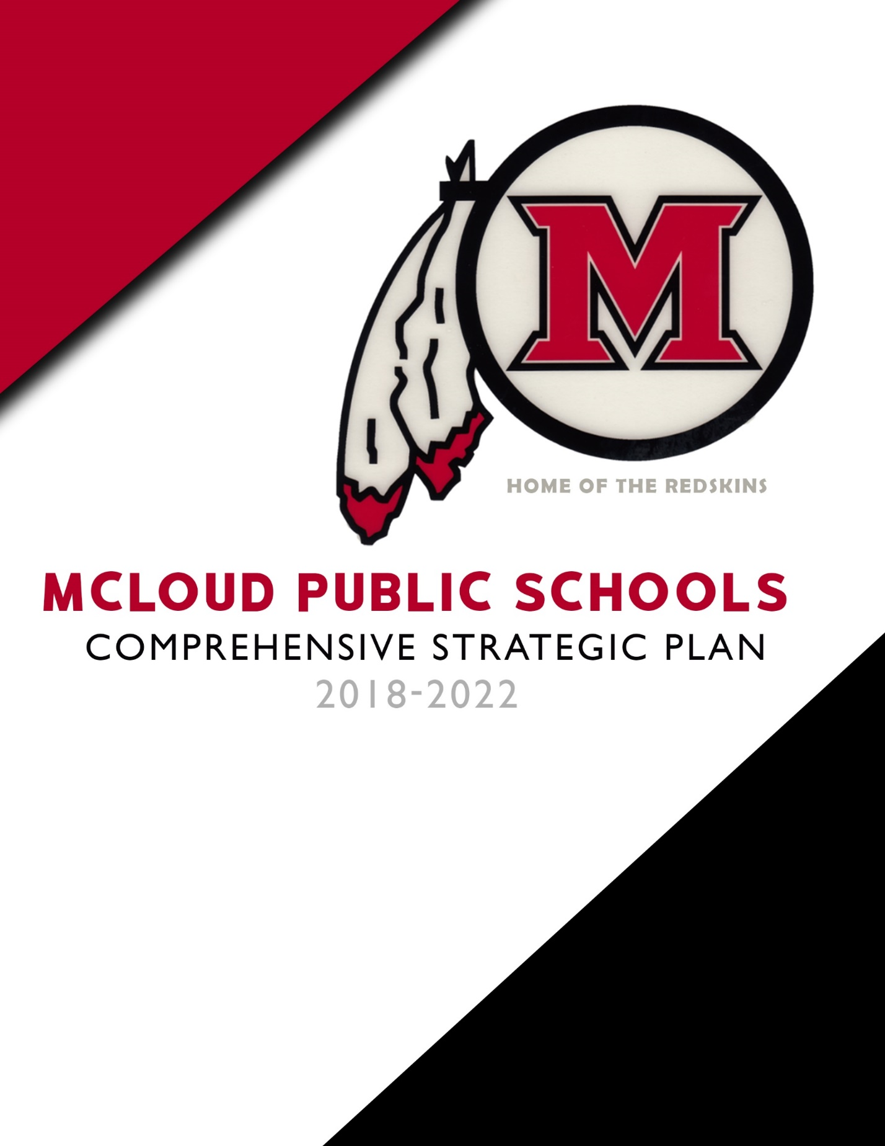

TABLE OF CONTENTS

3 A Message from the Superintendent
4 Board of Education
5 Action Planning Team
6 District Profile
7 Mission and Vision
8-20 Strategic Goal Summaries
Goal Area #1: Attendance and Graduation Rate
Goal Area #2: Academics – Teaching and Learning
Goal Area #3: Student Engagement
Goal Area #4: Facilities and Operations
Goal Area #5: Finance/Budget
21 Acknowledgements

A MESSAGE FROM THE SUPERINTENDENT

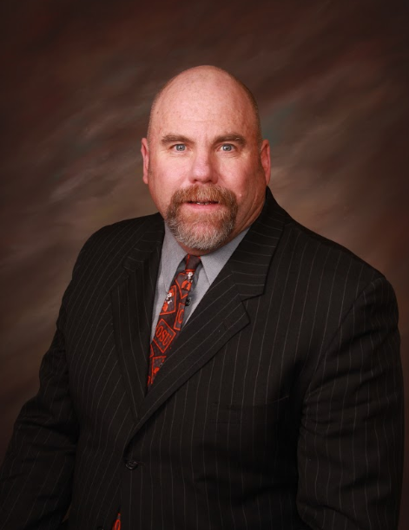 McLoud Public Schools’ 2018-2022 Comprehensive Strategic Plan is designed to provide a road map of excellence that the district will use to inform and define transformation and cultural change. Our district takes great pride in the importance and value of education we provide to our students. Parents, community members, students, and district employees have high expectations in preparing our students for college/career readiness. The plan will guide the district in our quest to provide the highest quality of education that our students and community expect.
The plan is the framework through which the district supports schools to ensure the academic success of each student. This framework allows progress to be measured, priorities established, resources allocated, and communications improved among all stakeholders. The goals, objectives, initiatives and action steps will be continually monitored, and the Board of Education will be regularly updated as to the implementation and progress of the plan.
Thank you to all who participated in the strategic planning process. I am appreciative for all the time, hard work, and commitment given by many in the development of this plan.

Mr. Steve Stanley
Superintendent

3
BOARD OF
EDUCATION

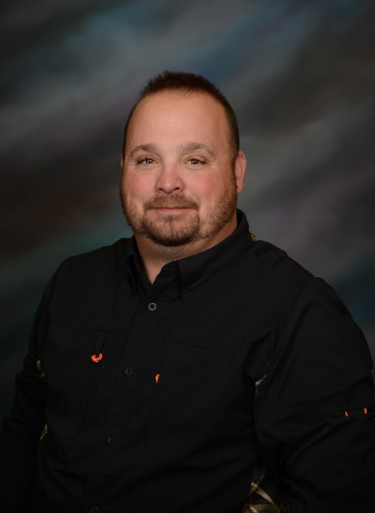

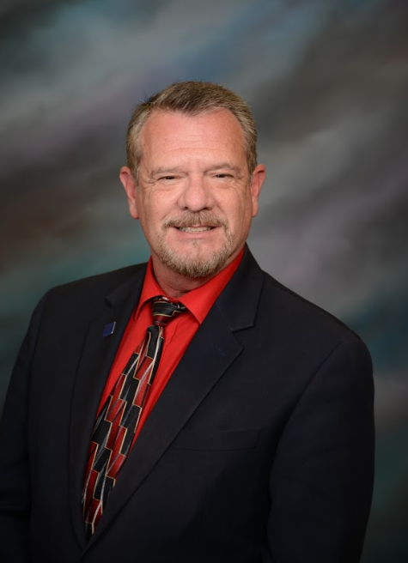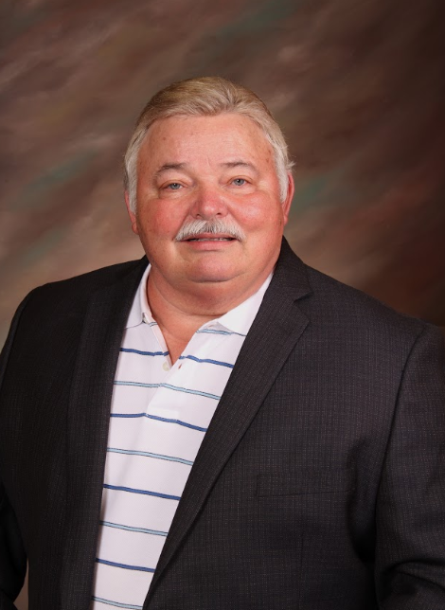
Melanie Krause - President
Dustin Greenberg – Vice President
Bobby Howard - Clerk
Doug Vanscoyoc – Deputy Clerk
Joe Nolen - Member

4

ACTION PLANNING TEAM

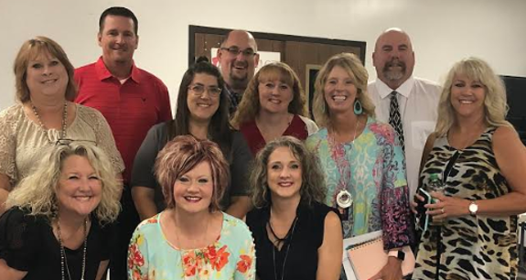

Steve Stanley - Superintendent
Jami Eddings - Director of Student Services
Patty Stanley - Director of Special Services
Rhonda Hockenbury - High School Principal
Bryan Jennings - Assistant High School Principal
Melanne Greenwood - Jr. High Principal
Julie Wolffrum - Assistant Jr. High Principal
Angela Drew - Intermediate Principal
Christina Gilliam - Intermediate Dean of Students
Andrew Winters - Elementary Principal
Sally Thomason - Early Childhood Center Principal

5

DISTRICT PROFILE

DISTRICT REVENUES: (ALL FUNDS)
LOCAL / COUNTY: $2,233,045
STATE: $9,523,946
FEDERAL: 1,268,067
130 TEACHERS
13 ADMINISTRATORS
100 SUPPORT STAFF

Administrators – 92% advanced degrees, 22.5 average years’ experience
Teachers - 24% with advanced degrees, 11.3 average years teaching experience

Enrollment Trends Ethnicity

6

MISSION AND VISION

OUR MISSION:
Working together with families and community to provide a safe, quality education that builds relationships while engaging and challenging all students.

OUR VISION:
Our district empowers all students to embrace learning.

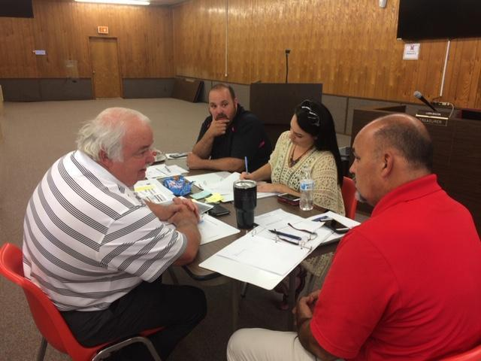
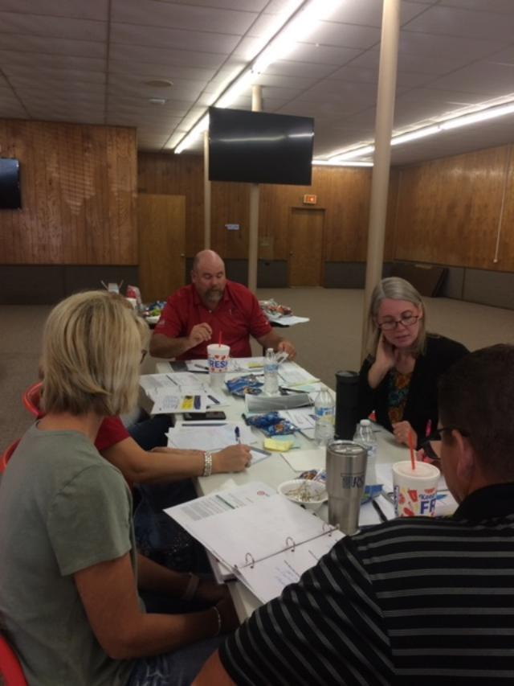
7
STRATEGIC GOALS
SUMMARY
GOAL AREA #1: Attendance and Graduation Rate

OBJECTIVE 1: INCREASED AWARENESS
» Initiative 1: Create a positive culture for increasing student attendance
» Initiative 2: Increase student attendance and graduation rate

OBJECTIVE 2: IMPROVE CHRONIC ABSENTEEISM
» Initiative 1: Implement a system to identify students who are
chronically absent
» Initiative 2: Implement strategies to improve chronic absenteeism

GOAL AREA #1
Attendance and Graduation Rate

OBJECTIVE 1: INCREASED AWARENESS

INITIATIVE 1: Create a positive culture for increasing student attendance

ACTION STEPS: TIMELINE:

Create a district wide slide show to be presented at Back to School Night Fall 2019

Review/Align Board Policy and Student Handbook 2019-2020

Parents/Guardians will receive phone calls (School Messenger) concerning 2018-2022
attendance

Implement High School Orientation for Freshman 2019-2022

Use Social Media (Twitter, Live Feed, Facebook, Digital Billboards) 2019-2022

8
Send letters to notify parents/guardians Throughout the
Year

Parents/Guardians sign an Attendance Policy 2019-2022

Superintendent and administration will meet to develop a process to 2019-2020
monitor absenteeism and graduation rate

Board Policy for attendance will be reviewed and aligned with Student Handbook 2019-2020

Measure(s) – Growth for attendance and graduation rate will be indicated on the OSDE
School Report Card.

INITIATIVE 2: Increase student attendance and graduation rate

ACTION STEPS: TIMELINE:

Provide test exemption incentives 2019-2022

Place Posters in the hallways showing attendance and graduation rates Fall 2019

Provide 9 weeks attendance awards 2019-2022

Teachers/Staff will use positive rewards/incentives to increase attendance 2019-2022

Implement attendance reward trips 2019-2022

Create attendance Bulletin Boards in each building Throughout the
School Year

By 2022, overall attendance rate will increase by 10% as measured by district records
and/or state results.

By 2022, overall graduation rate will increase by 5% in the high school as measured by district
records and/or state results.

OBJECTIVE 2: IMPROVE CHRONIC ABSENTEEISM

INITIATIVE 1: Implement a system to identify students who are chronically absent

ACTION STEPS: TIMELINE:

Kickapoo Tribe partnership/support 2018-2022

Implement a high school committee for chronic absenteeism Fall 2019
9
Research/create an Early Warning System 2019-2020
Implement an Early Warning System 2020-2021

Develop a process to monitor and evaluate the chronic absenteeism system 2019-2020

INITIATIVE 2: Implement strategies to improve chronic absenteeism
ACTION STEPS: TIMELINE:

All teachers will attend professional development on creating and implementing 2019-2020
an Early Warning System

Review the Board Policy and revise as needed 2018-2022

County CAB Process 2018-2022

Provide time for students with chronic absences to make work up (Saturday School, 2019-2020
After School, during school, etc.)

Develop a process to monitor strategies implemented in the district, school and 2019-2020
classroom

By 2022, the overall chronic absenteeism rate will decrease by 10% based on results from the OSDE School Report Card.
GOAL AREA #2: Academics – Teaching and Learning

OBJECTIVE 1: INCREASE STUDENT ACHIEVEMENT
» Initiative 1: Create and implement Response to Intervention (RTI)
programs in reading and math
» Initiative 2: Continue to create and build district curriculum
aligned with the Oklahoma Academic Standards

OBJECTIVE 2: INCREASE RIGOR OF INSTRUCTION
» Initiative 1: Use Higher Order Thinking Skills
» Initiative 2: Use Project Based Learning

OBJECTIVE 3: CREATE A COLLEGE AND CAREER READY CULTURE
» Initiative 1: Prepare students for College and/or Career Readiness
» Initiative 2: ICAP

10
GOAL AREA #2

Academics – Teaching and Learning

OBJECTIVE 1: INCREASE STUDENT ACHIEVEMENT

INITIATIVE 1: Create and implement Response to Intervention (RTI) programs in reading
and math

ACTION STEPS: TIMELINE:

Administer district aligned benchmarks K-12 grades to determine which Beginning,
students need instructional interventions Middle, and
End of each Year

Create a districtwide reading Response to Intervention (RTI) program 2019-2020
by using teaching interventions and evidence-based practices that researchers
have studied and shown to be effective

Pre-K through 12th grade teachers implement small group instruction tailored for 2018-2022
different skills levels and/or learning styles

Teachers will progress monitor and frequently assess each student’s skill ability to 2018-2022
determine whether an intervention is effective Ongoing throughout each Year
Create a districtwide math Response to Intervention (RTI) program by using 2019-2020
teaching interventions and evidence-based practices that researchers have Ongoing
studied and shown to be effective throughout
each Year

K-8th grade teachers will implement Response to Intervention (RTI) with students 2019-2022
who need additional support in math for 15-30 minutes or more as needed each day Ongoing
throughout
each Year

Teachers in grades 9 through 12 will implement Response to Intervention (RTI) 2019-2022
with students who need additional support in math one-time each week Weekly

Build math fluency districtwide using evidence-based best practices 2019-2022

Build achievement with our English Language Learners 2018-2022
11
Increase parental involvement in the student learning process 2018-2022
Ongoing
throughout
each Year

By 2022, the overall reading and math performance of students in need of
Response to Intervention (RTI) overall performance in reading and math will increase
as measured by the NWEA Map Assessments and RIT scores.

INITIATIVE 2: Continue to create and build district curriculum aligned with the
Oklahoma Academic Standards (OAS)

ACTION STEPS: TIMELINE:
Teachers will develop and/or revise curriculum maps in reading and math 2018-2022
aligned with the Oklahoma Academic Standards during PLC’s Ongoing
throughout
each Year

Teachers will develop and/or revise curriculum maps in science and 2019-2021
social studies during PLC’s Ongoing
throughout
each Year

Teachers will review the OSDE Curriculum Frameworks 2019-2022

Teachers at all grade levels will develop/revise curriculum maps and 2019-2022
vertically align with the Oklahoma Academic Standards during Professional
Development Days, teacher release time, and/or grade level team meetings

Assistance and training will be provided to all teachers to support 2019-2022
development/revision of curriculum maps Ongoing
throughout
each Year

The Curriculum and Assessment Director/Coordinator will provide 2018-2022
support and assist administration and teacher teams to develop/revise Ongoing
curriculum maps throughout
each Year

Teachers will use Common Formative Assessments (CFA’s) to monitor 2019-2022
student performance and growth Ongoing
throughout
each Year
12
Teacher leaders may seek outside professional development focused on 2019-2022
Creating Common Formative Assessments (CFA’s) Ongoing
throughout
each Year

By the end of the 2022 school year, 90% teachers will have received training
in curriculum alignment with the Oklahoma Academic Standards and creating
Common Formative Assessments so that students master state standards.

OBJECTIVE 2: INCREASE RIGOR OF INSTRUCTION

INITIATIVE 1: Use Higher Order Thinking Skills

ACTION STEPS: TIMELINE:

Provide professional development for all teachers on using Higher Order 2019-2020
Thinking (HOT) Skills
Use Professional Learning Communities (PLC’s) to research and develop 2019-2022
Higher Order Thinking strategies to implement with all learners

Teachers will use Bloom’s and Webb’s Depth of Knowledge Levels with 2018-2022
Questioning strategies to create higher level thinking with all learners

Develop a process to monitor the effectiveness of using Higher Order 2019-2020
Thinking skills in the classroom (Administration Focus Walks, data results)

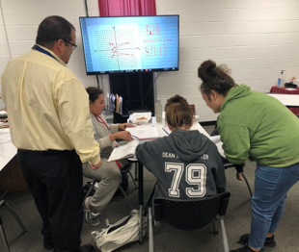
13
INITIATIVE 2: Use Project Based Learning

ACTION STEPS: TIMELINE:

Professional development will be provided for all teachers on using August 2, 2019
Learning (PBL) activities by Collier Education Consulting, L.L.C.

Provide professional development for all teachers on Unit Planning 2019-2020

Teachers will integrate Project Based Learning activities/units into curriculum 2020-2022
maps

Teachers will integrate PBL activities throughout each year 2020-2022

Develop a process to monitor the effectiveness of using Project Based 2019-2020
Learning activities/units in the classroom

OBJECTIVE 3: CREATE A COLLEGE AND CAREER READY CULTURE

INITIATIVE 1: Prepare students for College and/or Career Readiness

ACTION STEPS: TIMELINE:

Create college and career interests for 7th and 8th grade students 2019-2022

College visits (7th and 8th grade students) 2019-2022

Gordon Cooper (8th grade students) - Oklahoma Promise 2018-2022

College Fair (Juniors and Seniors) 2019-2022

Career Fair 2019-2022

Provide FAFSA Support for High School Students 2018-2022

Promote Parental Involvement 2018-2022

Measure(s) – By 2022, college and career interests for 7th and 8th grade students will
be created and implemented.

14
INITIATIVE 2: ICAP

ACTION STEPS: TIMELINE:

District team attended OSDE ICAP training 2018-2019

ICAP Kick-off meeting to build awareness August 28, 2018

Pilot the ICAP with 9th grade students 2019-2020

ACT Prep Course will be implemented 2020-2021

Student Data Trackers/Portfolios will be used 2020-2022

Measure(s) – By 2022, ICAPs with all students in grades 9-12 will be implemented.

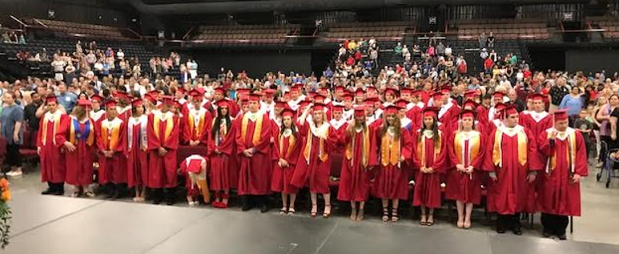

15

GOAL AREA #3: Student Engagement

OBJECTIVE 1: Active Engagement
» Initiative 1: Students will be engaged in the learning process
» Initiative 2: Individualized learning will be provided

GOAL AREA #3
Student Engagement

OBJECTIVE 1: Active Engagement

INITIATIVE 1: Students will be engaged in the learning process

ACTION STEPS: TIMELINE:
Professional development will be provided for all teachers in the following
Areas:
· Engaging students in the learning process 2019-2020

· Cooperative Learning - Kagan August 2, 2019
Collier Education Consulting, L.L.C., will provided onsite training

· Project Based Learning August 2, 2019
Collier Education Consulting, L.L.C., will provide onsite training Ongoing
Throughout
Each Year

· Real World Connections 2018-2022

· Peer Teaching/Mentoring will be implemented using Instructional 2019-2022
Rounds

Student engagement will be measured by walkthroughs, observation of implementation of
differentiated instructional strategies in the classroom, student questioning and lesson plans.

16
INITIATIVE 2: Individualized learning will be provided
ACTION STEPS: TIMELINE:
1:1 technology for all students (PK-12) 2019-2020

Google Classroom training will be provided for teachers August 2, 2018
Ongoing
Throughout
Each Year

Modules for teachers will be provided 2019-2020
Ken Thompson

Individual student goals and data will be utilized to promote growth 2019-2022
with all students (NWEA Map assessments)

Measure(s) – Individualized learning will be measured by goals and data using
NWEA Map assessments to determine growth.

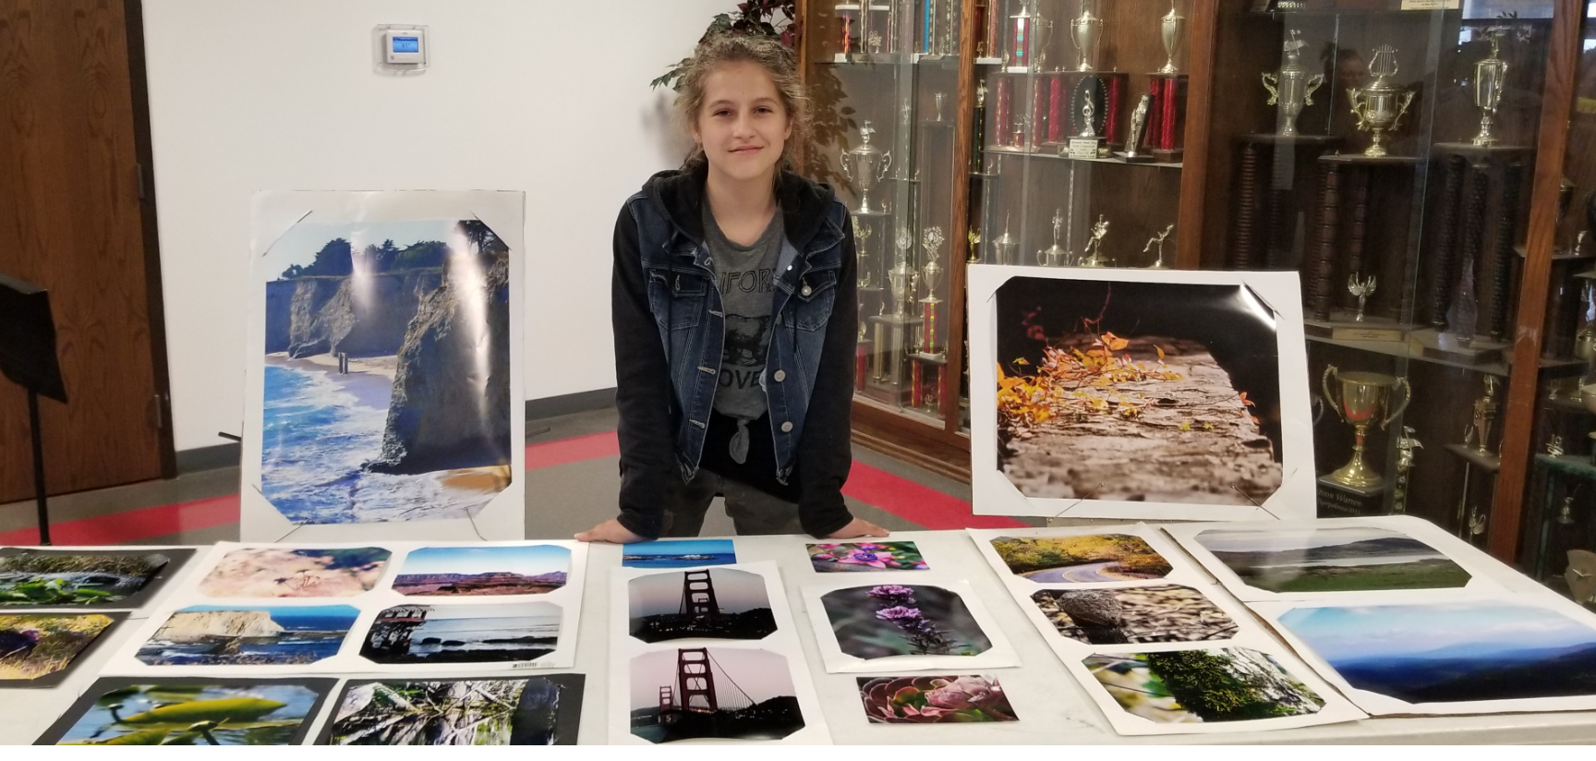

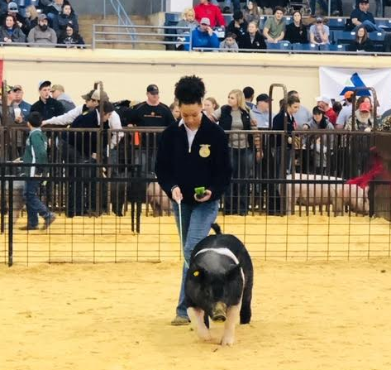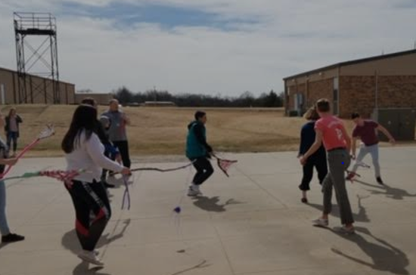
17
OBJECTIVE 1: Provide Increased Access to Up-to-Date Technology
» Initiative 1: Improved infrastructure
» Initiative 2: Improved technology maintenance
OBJECTIVE 2: Ensure Safe School Environment
» Initiative 1: To build a comprehensive Safety Plan for McLoud Public
Schools
OBJECTIVE 3: Provide Well-Maintained Buildings and Grounds
» Initiative 1: Replacements of building roofs, HVAC units, and district
lighting systems

GOAL AREA #4
Facilities and Operations

OBJECTIVE 1: PROVIDE INCREASED ACCESS TO UP-TO-DATE TECHNOLOGY

INITIATIVE 1: Improved infrastructure
ACTION STEPS: TIMELINE:
360 Chromebooks Fall 2018

One-to-one 2019-2020

INITIATIVE 2: Improved technology maintenance
ACTION STEPS: TIMELINE:
Develop a process for improved technology maintenance with a 2019-2020
district committee

18
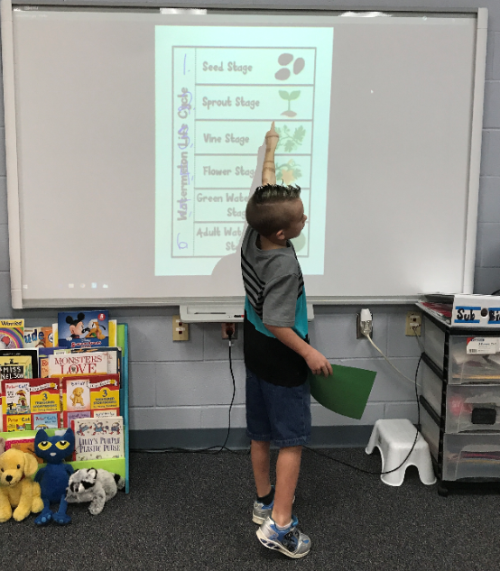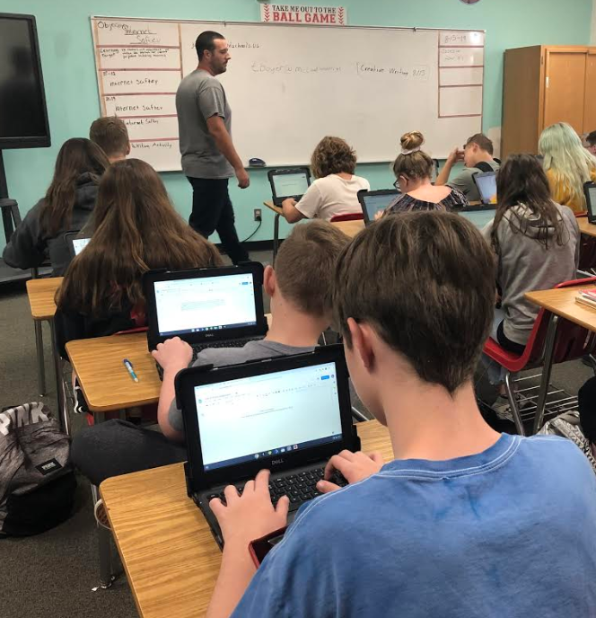

OBJECTIVE 2: ENSURE SAFE SCHOOL ENVIRONMENT

INITIATIVE 1: To build a comprehensive Safety Plan for McLoud Public Schools
ACTION STEPS: TIMELINE:
Work with Jason Gray (OSDE) to build a comprehensive Safety Plan 2019-2020

Phase I – Six Step Process for safety concerns August 26, 2019

OBJECTIVE 3: PROVIDE WELL-MAINTAINED BUILDINGS AND GROUNDS

INITIATIVE 1: Replacements of building roofs, HVAC units, and district lighting systems
ACTION STEPS: TIMELINE:
Maintenance of building roofs, HVAC units, and district lighting will be 2018-2022
monitored throughout each year

Previous Bond – New Intermediate School Spring 2018-
Fall 2019

Proposed Bond facility improvements – Paving Athletic Parking Lot, August-November
New Track, New Board Office, Athletic Fields, Redo Concession/Restroom 2019
19
GOAL AREA #5: Finance and Budget

OBJECTIVE 1: Align Expenditures to Goal Areas
» Initiative 1: Comprehensive Strategic Planning Process

OBJECTIVE 2: Seek Alternative Funding
» Initiative 1: Additional funding for goal area objectives

GOAL AREA #5

GOAL AREA #5
Finance and Budget

OBJECTIVE 1: ALIGN EXPENDITURES TO GOAL AREAS

INITIATIVE 1: Comprehensive Strategic Planning Process
ACTION STEPS: TIMELINE:
Determine who will present the Comprehensive Strategic Plan overview 2018
Kim Collier – Collier Education Consulting, L.L.C.

Present 5 Year Plan to the McLoud Board of Education November 14, 2019
Kim Collier – Collier Education Consulting, L.L.C.
Measure(s) - Support all of goal area objectives as identified by the Board of Education by 2022.
OBJECTIVE 2: SEEK ALTERNATIVE FUNDING
INITIATIVE 1: Additional Funding for Goal Area Objectives
ACTION STEPS: TIMELINE:
Administrators will contact possible donors for alternative funding of goal 2019-2022
area objectives

Develop a schedule and share opportunities found with Board of Education 2019-2022
and site principals
Measure(s) – Possible donations from donors will be identified and schedule(s) shared with the Board of Education as needed 20

Acknowledgements

Collier Education Consulting, L.L.C. commends the McLoud Public School District, Board of Education and members of the Action Planning Team in this commitment toward comprehensive strategic planning and improvement. Through this process, a five-year strategic plan, aligned to the district’s vision, mission, and core values, has been developed to provide guidance for McLoud Public Schools’ decision making and actions in the future. We also would like to acknowledge the dedication of the Avedis Foundation and support they have provided toward educational improvement.

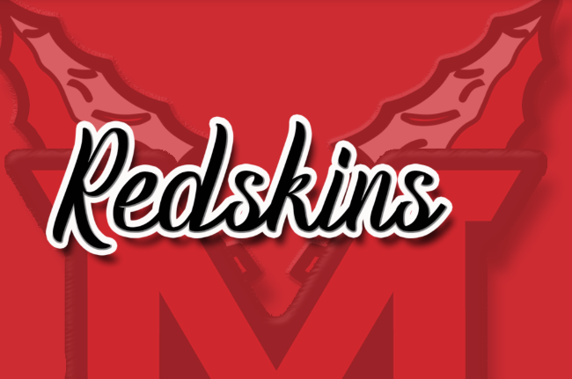

21

