Viola Rand Elementary School

Small School…

BIG FOOTPRINTS!
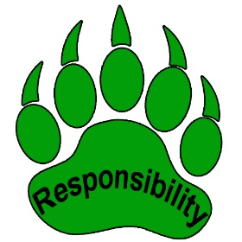
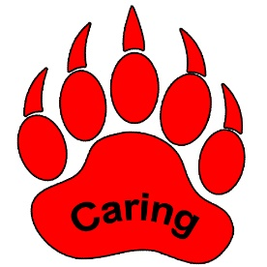

Family Handbook
2019-2020
55 Highland Avenue
Bradley, ME 04411
Telephone/Fax: (207) 827-2508
Website: www.rsu34.org Facebook: RSU#34 VRS Free App: RSU #34 ME
Viola Rand Elementary School 2019-20
This student handbook is a guide for students and parents in becoming acquainted with some of the more important procedures and expectations of the school as well as any significant changes of which parents should be aware. You are encouraged to utilize the district website/app www.rsu34.org to access information that is provided there. Staff contact information, school lunch information including menus, calendars of events, links to computer sites, policy information and district storm announcements are a few examples of information that is available there. We urge students and parents to talk to their teachers early and often regarding any questions and concerns that may arise. The faculty and administration want each child to achieve success and to enjoy being a student at the Viola Rand School.

INDEX
Staff Listing, School Board 3
District Personnel and Contact Information, Daily Schedule 4
Contact information / Attendance 5-7
Bullying 7
Conduct/Behavior 8-10
Food Service, Resource Center 11-12
Medical Matters 12-13
PRIDE 14
Pupil Records 14-15
Retention Policy, School Cancellations/Apptegy Communication System 15-16
Personal Devices, Dress Code, Solicitation, Party Invitations, Plagiarism 17
Testing/ Assessment Schedule 18
School Safety Plan, Weapons Policy, Affirmative Action 19
School Calendar 20
2019-2020 Viola Rand School Staff

Principal Cheryl Leonard
Secretary Heidi Gifford
Pre-kindergarten Marion Talon
Pre-k ed tech Sarah Prokey
Kindergarten Carrie Rand
Grade 1 Melissa Gasaway
Reading Recovery/Interventionist Jennifer Dalessandro
Special Education James Wohlgemuth
Classroom Music Erin Murphy
Physical Education Cid Dyjak
Guidance Trysha Lunn
Art Helena Bosse
Library Ed Tech Erin Murphy
RSU34 Elementary librarian Lynn Mayer
Occupational Therapist Kristi Swartz
Speech Therapist Kaitlin Michaud
Nurse Vanessa Koch
Custodian Owen Arey
Food Service Claudia Cox

Further information about NCLB highly qualified teacher designations are available on the www.rsu34.org web site as part of the Every Student Succeeds Act Report Card.

RSU #34 School Board
Jim Dill Old Town Hunter Umphrey Old Town
Laura Sanborn Alton Howard Jack Bradley
Donna Conary Old Town John Milligan Bradley
Lauree Gott Old Town David Wollstadt Old Town
Moriah Geer Old Town

Important Numbers
David Walker, Superintendent RSU34 827-7171
Jon Doty, Director of Curriculum, Instruction and Assessment 827-3932
Kimm Kenniston, Director of Special Education 827-3921
Betsy Dyer, Assistant Director of Special Education 827-3921
Stephanie Salley, Food Service Director 827-3908
Jef Hamlin, Technology Director 827-3900 x140
Affirmative Action Coordinator – Scott Gordon
Section 504 Coordinator – Kimm Kenniston
Title IX Coordinator – David Walker OR Director of the Office of Civil Rights, Washington DC

Daily Schedule
7:25 am First Walker Arrival/Bus Arrival –recess on playground
7:40 am First Bell / Flag Salute – Pledge of Allegiance
7:50 am Instructional Day Begins
10:30 am AM Pre-k dismissal
11:30 am Lunch/ Recess
11:45 am Afternoon Pre-K Begins
12:15 pm Lunch Recess Ends
2:20 pm End of School Day: Walkers and Old Town Rec Bus Dismissal
2:25 pm YMCA and Bradley Bus Dismissals
SPECIALS SCHEDULE
Monday - Music & Library (REMEMBER LIBRARY BOOKS!)
Tuesday – PE (WEAR SNEAKERS!!)
Tuesday – Guidance
Wednesdays – Art
Thursdays – PE (WEAR SNEAKERS!!)

- There should not be any vehicles in the driveway of the school between the hours of 7:10 and 7:55 AM and between 2:00 and 2:35 PM to help us ensure the safety of all students.
- Please help your child to arrive at school before 7:40 AM.
- Parents who drive their children to school should drop them off at the end of the driveway. This will help to keep all children safe.
- Walkers should leave the school grounds immediately after being dismissed.
- Parents who pick their child up at the end of the day should wait in their vehicles or the office lobby until the walkers are dismissed.
- Please park on the school side of the road when waiting with/for students.
- Parents who pick their child up before 2:20 must sign him/her out at the office.
- If you need to change the end of day plans for your child, please notify the school as early as possible and before 1:30pm.
- Every effort is made to provide outdoor recess daily, but in the event of heavy rain or wind chill temperatures below 10 degrees, students will remain indoors.

EMERGENCY CONTACT INFORMATION-

In case of a change of address or telephone number, the office should be notified promptly. It is crucially important that we have contact information to reach parents in case of an emergency.

ATTENDANCE- STRIVE FOR 5! (5 or fewer absences that is!!)
Attendance and punctuality in arriving at school are essential for students to make continuous progress in school. Frequent absence is the single most important cause of academic difficulty and is a documented indicator for failure to graduate high school. Prompt and regular attendance is an excellent habit to establish now. Please call the school anytime your child will not be in school.
Call-in Procedure- If a student will be absent from school or will be late arriving at school, we ask that parents or guardians call the school by 8:15 am to notify the office. If a parent wishes to make this call early in the morning before the office staff arrives at the school, he/she can leave a message in the school’s general voice mail box. This will alert the attendance coordinator that the child is safe at home. If the school does not receive notification that a child is out, the attendance coordinator will attempt to contact parents/guardians to verify that the child is at home. Your cooperation with this procedure is greatly appreciated.
- If a student is absent from school, he/she needs to bring a written excuse from home stating the date(s) and reason(s) for the absence(s). Even if a parent calls to notify us of an absence, we still need a written note for our records. In accordance with Maine law, we can only consider the following reasons as excused absences: personal illness; an appointment with a health professional that must be made during the regular school day; observance of a recognized religious holiday when the observance is required during the regular school day; a family emergency; or a planned absence for a personal or educational purpose which has been pre-approved. There is a form available at the office to be filled out prior to planned absences of 3 or more days.
Definition of Chronic and/or Excessive absenteeism:
-Chronic absence means missing approximately 10% or more of the school year (equivalent to 18 days out of a 176 day school year) regardless of whether absences are excused or unexcused. (Chang and Romero)
-A cumulative absence rate of twenty percent is the guideline in determination of excessive absence (total of 4 days absent at the end of September, total of 8 days absent at the end of October, total of 12 days absent at the end of November, etc.).

VRES Student Cumulative Days Absent Guide

Month Chronic Absence Excessive Absence
(10% or more) (20% or more)

September 2 4
October 4 8
November 6 12
December 8 15
January 10 19
February 11 22
March 13 26
April 15 30
May 17 34
June 18 36
Chang, Hedy and Romero, Mariajose Present, Engaged and Accounted For: The Critical Importance
of Addressing Chronic Absence in the Early Grades National Center for Children in Poverty, Mailman
School of Public Health, Columbia University, September 2008

Administration will follow a three-tier intervention system in attempt to correct chronic or excessive absenteeism:
Tier 1: Student crosses 10% threshold
-Phone/Letter communication
Tier 2: Student crosses 20 % threshold or remains above the 10% threshold
for two consecutive months.
-2nd Letter, Parent meeting, Parent Survey, Attendance Contract
Tier 3: None of the above interventions work
-3rd letter (certified), Notification of Authorities and/or DHHS
**Inquire in the office if you would like a more detailed intervention list
RSU #34 administration is required to follow State Attendance and Truancy laws and statutes (5001-A; 5051-A; 5053-A).

TARDINESS
Arrival after 7:50 a.m. is regarded as tardiness. Students are required to make up their work when tardy.
Continued unexcused tardiness may result in a meeting with parents.
Early Dismissal- Students will remain in their classrooms until dismissal. When it is necessary for a student to leave school prior to regular dismissal, the school requires a written note from the child’s parents stating the nature of the situation. The child should give this note to the homeroom teacher at the beginning of the day. We encourage parents to make dental and medical appointments after school hours whenever possible. Students need to be in school for at least half the day or the dismissal is recorded as an absence.
We will not release a student to anyone other than parents or legal guardians without written permission from parents.
Parents must sign students in and out of the building through the office if they arrive late or leave early.
Bullying-

RSU #34 Bullying Policy
It is the intent of the RSU #34 Board to provide all students with an equitable opportunity to learn. To that end, the Board has significant interest in providing a safe, orderly, and respectful school environment that is conducive to teaching and learning. It is not the Board’s intent to prohibit students from expressing their ideas, including ideas that may offend the sensibilities of others, or from engaging in civil debate.

Bullying Defined
“Bullying” means any physical act or gesture or any verbally, written, or electronically communicated expression that:
- A reasonable person should expect will have the effect of:
1. Physically harming a student or damaging a student’s property;
2. Placing a student in reasonable fear of physical harm or damage to his/her property; or
3. Substantially disrupting the instructional program or the orderly operations of the school; or

B. Is so severe, persistent, or pervasive that it creates an intimidating, hostile educational environment for the student who is bullied. For the purposes of this policy, bullying does not mean mere teasing, put-downs,
“talking trash,” trading insults, or similar interactions among friends, nor does it include expression of ideas or beliefs so long as such expression is not lewd, profane, or does not interfere with students’ opportunity to learn, the instructional program, or the operations of the schools. This does not preclude teachers or school administrators from setting and enforcing rules for civility, courtesy, and/or responsible behavior in the classroom and the school environment. The determination whether particular conduct constitutes bullying requires reasonable consideration of the circumstances, which include the frequency of the behavior at issue, the location in which the behavior occurs, the ages and maturity of the students involved, the activity or context in which the conduct occurs, and the nature and severity of the conduct.

Bullying, as defined by RSU #34 policy (NEPN/NSBA Code: JICK), is not acceptable conduct in RSU #34 schools and is prohibited while on school property, while in attendance at school or at any school-sponsored activity , while students are being transported to or from school or school-sponsored activities or events. This policy also applies to bullying that occurs at any other time or place that such conduct directly interferes with the operations, discipline, or general welfare of the school. Any student who engages in conduct that constitutes bullying shall be subject to disciplinary consequences up to and including suspension and expulsion. A student’s bullying behavior may also be addressed through other behavioral interventions. Students who have been bullied or who observe incidents of bullying are encouraged to report this behavior to a staff member or school administrator. Acts of reprisal or retaliation against any person who reports an incident of bullying are prohibited. Any student who is determined to have falsely accused another of bullying shall be subject
to disciplinary consequences.

STUDENT CONDUCT/BEHAVIOR-

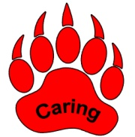
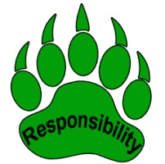
The Viola Rand School is a community of learners. Students, school staff and parents share a responsibility for maintaining a positive learning environment. Likewise, all members of the community can be expected to act in ways that represent:

Students should arrive at school with all necessary materials, including homework! Be ready to learn with a good night’s sleep! Arrive on time; if we miss even a minute, we miss a lot of learning! Remember your snack. School staff may give “Bear Paw” awards when students show extraordinary character as they go about their day at school. Look for opportunities to help a school neighbor and to be a leader. Remember, it is the character you display when no one is watching that really defines you!

In the event that a student misbehaves, a teacher or staff member will administer an appropriate consequence. Some examples of consequences include: talking to the student, “time-out” in a quiet spot or a referral to the office. For more serious or repeated offences, a parent meeting with the student and administration may be necessary, the student may receive an after school detention, may have to serve an in-school suspension or may lose the opportunity to participate in after school activities.
School rules apply for all school sponsored activities including after school functions and off site events.
If there are concerns about the bus, please contact Cheryl Leonard after trying to resolve the issue with the bus driver. We will not tolerate any student who chooses to disrupt or interfere with the physical safety of others. Remember, riding the bus is a privilege which may be revoked. School administration will handle bus discipline issues. Drivers will write up safety and behavioral concerns and forward them to the school administration for follow up at the school.
Procedures for Restraint and Seclusion
Please visit the policies section of the RSU 34 website, www.rsu34.org. (JKAA; JKAA-R)

The Matrix on the following page is the school’s guide to behavioral expectations:

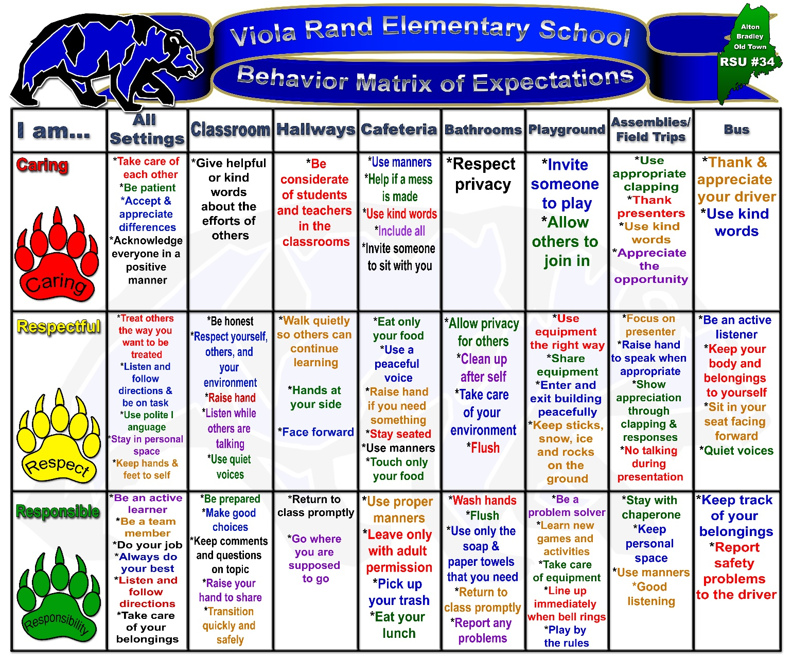

5-2-1-0

VRS promotes wellness for healthy staff and students by encouraging and rewarding positive choices.
- 5 - Eat 5 or more fruits and vegetables each day.
- 2 - Limit screen/TV time to 2 hours or less each day.
- 1 - Try to engage in 1 hour or more of physical activity each day.
- 0 - Do not drink sugary drinks (try water & lowfat milk)
http://www.letsgo.org/

HOW PARENTS CAN HELP

To guarantee the best possible education for your child, the home and school must work together. Here are a few suggestions as to how this may be accomplished:

- Come to events at the school so you will be part of your child’s school life.
- Let your child know that you respect and support the teacher and that you intend to work together for your child's best interests.
- Find out how much homework is expected and talk with your child about the importance of completing the homework assignments.
- Make sure your child gets plenty of rest and has an adequate diet. Encourage good health habits and allow free time for leisure activities.
- Don't pressure your child about grades or compare your child to other children. Look for the positive.
- Encourage interests in books, magazines, hobbies, trips, and current events.
- Have reading materials in your home. Read and work with your child.
- Feel free to contact the school whenever there is a problem. Don't just talk about school problems with your neighbors---get in touch with the school where someone can give your problem immediate attention. In the event of a classroom concern, please contact your child’s teacher first by calling or emailing; and, to possibly schedule an appointment.
- Remind your child to bring necessary items each day. ie. a snack, library books, gym shoes.

All visiting adults MUST register/sign-in through the office upon entering the school. An I.D. badge will be assigned and required to be worn while inside the building. PLEASE HELP KEEP OUR SCHOOL SAFE!!

We encourage and appreciate VOLUNTEERS IN OUR SCHOOL! Prior to coming in to help, a form and records check needs to be completed through the superintendent’s office. We will be happy to assist with this process!

Food Service-

Hot lunch money will be collected every Monday if payment is not made through the My School Bucks site online. Money should be sent in an envelope with the following information:
Student name, teacher, date, days of week hot lunch is being ordered, days of week ordering lunch milk and amount of money enclosed

Prices are: Hot Lunch $ 2.60 full/ $.40 reduced
Breakfast $1.50/ free
Milk (skim, 1%, fat free chocolate) $.50
Adult Breakfast: $1.75 Adult Lunch: $5.00

Free and Reduced Hot Lunches: Children from families whose income falls within certain ranges are eligible to receive lunches free or at a reduced price. Unusual circumstances such as prolonged illness in the family, unexpected expenses due to fire, flood or any other disaster, seasonal employment and similar emergency situations are taken into consideration. Applications may be requested at any time during the school year. All applications will be reviewed by the food service director within ten days. Applicants will be notified promptly as to the decision on their applications. All applicants will be handled privately and information will be kept strictly confidential. Reduced Prices: Lunch-$0.40; Breakfast-Free

**Please take the time to complete the lunch application (Free and Reduced Lunch Form) even if your child will not be having hot lunch. Much of our Federal and State funding is based on the number of qualifying students. Your help is of GREAT importance!
**Breakfast Note: Students eating breakfast should be at school by 7:40 a.m. to allow sufficient time to eat. Breakfast will be served in the classrooms and there will be a set menu for each day of the week.

**Peanut allergies – In the cafeteria, the yellow tables will be designated to be where peanut items may be eaten. The rest of the tables will be nut free. After consuming peanut food items any place in the school, students will be required to wash their hands before moving on to other activities. Any classroom with a child(ren) with a peanut allergy will be a nut free space.

Regional School Unit #34 Policy on Payment for Food Services
Students whose living conditions change such that they lack a fixed, regular, and adequate nighttime residence likely qualify for free lunch under the McKinney-Vento Act; students or parents should contact the school office for rapid referral to the RSU #34 Liaison.
It is preferred that all meals be paid for in advance or paid for at the time of service. Meals may be paid for by sending cash or a check with the student or through an on-line payment option.
Parents/Guardians may access a student’s lunch balance and/or make payments at any time by logging on to www.myschoolbucks.com. Parents may also check balances by calling the school or the RSU #34 Food Service Office. The school district will provide notice to parents/guardians on the 15th of each month when a student’s unpaid balance exceeds $25.00.
There will be a $20.00 fee charged on returned checks. Cash only or on- line payment may be requested of families who pay by checks that are repeatedly returned for insufficient funds.

Resource Center –
Jennifer Goodwin is the grant funded school to community liaison for RSU34. Her office is at the Viola Rand School. There is a Resource Center at the Old Town Elementary School where parents may go to find food as well as cleaning supplies and hygiene products. The dates when this is available are on the web site and go home in student communication folders. Ms. Goodwin also organizes weekly food bags to go home with children on Fridays if food security is a concern in a household. For more information about any of this, please call Jenn Goodwin at 827-2508.

Medical Matters-
Success in school depends to a great extent on good physical health.

Students are required to bring a note from their parents after any illness. We shall sincerely appreciate your cooperation in this regard.

Student Insurance: Parents have the opportunity to purchase school accident insurance at a reasonable cost for their children. An information sheet explaining the program will be sent to each home. The school receives no compensation for this service. Parents should note that the school does not pay medical bills of children who are injured in an accident at school.
Immunizations: Students must be immunized in accordance with Maine law. If your child does not have the updated immunizations by the start of the school year he/she will not be admitted until proof of all required immunizations are presented.

First Aid : Sometimes it is necessary for school personnel to administer basic first aid to students. Such first aid might include washing a cut and applying band-aids or ice packs. If your child has a significant injury while in school or becomes ill, you will be notified as soon as possible. It is extremely important to have current information on our emergency contact form in case we need to reach you. Please notify us during the year of any changes in contact information.

Medications: If at all possible, please arrange medication times so that they can be given at home (before and/or after school). If it is necessary for a student to take medication at school, there is a written medication policy that must be followed. Any medication, prescription and non-prescription, must be in the original containers, properly labeled and accompanied by written instructions from the parent/guardian before they may be dispensed. In addition, A Health Care Provider’s signature is required for all medication. Acetaminophen 325 mg. tablet, Ibuprofen 200 mg. tablet, Tums, Calamine Lotion and anti-biotic ointment are the only exceptions. However, medication to be administered for 15 consecutive days or less, such as an antibiotic, are not required to have a health care provider signature but must be brought to school in its original container with a current and clear pharmacy label—THIS INCLUDES: prescription and non-prescription medication, including cough drops.
***All medication must be kept in the school clinic or administrative office. Medication must be transported to and from school by a parent or other adult. Maine State Law permits students to carry and use emergency medications such as EpiPens and Inhalers with written permission from the parent/guardian and the Health Care Provider, and demonstration of proper use to the school nurse. See school nurse for details.

Illness: It is sometimes difficult to determine when to keep a child home and when to send a child to school. As a general rule we adhere to the following: a fever above 100 degrees, vomiting, diarrhea, or a rash of unknown origin in the previous 24 hours are examples of reasons to keep a child home from school. In all cases where you are unsure, contact your Health Care Provider. We urge parents to enlist the help of family and friends to be available in the event that a child is ill and cannot attend school. Being prepared for these situations will help ease the stress for parents and allow children sufficient time to fully recuperate by getting the rest and nurturing they need when they are sick. Please allow children the time they need to recover from an illness before having them return to school. We appreciate your cooperation in this matter. Communicable diseases are very common among young children. Chicken pox, colds, conjunctivitis, impetigo, influenza, and strep throat are most common. Our school follows accepted practiced control measures. Please notify the school immediately if you suspect that your child has a contagious disease so that we can take appropriate measures.
Please keep us informed regarding health problems that your child might have such as asthma, seizures, allergies, diabetes, etc.

Again, it is essential that current emergency contact information is on file in case parents need to be reached immediately.

P.R.I.D.E. (Parents and Residents Interested in Developing Excellence)-
P.R.I.D.E. members, including parents, school staff and town residents, meet every month throughout the school year to plan fundraisers and special school activities. Look for information in your child’s papers for meeting times and dates. Past fund raisers have included: raffles, product sales, raffle calendars and movie days.

P.R.I.D.E. was formed in 1989 and the following is a list of accomplishments since that date:
-Purchased a die cut machine along with $100.00 each year for dies
-Provided an annual trip to the Penobscot Theater in December
-Runs a booth at Riverfest
-Assembles school yearbooks
-Maintained playground and equipment with volunteer work days
-Provides food and volunteers during family dances, Halloween Fun Day, spring book fair, field day on the last day of school and various other school sponsored family events.
-Coordinates teacher appreciation week.
P.R.I.D.E. is always looking for new volunteers to help. The more volunteers we have, the more we can do for our children and our community. We encourage you to come out, get involved, and make the school a better place for our children!

Pupil Records-
Purpose of Pupil Records
Pupil records are collected and maintained to promote the instruction, guidance, and educational progress of the pupil, and for legitimate educational research.

Right to Inspect and Review
(1) Parents/guardians/eligible students shall have the right to inspect and review any and all official records, files and data directly related to their children, including all material that is incorporated into each student's cumulative folder, and intended for school use or to be available to parties outside the school system, and specifically including, but not necessarily limited to, identifying data; academic work completed; level of achievement (grades, standardized achievement test scores); attendance data; scores on standardized intelligence, aptitude, and psychological tests; interest inventory results; health data; family background information; teacher or counselor ratings and observations; and verified reports of serious or recurrent behavior patterns.
(2) Each school shall establish appropriate procedures for the granting of a request by parents for access to their child's school records. Such requests must be granted within a reasonable period of time, but in no case to exceed five (5) school days.
(3) Schools shall provide a trained school employee to interpret the information within the folder to the parents. (Note: Either the building principal and/or appropriate school staff will be available to parents for the purpose of interpreting the student's school record.)
(4) Parents may be allowed to make a copy of materials contained in their child's records at their own expense.

Right to Challenge
Parents shall have an opportunity for a hearing to challenge the contents of their child's school records, to insure that the records are not inaccurate, misleading, or otherwise in violation of the privacy or other rights of students, and to provide an opportunity for the correction or deletion of any such inaccurate, misleading or otherwise inappropriate data contained therein.

Directory Information
By school board policy, we are unable to release address information to other parents.

Retention Policy-

The retention of students in their present grade is an educational decision made by school officials. Students will be retained when it is in their best interest educationally. The basis for a retention decision rests primarily on an analysis of the students' academic achievement and/or their maturational development.

The building principal will keep parents informed of their child's progress and of the possibility that retention in a grade may be required. A parent conference will be arranged whenever appropriate prior to any decision to retain the student.

Any parent who chooses to question the school's retention decision regarding their child may appeal to the Superintendent of Schools. Any such appeal will be reported to the School Board.

School Cancellations-
In the event that it would be necessary to cancel school, the decision will be made by the Superintendent of Schools. Mr. Walker will then send out an automated phone notification including the details of the cancellation. Parents may also check the RSU 34 website for cancellation information: www.rsu34.org.

How Electronic Communication Benefits You:

Apptegy is the electronic notification tool that allows school administrators to quickly and efficiently keep you updated with personalized messages. This will help you (parents) to be actively involved with your child’s education. This electronic communication has the ability to:
-Reach thousands of parents in moments
-Send notifications even when school phone lines are down
-Rapidly deliver first-hand information during a crisis situation both by phone and e-mail.

How Electronic Communication Benefits RSU 34:

It will allow all of our schools to quickly and accurately communicate personalized messages to parents. We also intend to use this communication technology to build stronger relationships. Here are some examples of this:
-Parental & Community Involvement—Reminding parents of a school fundraiser or Parent Teacher Conferences
-Student accountability & attendance—Notifying parents of report cards or student absences
-Emergency notification & awareness—Alerting parents of a lockdown situation or unsafe incident
-Multilingual communication—Translating a message for non-English speaking parents
-School safety preparation—Announcing school closing due to inclement weather

Receiving Messages:

You will receive two different types of calls from the schools:
-Routine Notification—calls which do not directly affect the safety of students, staff or parents. These calls include upcoming events, delays in school transportation and absenteeism.
-Emergency Notification—calls are used during critical incidents where a child, staff member or parent’s safety is in immediate jeopardy. These calls include lockdowns, evacuations and relocations.
*Email Messages—The system also allows for emails to be sent to parents which enables the sharing of documents.

Importance of Accurate Contact Information

The most important thing parents can do is verify the accuracy of their contact information. Schools must have updated phone numbers and email addresses for electronic communications to work effectively and efficiently. Call your child’s school during the operating hours to verify your information is correct. The system will call the home, work, cell or any phone number to which you want a message sent. We will automatically have cell phone and home phone numbers entered into the system. A parent must specifically request a work phone number to be entered.

*VRS will attempt to send all non-emergency messages between the hours of 5:00 p.m. and 8:00 p.m.

Personal Electronic Devices

Students should leave any electronic devices turned off and in backpacks. It is safer to leave such devices at home, as the school cannot be responsible for missing or damaged items.

Dress Code-
Students are expected to dress appropriately for school. Students who wear clothing that is offensive to others or does not adequately cover the body will be required to change into more appropriate attire. Footwear should protect and cover children’s feet, so they are safe at recess. Sneakers are needed for physical education classes. The administration strongly discourages slippers as footwear at school. They are slippery on the classroom and corridor floors and inappropriate in the event of an evacuation. Dress should be weather appropriate and an extra layer or change of clothing, is helpful to have available at school. Please label your child’s belongings so that they will find their way home!

Solicitation-

Parents are reminded that door-to-door solicitation of any kind by the students is not allowed. This is a School Board policy.

Birthday Party Invitations-
Parents are asked not to send birthday party invitations to school unless the entire class is being invited.

Plagiarism-

The practice of taking someone else’s work or ideas and passing them off as one’s own is plagiarism. If a student creates a piece of work that uses or makes reference to anything that is not original, that use must be properly cited. With the access we have through technology, students are easily able to find pictures and documents that are highly relevant to their purpose, but are copyrighted and appropriate citation giving credit to the actual creator must be appropriately provided by the student.

Testing/Assessment Schedule-
In accordance with the Philosophy and Purpose of Education as adopted by Regional School Unit #34, the School Board recognizes the need for individual and group testing. The purpose of the testing program is to measure group and individual progress with respect to social, emotional, intellectual, physical, and cultural growth. The results of these tests provide a continuing record of each child's progress in comparison with national and state norms. They are also an individual aid to your children's teachers and counselors in diagnosing individual strengths and weaknesses in order to provide more effective instruction. Records of individual tests will be maintained in accordance with the State Confidentiality Law. Group data, if released, will comply with the
State Right-to-Know Law. The testing program as adopted by Regional School Unit #34 is reviewed annually and copies may be obtained from the Curriculum, Instruction and Assessment director.

Fall

Observation Survey Grade 1
Fountas and Pinnell Grade 1
Words Their Way Spelling Inventory Grade 1
Screening Pre-kindergarten

Winter

Fountas and Pinnell Kindergarten
F&P or running record Grade 1

Spring

Kindergarten screening Incoming kindergarten students
F&P or running record K
Fountas and Pinnell Grade 1
Envision Math End of Year Grades K - 1
Words Their Way Spelling Inventory Grades K-1

Key to assessments

Fountas and Pinnell (F&P) – Determines independent and instructional reading levels including comprehension and writing about reading
Observation Survey – Identifies key reading skills entering first grade. Identifies students for intervention.
NWEA – Periodic assessment of skills which is nationally normed. Provides quite specific data.
Cognitive Abilities Test (CogAT) – Ability test with verbal, quantitative and non-verbal clusters. Used to inform instruction and as a screener for Chapter 104 (Gifted and Talented) services.
(EmPower ME – State mandated achievement test for grades 3 and up.)

School Safety Plan-
RSU34 has a public safety committee comprised of administrators and nurses from each school, Mr. Walker, local and state police, Penobscot County Sheriff’s office, local fire fighters and EMTs, and MEMA (Maine Emergency Management Agency) that meets twice annually to review, update and plan for preparedness in our schools. We have a comprehensive plan in place in case of emergencies and have drills throughout the year. The drills we practice with staff and students are evacuation, clear the halls and lock down drills. In preparing students for these, students are told that in order to be prepared for any type of emergency, sometimes we need to exit the building and sometimes we need to get down and hide inside the building. The younger the students, the fewer the details provided.
Weapons Policy-
It is the policy of the RSU #34 to take a zero tolerance position on weapons in schools or on school property. Violators of this policy will be subject to severe school and/or legal consequences. In an effort to ensure a safe environment for students and employees, all persons are prohibited from the following conduct at all times on school premises, in any school or personal vehicle, or at any school-sponsored activity:

- Knowing possession or use of articles commonly used or designed to inflict bodily harm and/or to intimidate other persons. Examples of such articles include, but are not limited to: firearms, ammunition, explosives, “brass” knuckles, switchblades, butterfly knives, chains, clubs, and Kung Fu “stars”. The above applies to in or about any vehicle whether visible, concealed or in a storage compartment.

- Use of any object as a weapon, although not necessarily designed to be a weapon, to inflict or to threaten bodily harm and/or to intimidate, coerce or harass. Examples of such objects include, but are not limited to: belts, other articles of clothing, combs, pencils, files, compasses, scissors, and replicas of weapons.

- Students who discover they have accidentally brought a weapon to school must immediately turn in the article to an adult. This must be done without displaying the item to other students.

Regional School Unit #34 Insures Equal Employment, Equal Educational Opportunities and Affirmative Action Regardless of Race, Sex, Color, National Origin, Religion, Marital Status, Age, or Handicap.
RSU #34 annually mails many important notices directly to homes through the back-to-school issue of Community Connections. These notices include topics such as the Americans with Disabilities Act, your right to request the credentials of your child’s teacher, and asbestos guidelines for schools. If you have not received these notices this year or need another copy, please click the Community Connections link at www.rsu34.org or call your school’s office to request a copy.

