Bureau Valley Elementary (Manlius) News
November
Unity, Excellence and Pride!
We are what we believe. What we believe unifies us.
We promise to our students and communities to provide a positive learning environment which promotes both academic and social success

Website-- www.bv340.org

Bureau Valley (Pre-K – 8) Yearbooks

2018-2019 Yearbooks are being re-printed. Please be patient with us until the re-print is complete. Thank you!

Parent Reminders

- Student Absences – Call BVJHE at
- 815-445-2121 by 9am.
- Replenish your child’s lunch account as needed either by sending check/cash to school or paying online with debit/credit.
- Pick Up/Drop Off at BVJHE- Allow all buses the right of way…NEVER pass a school bus with lights blinking or stop arm extended. Parent pick up at the end of the day in Manlius should be about 3:10pm to avoid buses.

STEM trip – Mrs. Sheri Litherland

On November 7th, the 3rd through 5th grade students in Manlius had the opportunity to visit the Corteva Production Plant in Princeton. The students learned about seed corn production as they watched a couple of videos, toured the plant, and asked questions. Thank you to Brian Oester and his crew at Corteva for providing a great learning experience for our students!

Also, I would like to thank Corteva for the $2,000.00 that was awarded to our school in support of our STEM program.

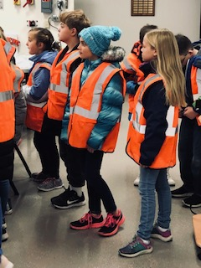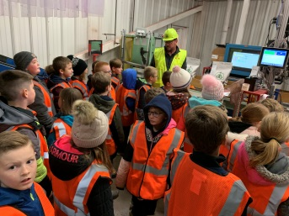

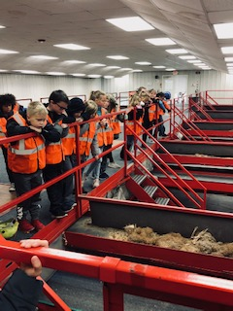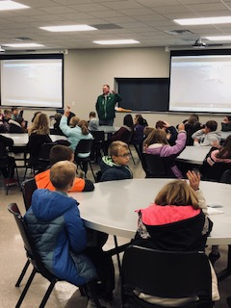

News from Mrs. Wilson’s 3rd Grade

Mrs. Wilson's 3rd grade just finished an interesting book report. They all read a book and turned a pumpkin into the main character. This was a great family project. You can see a sampling of the amazing results. Students then presented their report to the class. It was a fun homework assignment.

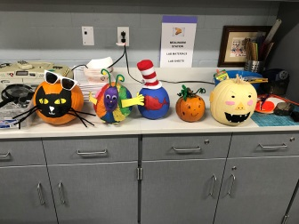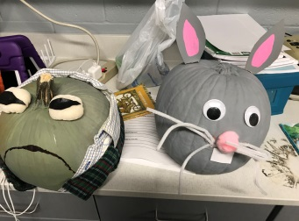

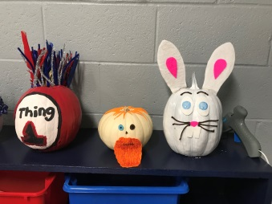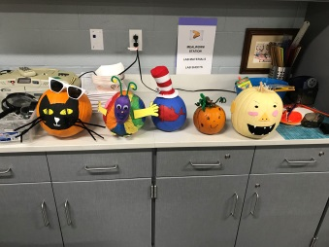

News from Ms. Bitting’s 3rd Grade

Mr. Joe York and his father and grandfather have all served in our country's military and all three gentlemen came to speak to Ms. Bitting's third graders on Veterans Day. Mr. York brought in military gear such as clothing, an MRE (Meals Ready to Eat), pictures, and medals to show the class. These three men told about their experiences in the military and patiently answered all of the questions that Ms. Bitting's students had for them. We cannot thank them enough for their service and for spending time with us here at Bureau Valley.

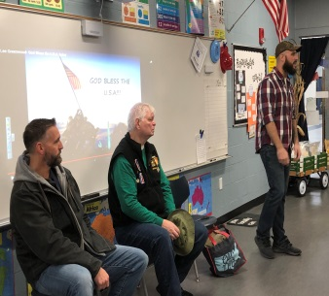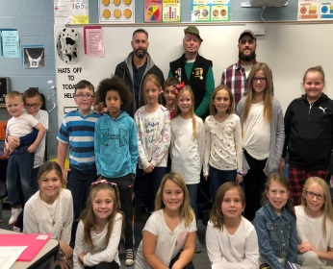

News from Mr. DeVenney’s 4th Grade

Mr. DeVenney’s Class studied the Titanic. Students then created a “trunk” of items they’d want to take on the trip with them. We had to take trunks instead of suitcases, because back in 1912 that is what people used when they traveled.

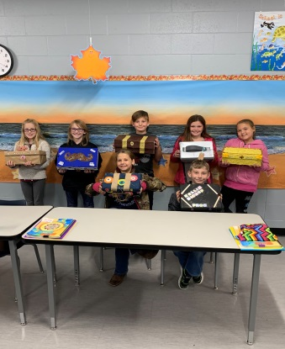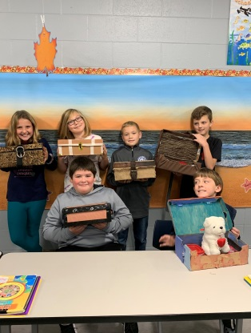

News from Mrs. Kuelper’s 5th Grade

Mrs. Kuelper's fifth grade science class studied light and sound. Students did an experiment to bend light. They used two bowls, two pennies, water, and tape. The students placed the bowls on a table next to each other and observed the two pennies. They stepped back until they could no longer see the pennies in the bottom of the bowl. One student poured water into the bowl until the student told them they could now see the penny in the bowl with water. Students were surprised when they could see the penny with the water. Why is this? The edge of the empty bowl stops you from seeing the penny. The water in the full bowl bends the light. You can now see the penny at the bottom.

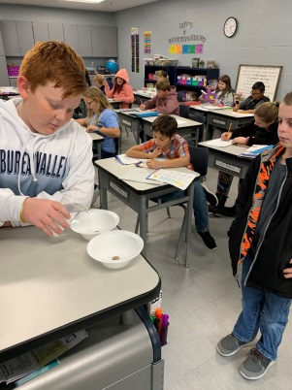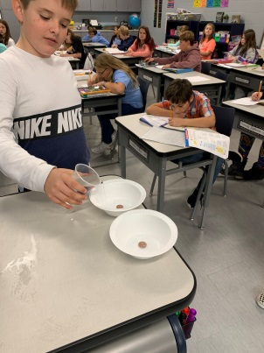

BVS SCHEDULE 2019-2020

Mon., Dec 2 8th BBB Princeton Tourney
No Salad Bar offered at lunch

Tues., Dec 3 BP Power in Rm 517 6th-3rd hour 7 & 8-4th hour
Interact in Rm 312 at lunch
8th BBB Princeton Tourney
No Salad Bar offered at lunch

Thurs., Dec 5 7 & 8 BBB @ Princeton 4:30 pm

Fri., Dec 6 FFA Meeting @ Lunch in Rm 312

Mon., Dec 9 6/7/8 BBB @ Geneseo 4:30 pm

Tues., Dec 10 3-8 Christmas Concert
3-5 6 pm 6-8 7pm

Wed, Dec 11 School Improvement Day-Dismiss at 11:00 am
6 BBB vs Peru Parkside 4:30 pm

Thurs., Dec 12 6 BBB @ LaSalle Lincoln 4:30 pm

Fri, Dec. 13 5th Grade DARE Graduation – 2pm

Sat., Dec 14 7 & 8 BBB Tourney @ Streator
First Lego League Robotics Club Competition in Moline

Mon., Dec. 16 Board of Ed Meeting – 6pm

Tues, Dec 17 BP Power in Rm 517 6th-3rd hour 7 & 8-4th hour
Interact in Rm 312 at lunch

Fri, Dec 20 School Dismisses at 2:00pm and End Second Quarter/First Semester

Mon, Dec 23 CHRISTMAS BREAK BEGINS-NO SCHOOL

Mon, Jan 6, 2020 School Resumes Regular Schedule

Tues, Jan 7 BP Power in Rm 517 6th-3rd hour 7 & 8-4th hour
Interact in Rm 312 at lunch

