Holiday Needs Wish List
If your family is in need this holiday season, some agencies do reach out to Peck Community Schools to adopt families for Christmas. The deadline for this form is Friday, November 22, 2019.
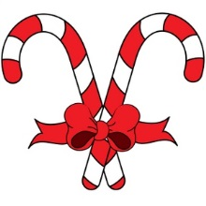
**This is not guaranteed and is subject to availability and requests submitted. We will share the information with requesting parties and are not responsible for who is selected by those agencies/individuals/organizations.**
YOU WILL BE CONTACTED if your family is selected.
Have you filled out a wish list through DHHS? Yes/No
Family Address:_______________________________________________________________________
Main contact: ___________________________________
Phone number:__________________________________
Family Member Name | Age | Clothing  Size | Clothing  Size | Wish 2 | Wish 3
Please list the members of your household below and fill out appropriate boxes:

________________________________________________________________________________________________________
For Office Use Only:
Date returned to Peck Community Schools: _________________________________________________________________
Agency/Individual/Group:______________________________________________________________________
Family Contacted: Yes/No

