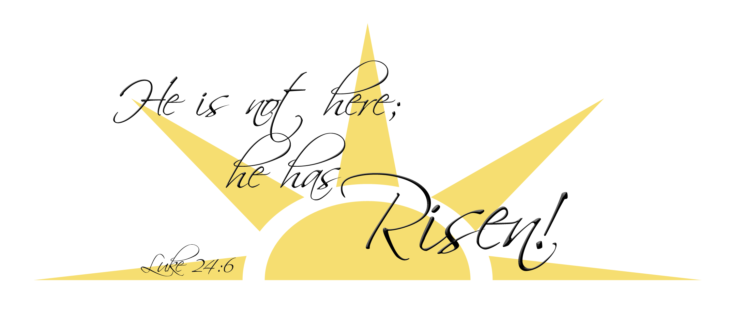
April 16th, 2017
Dear Friends in Christ,

Alleluia! Christ is Risen, He is Risen indeed, Alleluia!
I want to THANK YOU for your prayers and extend wishes of a joyful Easter to all my parishioners, staff, school, and visitors who have gathered here at the Immaculate Heart of Mary to celebrate all the events that have given us Salvation. The angel’s message still resounds in our hearts more than 2000 years after:
“Do not be afraid! I know that you are looking for Jesus who was crucified; He is not here; for He has been raised! (Mt. 28:5)

It has been 10 months since I became your pastor. The best way to minister as your shepherd is to extend this message: Do not be afraid! Jesus has won victory over death and sin. With confidence in His New LIFE, let us begin these 50 days celebration of the Paschal Mysteries turning our hearts to the Lord in our human frailty and experience His LOVE, which is stronger and more powerful than death.

Everyone is welcome to our celebration of Life, even those who have been away from the Church, I sincerely welcome you home this Easter; those who have been an essential part of our community, old and new parishioners, I thank you for building the Kingdom of God and being witnesses of the Risen Lord.

During our Easter Vigil we welcome 7 new Catholics into our Parish Family:
Marissa Hennessey, Carolyn Mendoza, Matthias Mendoza, Alexis Roswell, Neaven Nichols, Rodney Nichols, Jr., and Seth Roswell. WELCOME!

Thank you to everyone who made it possible for these celebrations to be a celebration of Faith. Special thanks to our RCIC teacher, our deacons and parish staff, altar society, school staff, Steven Shook and choir, Christine and all those involved in the decoration of the Church, and to those involved in different ministries: servers, lectors, EMs and ushers. You make IHM Parish and School a warm, caring and wonderful community of faith.

May the same joy with which we celebrate today be extended to the events that are coming up this summer:
April 30th – First Communion at 8 am
May, 7th – Confirmation at 2 pm
May, 20th – Daniel Ramos’ ordination to the Diaconate
May, 27th – Dc. Martin Siebold’s ordination to the Priesthood
May, 28th - Fr. Martin Siebold's First Mass at 11 am. Reception to follow.
I hope you will accompany our children and youth in these two important sacraments and rejoice with the ordinations.
Finally, when you come before the Lord in prayer, please pray for me.
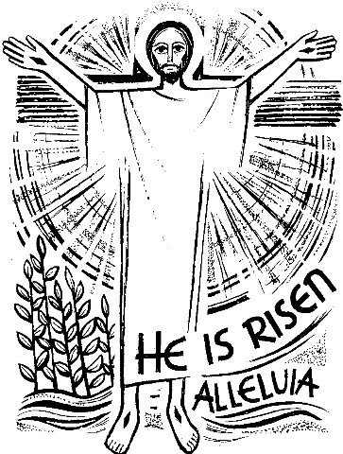
May the Risen Lord grant you Life and His Peace!
Happy Easter!

Fr. Ruben Quinteros

