C

CC

C

CC



### **175 Lincoln Street**

### **Blackstone Ma 01504**

### **508-883-4400**

### **Anotz@bmrsd.net**

🙞 🙜

#### II nnnnnnnn

THE BMR Community

Connections

PROJECT

# About the

# BMR-Community Connection Project

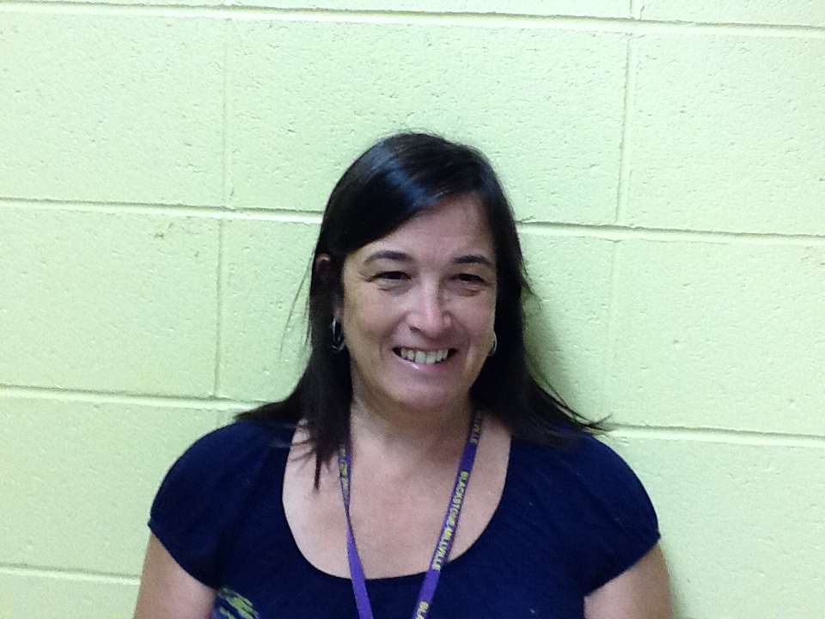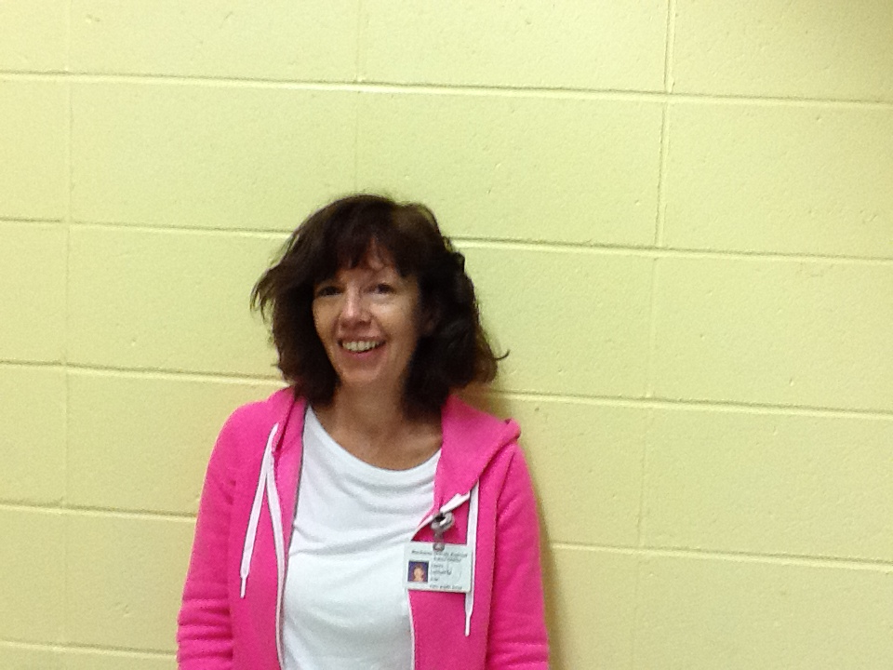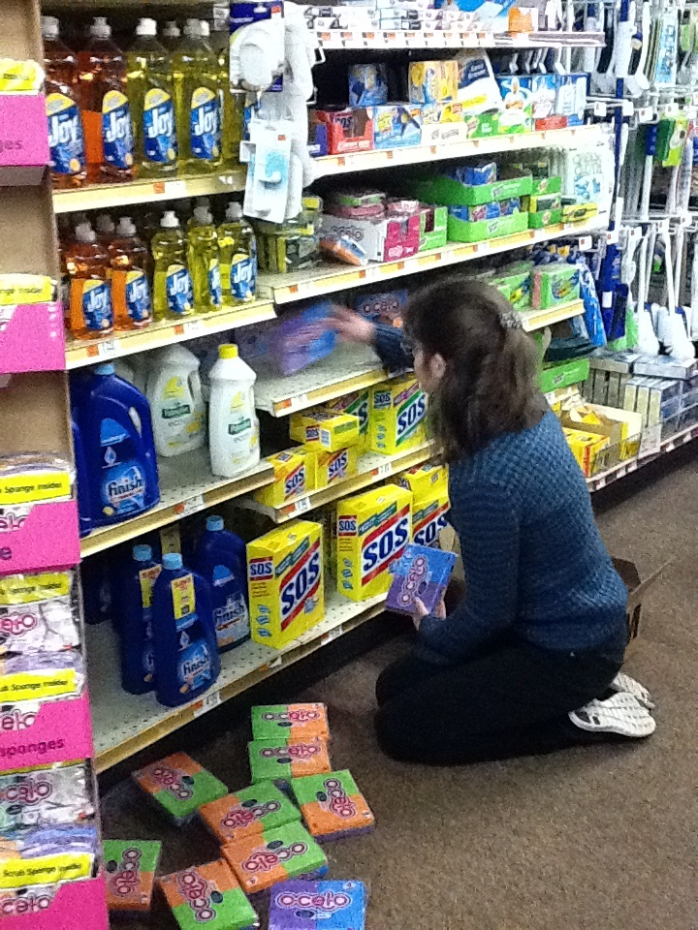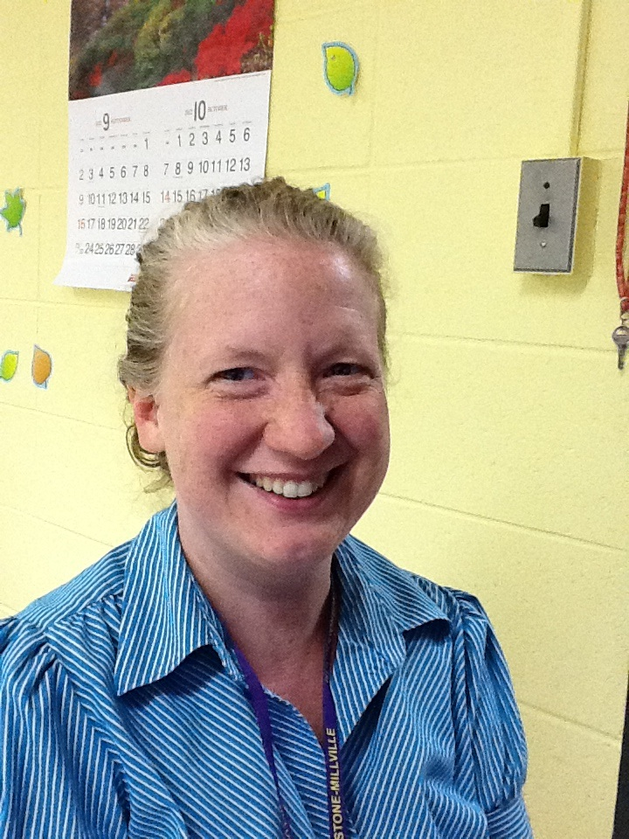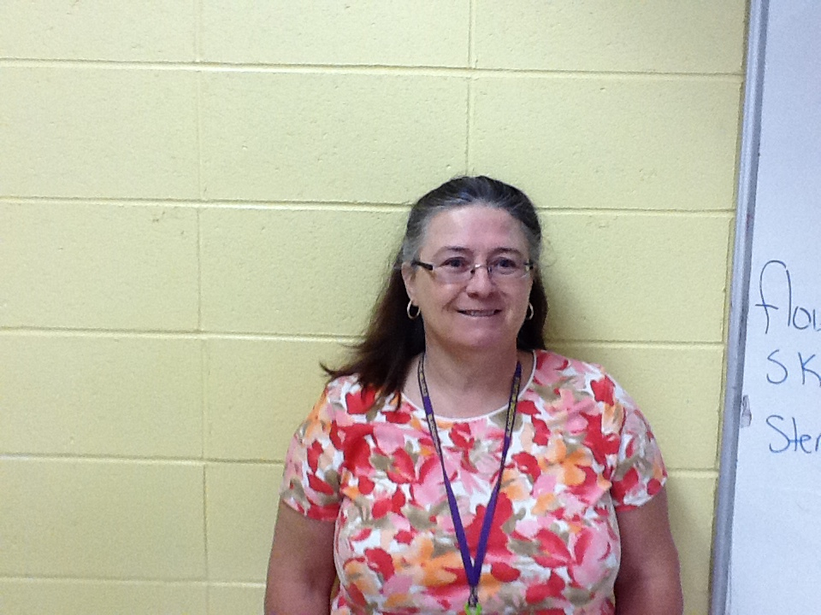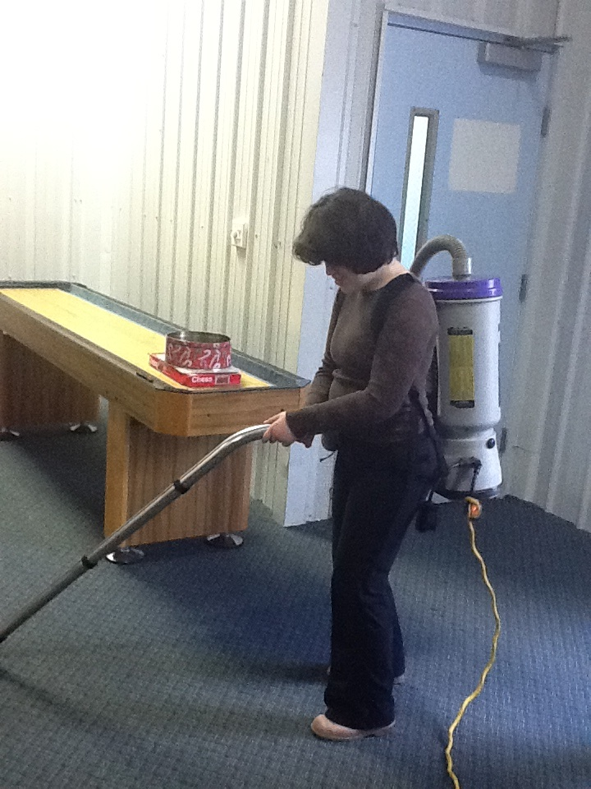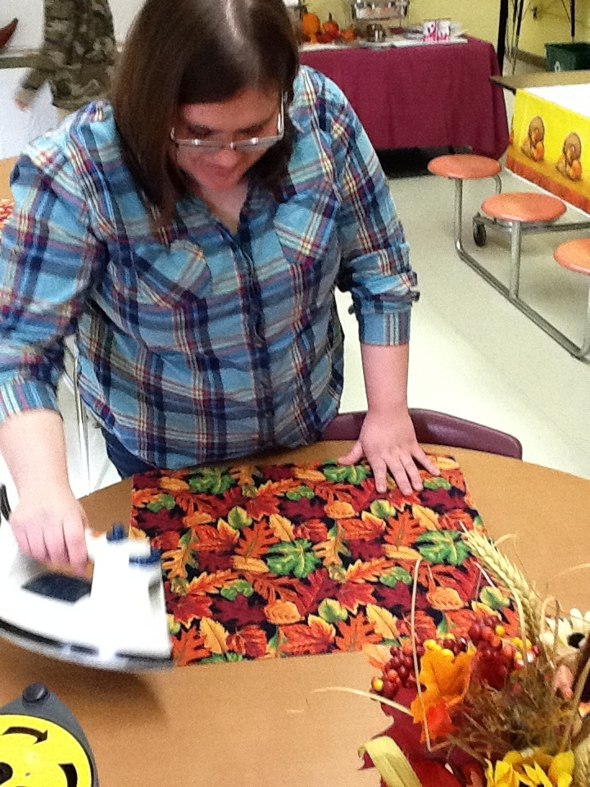

C

CC

**Amanda Notz** Special Education Teacher 25 years experience

**Karen Bartusek I**nstructional Assistant 15 years of experience

**Jeanne Laliberte** Instructional Assistant 17 years of experience

**Deborah Maloney** Instructional Assistant 15 years of experience

Providing transitional skills from school to adult life for individuals with intellectual and physical disabilities.

C

CC

**🙞 🙜**

In 2008, the Blackstone Millville Regional School District put in place a Life Skills/ Transitional Program to meet the needs of students with moderate to severe disabilities. The students learn various functional life, vocational and community skills, which are taught in a meaningful, functional, age-appropriate format. These skills are then integrated in community settings using natural occurring materials and situations, designed to help students acquire and generalize life skills that enhance his/her opportunities for meaningful experiences and relationships within the general community.

-Functional Life Skills

-Vocational Opportunities

Community

-Community c

**Vocational**  **-**Working 3-4 days a week at various vocational sites. -1 staff to1 to 2students training on the job sites **-**Practicing mock interviews and job applications

**Functional Academics** Banking /money skillsBudgetingAssistive technology usage Current Events

**Life Skills** Restaurant etiquetteHousekeepingShoppingLaundryCookingPhone usageUse of public transportation

**Social** Conversation Self advocacy Job related skills

**Park and Shop:** Stocking shelves, bagging collecting carts.

**CVS:** Stocking shelves

**TJX Corporation:** Stocking, bagging, & organizing displays of clothes.

**Blackstone Library**: Shelving returned books and gathering book orders.

**Blackstone Boys and Girls Club:** General cleaning.

**Blackstone Senior Center**: Assist in serving the Seniors their lunches and clean up.

**Blackstone Fire Department:** Assist staff with washing the fire trucks and ambulances.

**Salvation Army**: “Sorting out clothes.

**BMR** **HS School Store:** Assisting in cleaning and stocking of merchandise.

**Blackstone Municipal Center Administrative Offices**: paper shredding, labeling and copying.

**Marty’s Kitchen:** Food Prep, Cooking, Host/Hostess, & Waiting tables.

**St. Paul’s** **Church**: Landscaping and general cleaning.

**Activities**

**Food Pantry** The program gathers donations from district employees. The students then purchase food and toiletries items to stock the local food pantry once a month.

**Time to Mingle** Social events with outside districts during the weekends

**BMR Bistro** Running a School Bistro for staff including; planning, budgeting, money skills and socialization.

**Apartment** A classroom was created to look like an authentic apartment with a dining room, bedroom and living room. Students take care of the apartment doing various functional activities that they can use throughout their adult lives.

**Sandwich Delivery** Once a week, students gather orders from various staff to call in, purchase and deliver staff sandwiches/meals.

**Works in progress** for 2014: Community Garden to assist in growing healthy foods for school and the food pantry. Obtaining membership and going to a local health club

Bistro

**Curriculum**

Job Sites