Enter your user ID and password and click the orange “sign in”.

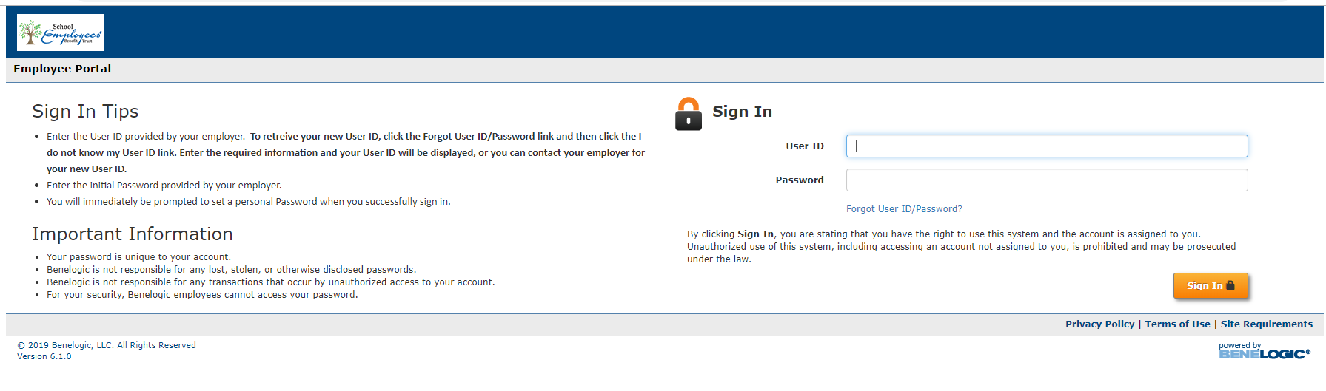

Check the I accept box and click the orange “submit”.
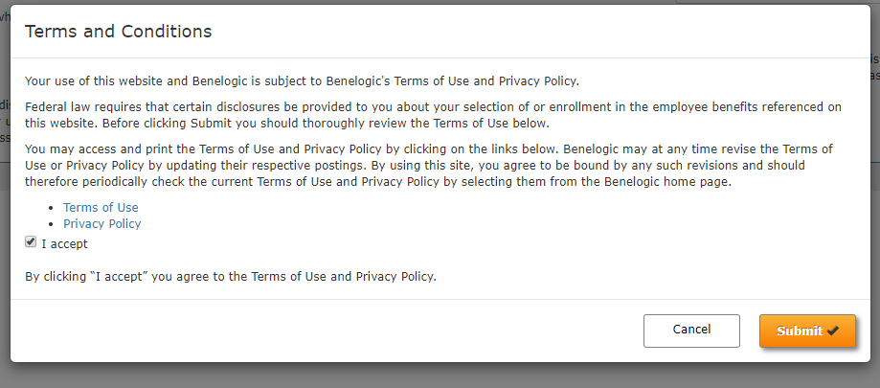

Click GO to start.
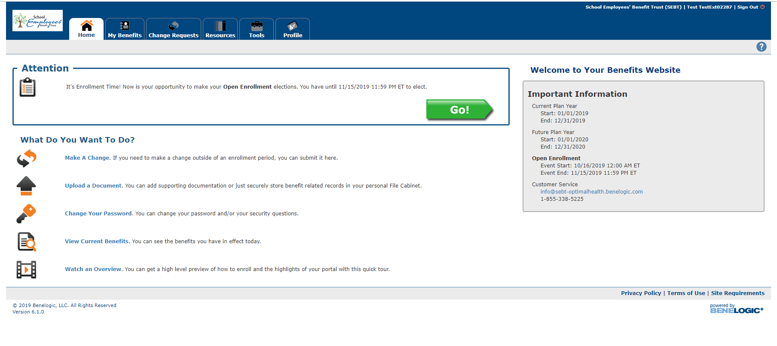
Here is where you have the option to either QUICK ENROLL or STEP-BY-STEP. As mentioned in the OE brochure, if you are not making any changes and just need to verify the benefits and covered dependents are correct, you may want to choose quick enroll. If you decide to make a change during quick enroll, you may do so by click on the edit pencil.
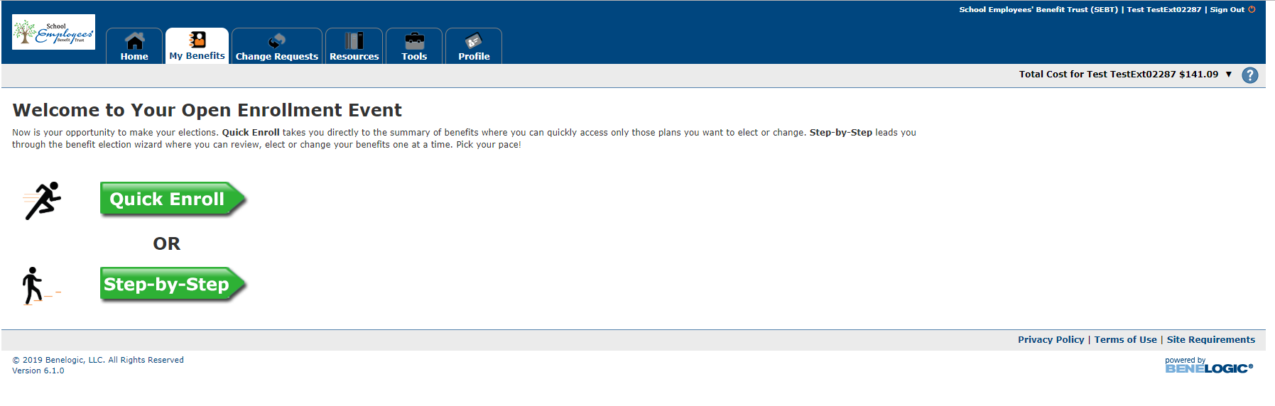

Here are the QUICK ENROLL screens: Click on the edit pencil to make any changes.
If you get a red issue button (by blue arrow), look down by the red shaded box below. It just means documentation may be needed. For instance, if you are covering a spouse, it will ask for documentation. Or if you don’t have coverage currently, it may have the message: No plan election as this time.
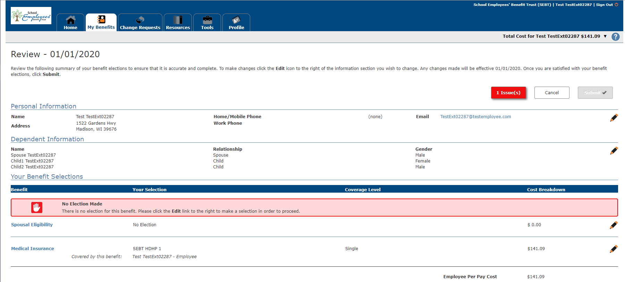

Here is the spousal eligibility screen. Documentation needed for a particular option is in red. You can click on it and it should bring up the form so you can print, complete and upload in your file cabinet.
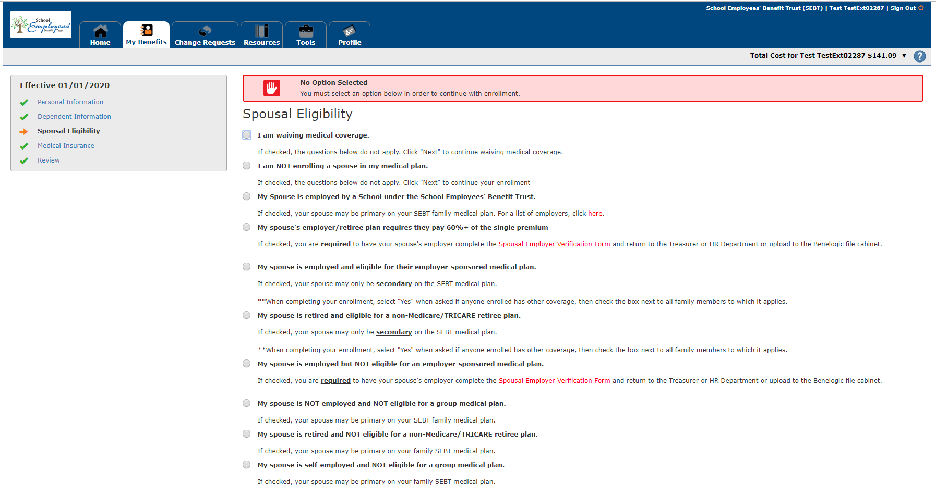

Here is the review screen. I purposely made an error to show an example. During my testing stage, I waived coverage, but then I chose CDHP 1 single coverage. The system caught that and gave me a red “issue” with yellow highlighted explanation. If this happens to you, just click on the edit pencil to make the correction. 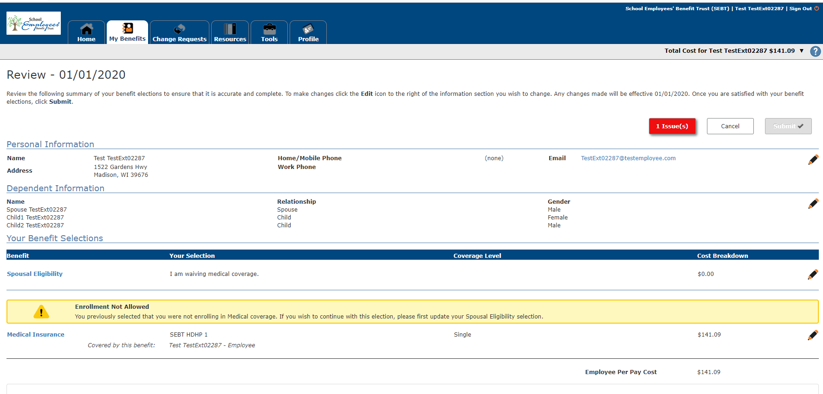
Here are the step by step:
Make any changes needed for your personal information and click next.
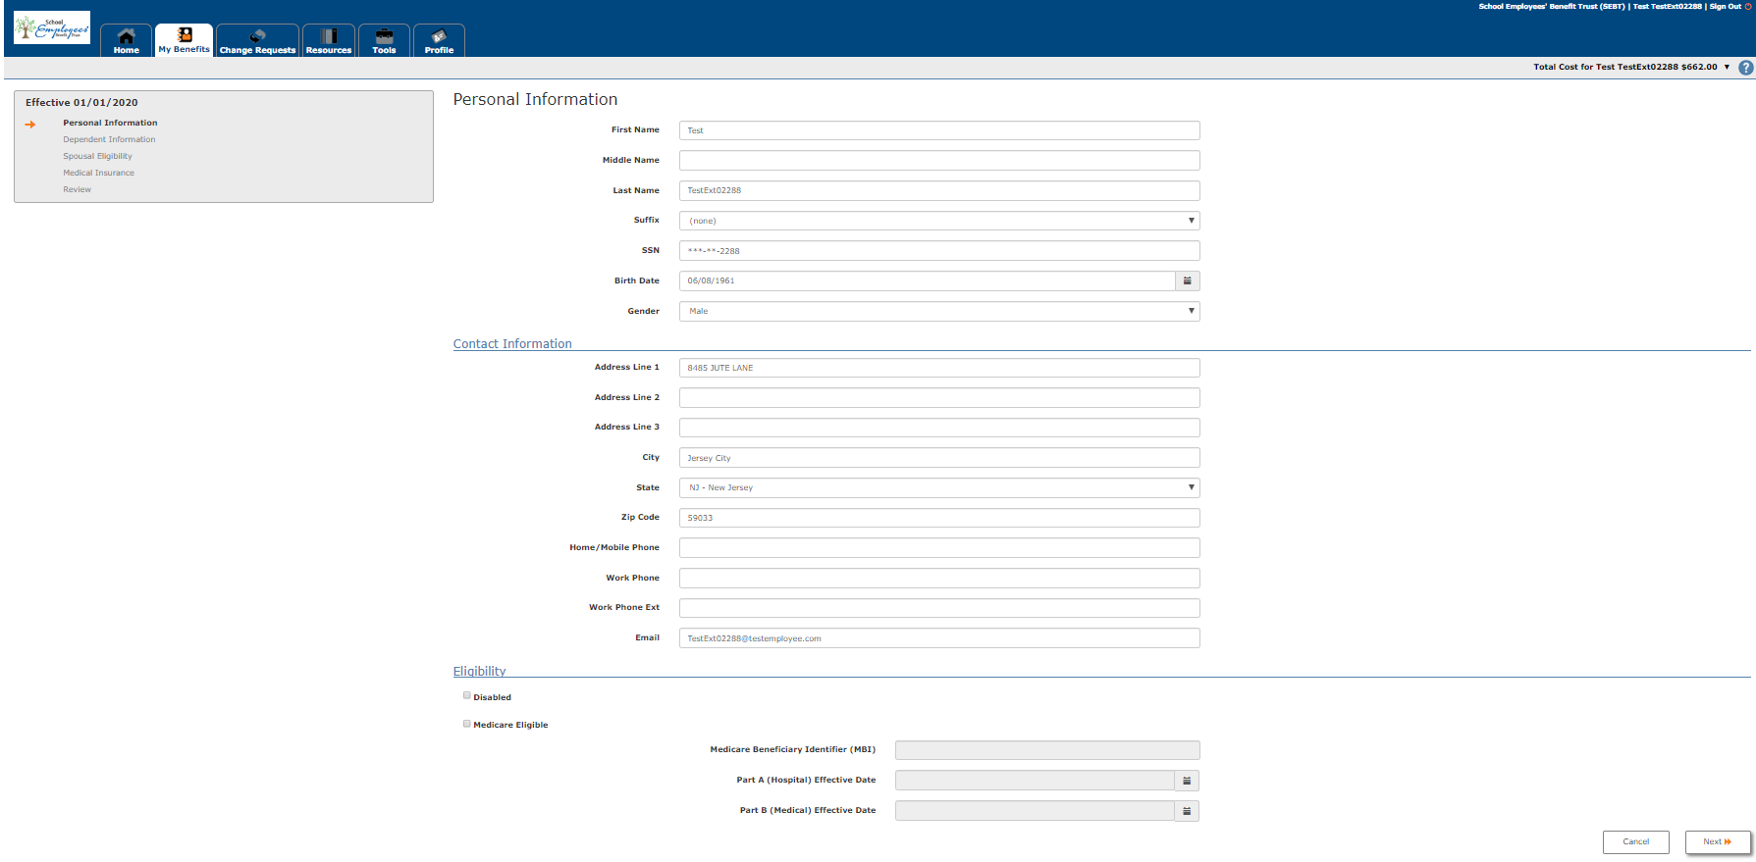
Click on the edit pencil to make changes to your dependents.
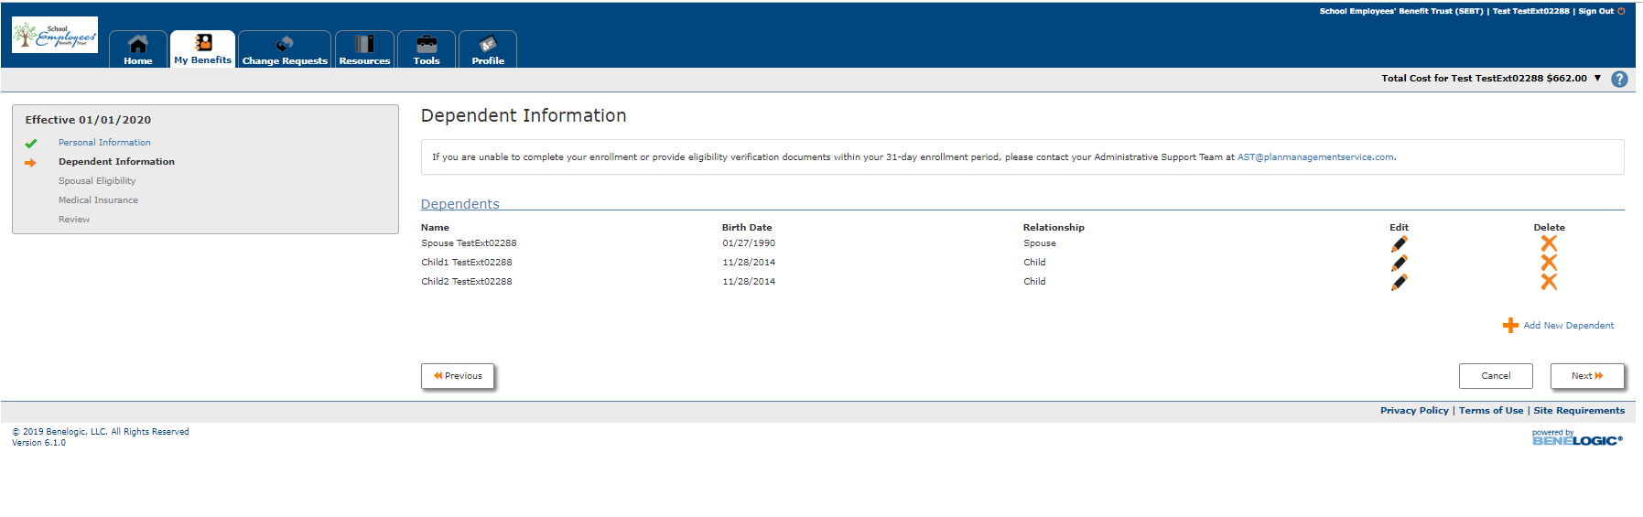Same spousal eligibility screen as quick enrollment.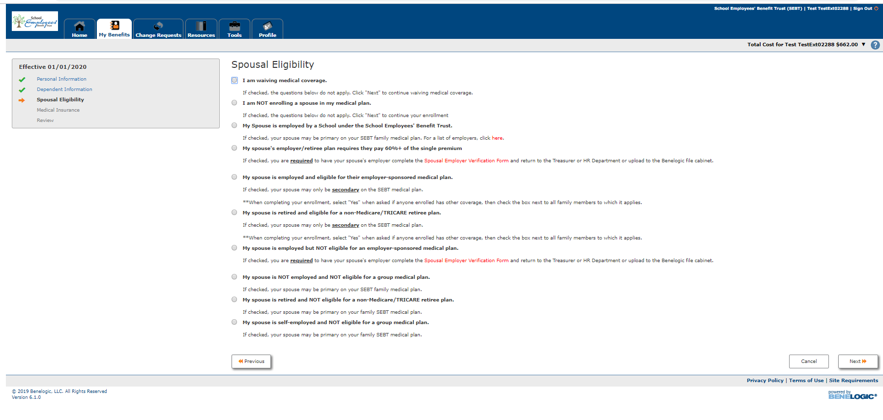
Here is where you will elect coverage plan type or waive coverage. You will notice under the coverage level; the employee cost is listed. This is the correct employee cost for the 2020 plan year.
This particular screen shows applicant is choosing single coverage. You MUST click on who is to be covered. For this instance, it will be just the employee. Click orange save button when done.
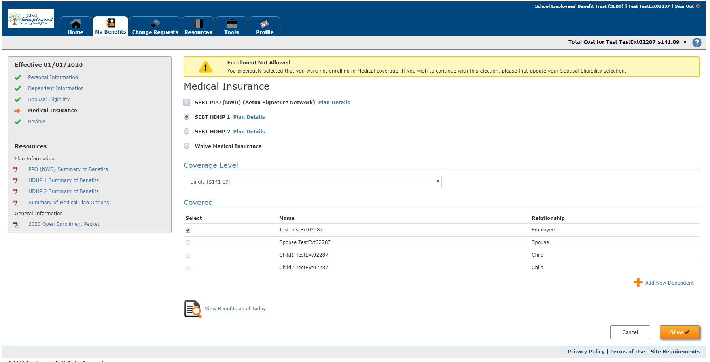

This particular screen shows the applicant is choosing family coverage. Again, you must choose WHO is going to be covered. Click orange save button when done.
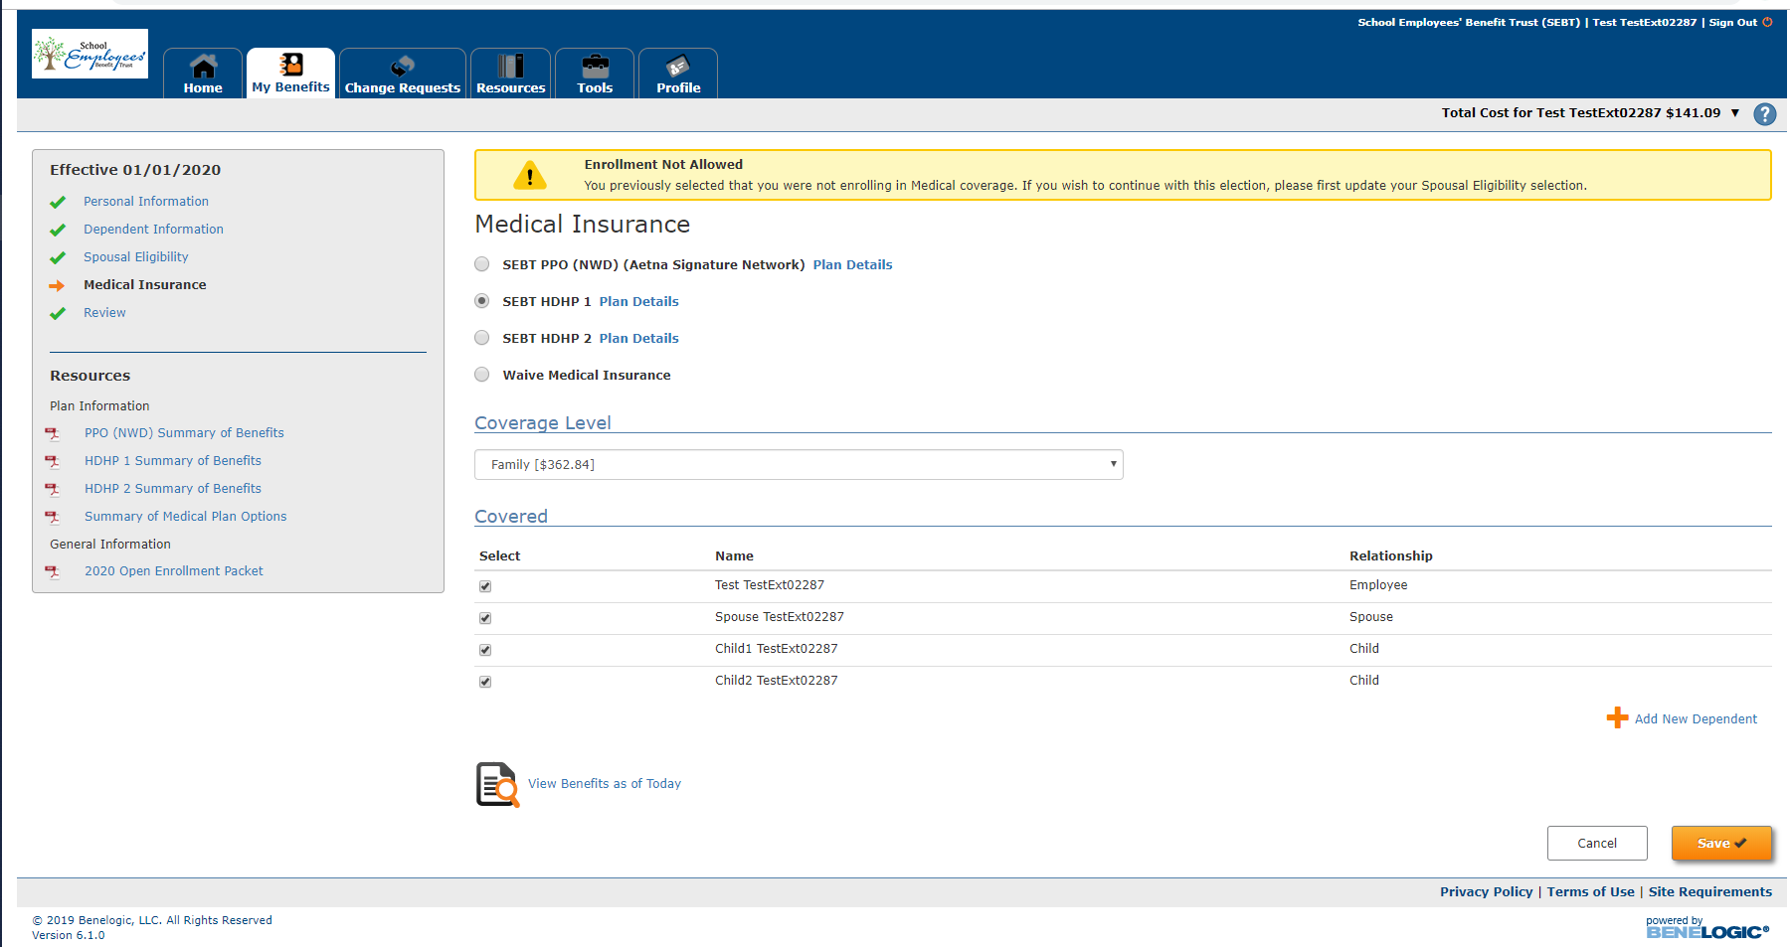

This screen is requesting verification if any family member has other coverage. Default is NO, but if someone does, click yes and fill in the information. Click the orange save button.
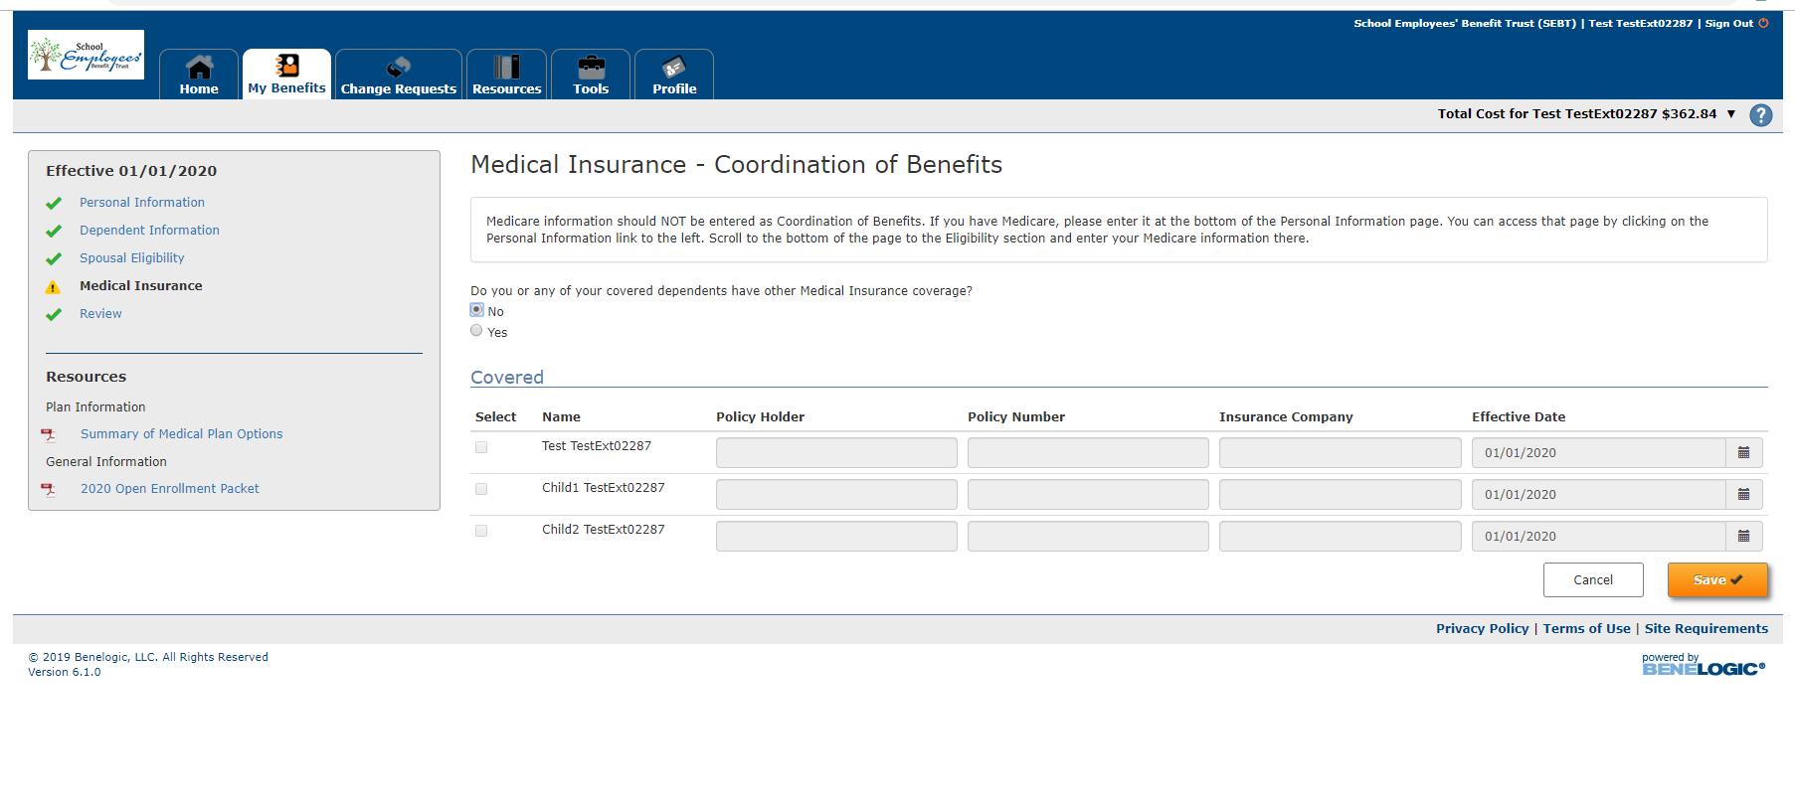
Here is the review screen. Look over to make sure your selections are correct. If changes need made, you can click on the edit pencil. If it looks good, click on the orange submit button. Blue highlight box is a reminder that documentation may still be needed.
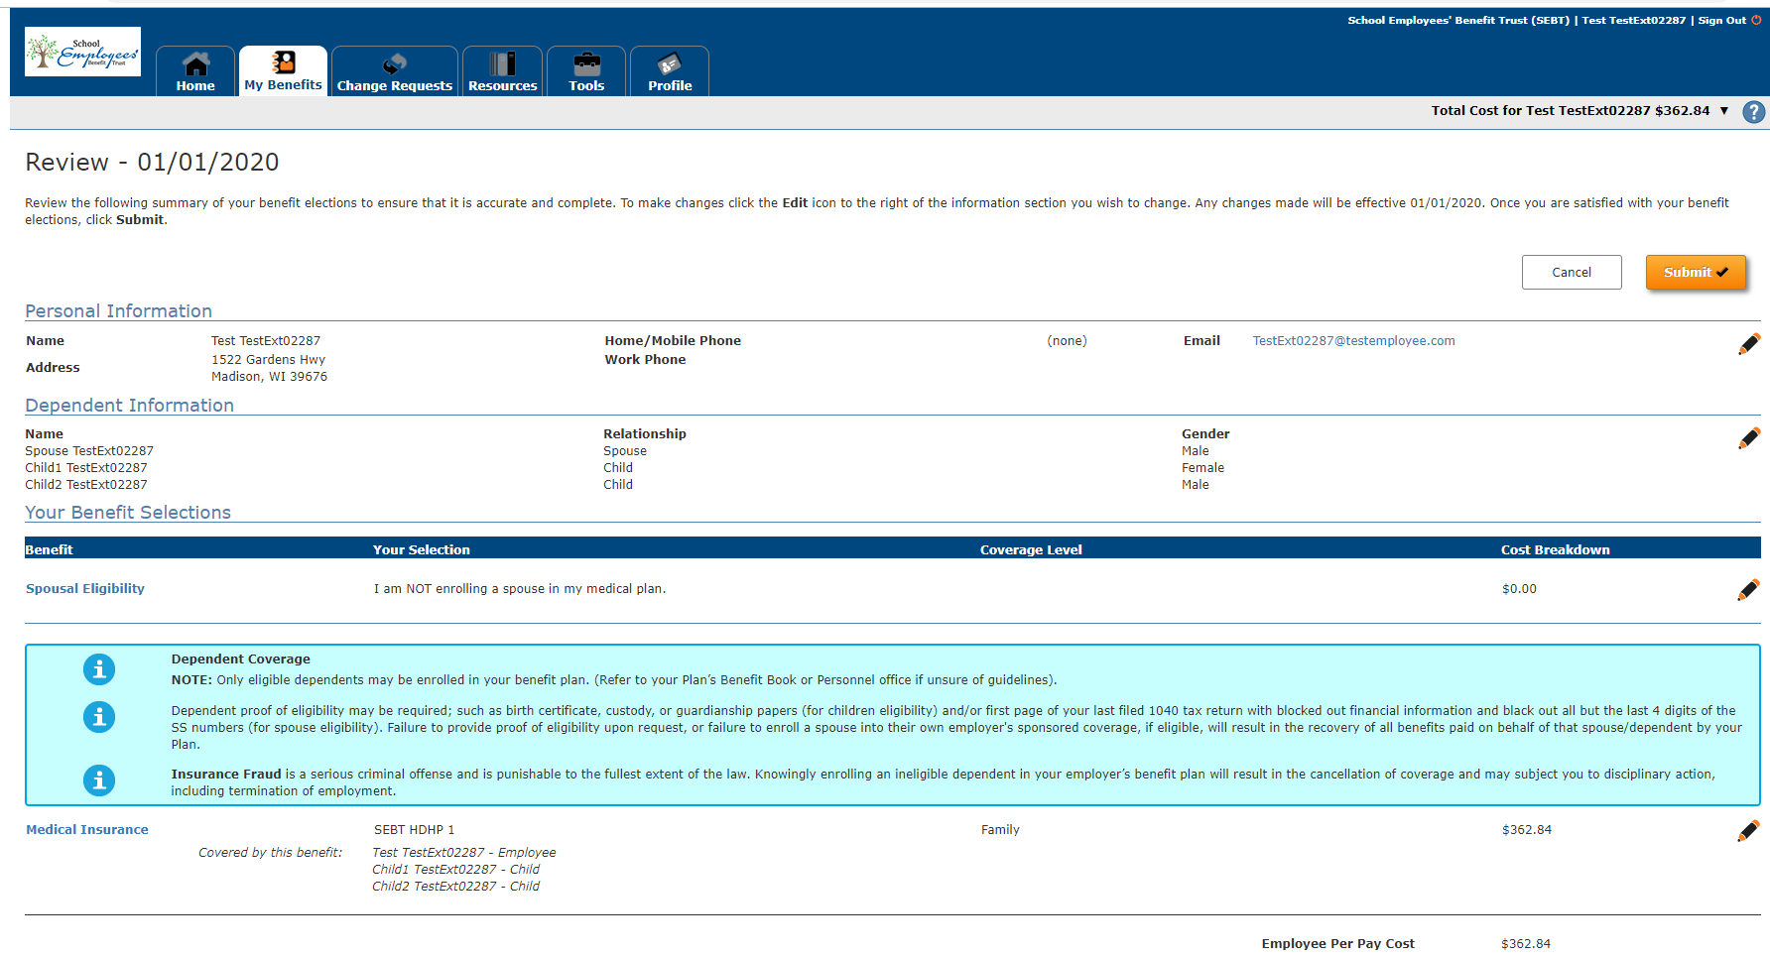
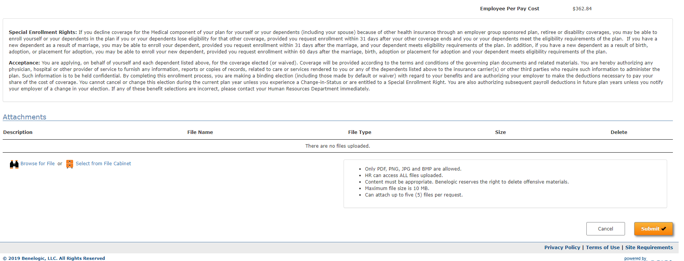

Very last page, click the orange submit button for the last time!
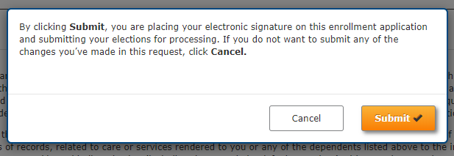
This yellow highlighted box is just reminding you of documentation needed. You can upload the document yourself or bring to me and I will be happy to do it for you. You can click on view confirmation button and a summary of your selection will be display. I believe you can print it too.
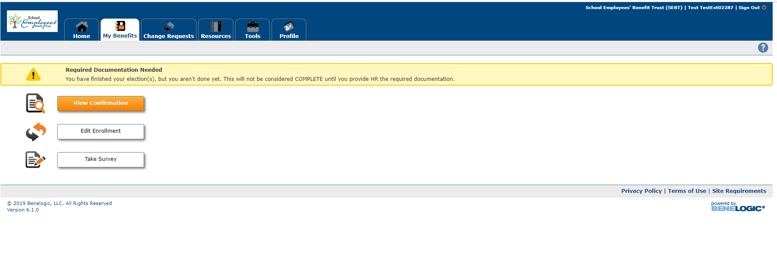
You can make changes to your selection till November 15th. This screen appears after logging in. Click on the blue “Edit” if you would like to make changes to your selection.
