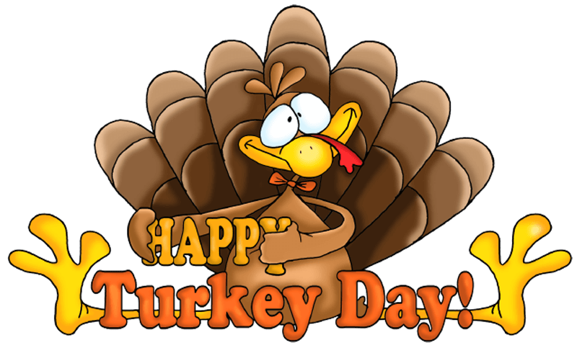
NOVEMBER 2019
Lunch
MILK IS SERVED WITH ALL MEALS
MENU ITEMS ARE SUBJECT TO CHANGE WITHOUT NOTICE
Monday | Tuesday | Wednesday | Thursday | Friday
1
No School
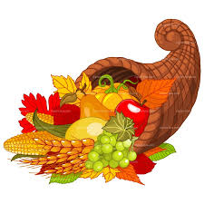
4  Mc Rib On A Bun  Tater Tots  Baked Beans  Cucumbers  Pears | 5  Crispito’s  Lettuce Salad  Mexican Rice  Mandarin Oranges  Snickerdoodle | 6  Cheeseburger On A Bun  Lettuce & Tomato  Tri Tater  Corn  Peaches | 7  Homemade Pizza  Lettuce Salad  Baby Carrots  Fresh Broccoli  Rosy Applesauce | 8  Sloppy Joes On A Bun  Seasoned Potatoes  Green Beans  Grapes
11  Taco Salad  Tortilla Chips  Salsa  Peaches  Cinnamon Roll | 12  Chicken & Noodles  Mashed Potatoes  Fresh Broccoli  Dinner Roll (6-12 only)  Rosy Applesauce | 13  Hamburger On A Bun  Lettuce & Tomato  Tri Tater  Baked Beans  Pineapple | 14  Chicken Patty  Mashed Potatoes & Gravy  Green Beans  Dinner Roll w/Jelly  Apple | 15  Chicken Wrap  Lettuce & Tomato  Mexican Rice  Cooked Carrots  Mandarin Oranges  Chocolate Chip Cookie
18  Sausage Bites  Mashed Potatoes  White Gravy  Broccoli w/Cheese  Applesauce  Snickerdoodle | 19  Ham & Cheese Melts  Tri Tater  Lettuce Salad  Baby Carrots  Peaches | 20  Chicken Nuggets  Nachos  Green Beans  Strawberries & Bananas  Rice Krispy Bar | 21  Totchos  Tater Tots  Baked Beans  Baby Carrots  Pears | 22  Macaroni & Cheese  Meatballs  Peas  Cucumbers  Dinner Roll (6-12 only)  Grapes
25  Baked Chicken Drumstick  Mashed Potatoes & Gravy  Corn Casserole  Pumpkin Dessert  Mandarin Oranges | 26  Pepperoni Pizza  Lettuce Salad  Baby Carrots  Pineapple  Oatmeal Cookie | 27  No School | 28  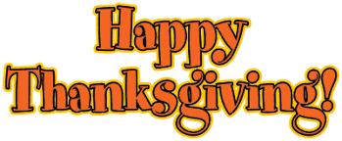  Thanksgivng | 29  No School

Current As Of: 10-20-2019 USDA IS AN EQUAL OPPORTUNITY PROVIDER AND EMPLOYER.

