

**The Knightly News**

**October 25, 2019**

**FROM THE PRINCIPAL’S OFFICE: Laser Science Show**

Monday, October 21, 2019 was an exciting day for students at Elmwood-Murdock Elementary! S.O.S. sponsored the show for students which taught them the following concepts: persistence of vision; perception of motion; light rays and momentum; how lasers make light; how science, technology, engineering, art and math work together; and the careers that all go into the production of a science show. It was a great learning opportunity for all!

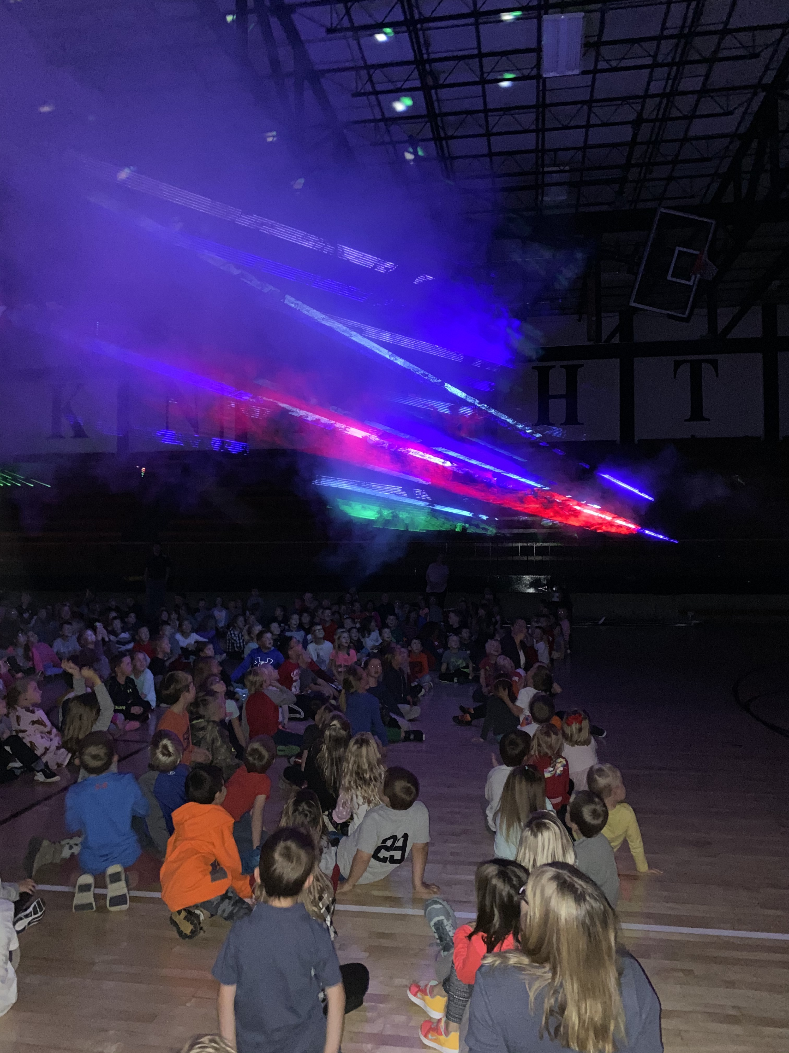

**DATES TO REMEMBER**

**October 25** – S.O.S. Halloween Trick or Treat 7-8pm Elementary School

**October 28** – Guest Speaker David Flood, Grades 4-6, sponsored by Booster Club

**October 31** – Halloween

**November 1st** and **November 4th** No School

November 5th - S.O. S. Meeting 6:30 @ the Elementary Cafeteria

**November 8th** – S.O.S. Baked Potato Bar Fundraiser at Quonset 5:30-8:00

**November 16th** – One Act Performance – 7:00 @ the high school

**November 18th** – Elementary Family Reading Night sponsored by S.O.S.

**GIRLS BASKETBALL CAMP**

**Just a quick reminder on Saturday's Lady Knight Youth Camp location/time change.**

Important change to the location and time for the final Saturday of Girls BB clinic on October 26.

Due to the gyms being used at the High School on October 26, that day's youth girls  BB clinic will be **held at the Elementary in Elmwood**.  With the gym space being limited and due to the GREAT turnout for our camps, we will be doing two sessions.  **Grades 2-5 will be held from 1:00 - 2:30 pm, and Grade 6-8 will be held from 2:30 - 4:00 pm.**  This should allow ample space for all age groups.  I do understand that the time change could affect some players ability to attend, and I fully understand those circumstances.   Please arrive at least 10 minutes before your time slot is set to begin so that we can begin our sessions on time.  Please use the south activity entrance for that day.

We have had a great turnout, and the coaches are excited with the talent that is in the JH and Elementary.

If you have any questions, please let me know at 402.540.0252 or via email at [pdwyer@emknights.org](mailto:pdwyer@emknights.org).

Paul Dwyer

**Art Projects on Display**

Thanks to Mrs.Trundle and local businesses for displaying various art projects in the community.

1st Grade Owl Masks on display at Burrow’s Reality and Community Center

5th Grade Watercolor sunsets on display at the bank.

6th Grade scratch art owls on display at the Community Center.

**Treat Someone or Yourself**

The Fourth Graders are selling the one pound bag of BAKER’S CHOCOLATE for $9.50. The funds enable the class to go on additional Nebraska history tours and do other educational activities. The meltaway flavors include: salted or milk chocolate, solid milk or dark chocolate, orange, cherry, raspberry, mocha, coconut, mint in dark or solid chocolate, or please all and everyone with the assorted bag.

To order contact any Fourth Grader, Mrs. Backemeyer, or Ms. Nutzman.

[cbackemeyer@emknights.org](mailto:cbackemeyer@emknights.org)

[knutzman@emknights.org](mailto:knutzman@emknights.org)

**SOS (Support Our Students)**

Get your Elmwood-Murdock gear by October 31st and support our students at the same time.

Find gear at www.erinbethdesigns.com. Clink on the EM SOS Fundraiser link.

Information on the ShopWithScrip program was sent home with students a

few weeks ago. This program is a simple way for our organization to raise

money simply by you using gift cards where you’re already shopping. If you

missed this information or have any questions regarding the program, more

information can be found at myscripwallet.com or shopwithscrip.com. Our

organization’s enrollment code is: 8L28F1F562519. Any questions contact

our coordinator at: sommerknip@gmail.com

**TEAMMATES MENTORING PROGRAM**

The mission of TeamMates is to positively impact the world by inspiring

youth to reach their full potential through mentoring. This is done by

providing support and encouragement for school aged youth.

TeamMates is a school based mentoring program that was founded by Tom

and Nancy Osborn. We are very excited for this upcoming school year. We

are always looking for both mentors and mentees. Anyone

In grades 3-12th grade is welcome to join. As well as getting quality time

with your mentor¨ we are looking at doing some fund raising and group

activities. If you would like to become a mentor or mentee¨ please contact

JoDee Paulsen at 402-994-2125 or jpaulsen@emknights.org. We are very

excited to be able to offers students the opportunity to be positively

impacted by this program.

**NEWS FROM THE NURSE:**

Flu season is here again! It is recommended to get your flu shot as soon as possible to avoid influenza and/or serious complications from influenza. The CDC always has great information about the flu vaccine, and most insurance companies cover the flu vaccine 100%. There is also a program called VFC (Vaccines for Children) that gives flu shots to families who are under insured or uninsured. The phone number for that program is 402-593-2232. Thank you for doing your part in keeping our kids healthy!

Thank you in advance!

Cortney Sorensen

csorensen@emknights.org

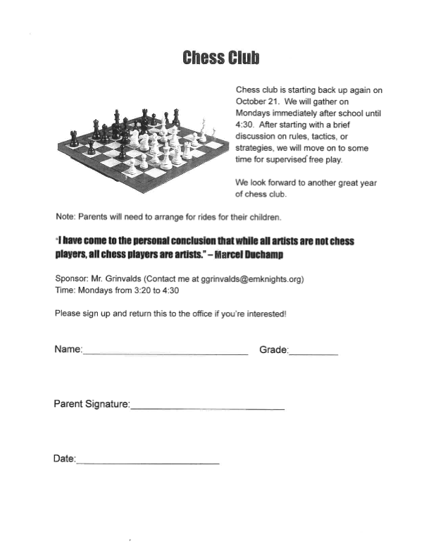

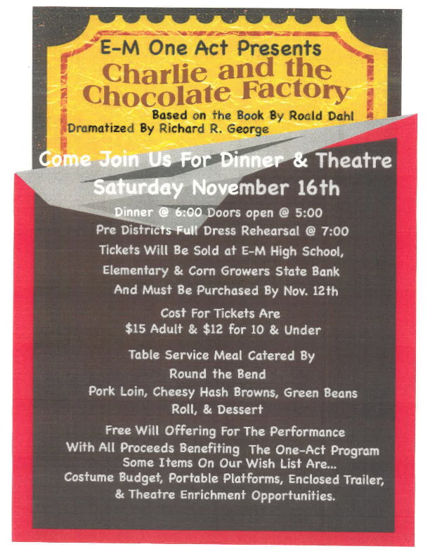





The following is a community announcement and is not affiliated with Elmwod-Murdock Schools.

**Backpack Craft Fair**

We are currently looking for vendors for the 4th annual Elmwood -Murdock  Back Pack Craft fair. It will be held on Saturday November 30th from 9:00am to 3:00pm at the Elmwood-Murdock Elementary building in Elmwood. If you are interested please contact Teresa Hawks at

[Trhawks85@yahoo.com](mailto:Trhawks85@yahoo.com)