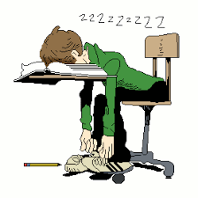 Have you ever wondered if your child was getting enough sleep? Sleep plays a big part in how well students do at school. For more information read how much sleep the CDC recommends students get. https://www.cdc.gov/healthyschools/sleep.htm

