The Knightly News

October 4, 2019

FROM THE PRINCIPAL’S OFFICE:
It was great to see so much excitement and participation in the Homecoming Week festivities. This week was a great opportunity to practice school pride and the togetherness we have as a school and community. Below are our Knightly Pride Activity Expectations. If you could please help us reinforce these at events with your children, it would be GREATLY appreciated!
Mrs. Nichelson

KNIGHT PRIDE
ACTIVITIES EXPECTATIONS

BE SAFE
- Keep hands, feet and all other objects to yourself
- Wait your turn
- Walk at all times

BE RESPECTFUL
- Be polite
- Have “Knight Pride”
- Use appropriate school language (verbal and non-verbal)
- Use good sportsmanship

BE RESPONSIBLE
- Follow dress code
- Leave area as you found it or better
- Report all unsafe behavior and vandalism
- Sit in designated area
I’m a firm believer that it takes a team to help a child grow into all that they potentially can be. The more parents, students, teachers, and other significant people can help a child, the more likely they will be successful.

DATES TO REMEMBER
October 16 – S.O.S. Meeting 6:30- Elementary Cafeteria
October 21 – Laser Science Show
October 25 – S.O.S. Halloween Trick or Treat 7-8pm
October 31 – Halloween Parties
November 1st and November 4th No School
November 18th – Elementary Family Reading Night

SOS (Support Our Students)
SOS Trick Or Treat Event--The Fall Festival is changing this year! Mark your calendars for the SOS's first 'Trick Or Treat The Hallways!' event on Friday, October 25th from 7 to 8 pm. Elementary age kids and younger are invited to trick or treat the hallways of the Elmwood-Murdock Elementary school where there will be tons of rooms to stop by to show off your costumes and grab some great candy.

The SOS really needs a lot of volunteers this year to sponsor a table/doorway for each classroom. We are looking for parents, teachers, older siblings and/or grandparents to sponsor a door. Sponsors would provide the pre-packaged purchased candy or Halloween favors they are handing out but most importantly decorate their door/table with a theme and dress up in their favorite costume! Themes/costumes don't have to be scary! They can also be funny, cute, sporty or just plain silly! Please contact Pam Goudie at pgoudie2@gmail.com or text to 402-618-6971 if you can sponsor a table!
Meeting this week! Mrs. Smith will share what to expect from Family Literacy Night.
Get your Elmwood-Murdock gear and support our students at the same time.
Find gear at www.erinbethdesigns.com. Clink on the EM SOS Fundraiser link.
Information on the ShopWithScrip program was sent home with students a
few weeks ago. This program is a simple way for our organization to raise
money simply by you using gift cards where you’re already shopping. If you
missed this information or have any questions regarding the program, more
information can be found at myscripwallet.com or shopwithscrip.com. Our
organization’s enrollment code is: 8L28F1F562519. Any questions contact
our coordinator at: sommerknip@gmail.com

TEAMMATES MENTORING PROGRAM
The mission of TeamMates is to positively impact the world by inspiring
youth to reach their full potential through mentoring. This is done by
providing support and encouragement for school aged youth.
TeamMates is a school based mentoring program that was founded by Tom
and Nancy Osborn. We are very excited for this upcoming school year. We
are always looking for both mentors and mentees. Anyone
In grades 3-12th grade is welcome to join. As well as getting quality time
with your mentor¨ we are looking at doing some fund raising and group
activities. If you would like to become a mentor or mentee¨ please contact
JoDee Paulsen at 402-994-2125 or jpaulsen@emknights.org. We are very
excited to be able to offers students the opportunity to be positively
impacted by this program.

NEWS FROM THE NURSE:
Flu season is here again! It is recommended to get your flu shot as soon as possible to avoid influenza and/or serious complications from influenza. The CDC always has great information about the flu vaccine, and most insurance companies cover the flu vaccine 100%. There is also a program called VFC (Vaccines for Children) that gives flu shots to families who are under insured or uninsured. The phone number for that program is 402-593-2232. Thank you for doing your part in keeping our kids healthy!
Thank you in advance!
Cortney Sorensen

csorensen@emknights.org

GIRLS BASKETBALL CAMP
The Elmwood-Murdock Girls Basketball team will be sponsoring a Youth basketball clinic on Saturday afternoons in October from 2:00 - 4:00 pm in Murdock for grades 3-8. For more information and to register, download the form at https://5il.co/a579 and return to either school office.

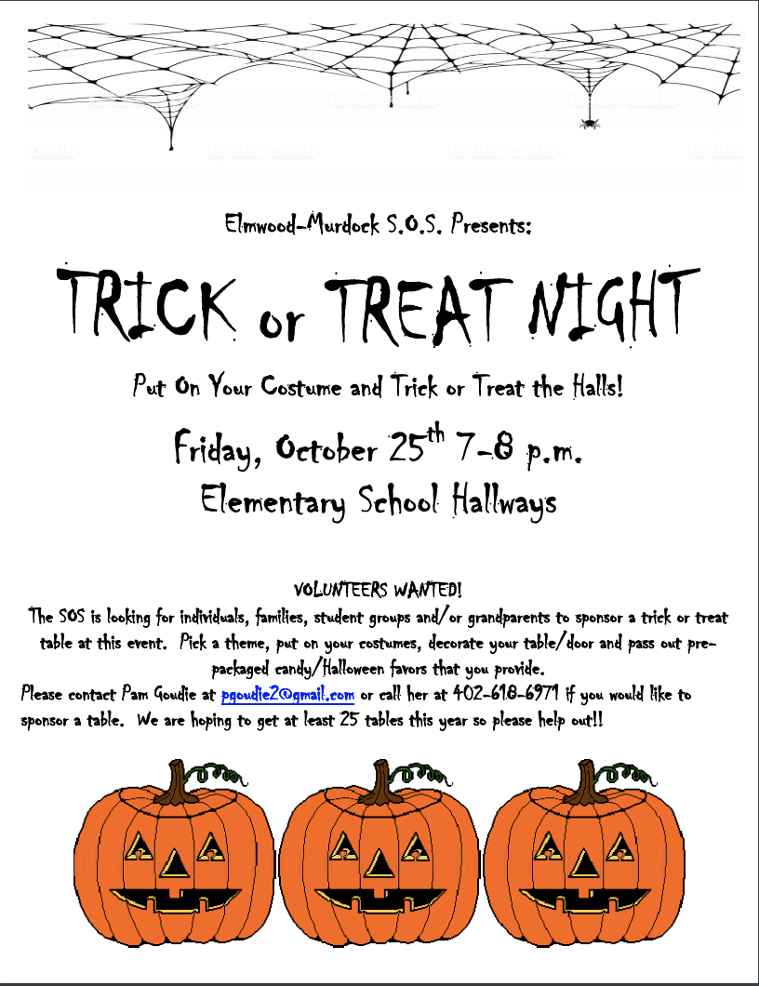
The following is a community announcement and is not affiliated with Elmwod-Murdock Schools.

Backpack Craft Fair
We are currently looking for vendors for the 4th annual Elmwood -Murdock Back Pack Craft fair. It will be held on Saturday November 30th from 9:00am to 3:00pm at the Elmwood-Murdock Elementary building in Elmwood. If you are interested please contact Teresa Hawks at
Trhawks85@yahoo.com

