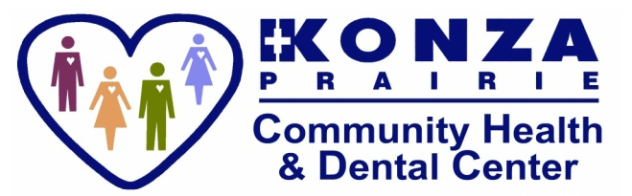
Junction City 785-238-1829 * Manhattan 785-320-7134
DENTAL LETTER
DENTAL CONSENT FORMS

Dear Families,

KPCHC is dedicated to improving your child’s oral health by offering outreach dental services at your child’s school. After your child is treated, you will receive a report stating what services were provided along with a dental referral if needed. The information and any photographs taken from your child’s participation in this special event will be utilized for statistical purposes or advancement in dentistry. The information that identifies your child or family will never be disclosed on any form or publication.

KPCHC is a federal qualified health center that offers many services. Because Konza receives some federal financial support, we can offer a sliding fee scale to those who qualify. This scale makes health care affordable to people with or without insurance.

Options Available:

- Screening Only: No paperwork needed.
- Screening and Fluoride Varnish: complete section 1 only.
- Screening and Fluoride Varnish and dental services: complete section 1 and 2.

I do not wish for my child to receive any offered services, including screening.
Parent Name: _______________________________________
Parent Signature:_____________________________________ Child Name: _________________________________________ Grade: _____________

PAPERWORK DUE BY: __________________10/15/2019_______________

When filling out forms, please fill them out completely. It’s a big help to your nurse, staff and medical providers. Incomplete forms will be returned to you for completion and may result in your child not being seen.

