DAY COUNTY CONSERVATION DISTRICT is offering a scholarship to high school seniors who live in Day County and who are involved in conservation.

Types of projects include but are not limited to: FFA & 4H projects, conservation farming, judging contests, speeches, demonstrative talks, and work experiences.

Please submit the following:

- Narrative description of your involvement in conservation
(200 words or less) Ideas to include, but not limited to:
- What you learned about conservation
- Projects you have participated
- Future ideas involving conservation
- What conservation means to you

- Photo for publicity

- Completed application form

- Deadline to be submitted is 4:00pm November 27, 2019

Awards will be presented at the Day Conservation Award Banquet January 6, 2020.

For more information call Josh at 345-4661 ext. 3, or email at daycd@sdconservation.net.

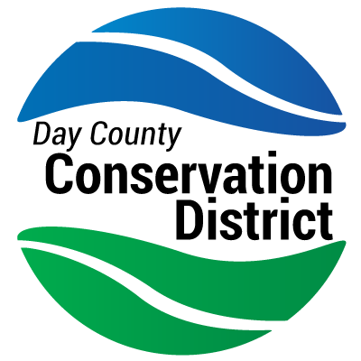
Day County Conservation District SCHOLARSHIP

Scholarship Application

- Student’s Full Name:

- Student’s Address:

Phone number:
Email Address:

- Name of Parents:

- Awards, Honors, Offices in High School:

- Extra-Curricular & Community Activities, Honors:

- Any awards, medals, or recognition earned relating to conservation:

- College, University or Vocational School you plan to attend:

- What major course of study do you intend to pursue:

Signature of Applicant
Date

