How Do I Read My Student’s Report Card?

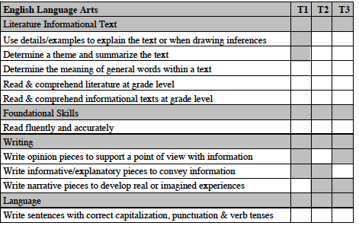
Trimester 1, 2, & 3- Similar to the “quarter” system used in previous years. We are now using a 12-week grading period. These dates are outlined in the 2015-2016 school calendar which is posted on the school website plano88.org. Gray boxes indicate that particular standard was not formally assessed during that trimester.
Power Standards have been identified to focus instruction and to provide specific feedback regarding academic progress.
Grade level power standards are expected learning standards for students to secure before the end of that particular grade level, not the end of the trimester.

- Academic Performance Levels will be used:
Secure (S): Student performance meets the demands of the task and demonstrates a firm grasp of the concepts and procedures involved. Student can independently apply understanding in different contexts.
Developing (D): Student accomplishes part of the task independently. Student can sometimes explain or demonstrate the process but may need prompting to complete it.
Beginning (B): Student seldom demonstrates an understanding of concepts and procedures, while requiring consistent support.

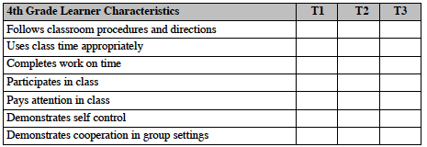
Learner Characteristics are behaviors associated with the learning process. These are reported separately from the academic standards.

Consistently (*) Sometimes (+) Rarely (-)

Learning Standards= Academics
Learner Characteristics= Behaviors

