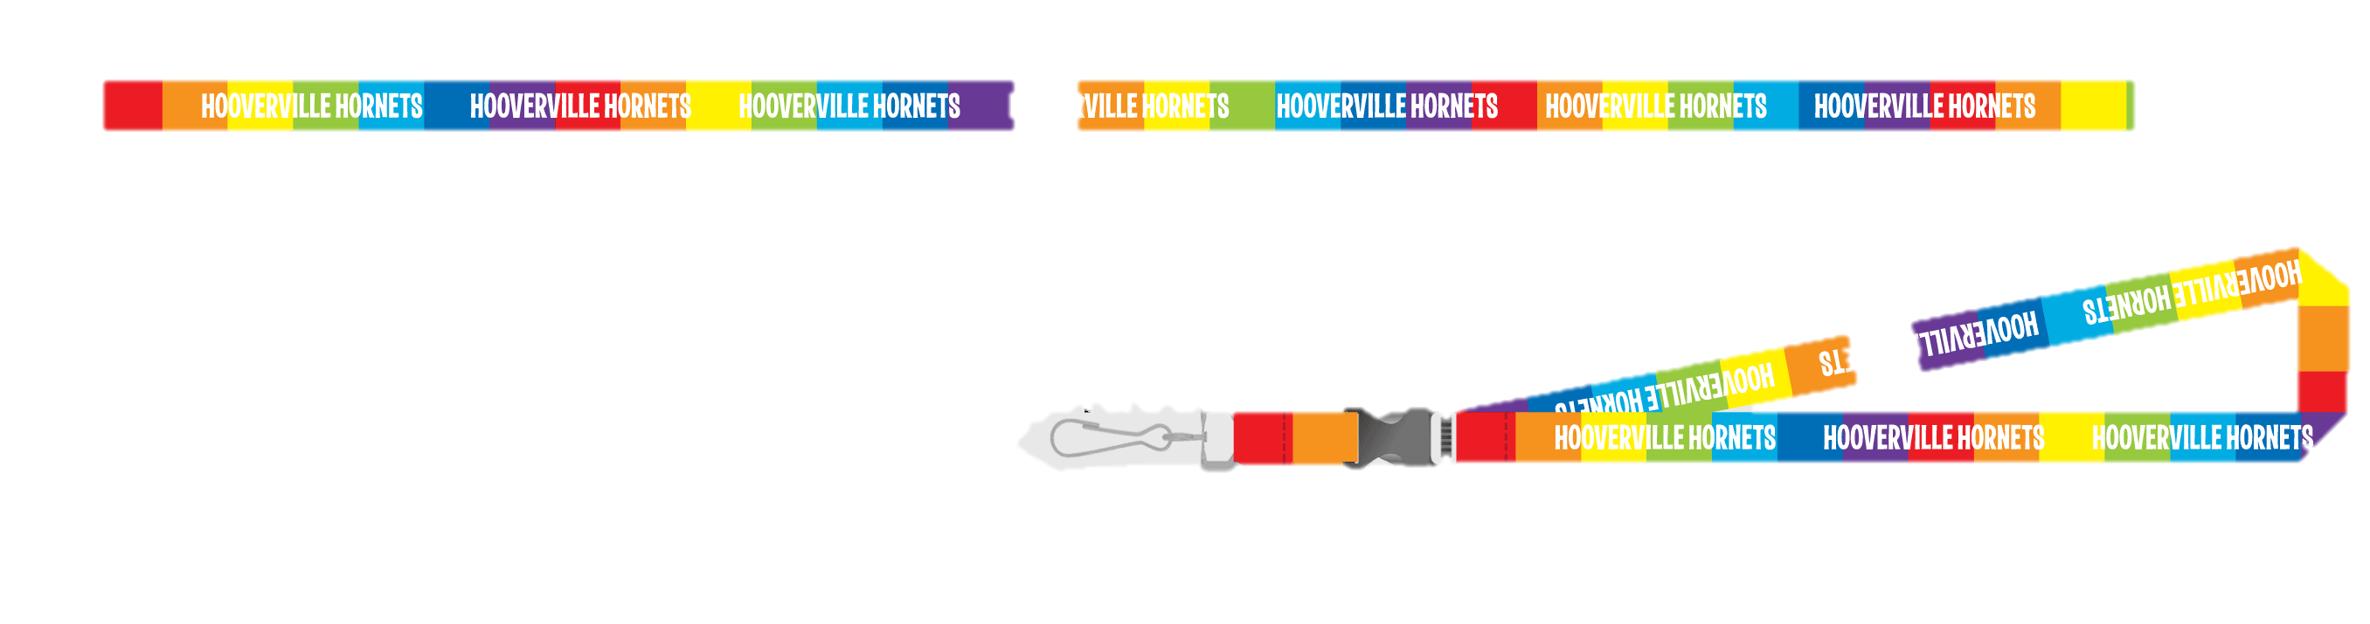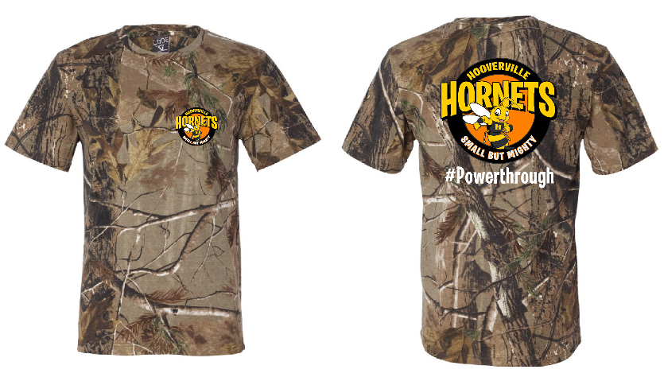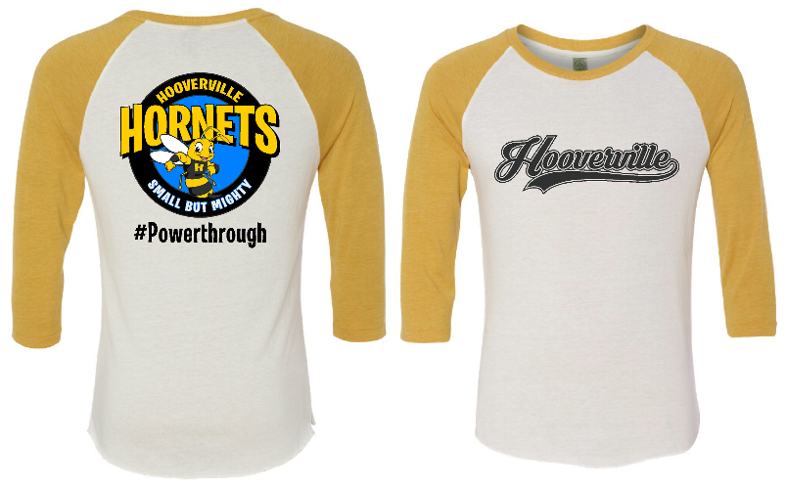

Choice of 2 colors!

Project Team Inspired Lanyard

Camo

T-Shirt

Back

Front of Baseball T

Gray-Adult only

Hooded Sweatshirt

Crew Neck Sweatshirt

Back

Front of T-Shirt

Show Your Hive Pride!

Designs come in Youth AND Adult sizes!