

**Bishop Elementary School**

**Newsletter**

**October 2019**

**\*\*\*\*\*\*\*\*\*\*\*\*\*\*\*\*\*\*\*\*\*\*\*\*\*\*\*\*\*\*\*\*\*\*\*\*\*\*\*\*\*\*\*\*\*\*\*\*\*\*\*\*\*\*\*\*\*\*\*\*\*\*\*\*\*\*\*\*\*\*\*\*\*\*\*\*\*\*\*\*\*\*\*\*\*\*\*\*\*\*\*\*\*\*\*\*\*\*\*\*\*\*\*\*\*\***

**Gretchen Skrotzki, Principal**

**Garrett Carr, Vice Principal**

**FROM THE PRINCIPAL**

October is a very busy month for us at Bishop Elementary School. As far as an academics go, this month teachers and students are really delving into our mathematics, English language arts, and science and social studies curricula. As well, during the first two weeks of October, we will be testing every student in reading, mathematics, language, and fluency (only for K-3) using NWEA’s MAP, which is a norm referenced assessment tool. The data that we retrieve from this tool will be used by teachers to differentiate their instruction and provide intervention or enrichment to students who need it.

In addition to delving into the curriculum and assessing our students, this month is jam packed with school related events and activities. Our first “Coffee with the Principals” will occur October 11th from 7:30am to 8:30am in the BAC classroom. Please come visit Mr. Carr and I to learn about the new initiatives we have going on at Bishop Elementary School this school year. As well, please note that our annual Harvest Hoedown will take place on October 19th from 2-5pm, and Red Ribbon Week will occur October 21st-October 25th. We will be sending home more information about each of these events in the weeks to come.

In conclusion, please remember to follow us on Facebook and check out our website. Our Facebook page and website are regularly updated with important information. Happy Fall!

Dr. Skrotzki, Principal

**Just a reminder...this is** WHY attendance is so important!!

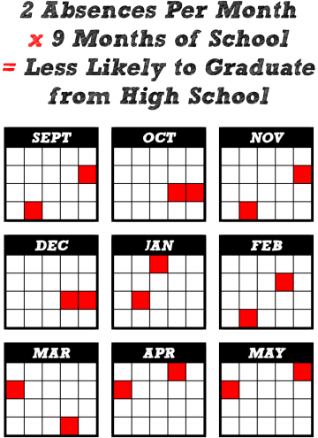

**Tardiness & Early Pick Up:**

****Please refrain from dropping off late or picking up your child early. 15 minutes a day equals to over an hour of missed instruction a week.

Student Council Elections took place in September. 32 student candidates gave speeches to the entire 4th and 5th grades for the 4 positions of President, Vice President, Treasurer, and Secretary. Students had to show up to the polls to vote which took place that day at lunch. 261 students voted, which was a voter turnout rate of 84%. Elected was President Brooke Taylor, Vice President Hunter Dailey, Treasurer Kylie Acree, and Secretary Lucas Turner. Thank you to all the candidates and thank you to those who voted.

**PARKING LOT TRAFFIC**



PARENTS: When dropping off or picking up your child at school, please pay attention to the STOP signs that are posted in our parking lot. Remember there is a STOP sign at the Pine Street exit by the BAC . We have many students walking in that area, so be sure you are aware. We want to keep all of our students safe at all times. Thank you



**Wednesday October 16th**

**5th grade Band students:**

Please remind your students to remember their band instruments.  Students will not be allowed to use the schools phones to call home.

**RED RIBBON WEEK**

Red Ribbon Week will be celebrated the week of October 21st-25th.   This year's focus is ”Send a Message. Stay Drug Free”. Look for our red ribbons around school during the last week of October and help us celebrate the importance of being drug free.

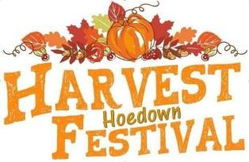

The annual Harvest Hoedown will be held on Saturday, October 19. This is a fun and safe atmosphere for our families and a great fundraiser for our teachers! Come be a part of a Bishop Elementary tradition. We are looking for volunteers, as well! Contact Martha at (760-914-2445) for more info.

The next PTO meeting will be on October 16th at 6:00 at Ste. 140 Cottonwood Plaza. Members and parents are invited to come and get involved.

 - Martha Scobie

**HALLOWEEN PROCEDURES AT SCHOOL**

October 31st will be a regular instructional day for all classes at Bishop Elementary

School. Costumes will be allowed in the afternoon, but they are optional.

Kindergarteners are to bring their costumes to school and will change after lunch. The parade for Grades K-2 will begin at 12:45. During the last hour of the day, students in

all grades may change into their costumes and enjoy their classroom parties.

In choosing a costume for your child, please remember the following guidelines: no masks, no guns, knives, swords or toy weapons of any kind and no gory or ghoulish costumes.

 Costumes should not be “see through”. They should be appropriate for an elementary school K-5 celebration.

If you do not wish your child to participate in Halloween activities, you may choose to pick up your child for the afternoon.





**CALENDAR OF EVENTS**

**OCTOBER**

Sep 15 – Oct.15…………Hispanic Heritage

October 11……………….Coffee with the Principals

October 16………………. Picture Make-Up Day Gr TK-5th

October 16 …………….. PTO Meeting, 6:00

October 19……………….Harvest Hoedown

2:00 – 5:00 p.m.

October 24 ………………McTeachers Night

At McDonalds, 5:00 – 8:00 p.m.

Oct. 21 -25……………….Red Ribbon Week

Oct 25……………………… 4th grade Gold Rush Day

Oct 31…………………….. 4th grade to LAWS

October 24th is McTeacher Night at McDonalds

from 5:00 p.m. to 8:00 p.m.

**HALLOWEEN GRAMS ON SALE**

Bishop Elementary Student council will also be selling Halloween Grams for $1.00 (includes a trinket and a gram) the week of Oct. 16th - Oct. 29th in the office before recess, and after school.

MCj03982290000[1]

MCj03512090000[1]

**LOST AND FOUND**

Please remember that we sort through our Lost and Found articles of clothing on a monthly basis. Around the 15th of each month, we take those articles to the local Thrift Shop. If your child has lost any clothing, please feel free to check out our Lost and Found box.

****Making sure your child’s name is on all jackets and sweaters will help a lost article of clothing find its owner.



 **HATS FOR SALE**

With Bishop Elementary Logo **$15.00 each**