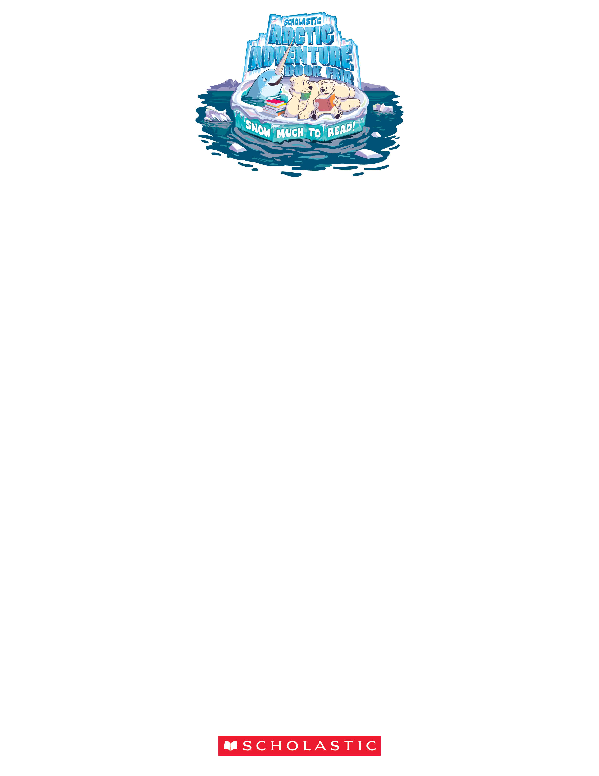
© 2019 Scholastic Inc. All rights reserved. 15386 F19 • 600000
Permission to reproduce this item is
granted by Scholastic Book Fairs®.
UNITY WEST SCHOOL LIBRARY

BOOK FAIR HOURS
October 21– October 26, 2019

Student Preview Days will be Monday & Tuesday
October 21st & 22nd

Wednesday October 23rd
7:30am to 8:15am & 2:30pm to 6:00 pm

Thursday October 24th
7:30 am to 9:00 pm
(11:20am Dismissal – Parent Teacher Conference 3-9pm)

Saturday October 26th
10:00am to 12:00 pm

