October 2019 Wagoner Public Schools Teague
This institution is an equal opportunity provider.
MONDAY TUESDAY WEDNESDAY THURSDAY FRIDAY

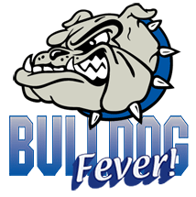 | Build your own tray:  *Pick 3 or the 5 items  *You must take a fruit or vegetable  *You may take all 5 | 1  Chicken & Waffles  Fresh Veggie Mix  Fruit | 2  Pot Roast  Roasted Potatoes and Carrots  Corn bread  Fresh Veggie Mix  Fruit | 3  Chicken Fried Chicken  Mashed Potatoes/Gravy  Green Beans  Fresh Veggie Mix  Hot Roll  Fruit | 4  Pepperoni Pizza Stick  Black Bean Salad  Fresh Veggie Mix  Fruit
Assorted Sandwiches:  Peanut Butter/Jelly Crustable  Ham & Cheese Sandwich  Turkey & Cheese Sandwich  Roast Beef & Cheese Sandwich  *Comes with Fruit, Milk/Juice |  | 8  White Chicken Chili  Roasted Broccoli  Cornbread  Fresh Veggie Mix  Fruit | 9  Chicken Soft Taco  Refried Beans  Fresh Veggie Mix  Warm Cinnamon Apples | 10  Beef Fingers  Mashed Potatoes/Gravy  Green Beans  Fresh Veggie Mix  Hot Roll  Fruit | 11  Mini Twins  Chips  Fresh Veggie Mix  Fruit
Assorted Salads:  *Ham/Cheese Salad  *Turkey & Cheese Chef Salad  *Comes with Fruit, Milk/Juice | 14  Biscuit & Gravy  Sausage Patty  Green Beans  Fresh Veggie Mix  Fruit | 15  Mini Corn Dogs  French Fries  Fresh Veggie Mix  Fruit | 16  Chicken & Noodles  Mashed Potatoes  Roasted Carrots  Fresh Veggie Mix  Hot Roll  Fruit | 17  FALL BREAK | 18  FALL BREAK
1% White Milk  FF Chocolate Milk  Assorted Juice  Extra Milk is $0.75 each |  | 22  Omelet  Smokies  Muffin  Fresh Veggie Mix  Warm Cinnamon Apples | 23  Beef & Bean Burrito  Tortilla Chips with Queso  Salsa Cup  Fresh Veggie Mix  Fruit | 24  Chicken Drumstick Breaded  Mashed Potatoes/Gravy  Green Beans  Fresh Veggie Mix  Hot Roll  Fruit | 25  Hot Ham & Cheese Sandwich  Chips  Fresh Veggie Mix  Fruit
*Fresh Veggie Mix offered daily Broccoli & Carrots or  Tomatoes  Menu Subject to Change |  | 29  Asian Chicken  Rice  Breadstick  Fresh Veggie Mix  Fruit | 30  Frito Chili Pie  Cinni Minis  Fresh Veggie Mix  Fruit | 31  Corn Dog  Chips  Fresh Veggie Mix  Fruit
November 2019 Wagoner Public Schools
This institution is an equal opportunity provider.
MONDAY TUESDAY WEDNESDAY THURSDAY FRIDAY

 | Build your own tray:  *Pick 3 or the 5 items  *You must take a fruit or vegetable  *You may take all 5 |  |  |  | 1  Pizza  Black Bean Salad  Side Salad  Fresh Veggie Mix  Fruit
Assorted Sandwiches:  Peanut Butter/Jelly Crustable  Ham & Cheese Sandwich  Turkey & Cheese Sandwich  *Comes with Fruit, Milk/Juice |  | 5  Pot Roast  Roasted Potatoes and Carrots  Corn bread  Fresh Veggie Mix  Fruit | 6  Taco Salad  Lettuce & Tomato  Refried Beans  Fresh Veggie Mix  Fruit | 7  Beef Fingers  Mashed Potatoes/Gravy  Green Beans  Fresh Veggie Mix  Hot Roll  Fruit | 8  Cheeseburger  Chips  Fresh Veggie Mix  Fruit
Assorted Salads:  *Ham/Cheese Salad  *Turkey & Cheese Chef Salad  *Comes with Fruit, Milk/Juice |  | 12  Biscuit & Gravy  Sausage Patty  Green Beans  Fresh Veggie Mix  Fruit | 13  Ravioli  Breadstick  Marinara Cup  Fresh Veggie Mix  Fruit | 14  Turkey  Mashed Potatoes/Gravy  Green Beans  Stuffing  Sweet Potatoes  Fresh Veggie Mix  Hot Roll  Fluff | 15  Pizza  Black Bean Salad  Side Salad  Fresh Veggie Mix  Fruit
1% White Milk  FF Chocolate Milk  Assorted Juice  Extra Milk is $0.75 each |  | 19  Asian Chicken  Rice  Breadstick  Fresh Veggie Mix  Fruit | 20  Nacho’s  Refried Beans  Fresh Veggie Mix  Fruit | 21  Chicken Fried Chicken  Mashed Potato/Gravy  Green Beans  Fresh Veggie Mix  Hot Roll  Fruit | 22  Chicken Sandwich  Chips  Fresh Veggie Mix  Fruit
*Fresh Veggie Mix offered daily Broccoli & Carrots or  Tomatoes  Menu Subject to Change |  | 26  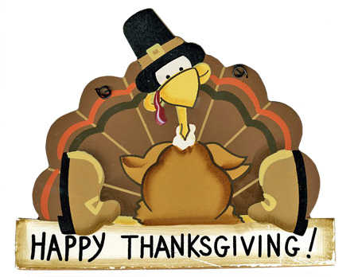 | 27  Thanksgiving | 28  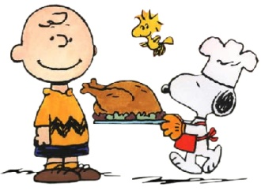 | 29  Break

