^{Hello White Pass Families!}

Happy Fall to all of you! As Fall begins, the weather is also growing colder and more rain is coming. It is very important to mark your child’s coat(s) when they bring them to school in case they are left out at recess so we can properly return them to their owner!
Also, it would be greatly appreciated if all students could carry an extra pair of clothes in their backpacks in case of becoming wet outside, spills from breakfast/lunch/snack time, or if they have an accident here at school. This would help the school in getting your child clean and back to class right away without having to burden families from bringing a new change of clothes to school. If this does happen, we apologize for the inconvenience and appreciate your flexibility and help.
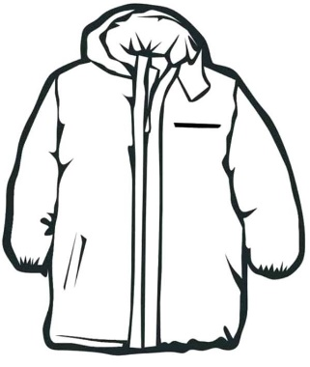
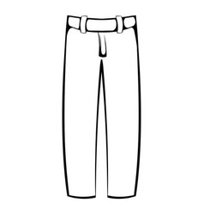
If you have any questions, please do not hesitate to reach out! Enjoy your weekend
^{-Chantél Merriman}
^{Elementary Counselor}
^{360.497.7300 ext.2014}
^{cmerriman@whitepass.k12.wa.us}

