October
2019
Breakfast/ Lunch
Monday | Tuesday | Wednesday | Thursday | Friday
 | 1 | 2 | 3 | 4
 | Breakfast- Breakfast taco  A-Hot Ham & cheese  B- Popcorn Chicken | Breakfast- Waffles w/ Syrup  A-Italian Meatball Sub  B- Fish Sticks | Breakfast- Sausage Pancake Stick  A-Tex-Mex mac n’ Cheese  B- Pulled Pork Sandwich | No School
7 | 8 | 9 | 10 | 11
Breakfast- Breakfast Pizza  A-Grilled Ham & Cheese  B-Crispy Chicken Sandwich | Breakfast- Cheesy Scrambled eggs w/ toast  A-Chicken and Noodles  B-Corn Dog | Breakfast- French Toast w/ syrup  A-Beef Soft Shell Tacos  B-Chicken Wrap | Breakfast- Egg & cheese biscuit  A-Goulash  B-Cheeseburger | Breakfast- Long John Donut  A-Walking Taco  B-Hot Dog on a bun
14 | 15 | 16 | 17 | 18
Breakfast-  A-Sliced Turkey with Gravy  B-Chicken Nuggets | Breakfast- Breakfast Taco  A-Spaghetti w/ Meat Sauce  B-Pork Rib Sandwich | Breakfast- Waffles w/ Syrup  A-Beef & cheese burrito  B-Crispy Chicken sandwich | Breakfast- Sausage Pancake Stick  A-Italian Dunker  B-BBQ Meatball Sub | Breakfast- Glazed Donut  A-Sloppy Joe on bun  B- Pepperoni pizza
21 | 22 | 23 | 24 | 25
Breakfast- Pancake w/ Syrup  A-BBQ Chicken Sandwich  B-Country Pork Fitter | Breakfast- Sausage, Tri-Tater, and Toast  A-Ham & Scalloped Potatoes  B-Cheese Pizza | Breakfast- Dutch Waffle  A-Super Mexi Tots  B-Popcorn chicken | Breakfast- Breakfast Sliders  A-Chicken Alfredo w/ Noodles  B-Cheeseburger | No School
28 | 29 | 30 | 31
Breakfast- Breakfast Pizza  A-Mac n’ Cheese  B-Mini Corn Dogs | Breakfast- Cheesy Scrambled Eggs w/ Toast  A-Nachos Grande  B-Chicken Wrap | Breakfast-French Toast w/ Syrup  A-Tangerine Chicken  B-Meatballs w/ gravy | Breakfast- Egg & Cheese Biscuit  A-Tater Tot Casserole  B-Stuffed Crust Cheese Pizza
 | 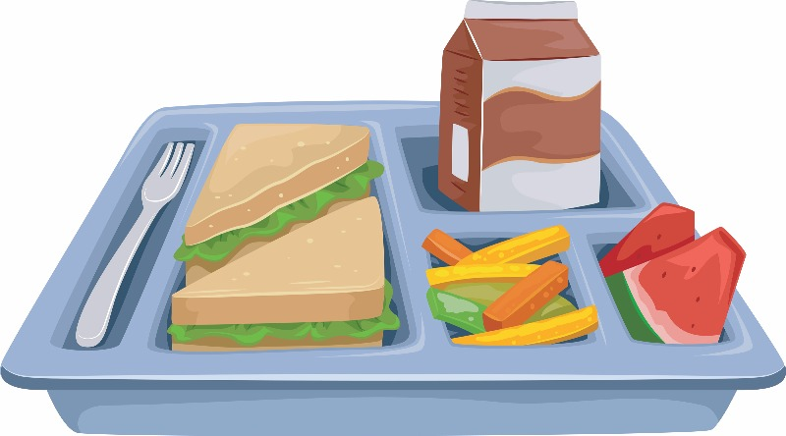 |  |  | 