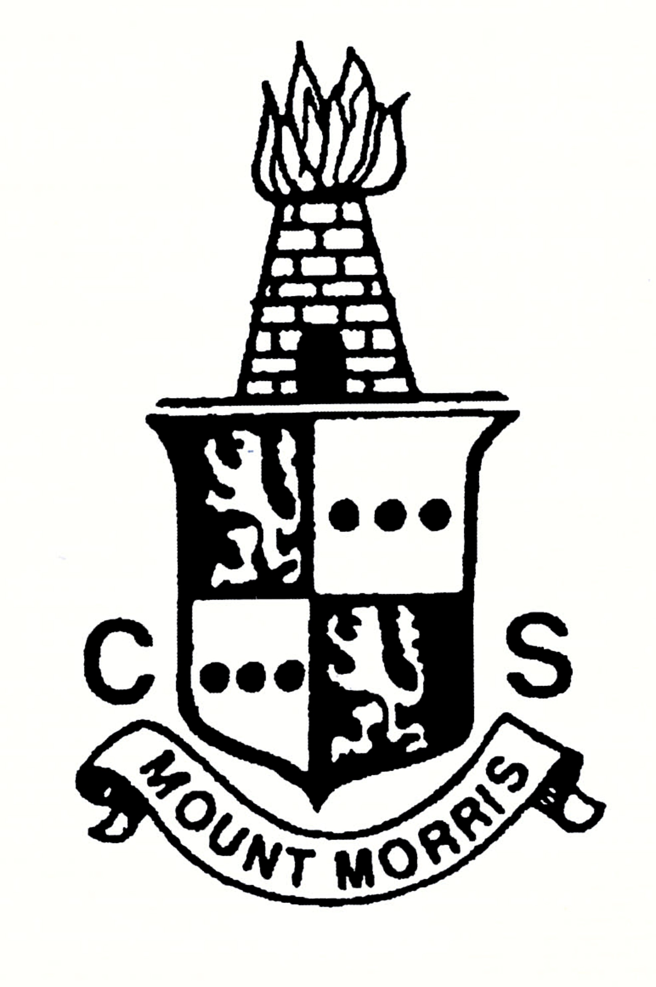Mount Morris Central School

~ Dare to be Excellent ~

September 16, 2019

Dear Parents of Students in Grades PreK-6,

It has been an exciting start to the new year and we are eager to welcome families to our annual Welcome Back Open House which will be held on Monday, September 23, from 5:30 to 7:00 pm.

The event will again be a PreK-12 event. Thus, if you have students in a variety of grade levels, you will have the opportunity to meet all of your children’s teachers. Upon arrival, please feel free to visit the many booths that local agencies will have set up in the main lobby. Then be sure to make your way to your child’s classroom. Your child’s teacher will be waiting to meet you in the classroom and is looking forward to sharing some of the accomplishments of your student.

This year, we will be providing a special bus run to bring families to the event. The bus will begin picking up families at approximately 5:00 p.m. The bus will pick up and drop off at the following locations:

* The first stop at 5:00 at the Mount Morris Library.
* The second stop at 5:10 at the Sullivan Street regular stop.
* The third stop at 5:20 at the corner of Hawksview and Tallman (Lower side).

The bus will arrive at 5:30 p.m. at school and will go out two additional times to pick up families. The bus will be in front of the school when you are ready to return home.

Do not forget to stop down to the cafeteria for some pizza before going home!

I look forward to seeing you on September 23rd. If you have any questions or concerns, please feel free to call the elementary office at (585) 658-5037.

Sincerely,



Danielle M. Dean

Elementary Principal