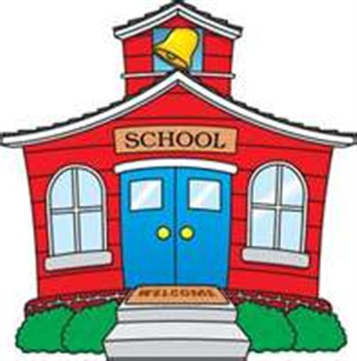
AM CLASS:
DOORS OPEN AT 7:50 AM
MON., WED., & FRI. CLASS HOURS 8:00 – 11:05
TUE. & THUR. CLASS HOURS 8:00 – 10:30
PM CLASS:
DOORS OPEN AT 12:20 PM
MON. – FRI. CLASS HOURS 12:30- 3:35

New Generation School Hours:
7:50 – 3:35 Monday thru Friday

