9/11/19
Rich Hill R-IV Surplus Property Listing
2013 SCAG STT S/L COMMERCIAL DECK MOWER
Mower will be sold as is to the highest bidder. All sales are final. Sealed bids are due to the Rich Hill Central Office at 703 N. 3rd St., Rich Hill, MO 64779 by Thursday October 3 2019 at 5PM. The Rich Hill R-IV Board of Education reserves the right to reject any or all bids.
For any questions, or to make an appointment to see the item, contact Heath Oates, Superintendent, at 417-395-2418 ext 201 or email at hoates@richhill.k12.mo.us.

Mower Serial # G5500083
72” Deck Serial # G6600097

Mower Front View | 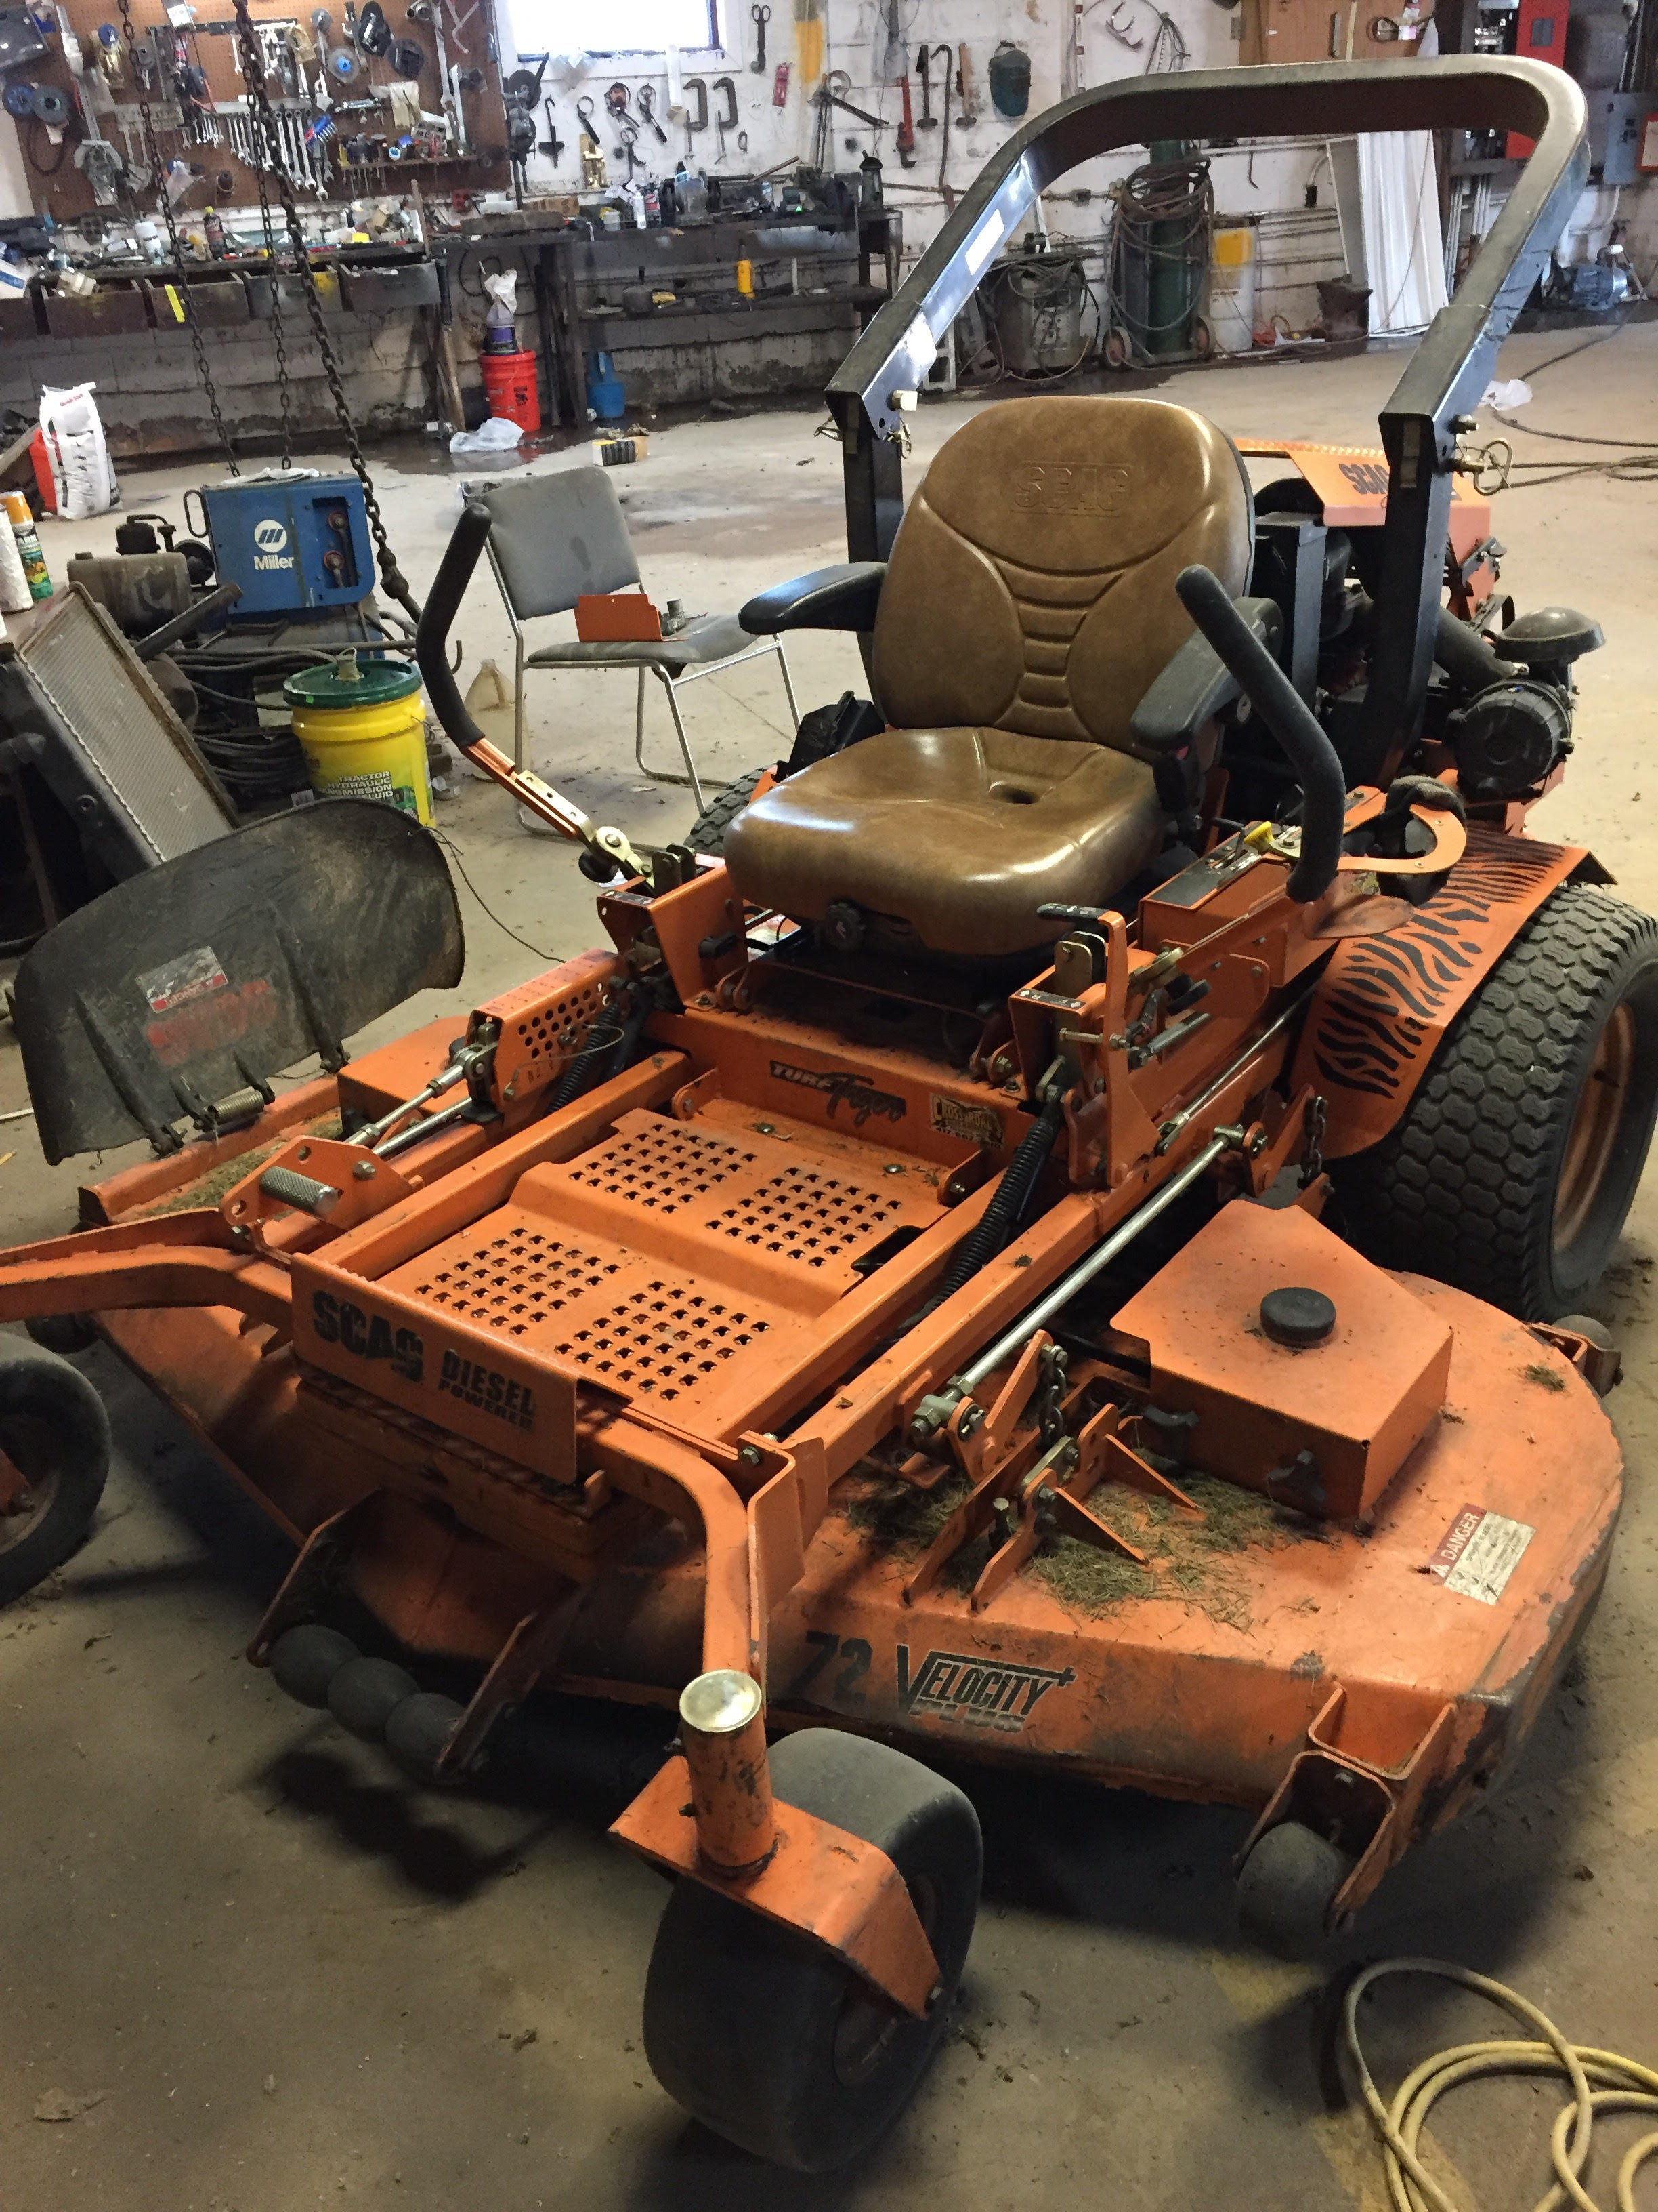
Mower Front View 2 | 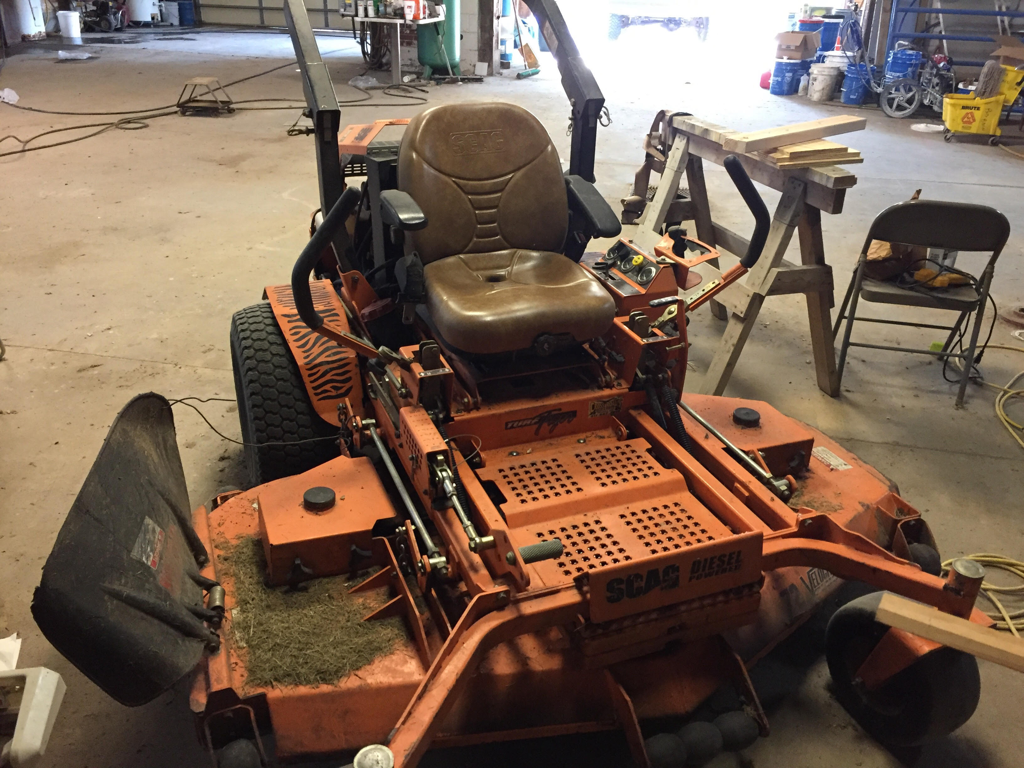
Mower Cockpit View | 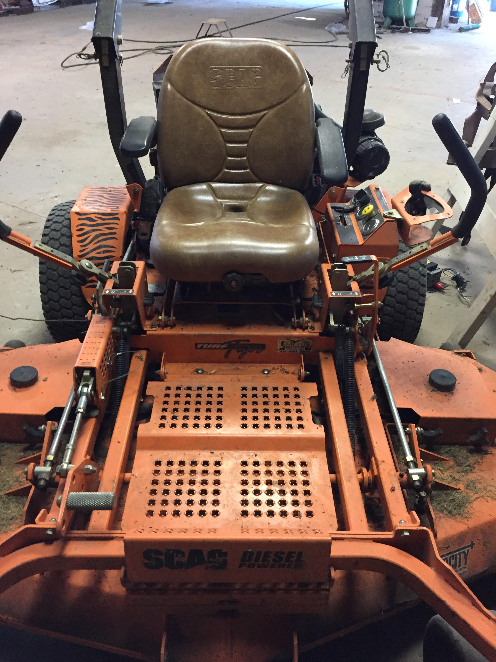
Mower Back View | 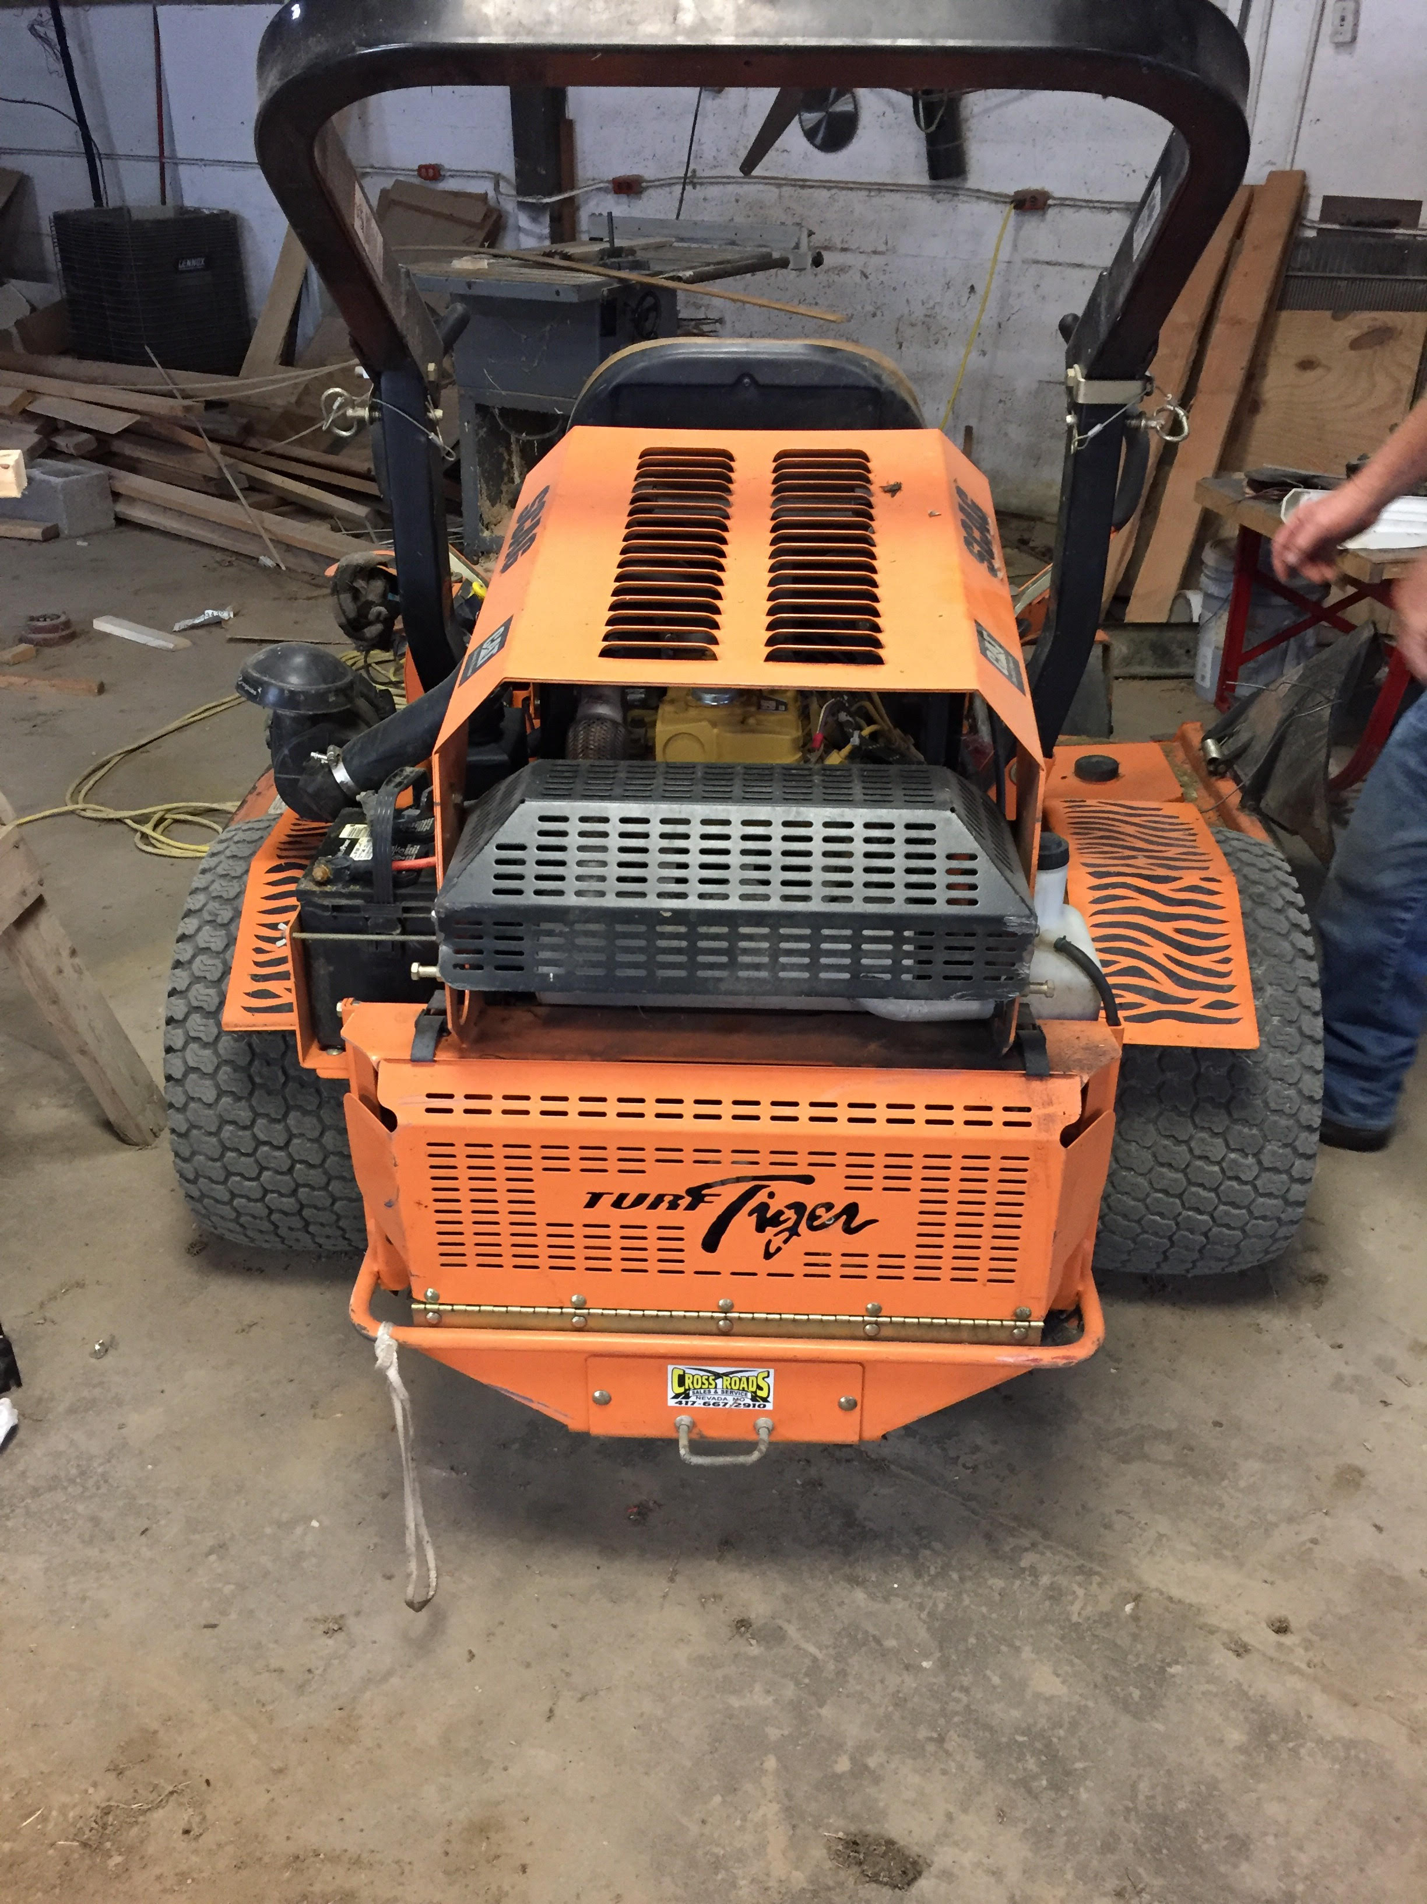
Mower Panel View | 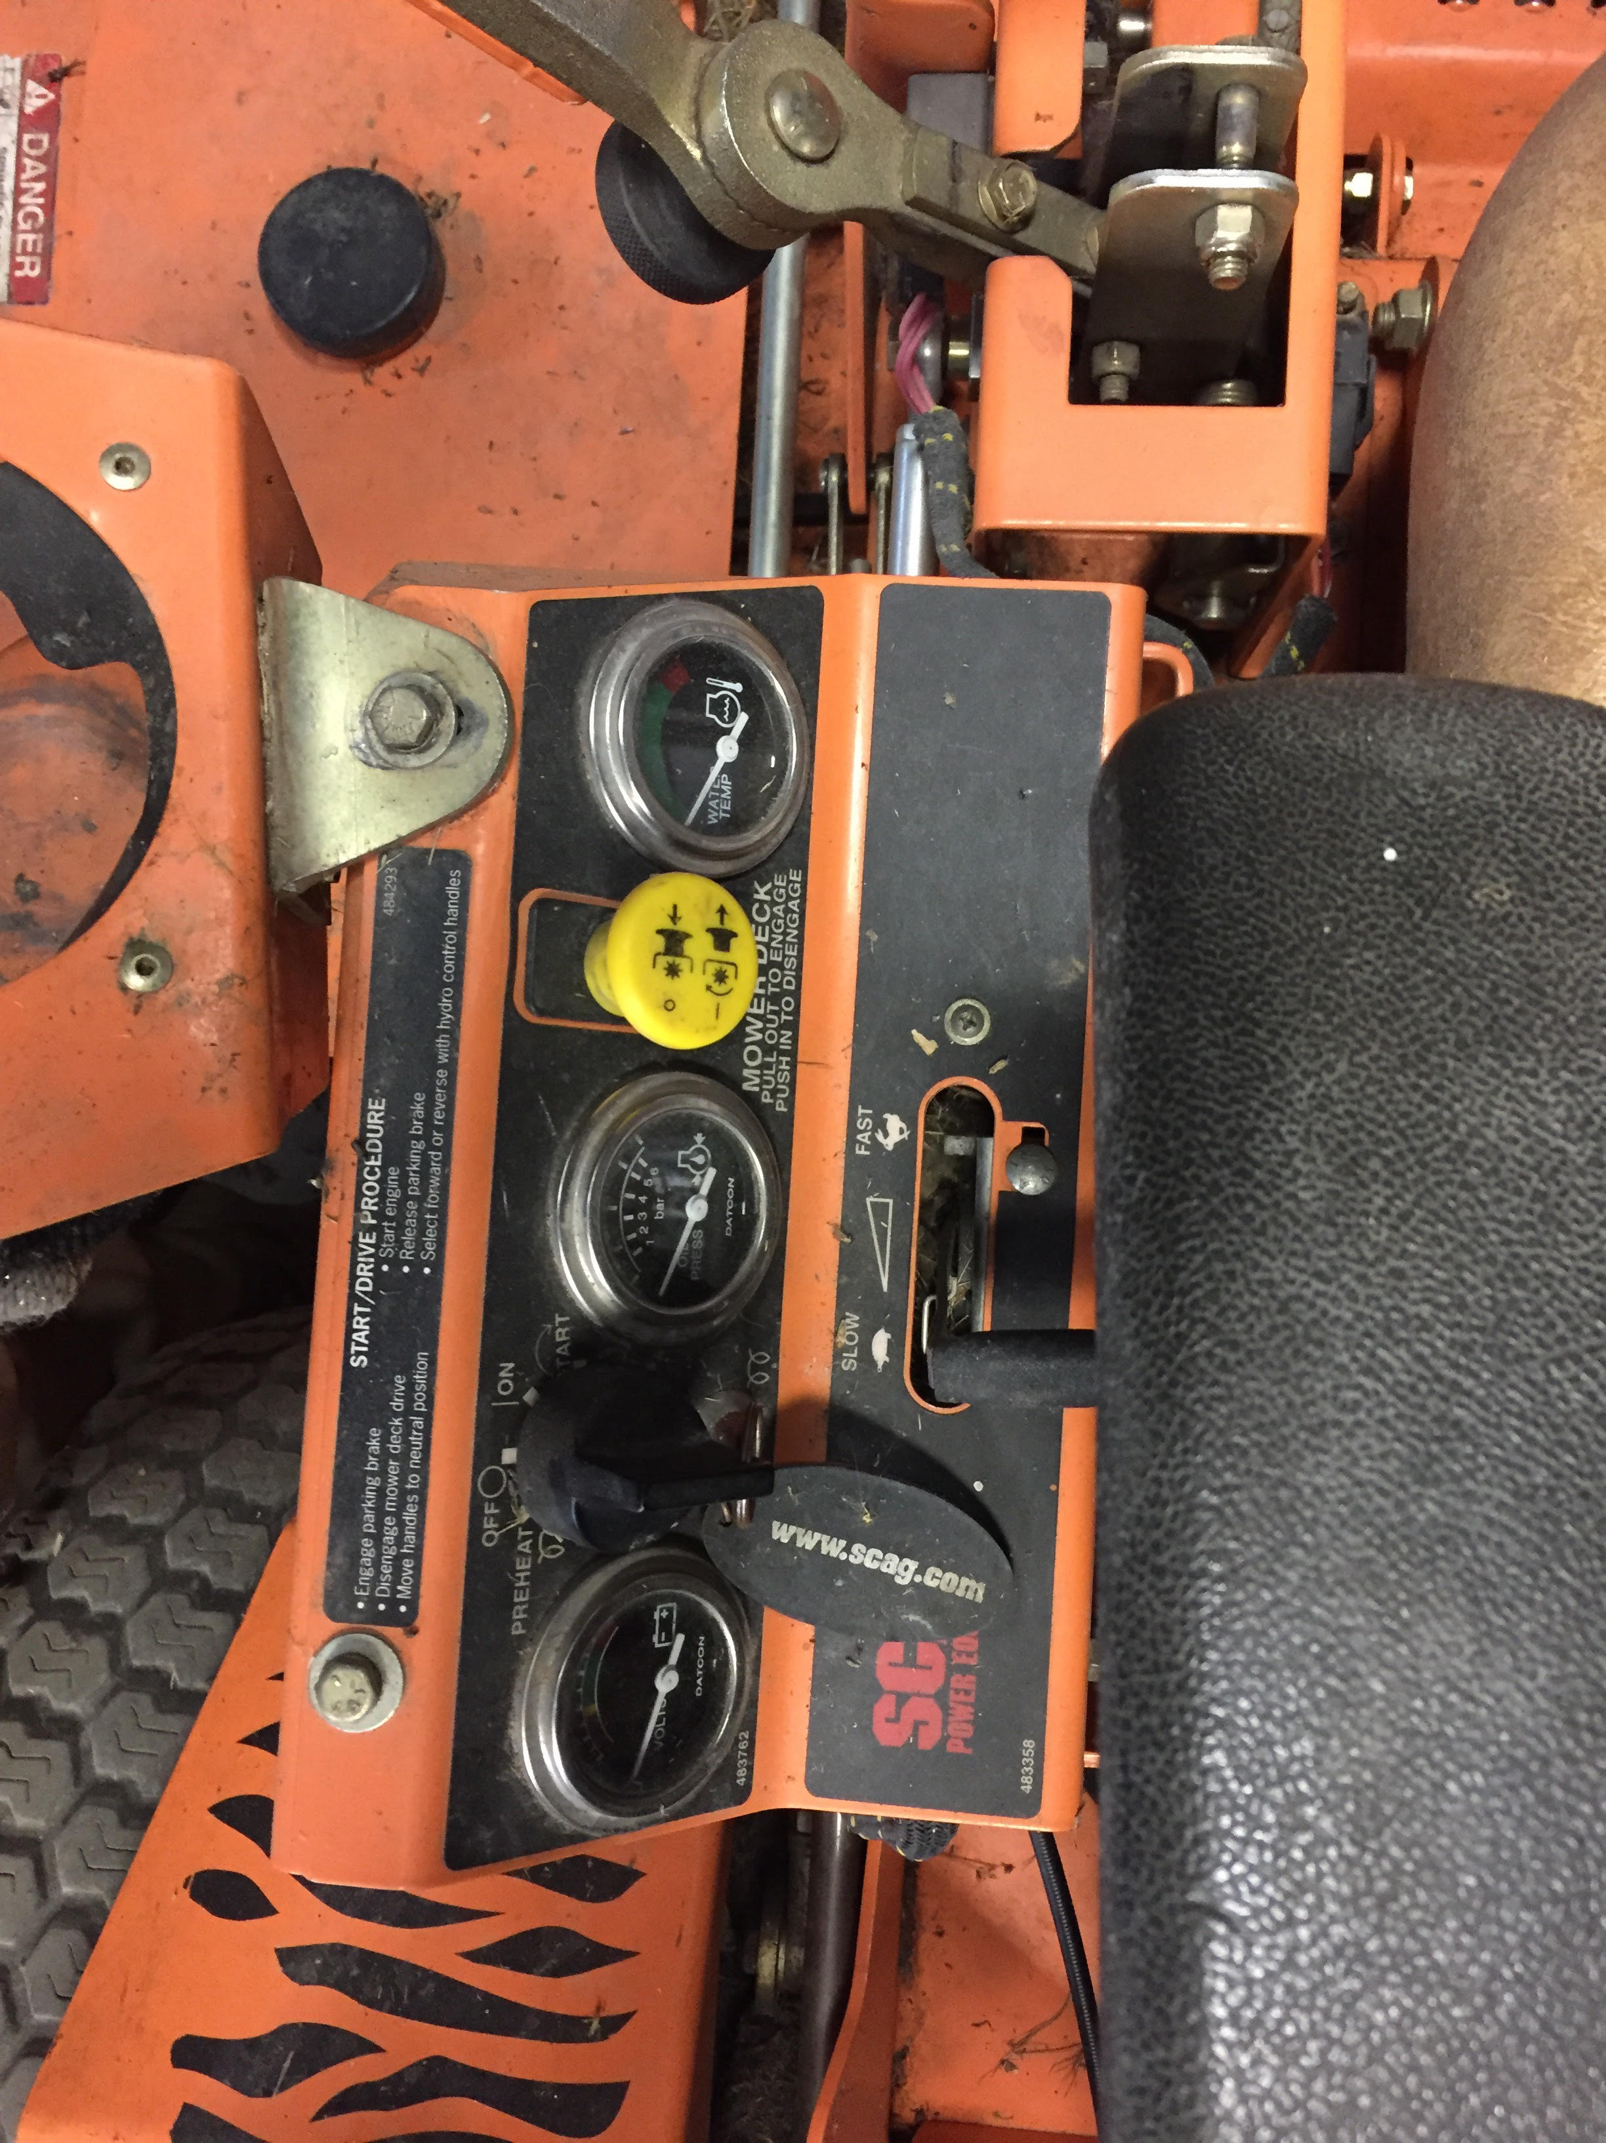
Mower Engine View | 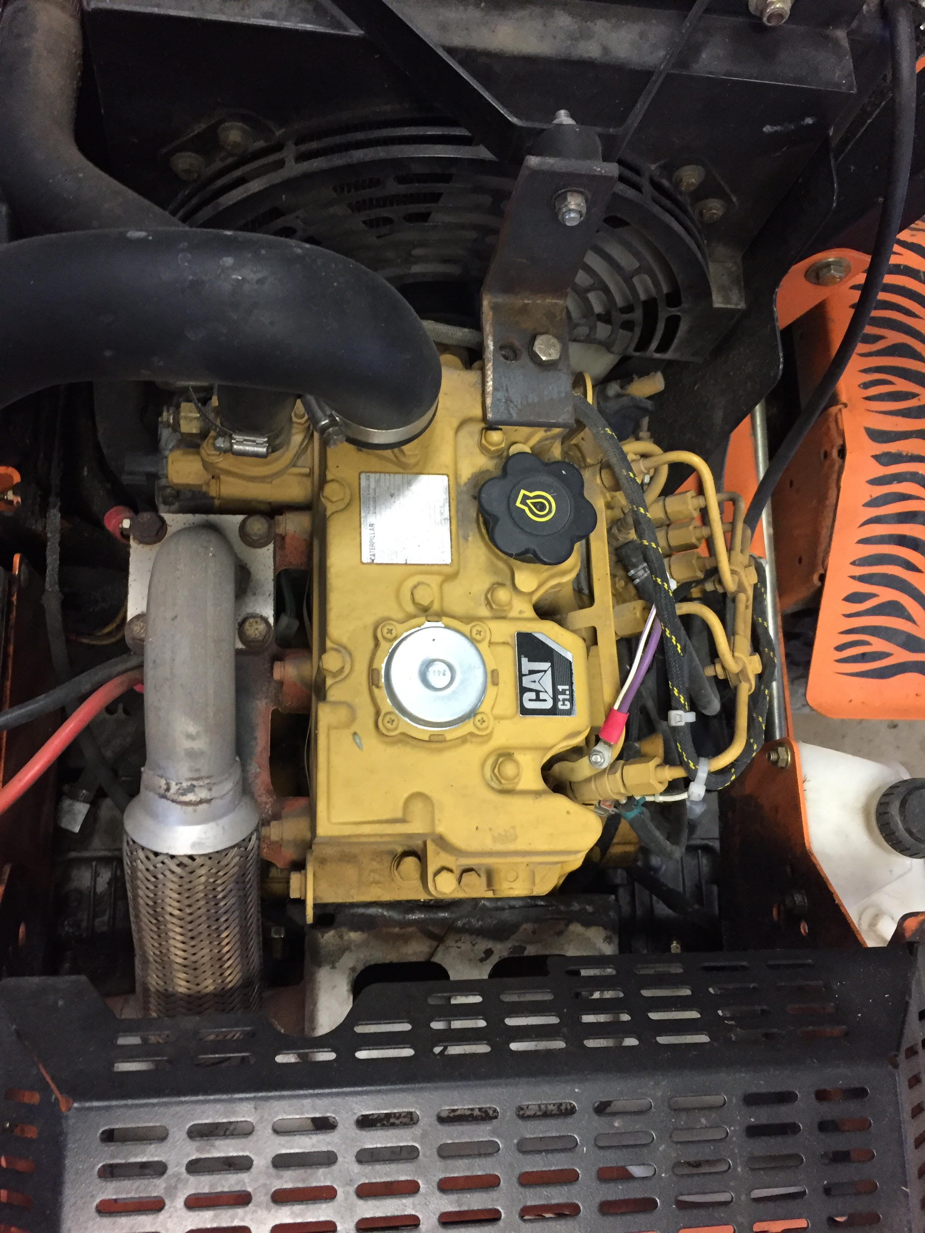
Mower Hours View: 10,771 | 