9/11/19
Rich Hill R-IV Surplus Property Listing
Grizzly G9957 12” 3-Phase 220V Table Saw
Saw will be sold as is to the highest bidder. All sales are final. Sealed bids are due to the Rich Hill Central Office at 703 N. 3rd St., Rich Hill, MO 64779 by Thursday October 3 2019 at 5PM. The Rich Hill R-IV Board of Education reserves the right to reject any or all bids.
For any questions, or to make an appointment to see the item, contact Heath Oates, Superintendent, at 417-395-2418 ext 201 or email at hoates@richhill.k12.mo.us.
Label with Product Specs | 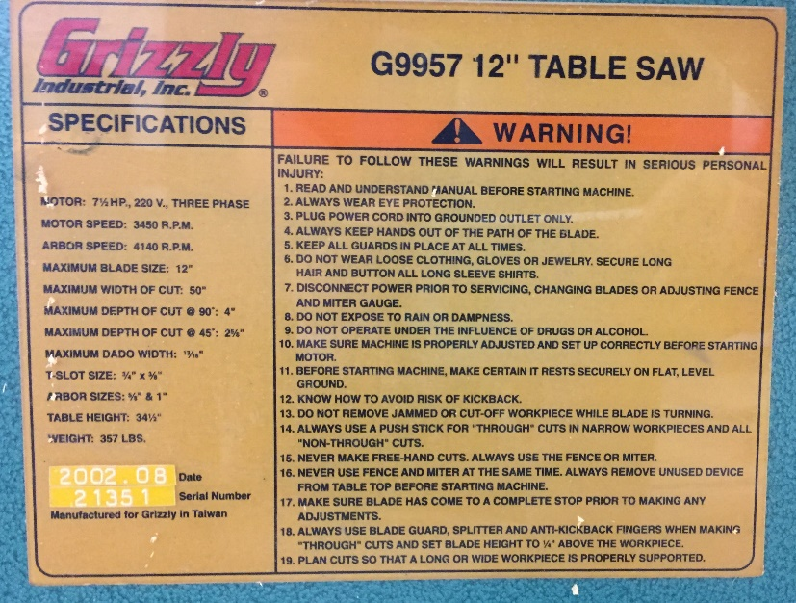
Side Panel View | 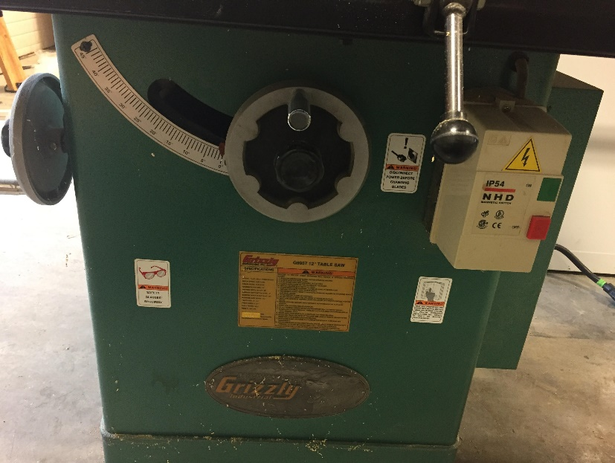
Plug View | 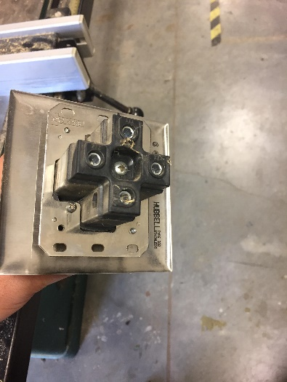
Complete Side View | 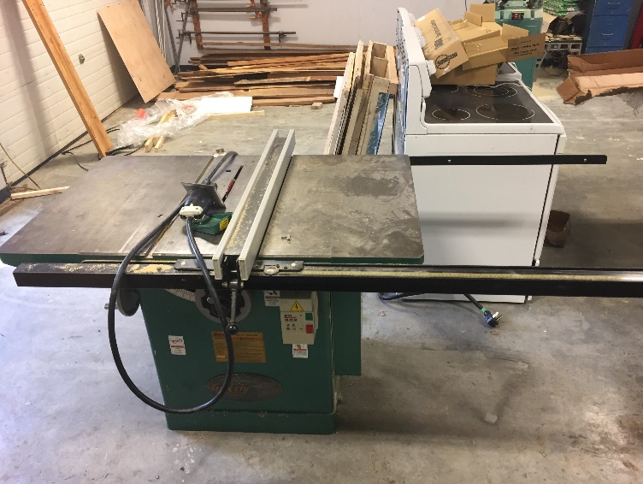
End View | 