Glenwood R-VIII
School District

Online Course Student/Parent Handbook

Table of Contents

Introduction/Senate Bill 603 2
What is MoCAP? What is Launch? 2
Why Consider Online Learning? 3
Profile of a Successful Online Student 3
Making the Decision 4
Enrollment Procedures 5
Homeschool Students 6
Academic Information 6
Dropping a Course 6
No Show Procedure 7
Getting Started 7
Navigating Canvas 8
Plagiarism/Academic Dishonesty 8
Progress Monitoring 9
State Testing 9
IEP/504 Students 9
School Athletics and Activities 9
Technology 10
Final Advice to Parents 10
Online Learning Agreement 11
Appendices
Online Learning Readiness Rubric 13

Introduction

This guide has been prepared for parents, guardians, counselors and others who want to help students first decide whether online courses are a good option for them and, if so, how to proceed. In the pages that follow, you will find information about:
- the characteristics of a successful online learner,
- how to enroll in online courses and,
- the impact coursework may have on academics and activities.

Senate Bill 603 At a Glance
In the spring of 2018, SB 603 was passed, thereby expanding the online learning opportunities for students in Missouri. Highlights of this legislation are below.
- The school district must adopt a policy that creates a process for students to enroll in virtual courses and may include consulting with a school counselor.
- The school district must pay for eligible K-12 students to take virtual courses as long as the student: one, resides in the district; two, is currently enrolled in the district and, three, was enrolled full-time in a public school the previous semester. **Exceptions for homeschool students who reside in the district is referenced below in the ‘homeschool student’ section of this document.
- School districts are not required to pay for courses beyond full-time enrollment. Therefore, if a student is already enrolled in seven courses in a semester during the regular year (or two courses during the summer school session), the district will not be required to pay for additional courses.
- School districts are able to determine a student’s eligibility to enroll in an online course and can refuse enrollment based on ‘the best educational interest of the child’. Should the parent disagree with the district’s determination, an appeal may be made to the local school board.

What is MoCAP? What is Launch?

Missouri Course Access and Virtual School Program (MOCAP) was established in 2007 as the state’s online school. It was previously known as Missouri Virtual Instruction Program (MOVIP). Currently, MOCAP offers courses for 6th through 12th grade. Students can take courses from any Internet-connected computer, available 24-hours a day, seven days a week. MOCAP's mission is to offer Missouri students equal access to a wide range of high quality courses, and interactive online learning that is neither time nor place dependent.

Local school districts and charter schools may use their own preferred online provider. The Glenwood R-VIII School District’s preferred provider is Launch. Launch is operated and overseen by the Springfield, MO School District and current offers over 120 courses. Courses are designed by Missouri teachers and aligned to the state standards. A formal review process is built into all course development to ensure high quality and rigor. Students wishing to take advantage of online learning opportunities will do so through Launch. All information/procedures that follow in this document are in reference to Launch.

If a student wishes to pursue an online class offering through other MoCAP options outside of Launch, he/she will need to contact the counselor/admin to begin the appeal process. More specifics on that process are at the end of this document.

Current course offerings through Launch can be found at: https://fueledbylaunch.com/courses/

Why Consider Online Learning?

Students take online courses for a variety of reasons. For some students, it expands the range of courses and opportunities, particularly if a student cannot access a face-to-face course due to scheduling conflicts. For others, it allows students to take courses not even offered at the local level. Other students may use online course opportunities for credit recovery or as a viable homebound option. And, still others may simply prefer the online learning format.

From a student’s point of view, online learning may be attractive because it is:
- Personalized to individual needs and learning goals.
- Flexible so a student can try different ways to learn.
- Interactive and engaging because students will be meeting people from other school districts in a safe, monitored environment.
- Relevant to the online life many students lead.
- Paced by individual progress so students can move as fast or as slow as needed in order to attain learning goals.
- Collaborative with faculty, peers and others.
- Responsive and supportive when a student needs extra help or time to learn.
- Available to all students 24 hours a day.

Profile of a Successful Online Student

The most important question to answer is whether or not the student is well suited to be in an online learning environment. Parents and students should be aware that the demands of online courses are equal to or exceed those of traditional ‘face to face’ courses. Online instruction places much more responsibility on the student. A student should plan to spend at least one hour a day, five days a week, on each course. In other words, at least five hours per week on each course. This is similar to the amount of time a student would spend in a course at the local “brick and mortar” school. Instructors with online teaching experience agree that students who are successful at online learning have the following critical characteristics:

- Good Time Management
Can the student create and maintain a study schedule throughout the semester without the face-to-face interaction with a teacher?
- Effective Communication
Can the student ask for help, make contact with other students and/or instructors
online and describe any problem he/she is having with the learning materials
using email?
- Independent Study Habits
Can the student study and complete assignments without direct supervision and
Maintain the self-discipline necessary to stick to a schedule?
- Self-Motivation
Does the student have a strong desire to learn skills, acquire knowledge and fulfill assignments in online courses because of their educational goals?
- Academic Readiness
Does the student have the basic reading, writing, math, and computer literacy skills to succeed in an online course?
- Technologically Prepared
Does the student know how to open, create and/or save a document, use various technology tools and identify file formats (e.g., doc, xls, pdf, jpg)?

**The Stanford Research Institute examined the accessibility of online learning for students, especially those who were at risk of failure. Their report cautions that students who have failed face-to-face classes may have challenges that will affect their success in an online course as well. Many students do not realize that they will have to be even more accountable for their time, performance and productivity in an online class.**

Making the Decision

In this process, a crucial role of the parent is to help the student decide if online learning is the most effective way for him/her to learn. Using the profile in the previous section is a starting point for making this determination. Once a parent decides if a student is likely to be successful, there are other questions to consider.

Technology
- What are the technical requirements for the courses the student wants/needs to take?
- Can the parent/guardian provide the technology and internet access that the student needs to participate?
- How technologically savvy are the parents/students?

Learning Environment
- Is there a quiet area in the home in which the student can work on the online course or does the student have easy access to a facility that provides this form of environment (such as the public library)?
- Will there be a regular, designated time of day in which the student will work on the course(s)?
- Is the student willing and able to ask for help when needed?

Considering the Course
- Are there prerequisites for the online courses? Has the student met these requirements?
- How rigid are the course assignment/test dates?
- What is the time commitment (daily and length of term)?
- How do students/parents receive grade updates and the final grades?
- When can a student drop the course if he/she finds it too difficult?

Enrollment Procedures

In order to enroll in an online course under the provisions of Senate Bill 603, students must be a resident of the Glenwood R-VIII School District and be willing to enroll in the district.

Upon determining that online learning may be a viable option for a student, parents should contact the school counselor to pursue possible enrollment. A meeting will be scheduled with the student’s counselor and administrators and student eligibility will be determined. The school district may deny a student/parent request to enroll in an online course at district cost if one or more of the following is true:
- The online course is not capable of generating academic credit.
- The student has not completed the prerequisite coursework for the requested online course.
- The student has failed a previous online course(s).
- The course enrollment request does not occur within the same timeliness established by Launch and/or the school district.
- The school does not feel that enrolling in Launch courses is in the student’s best educational interest.

Should a student meet the eligibility expectations and the counselor and administrators feel that it is in the student’s best educational interest, he/she will be enrolled in the Launch courses agreed upon.

Homeschool Students

If a student who resides in the Glenwood R-VIII School District was homeschooled the prior semester and wishes to take online courses at the district’s expense, the following criteria must be met:
- The student must reside in the district (and provide proof of residency)
- The student must enroll in Launch courses only
- The student must meet all of the Launch expectations (regarding prerequisites, etc.)
- The student may only enroll in a maximum of seven courses a semester during the school year.

Academic Information

Launch offers various types of online coursework. All coursework is aligned to the Missouri State Standards. Content is reviewed annually to ensure updated resources as well as access to high-quality digital resources.

- Traditional Virtual
  - Students earn a letter grade and percentage
  - Starts and stops with the traditional calendar; has set due dates
  - NCAA and MSHSAA approved
  - Course can be taken over a quarter or semester
  - Requires a proctored final exam conducted via web conferencing
  - Curriculum built in a project-based learning format to include individual and group work delivered via individual assignments, culminating events, group discussions, etc.

By utilizing the Canvas Learning Management System Mastery Paths Platform, instruction can be personalized to meet the needs of individual students. Students can accelerate through content due to prior knowledge or can be provided additional assistance or remediation as needed.

Dropping a course

Traditional Virtual: Students have 20 school days from the start date to drop a semester course without grade penalty and 10 school days for a quarter course. Snow days would not factor into this count.

No-Show Procedure

Students will be dropped from courses if they fail to log in for 20 consecutive days.

In an effort to maintain accurate attendance records for online courses, the following no-show procedure will be implemented for all students participating in Launch. Students are considered a “no-show” if they do not log into their Launch course for the specified times outlined in the policy. Student login is monitored by the Launch office weekly.
- A student is considered a “no-show” if he or she has not logged into and participated in their course prior to the stated course drop date. Students will be dropped with zero days of attendance reported with counselor or liaison being notified at least 2 school days prior.
- After the drop date, a student can be dropped and is considered a “no-show” if he or she has not logged into and participated in his or her Launch course for 20 consecutive calendar days. The last date of attendance will be reported as his or her last date of login and participation. Counselors or district liaisons will receive notice of potential drop at calendar day 15 of no consecutive login and participation. If the student’s last date of attendance is after the stated course drop date, the student will receive an F for the course in addition to being dropped.

Getting Started
Prior to Day 1
- Your building counselor will provide you with an enrollment notification; it includes your login information and course list.
Day 1
- All Launch courses are offered through Canvas. Learn how to check your Canvas inbox.
- Watch the introduction announcement for your course.
- Complete at least one assignment to ensure you know the process.
Day-to-Day
- Start everyday by checking your Canvas inbox.
- Look at any recent feedback given from your teacher.
- Check the calendar for due dates each day.
- Keep working on the next assignments in your module.
Additional Support
- Communication through Inbox: Students can message teachers through the inbox feature in Canvas. Teachers may use this to reach the student as well. Typical response time is 24 hours.
- Announcements: Video announcements are posted weekly on the course homepage and provide information for the week including the teacher’s office hours.
- Conferencing: On a weekly basis, teachers host a one hour video conference. This is a time for students to chat face-to-face with teachers and receive immediate feedback from teachers.
- Parent/Guardian Feedback: Teaches will make weekly contact with parents if a student is inactive or failing.

Navigating Canvas
Announcements: Launch teachers will post a video announcement every week. Students need to be sure to watch these for important information regarding the course.
Feedback: Teachers provide feedback via rubrics and comments. Students should be reading this feedback in order to enhance their performance in the course. Also, students should feel free to respond to the feedback the teacher provides.
Instructor Information: Instructor information is provided at the bottom of the course page.
To Do: This is where the student will find a list of assignments and due dates. The list is found on the course homepage and will also lead the student to videos, discussion boards and other assignment items as needed. The calendar tab also provides a list of due dates.
Grades: The grades tab allows the student to see current progress in the Launch course and see the teacher’s feedback comments.
Syllabus: This link provides the syllabus for the course. It outlines the course’s major topics and units of study.
Google Drive: Students will use Google Drive to create many of the assignments and submit Google files to Canvas.

Plagiarism/Academic Dishonesty
Using someone else’s work and claiming it as your own, even if it is unintentional, is plagiarism. It is important that students cite sources and use quotation marks appropriately to avoid plagiarism. Launch has a specific plagiarism policy and list of consequences. These same consequences can be invoked for cheating and/or forging/falsifying documents.
- 1st offense: Student will be allowed to redo assignment for full credit and a formal warning will be issued.
- 2nd offense: Student will be allowed to redo the assignment for half credit and a second formal warning will be issued.
- 3rd offense: Student will receive a zero for the assignment and be referred to the Launch principal for possible additional consequences.

Progress Monitoring

Parents are given parent observer accounts to monitor progress of their students.

District employees (when given permission) can monitor student progress using Dropout Detective.

State Testing

All MOCAP and/or Launch students are required to participate in the Missouri Assessment Program (MAP) and End of Course (EOC) testing when appropriate. MAP and EOC tests measure a students’ progress toward mastery of the Show-Me Standards, which are the educational standards in Missouri. All testing is conducted at the local school site in which the student resides.
- MAP: All students in grades three through eight in Missouri will take the MAP test in communication arts and math. Students in grades five and eight will also take the MAP test in science.
- EOC: End-of-Course assessments are taken when a student has received instruction on the course-level expectations for an assessment, regardless of grade level (but typically in high school). EOC tests are required in the subject areas of Algebra I, Biology, English II and Government.

IEP/504 Students

Launch instructors are trained in accommodating students’ needs. The school’s process coordinator will email your student’s IEP or 504 to Launch so that it can be distributed to the student’s teachers. Accommodations will be made accordingly.

School Athletics and Activities

Students may participate in athletics/activities if they are enrolled at the Glenwood R-VIII School District and taking a minimum of six seat-time or Launch classes. Home school students may participate in athletics/activities if they enroll in a minimum of two credit bearing seat time or online classes. All classes must be completed by the end of the semester. To be eligible the following semester, students must earn a minimum of 3 full credits the semester prior and have passed the two Launch classes.

Technology

Students will be required to provide their own technology to access the Launch curriculum through Canvas. The district will not provide internet access; this is the responsibility of the parents/guardians. All Launch courses are hosted by Canvas, an Interactive Learning Management System.

Students are provided with HELP Desk Support through Launch, available from 7:30 a.m. to 9:00 p.m., 7 days a week. There are three ways to access help:
- Send an email to support@fueledbylaunch.com (typical response is within 30 minutes)
- Use your Canvas inbox to send a message to HELP.
- Call the Launch office at 417-523-0417. The office is only open from 7:30-4:00 Monday through Friday.

If students are enrolled in an online PE class, they will be issued a heart rate monitor and USB charger. This device must be returned in good working condition at the end of the semester or there is a $150 fee that parents/guardians are responsible for paying.

Final Advice for Parents

Throughout the student’s enrollment in the online course, it is best practice to do the following:
- Set up a study space, including technology required.
- Be prepared for any technical issues that may come up.
- Review the syllabus with your student.
- Define expectations for when and where your student will work on the course.
- Agree on incentives and consequences.
- Reinforce that online courses are as important as face-to-face courses and do become a part of the educational record.
- See that your student establishes a routine for working on his/her online course.
- Help your student maintain a regular study schedule.
- Monitor your student’s progress.

Glenwood R-VIII School District
Online Learning Agreement

Please complete the information below as a part of the enrollment process.

Student Name (First, Middle, Last): ________________________________________________

Gender: __________________________ Birthdate: __________________________________

Race: ____________________________ Grade Level: _______________________________

Student Email: ________________________________________________________________
Does student have a current IEP (circle one)? Yes No

Does student have a current 504 (circle one)? Yes No

Parent/Guardian Name (First, Last): _______________________________________________

Parent/Guardian Phone Number: (___________) __________- _____________

Parent/Guardian Email: _________________________________________________________

Parent/Guardian Address: _______________________________________________________

Online Handbook Agreement

The Online Course Parent/Student Handbook is a vital part of our program. Though the handbook does not contain every specific rule or regulation concerning the program, it does have all major policies and general information to help students and their parents better understand this unique program. Please read the handbook carefully.

We have received and reviewed the Online Course Parent/Student Handbook and understand that it is our responsibility to follow all of the expectations set forth within the handbook.

_______________________________________________ ____________
Student Signature Date

_______________________________________________
Student Name (Printed)

_______________________________________________ ____________
Parent Signature Date

_______________________________________________
Parent Name (Printed)

APPROVAL SIGNATURE:

_______________________________________________ ____________
Principal Signature Date

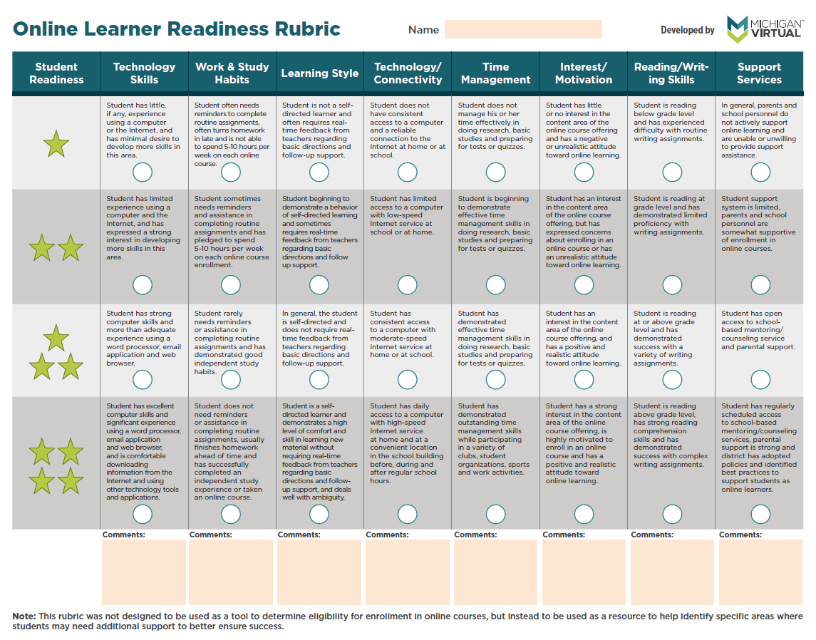
Appendices

