Lady Husky Golf History
L A D Y H U S K Y

GOLF
Belt High School launched its girls’ golf program in the spring of 2008. Coach Koontz and eleven young ladies battled against Montana’s spring weather and a variety of area golf courses and survived more than thrived that first season. Over the past eight years the girl’s team has fielded at least ten members each season and has steadily progressed from being a happy-go-lucky band that resembled the Keystone Cops to a perennial state contender. Four Lady Husky golfers qualified for the state meet the first year at the Livingston Golf Club, including: Rachel Keith, Abby Meecham, Emily Urick, and Mikaila Stinar. None placed individually, and the team finished seventh out of seven, but the girls were off and running. Lisa and Matt Urick served as assistant coaches for the program for the first four years of Lady Husky Golf. The ladies again qualified a full team for the state meet at Merion Hills in Malta in 2009. Kate Dawson joined Rachel Keith, Mikaila Stinar, and Emily Urick as they made their second appearance at the state competition. The team finished in seventh place, and Urick captured Belt’s first individual medal, finishing in twelfth place. Heather Wall also qualified for the state meet. In 2010, Emily Urick improved a couple positions as a junior, finishing tenth individually at the state meet at Madison Meadows in Ennis. Stephanie Back and Heather Wall teamed with Urick and Keith to represent Old Belt High that spring as the team finished in seventh place again. In 2011, the girls won their first regular season meet, grabbing the top prize at the Chinook Invitational (the first of five straight in this meet). The state meet was held at Marias Valley Golf in Shelby, where Urick earned her highest finish as an individual. Urick shot a school record 91 and finished as fifth medalist while the team finished in fifth place as well. Maggie Croff and Georgia Shultz tasted state competition for the first time as they joined Urick and Heather Wall. Josie Stinson and Noelle Watters also qualified for state. After winning three regular season tournaments, the Lady Huskies broke into the state trophy column in 2012 when they took the second place trophy at the state tourney when it returned to Ennis. Lalisa Triratanajarasporn led the way, finishing as fifth medalist. Sophomore Josie Stinson medaled in tenth place, and Georgia Shultz and Heather Wall also made the trip. Five more ladies qualified for state, including: Teryn Botti-Anderson, Kieran Bergstrom, Maggie Croff, Taylor Hoyer, and Willow Wall. Michelle Stinson began her tenure as assistant coach at the beginning of the season. The girls got closer to a state title in 2013, as they finished second by just two strokes overall when the state competition was contested in Ennis for the third time in four years. The Lady Huskies won a team record five regular season competitions in seven tries leading up to state. Josie Stinson vaulted to the top of the podium as the individual state champion, shooting a school record 87 two days in a row. Shultz nabbed the twelfth place medal and Johanna Stinson and Maggie Croff added their efforts to the team event. Kieran Bergstrom, Taylor Hoyer, and Samantha Gondeiro also shot state qualifying scores. After two close calls, the Lady Huskies finally reached the “Promised Land” by dominating the state competition and claiming the top team prize at the 2014 state meet. Although only three girls qualified for state, they were three dandies. Josie Stinson repeated as individual champion, canning a 15 foot par putt on the last hole to win the title by one shot. Johanna Stinson finished fourth overall and Samantha Gondeiro medaled in tenth spot as the Lady Huskies won the state team crown by a whopping 62 strokes. The girls won five regular season meets in six attempts and Josie Stinson lowered her school record low score to 85 strokes for an 18-hole competition at the Pondera Country Club in Conrad. In 2015 Michelle Stinson took over as head coach of the program and coach Koontz moved the assistant spot. The Lady Huskies began the season with very little experience, but improved rapidly as April turned to May. Junior Johanna Stinson returned as the only letterman to lead the team. After a slow start the girls captured four regular season meet victories and qualified a full team of four players for the state competition in Shelby. On a couple cool days in mid-May, Stinson the younger, senior Dakota Romero, sophomore Adrianna Irvine, and freshman Hannah Schweitzer took on the Marias Valley Course in Shelby in hopes of bringing home state iron for the fourth straight year. The girls finished in third position, led by Stinson’s second place finish. On day two, she fired a school record tying 85. Near record numbers of Lady Husky golfers took to the links in 2016. Fourteen ladies competed in eight regular season tournaments, capturing first place honors in five of those events. Lone senior Johanna Stinson led the way, earning the individual medal in five meets. Juniors Kara Neal and Adrianna Irvine also qualified for the state meet, as did sophomore Hannah Schweitzer. At state in Hamilton, the girls had a rough day one but came back strong in their second round to post 654, good for a fourth place. Stinson capped her brilliant high school career with her third state medal…a third place finish to go with the 4th and 2nd she earned as a sophomore and junior. Head coach Stinson and coach Koontz were pleased with the progress of the underclassmen, and with just one graduating player, 2017 looks to be another banner year for Lady Husky golf.

2016 Lady Husky Golf
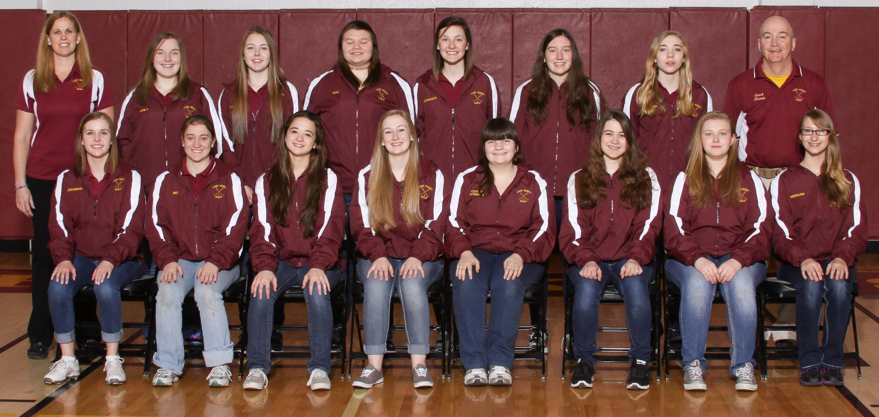

Front Row: Johanna Stinson, Mo Wall, Ashley Triviso, Elyse Adams, Raenita Berlinger, Katha Maucher, Hannah Schweitzer, Morgan Davis Back Row: Coach Stinson. Emily Highfill, Kara Neal, Kali Duncan, Adrianna Irvine, Julia Vogt, Tori Shelton, Coach Koontz State Qualifiers: Neal, Irvine, Stinson, Schweitzer

2016 State Golf Meet
Hamilton Golf Club
Coach Stinson, Johanna Stinson, Hannah Schweitzer, Adrianna Irvine, Kara Neal
Team-4th Place
Johanna Stinson-3rd Medalist

2015 Lady Husky Golf
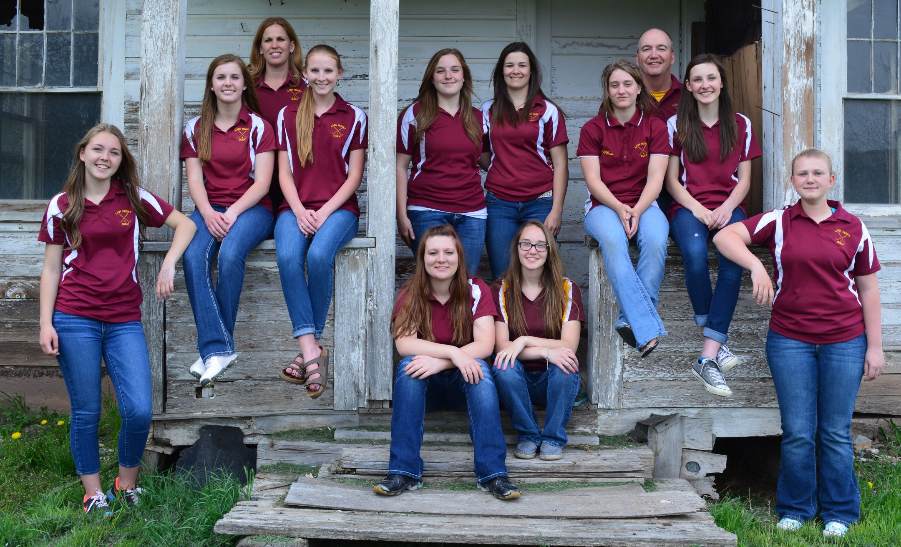
Front Row: Kara Neal, Amanda Hunsaker, Lindsay Ryan, Hannah Schweitzer Middle Row: Johanna Stinson. Hannah Reiser, Emily Highfill, Dakota Romero, Mo Wall, Adrianna Irvine Back Row: Coach Stinson, Coach Koontz State Qualifiers: Stinson, Irvine, Schweitzer, Romero

2014 State Meet
2015 State Meet
Marias Valley-Shelby
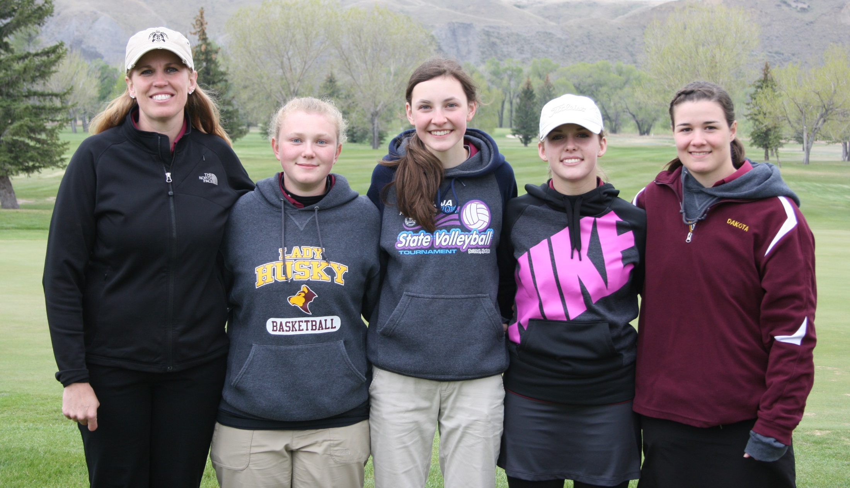
Coach Stinson, Hannah Schweitzer, Adrianna Irvine, Johanna Stinson, Dakota Romero
Team-3rd Place
Johanna Stinson-2nd Medalist

2014 Lady Husky Golf

Coach Stinson, Josie Stinson, Amanda Hunsaker, Hannah Reiser, Samantha Gondeiro, Brittney Garrison,
Adrianna Irvine, Mary Kate Maki, Emily Highfill, Johanna Stinson, Mo Wall Coach Koontz
State Qualifiers-Stinson, Stinson, Gondeiro

2014 State Meet
Double Arrow-Seeley Lake
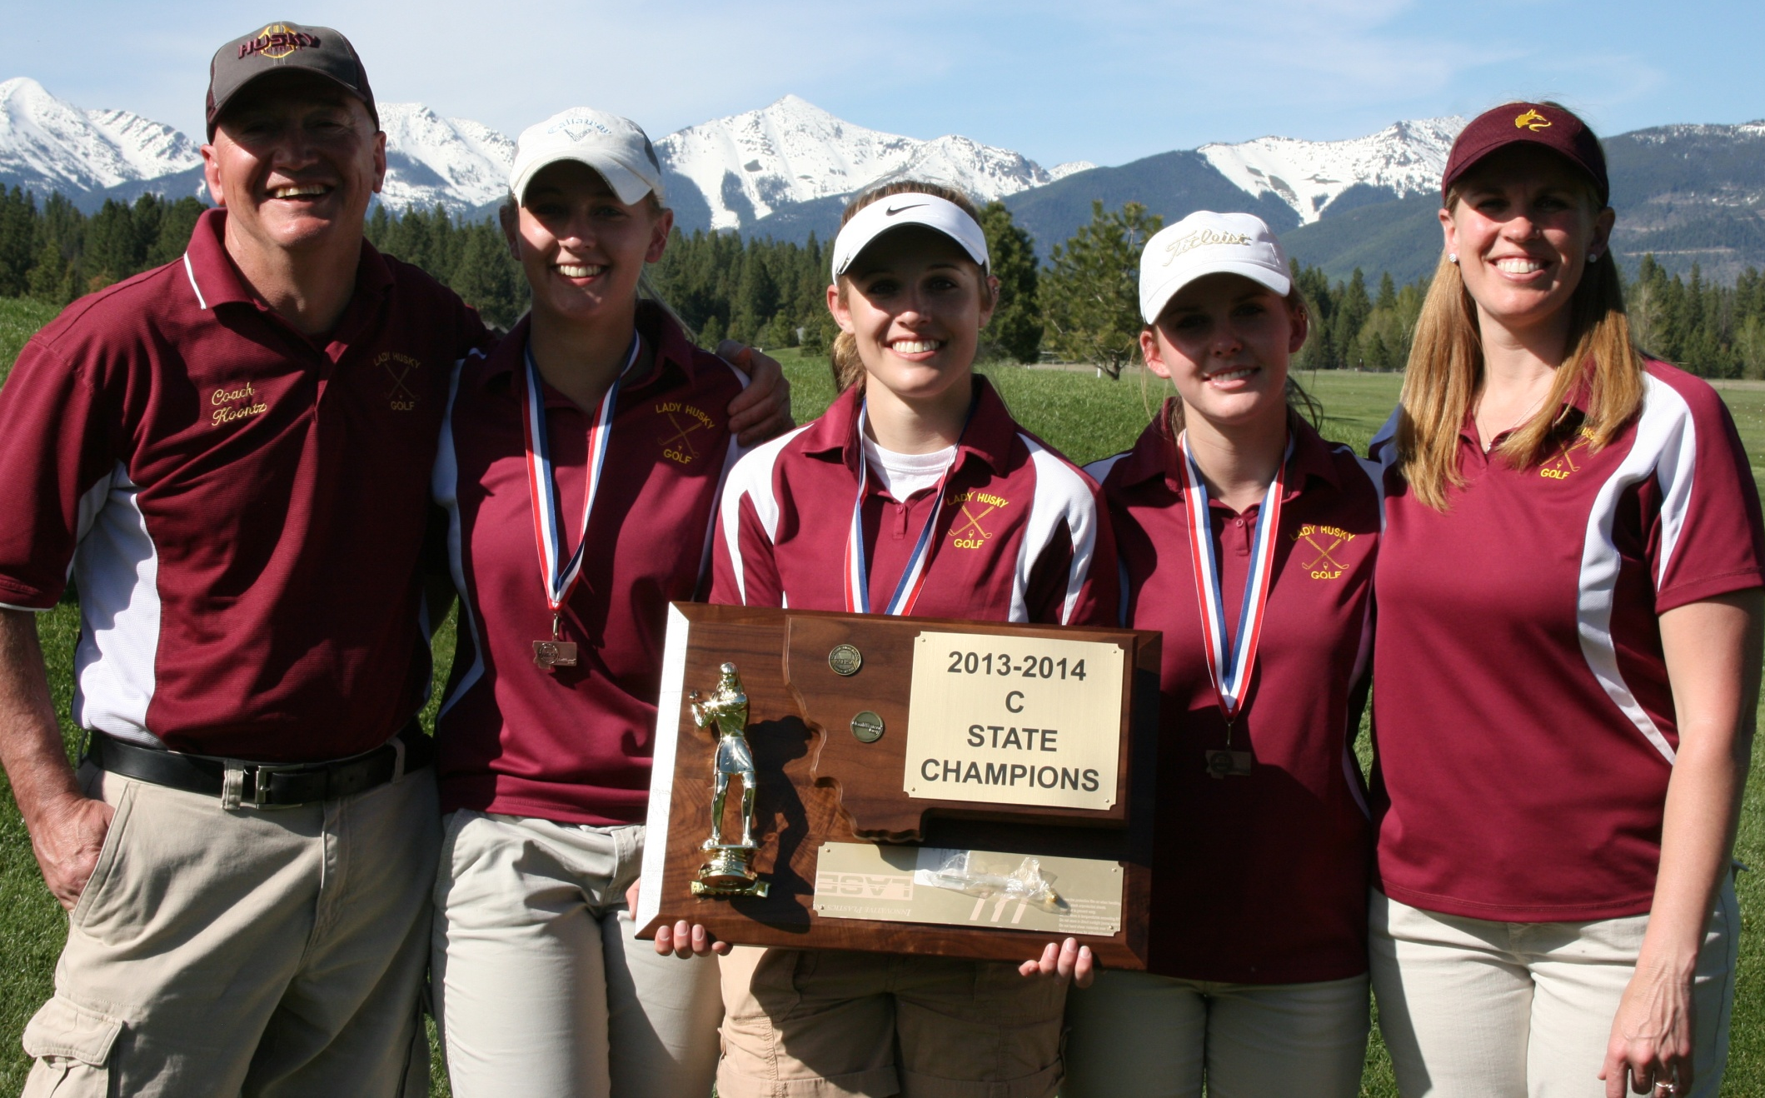
Coach Koontz, Samantha Gondeiro, Josie Stinson, Johanna Stinson, Coach Stinson
Team-1st Place
Josie Stinson-State Champion Johanna Stinson-4th Medalist
Samantha Gonderio-10th Medalist

2013 Lady Husky Golf
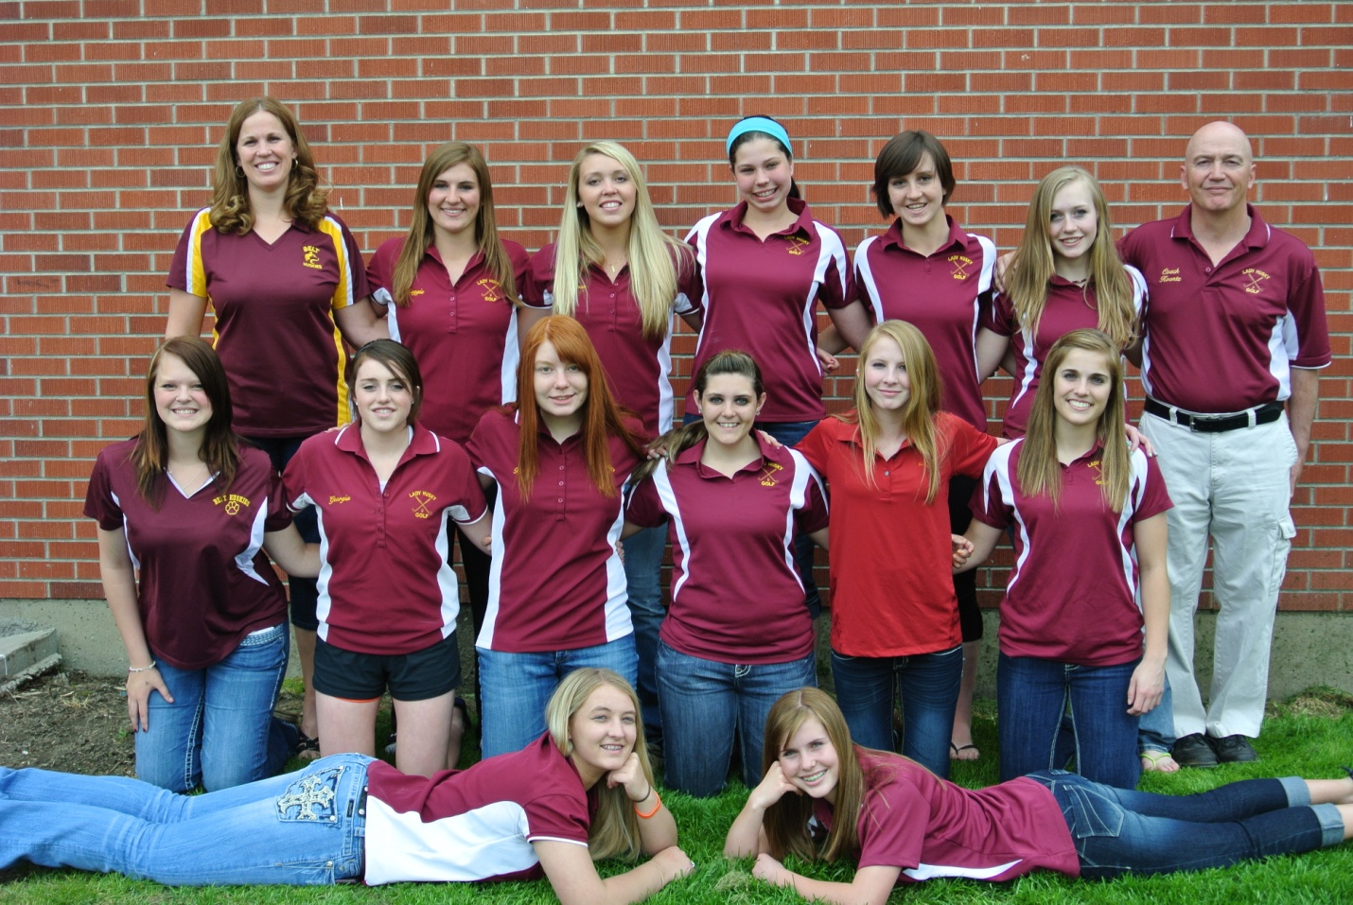
Back-Coach Stinson, Maggie Croff, Kieran Bergstrom, Makenzie Downard, Taylor Hoyer, Kiley Smith, Coach Koontz
Middle -Mary Kate Maki, Georgia Shultz, Teryn Botti-Anderson, Kendra Sanborn, Hannah Reiser, Josie Stinson
Front -Samantha Gondeiro, Johanna Stinson
State Qualifiers- Stinson, Shultz, Croff, Stinson, Hoyer, Gondeiro, Bergstrom

2013 State Meet
Madison Meadows-Ennis
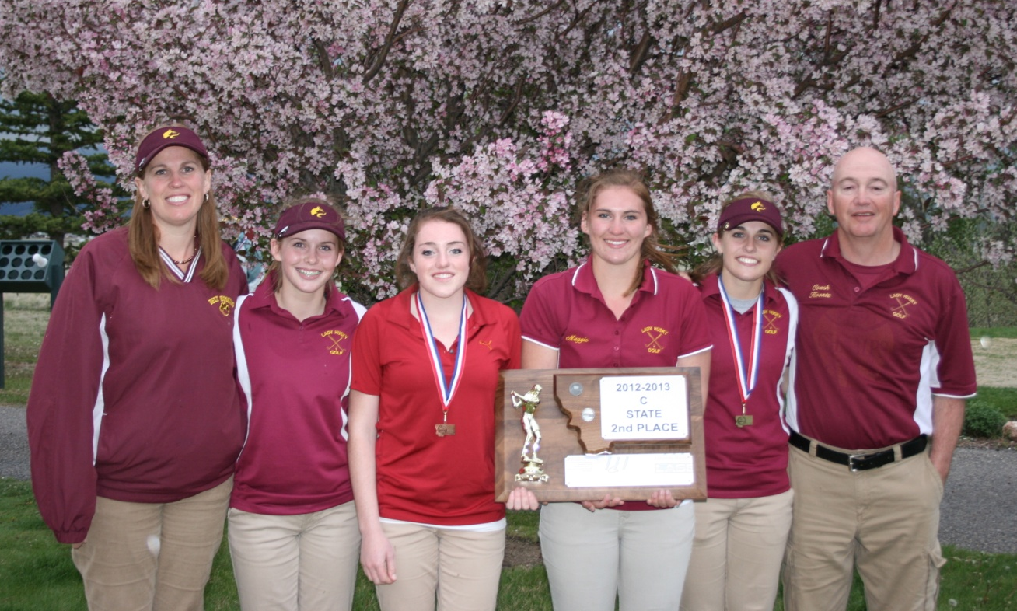
Coach Stinson, Johanna Stinson, Georgia Shultz, Maggie Croff, Josie Stinson, Coach Koontz
Team-2nd Place
Josie Stinson-State Champion Georgia Shultz-12th Medalist

2012 Lady Husky Golf
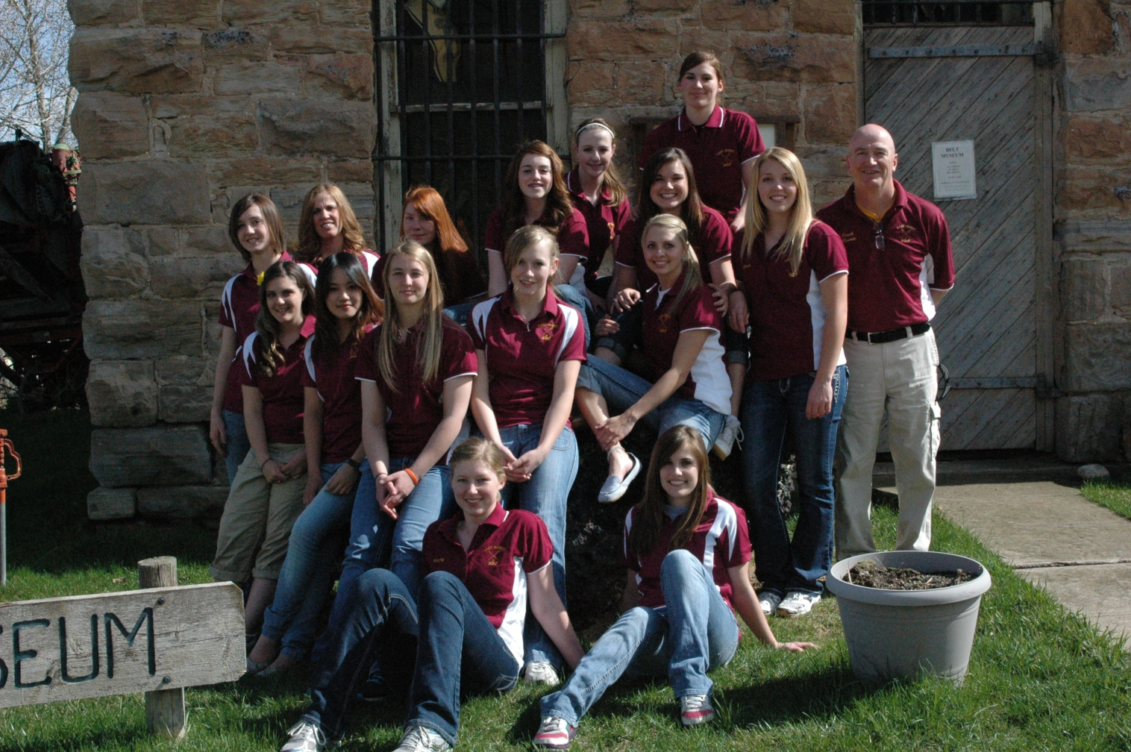
Back-Taylor Hoyer, Coach Stinson, Teryn Botti-Anderson, Georgia Shultz, Willow Wall, Maggie Croff
2nd Row-Heather Wall, Kieran Bergstrom, Coach Koontz
3rd Row-Kendra Sanborn, Lalisa Triratanajarasporn, Samantha Gondeiro, Kiley Smith, Markie Muretta
Front-Katie McKinney, Josie Stinson
State Qualifiers- Triratanajarasporn, Stinson, Croff, H. Wall, W. Wall, Shultz, Bergstrom, Hoyer, Botti-Anderson,

2012 State Meet
Madison Meadows-Ennis
Lalisa Triratanajarasporn, Coach Koontz, Heather Wall, Georgia Shultz, Coach Stinson, Josie Stinson
Team-2nd Place
Lalisa Triratanajarasporn-5th Medalist Josie Stinson-10th Medalist

2011 Lady Husky Golf
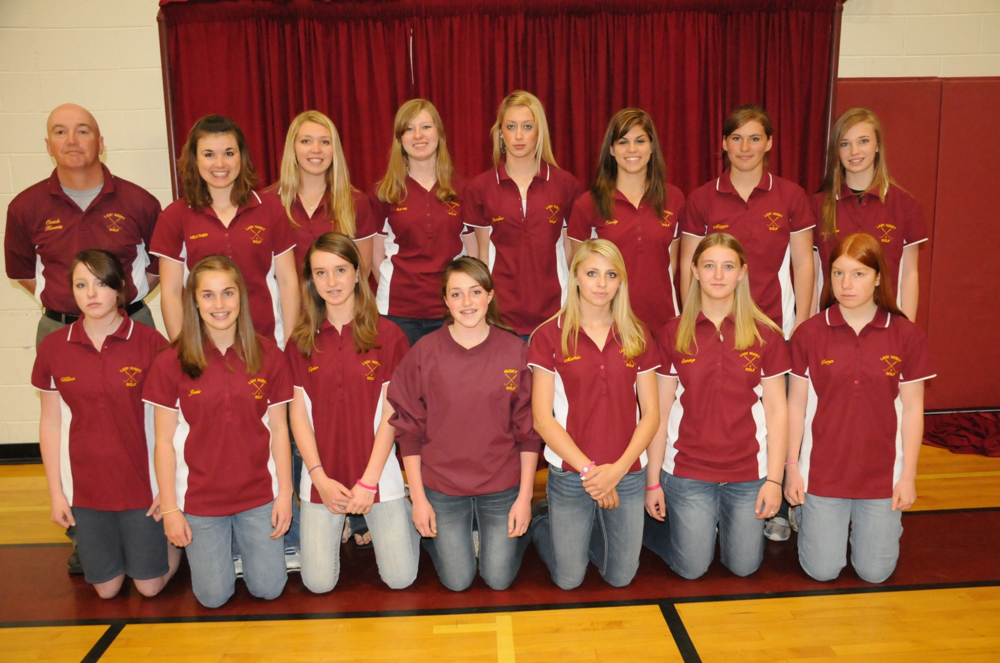
Back-Coach Koontz, Heather Wall, Kieran Bergstrom, Katie McKinney, Jennika O’Neil, Emily Urick, Maggie Croff, Meaghan Winder
Front-Willow Wall, Josie Stinson, Taylor Hoyer, Georgia Shultz, Markie Muretta, Samantha Gondeiro, Teryn Botti-Anderson,
Inset-Noelle Watters
State Qualifiers- Urick, Croff, H. Wall, Shultz, Watters, Stinson

2011 State Meet
Marias Valley-Shelby
Heather Wall, Maggie Croff, Coach Koontz, Georgia Shultz, Emily Urick
Team-5th Place
Emily Urick-5th Medalist
2010 Lady Husky Golf
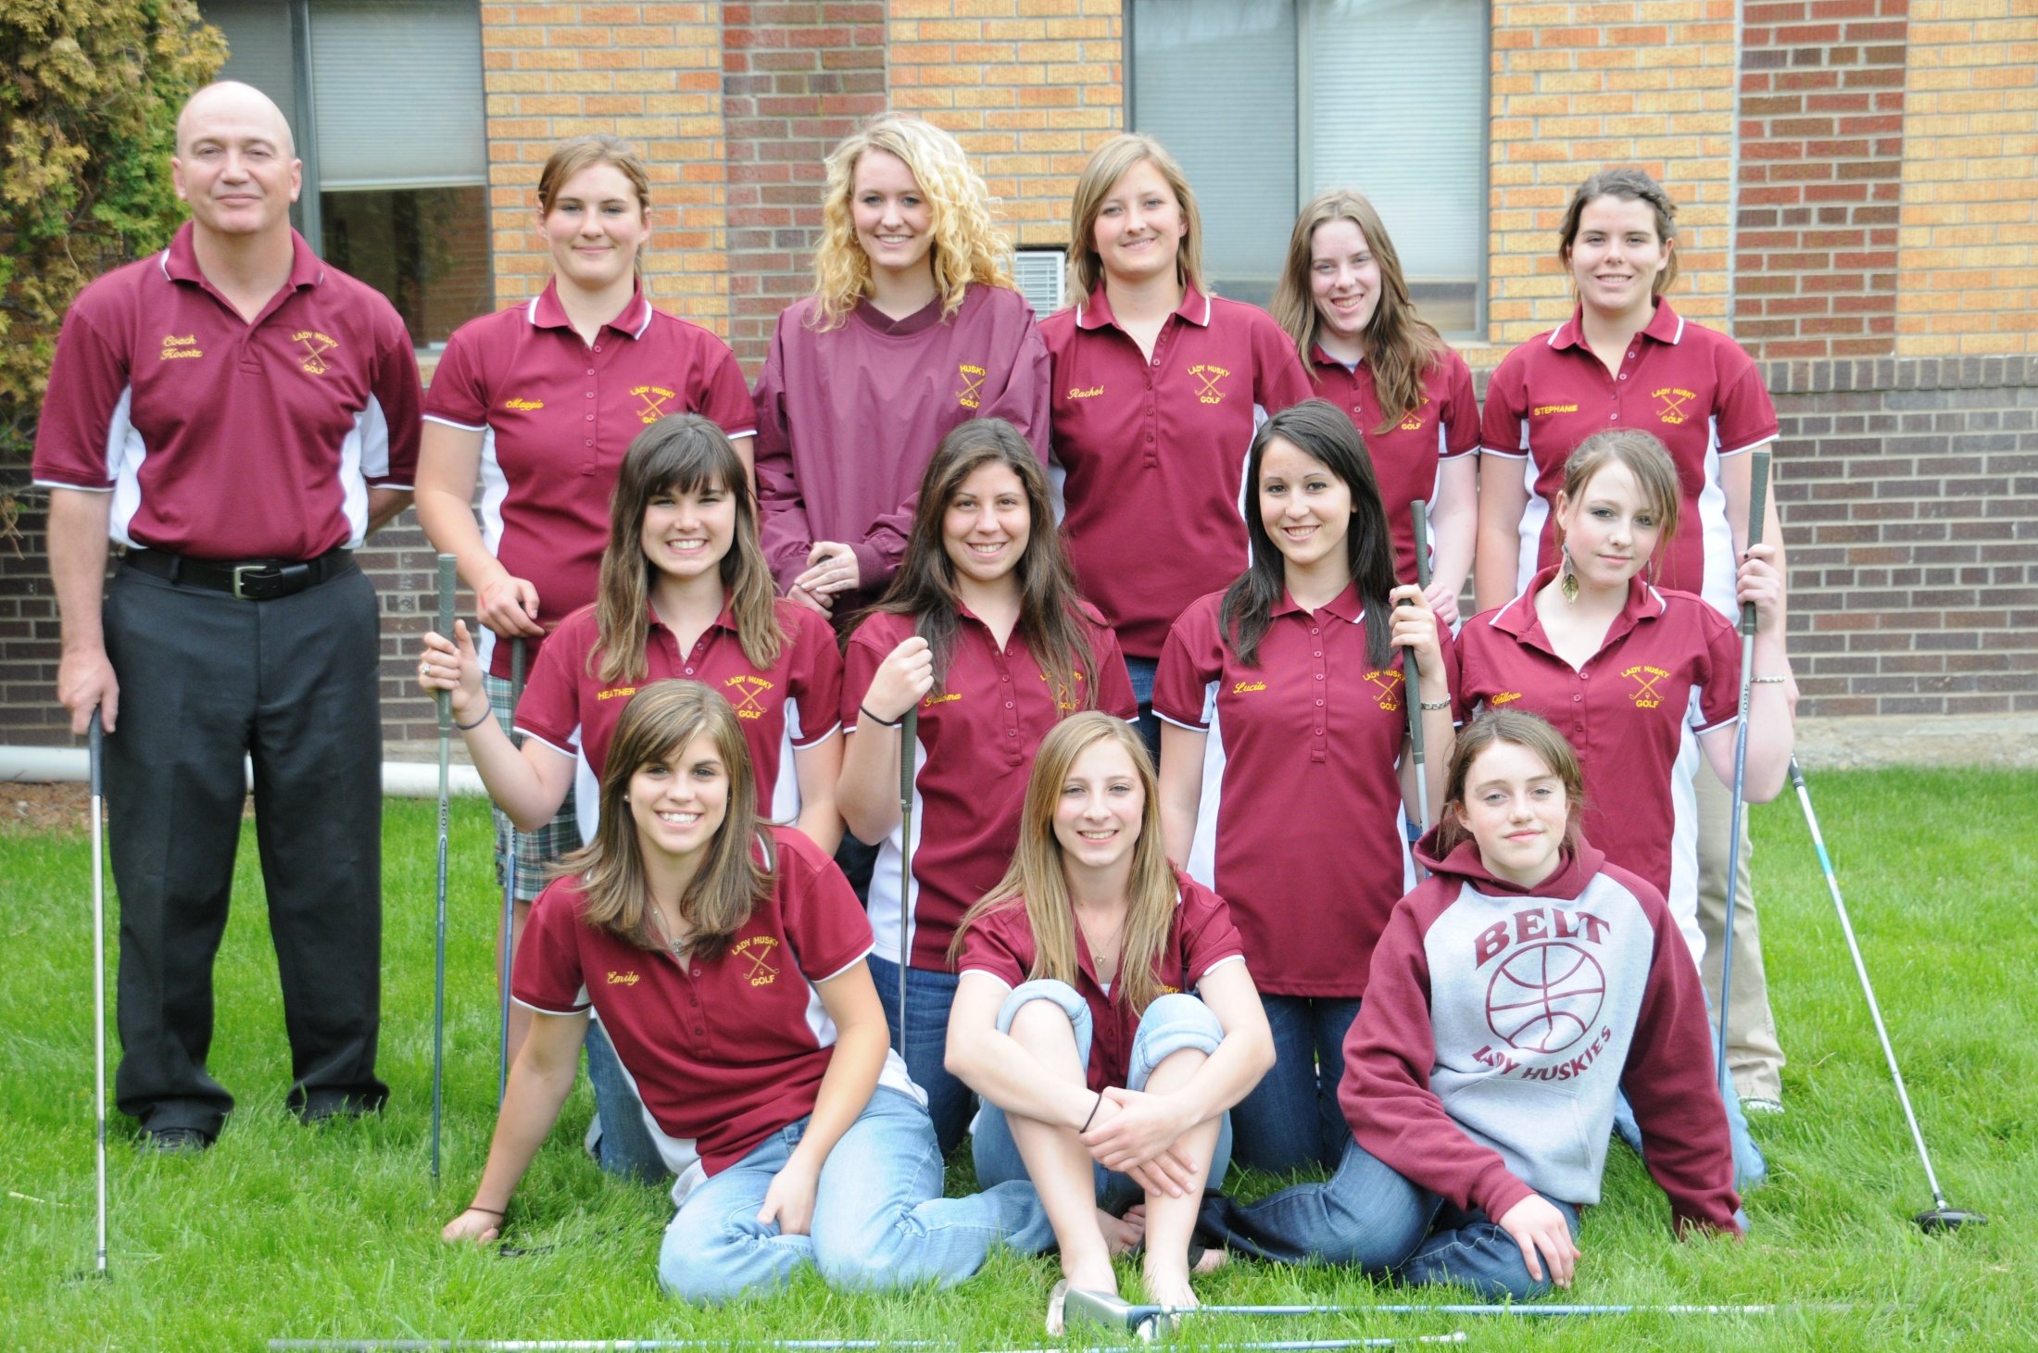
Back-Coach Koontz, Maggie Croff, Devan Visocan, Rachel Keith, Kaylene Smith, Stephanie Back
Middle-Heather Wall, Paloma Fernandez-Couto, Lucile Bernard, Willow Wall
Front-Emily Urick, Noelle Watters, Georgia Shultz
State Qualifiers- Urick, Back, Keith, H. Wall

2010 State Meet
Madison Meadows-Ennis
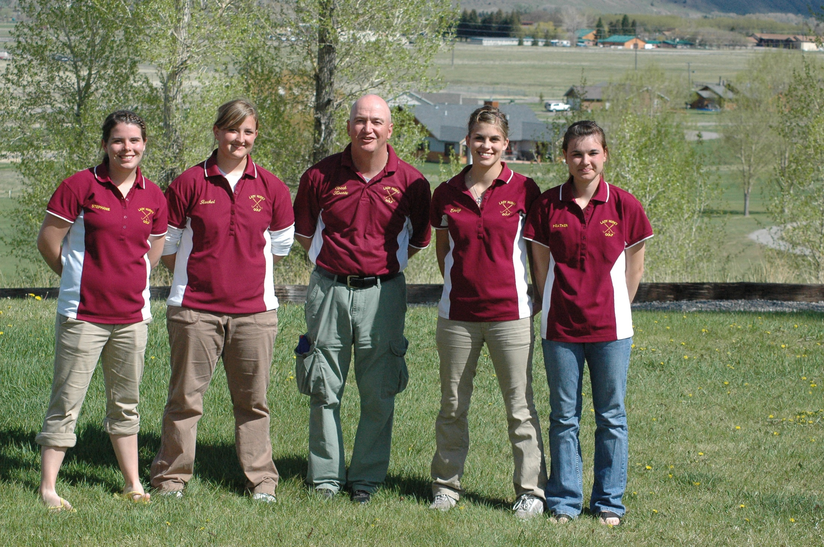

Stephanie Back, Rachel Keith, Coach Koontz, Emily Urick, Heather Wall
Team-5th Place
Emily Urick-10th Medalist
2009 Lady Husky Golf
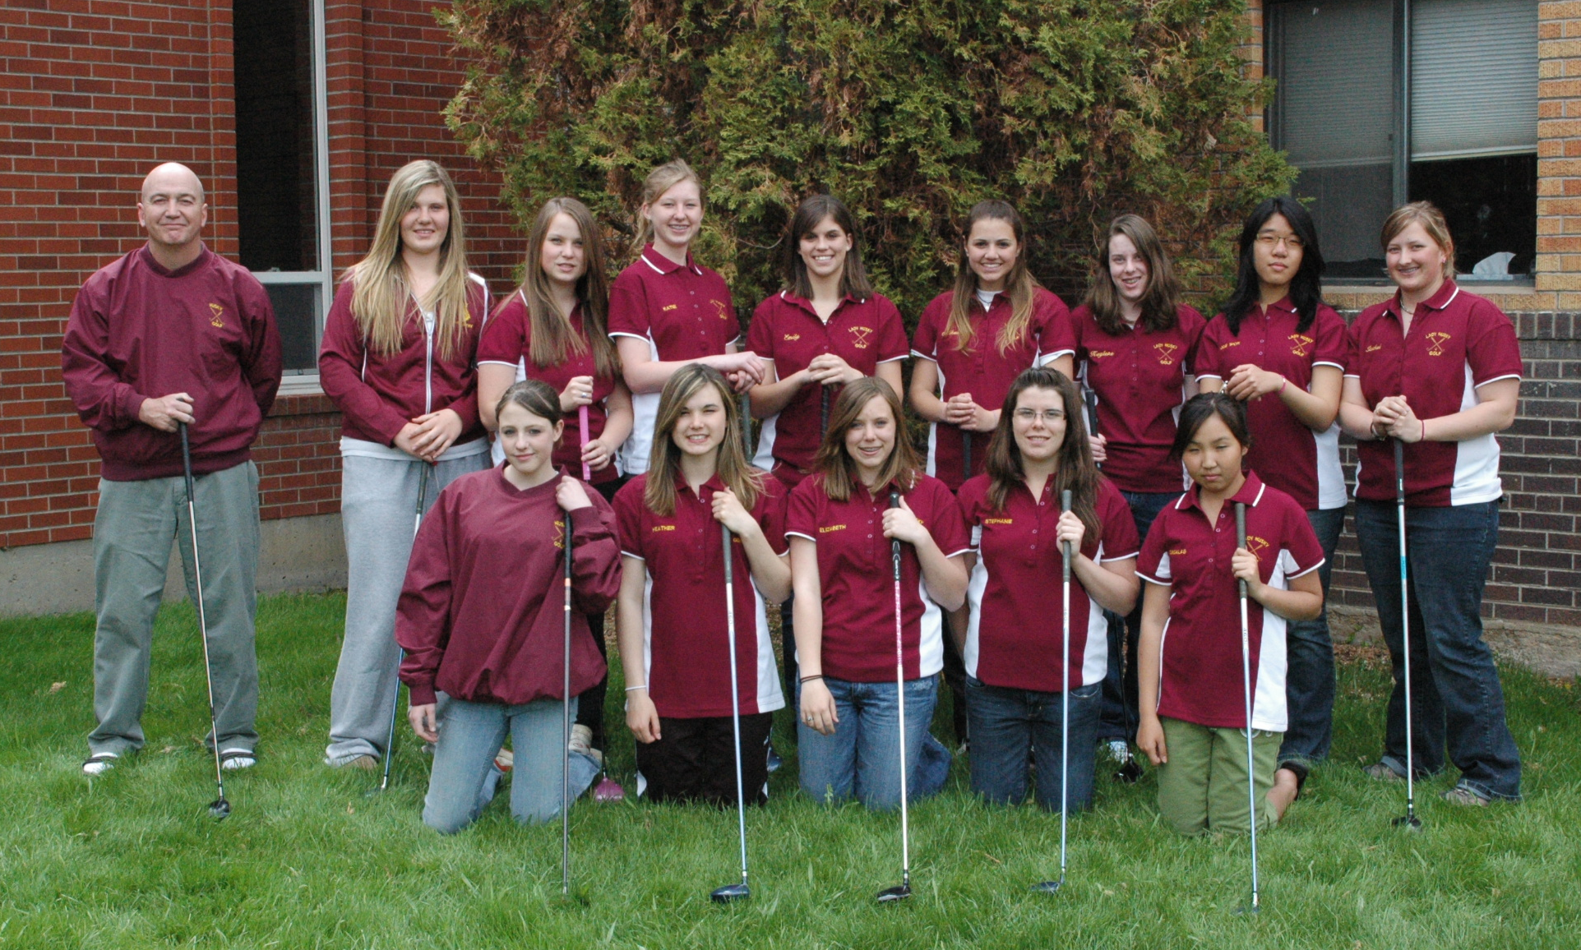
Back-Coach Koontz, Stasha Permann, Kate Dawson, Katie McKinney, Emily Urick, Mikaila Stinar, Kaylene Smith,
Jae Won Jeon, Rachel Keith
Front-Willow Wall, Heather Wall, Elizabeth Harrison, Stephanie Back, Tungalag Norov
State Qualifiers- Urick, Keith, Stinar, Dawson, H. Wall

2009 State Meet
Marion Hills-Malta
Mikaila Stinar, Rachel Keith, Emily Urick, Kate Dawson, Coach Koontz
Team-7th Place
Emily Urick-12th Medalist

2008 Lady Husky Golf
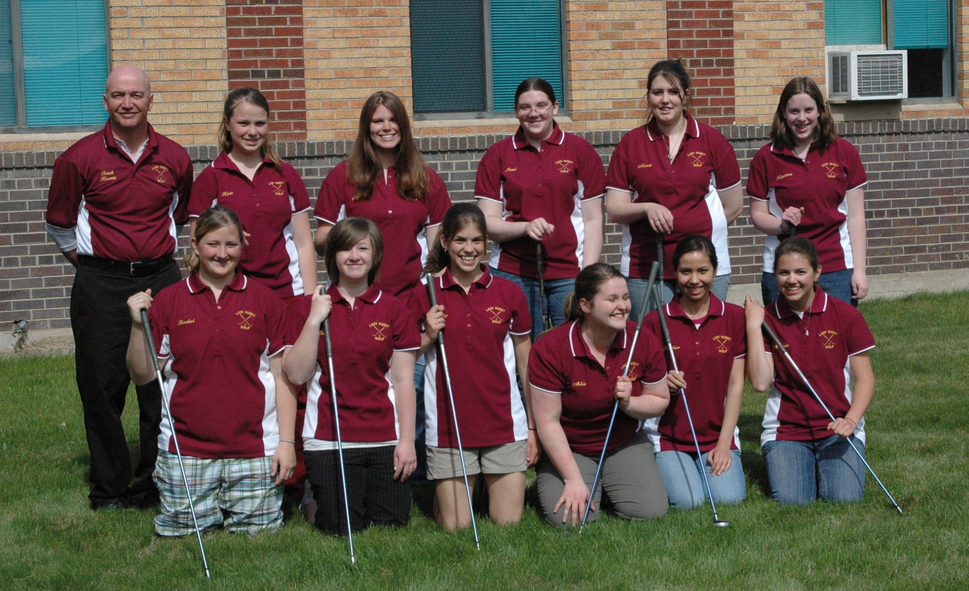
Back-Coach Koontz, Kate Dawson, Stephanie Blomgren, Jamie Dyson, Nicole Dickson, Kaylene Smith
Front-Rachel Keith, Jenie Ogle, Emily Urick, Abbie Mecham, Heather Franzen, Mikaila Stinar
State Qualifiers- Urick, Keith, Mecham, Stinar

2008 State Meet
Livingston Golf Club
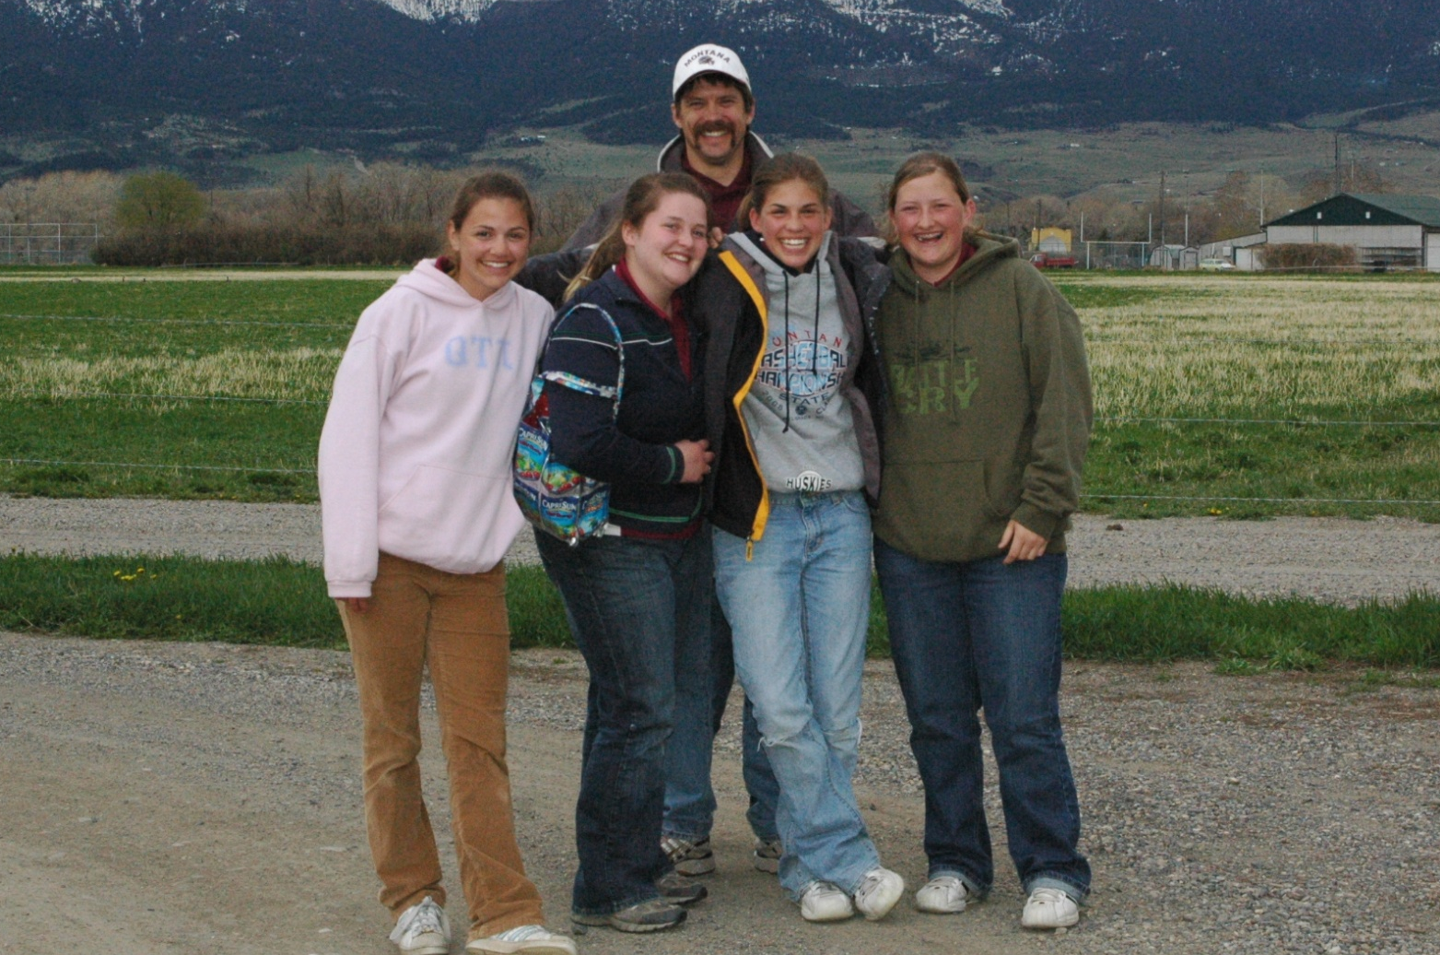
Mikaila Stinar, Abbie Mecham, Coach Matt Urick, Emily Urick, Rachel Keith
Team-7th Place
Lady Husky Golf Records
State Medalists:
Josie Stinson 1st (2013), 1st (2014), 10th (2012)
Johanna Stinson 3rd (2016), 2nd (2015), 4th (2014)
Emily Urick 5th (2011), 10th (2010), 12th (2009)
Lalisa Triratanajarasporn 5th (2012)
Samantha Gondeiro 10th (2014)
Georgia Shultz 12th (2013)
-Records-
Academic All-State Recognition:
4 Emily Urick, 4 Josie Stinson, 4 Johanna Stinson
Low Team Score:
287 J. Stinson, J. Stinson, S. Gondeiro-2014 Double Arrow (Seeley Lake)
State Medalists:
3 Emily Urick, 3 Josie Stinson, 3 Johanna Stinson
Low State Score (36 Holes):
174 Josie Stinson-Madison Meadows (Ennis)
Low State Round (18 Holes):
85 Johanna Stinson-2015 Marias Valley (Shelby)
Low 18 Hole Round:
85 Josie Stinson-2014 Pondera Country Club (Conrad), 85 Johanna Stinson-2015 Marias Valley (Shelby)
Low Career Average (4 Years)
102.5-Johanna Stinson
Low Season Average:
92.6 Josie Stinson-2014
Low Rookie Average:
117.3 Johanna Stinson-2013
Sub 100 Club:
Emily Urick Lalisa Triratanajarasporn Josie Stinson Georgia Shultz Johanna Stinson
Sub 90 Club:
Josie Stinson Johanna Stinson
Four Year Lettermen:
Emily Urick, Heather Wall, Josie Stinson, Johanna Stinson
Meet Scores
2016
Player | Marias Valley | Signal Point | Choteau | Marias Valley | Arrow-  Head G.C. | Hamilton | Signal Point | Chinook | Hamilton | Hamilton | Meet Average
Johanna Stinson#+ | 95 | 99 | 99 |  | 89 | 93 | 100 | 94 | 101 | 93 | 95.8
Hannah Schweitzer#+ | 118 | 118 | 112 | 109 | 104 | 113 | 120 | 122 | 129 | 113 | 115.8
Kara Neal#+ | 138 | 115 | 109 |  |  | 127 | 138 | 110 | 117 | 112 | 117.6
Adrianna Irvine#+ | 120 | 123 | 107 | 125 | 132 | 122 | 138 | 125 | 128 | 133 | 125.3
Mo Wall | 141 | 135 | 130 | 126 | 121 |  | 137 | 129 |  |  | 131.2
Kali Duncan | 141 | 137 | 124 | 137 | 134 |  | 127 | 135 |  |  | 134
Emily Highfill | 125 | 141 | 125 | 141 | 132 |  |  | 141 |  |  | 134.1
Tori Shelton |  | 165 | 141 | 149 | 142 |  | 143 | 135 |  |  | 145.8
Katha Maucher |  | 172 | 152 | 150 | 129 |  | 140 |  |  |  | 148.6
Elyse Adams |  |  | 154 |  |  |  | 146 |  |  |  | 150
Ashley Triviso |  | 146 |  |  |  |  | 157 |  |  |  | 151.5
Morgan Davis |  | 169 |  |  |  |  | 153 |  |  |  | 161
Raenita Berlinger |  | 180 |  |  | 163 |  | 167 |  |  |  | 170
Team Score | 333* | 340* | 427 | 371 | 325* | 328 | 333* | 326* | 346 | 318
#-Letter Winners +-Academic All State *Team Victory

2015
Player | Marias  Valley | Marias Valley | Choteau | Signal Point | Signal Point | Conrad | Conrad | Chinook | Marias  Valley | Marias  Valley | Meet Avg.
Johanna Stinson#+ |  | 103 | 97 | 105 | 101 | 94 |  | 91 | 91 | 85 | 95.8
Adrianna Irvine#+ |  |  | 132 | 124 | 126 | 128 | 116 | 125 | 125 | 121 | 124.6
Hannah Schweitzer#+ | 138 | 140 | 127 | 127 | 129 | 117 | 124 |  | 129 | 113 | 127.1
Dakota Romero#+ | 158 | 126 | 123 | 135 | 136 | 126 | 129 | 113 | 124 | 131 | 130
Kara Neal#+ | 152 | 147 |  | 130 | 119 | 121 | 123 | 122 |  |  | 131.4
Hannah Reiser#+ | 146 |  | 129 | 133 |  |  |  | 134 |  |  | 135.5
Emily Highfill | 154 |  | 139 | 134 | 142 |  | 132 | 139 |  |  | 140
Mo Wall |  |  | 151 | 154 | 130 |  | 135 | 131 |  |  | 140.2
Amanda Hunsaker | 154 | 143 |  | 154 | 142 |  |  |  |  |  | 148.2
Lindsay Ryan |  |  |  | 167 |  |  | 151 | 159 |  |  | 159
Team Score | 592 | 369 | 479* | 362* | 356* | 458 | 363 | 326* | 340 | 319
#-Letter Winners +-Academic All State *Team Victory

2014
Player | Signal Point | Choteau  C. C. | Signal Point | Conrad  C. C. | Signal Point | Chinook  G. C. | Double Arrow | Double Arrow | Meet Avg.
Josie Stinson # + | 102 | 88 | 93 | 85 | 100 | 89 | 94 | 90 | 92.6
Johanna Stinson # + | 110 | 98 | 107 | 97 | 106 | 102 | 96 | 94 | 101.2
Sammy Gondeiro # + | 119 | 114 | 107 | 126 | 103 | 115 | 114 | 103 | 112.6
Brittney Garrison |  |  |  |  | 140 |  |  |  | 140
Hannah Reiser | 157 | 138 | 138 | 145 | 148 |  |  |  | 145.2
Mary Kate Maki | 148 | 137 |  | 146 | 153 |  |  |  | 146
Adrianna Irvine | 177 |  | 149 |  | 144 | 151 |  |  | 155.2
Emily Highfill | 178 |  | 148 |  | 149 | 156 |  |  | 158
Amanda Hunsaker |  |  | 151 |  | 165 | 169 |  |  | 161.7
Mo Wall | 175 |  |  |  | 160 | 171 |  |  | 168.7
Team Score | 329* | 437* | 307* | 454 | 309* | 306* | 304 | 287*

#-Letter Winners +-Academic All State *Team Victory

2013
Player | Marias Valley | Signal Point | Fairfield  (9) | Choteau  C. C. | Choteau  C. C. | Signal Point | Marias Valley | Chinook  G. C. | Madison  Meadows | Madison  Meadows | Meet Avg.
Josie Stinson #+ | 94 | 97 | 44 |  | 101 | 99 | 93 | 104 | 87 | 87 | 94.4
Georgia Shultz #+ | 111 | 114 | 50 | 104 |  | 106 | 103 | 109 | 105 | 99 | 105.6
Maggie Croff #+ | 111 | 110 |  |  | 106 | 106 | 117 | 111 | 118 | 111 | 111.2
Johanna Stinson #+ | 122 | 119 | 65 |  | 113 | 124 | 108 | 123 | 108 | 109 | 117.3
Taylor Hoyer # | 116 | 128 | 54 | 117 | 113 |  | 125 | 123 |  |  | 118.5
Sammy Gondeiro #+ | 126 | 141 |  | 115 |  | 122 |  | 109 |  |  | 122.6
Kieran Bergstrom #+ | 125 | 132 | 58 |  |  |  | 116 | 142 |  |  | 126.2
Teryn B-Anderson | 125 | 132 |  |  | 126 | 123 |  | 126 |  |  | 126.4
Kiley Smith |  | 136 |  |  |  |  |  | 146 |  |  | 141
Kendra Sanborn |  | 149 |  | 138 |  | 135 |  | 151 |  |  | 143.2
Mary Kate Maki |  | 180 |  | 139 |  | 151 |  | 147 |  |  | 154.2
M. Downard |  | 170 |  |  | 143 | 142 |  | 163 |  |  | 154.5
Hannah Reiser |  | 171 |  | 157 |  |  |  | 143 |  |  | 156
Team Score | 441* | 323* | 206* | 477 | 433 | 311* |  | 324* | 300 | 295
#-Letter Winners +-Academic All State *Team Victory

2012
Player | Marias Valley | Signal Point | Choteau  C. C. | Choteau  C. C. | Signal Point | Chinook  G. C. | Ennis | Ennis | Meet Avg.
L. Trirattanajarasporn # | 108 | 112 | 100 |  |  | 104 | 102 | 95 | 101
Josie Stinson #+ | 112 | 117 | 105 | 102 | 117 | 108 | 98 | 103 | 107.7
Georgia Shultz #+ | 126 | 115 | 109 | 106 | 119 | 108 | 110 | 108 | 112.6
Willow Wall # | 120 | 128 | 105 | 105 | 123 | 117 |  |  | 116.3
Heather Wall # | 122 | 112 |  | 108 | 125 | 119 | 112 | 124 | 117.4
Kieran Bergstrom #+ |  | 133 | 115 | 118 | 123 |  |  |  | 122.2
Maggie Croff #+ | 113 | 124 | 115 | 129 | 128 | 137 |  |  | 124.3
Taylor Hoyer # | 139 | 144 | 129 | 119 | 126 | 128 |  |  | 130.8
Markie Muretta |  | 140 |  |  | 123 |  |  |  | 131.5
Teryn Botti-Anderson #+ |  | 156 | 119 | 111 | 132 | 149 |  |  | 133.4
Sammy Gondeiro | 144 | 163 | 131 | 124 | 129 | 135 |  |  | 137.6
Kiley Smith |  | 146 | 128 | 141 |  |  |  |  | 138.3
Kendra Sanborn |  | 163 |  |  | 135 | 158 |  |  | 152
Justine Marshall |  |  |  |  | 159 |  |  |  | 159
Katie McKinney #+ |  | 165 |  |  | 169 | 156 |  |  | 163.3
Team Score | 342 | 339 | 419* | 421 | 359* | 320* | 310 | 306
#-Letter Winners +-Academic All State *Team Victory

2011
Players | Marias Valley | Signal Point | Choteau  C. C. | Choteau  C. C. | Signal Point | Marias Valley | Chinook  G. C. | Marias Valley | Marias Valley | Meet Avg.
Emily Urick # | 110 | 104 | 105 |  | 96 | 101 | 115 | 104 | 91 | 105.1
Maggie Croff #+ | 113 | 144 | 126 | 117 | 117 | 114 |  | 117 | 125 | 116.8
Heather Wall # | 130 | 113 | 117 |  | 118 | 112 | 116 | 108 | 119 | 117.6
Georgia Shultz #+ | 125 | 141 | 126 | 116 | 132 | 122 | 112 | 111 | 117 | 124.8
Noelle Watters # |  | 130 | 128 |  | 119 | 139 | 145 |  |  | 129
Willow Wall | 149 | 135 |  | 121 | 134 | 136 | 124 |  |  | 135
Taylor Hoyer | 135 | 135 |  | 123 | 149 |  | 171 |  |  | 135.5
Josie Stinson #+ | 149 |  |  | 127 | 139 | 132 | 120 |  |  | 136
Kieran Bergstrom | 141 | 136 |  | 124 | 143 | 138 | 140 |  |  | 136
Markie Muretta | 142 |  |  |  | 132 |  | 147 |  |  | 137
Jennika O’Neil | 145 |  |  |  | 147 |  |  |  |  | 146
Sammy Gondeiro | 153 | 148 |  | 142 | 155 |  | 143 |  |  | 149.5
Teryn Botti-Anderson | 167 |  |  | 146 | 155 |  |  |  |  | 156
Katie McKinney | 156 |  |  | 161 | 155 |  |  |  |  | 157.3
Meaghan Winder |  |  |  | 123 |  |  | 143
Team Score | 468 | 358 | 474 | 478 | 331 | 327 | 343* | 323 | 327
#-Letter Winners +-Academic All State *Team Victory

2010
Player | Marias Valley | Signal Point | Marias Valley | Choteau  C. C. | Choteau  C. C. | Signal Point (9) | Chinook  G. C. | Ennis | Ennis | Meet Avg.
Emily Urick #+ | 116 | 105 | 97 | 110 |  | 61 | 103 | 108 | 105 | 106.2
Stephanie Back # | 114 | 109 | 110 | 118 |  |  |  | 128 | 124 | 112.7
Rachel Keith #+ | 111 | 118 | 112 | 113 |  | 65 | 126 | 111 | 107 | 116
Heather Wall # | 128 | 123 |  | 116 |  | 62 | 147 | 114 | 127 | 122.3
Willow Wall # | 130 |  | 124 | 122 | 127 | 74 | 149 |  |  | 130.4
Maggie Croff | 128 | 138 |  |  |  | 67 | 152 |  |  | 139.3
Georgia Shultz | 149 | 163 | 132 | 128 | 129 | 67 | 152 |  |  | 142.1
Paloma Fdez-Couto |  |  | 135 |  | 142 | 75 | 167 |  |  | 148
Noelle Watters | 152 | 166 | 137 | 160 | 145 | 67 | 145 |  |  | 150.8
Devan Visocan | 163 |  | 147 |  |  | 82 |  |  |  | 155
Kaylene Smith # | 154 |  |  | 152 |  | 93 | 163 |  |  | 156.3
Lucile Bernard |  |  |  |  |  | 82 | 167 |  |  | 167
Team Score | 341 | 332 | 319 | 339 | 398 |  | 376 | 333 | 336
#-Letter Winners +-Academic All State

2009
Player | Marias Valley | Signal Point | Signal Point | Choteau  C. C. | Chinook  G. C. | Malta | Malta | Meet  Avg.
Emily Urick #+ | 105 | 103 | 109 | 114 | 109 | 114 | 105 | 108.4
Rachel Keith #+ | 130 | 119 | 101 | 136 |  | 119 | 135 | 123.3
Stasha Permann # |  |  | 121 | 135 | 122 |  |  | 126
Stephanie Back # | 143 | 126 | 112 | 134 | 118 |  |  | 126.6
Mikaila Stinar #+ | 138 | 120 | 111 | 141 |  | 137 | 122 | 128.1
Heather Wall # | 142 |  | 136 | 123 | 120 |  |  | 130.2
Kate Dawson #+ |  | 116 | 119 |  |  | 146 | 145 | 131.5
Elizabeth Harrison #+ | 152 |  | 128 | 145 | 122 |  |  | 136.7
Tungalag Norov |  |  | 147 | 143 | 130 |  |  | 140
Willow Wall | 164 |  | 134 | 159 | 140 |  |  | 149.2
Katie McKinney |  |  | 152 |  |  |  |  | 152
Jae Won Jeon |  |  | 141 | 166 |  |  |  | 153.5
Kaylene Smith | 169 | 164 | 164 | 166 |  |  |  | 165.7
Team Score | 373 | 338 | 321 | 385 | 349 | 370 | 362
#-Letter Winners +-Academic All State

2008
Player | Marias Valley | Signal Point | Anaconda Hills | Choteau  C. C. | Choteau  C. C. | Chinook  G. C. | Livingston | Livingston | Meet Avg.
Emily Urick #+ | 129 |  | 132 | 122 | 114 | 116 | 118 | 139 | 124.3
Rachel Keith #+ | 136 |  | 135 |  | 120 | 125 | 129 | 118 | 127.2
Abbie Meecham # |  |  | 136 | 130 | 113 | 105 | 133 | 163 | 130
Heather Franzen #+ |  |  | 142 |  |  | 125 |  |  | 133.5
Mikaila Stinar #+ | 147 | 130 | 144 | 147 | 126 | 119 | 145 | 133 | 136.4
Kate Dawson #+ |  |  | 142 | 152 |  |  |  |  | 147
Stephanie Blomgren # | 169 | 159 |  |  |  |  |  |  | 154
Jenie Ogle | 162 |  | 173 | 158 |  | 151 |  |  | 161
Kaylene Smith | 172 |  | 177 |  | 170 | 157 |  |  | 167.5
Jami Dyson | 179 |  |  |  |  |  |  |  | 179
Team Score | 412 |  | 409 | 399 | 347 | 340 | 380 | 390
#-Letter Winners +-Academic All State

