PROSPERITY-RIKARD
ELEMENTARY SCHOOL
“We’re All In This Together”

August 27, 2019

Dear Parents and Guardians,
Thank you all so much for a great first week of school! The teachers and students have worked very hard learning/reviewing the procedures for the classrooms, hallways, cafeteria and recess. We appreciate all of your hard work following the car line procedures as well. Just a few reminders for the car line. In the morning drop-off line, please make sure you pull up as far as you can and a staff member will help your child get out of the car. Please do not stop at the curve and let your child out. Also, please have your child exit on the right side of the car and do not pass any cars in the line. This is for the safety of your child and all other children at PRE. In the afternoon car line, please make sure you do not switch lanes once your number has been called. We ask that you do not talk on your phone and that you stay in your car at all times.
If you need to change your child’s transportation please send a note or come into the office to make the change. We will not accept phone calls to change the way your child gets home.
We will be starting with our Life Skills next week at school. Each Monday we will introduce a new Life Skill and then reflect on it each day. We ask that you talk with your child about the Life Skill and practice using it at home. I will have a section in the newsletter for the Life Skills.
This Friday is the last day to turn in your child’s summer reading log. We will let you know which MCHS football game your child will receive a ticket for as soon as we hear from the school.
I hope you have had time to review the handbook that your child brought home last week. If you have questions please don’t hesitate to call.

Mrs. Peel,
Principal

“At the end of the day, the most overwhelming key to a child’s success is the positive involvement of parents.” -Jane D. Hull
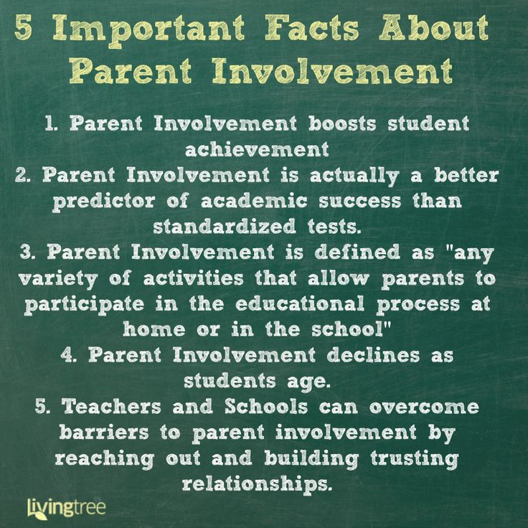
Box Tops
Please continue to collect Box Tops for our school. You can also download the APP to your phone and scan your receipt.
UPCOMING EVENTS
- August 30 – Last day to turn in Summer Reading Logs
- September 2 - LABOR DAY / NO SCHOOL
- September 10 - Ident-a-Kid
- September 17 - FALL PICTURES
- September 18 - Early Release @ 12:40
- September 19 - Interim Reports
- September 24 - Fund Raiser Kick Off
- September 24 – Boy Scout Interest Meeting @ 6:30

PTO NEWS
November 17 – 4th/5th PTO Program
December 19 – 2nd grade/PTO Program
March 12 – 1st grade/PTO Program
April 30 – 3rd grade/PTO Program
Kindergarten - TBA

Atención familias Hispanas: Si usted necesita traducción de este informativo, por
favor comuníquese con el Sr. Nunez al teléfono 803-271-2256.”

We are a Title One School and a
Farm To School Location

