Lancaster County Public Schools
September 2019 Lunch Menu for;
Lancaster Primary, Middle, & High School
Monday | Tuesday | Wednesday | Thursday | Friday
BREAKFAST-$1.20  REDUCED-.30  ADULT-2.00  LUNCH at LPS-2.65  LUNCH at LMS & LHS-  $2.75  REDUCED LUNCH-.40  ADULT LUNCH-$3.50  ADULT SUB & WRAP  LINE LUNCH-$4.00 | 3) Turkey Taco  WG Tortilla Chips  Corn  Pears  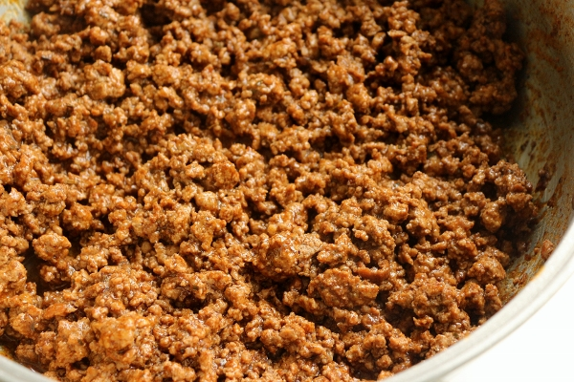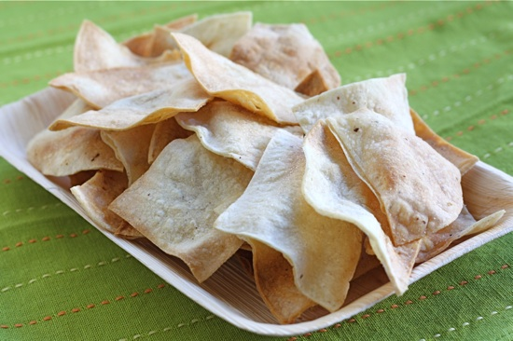 | 4) Teriyaki Chicken  WG Rice  Broccoli  Peaches  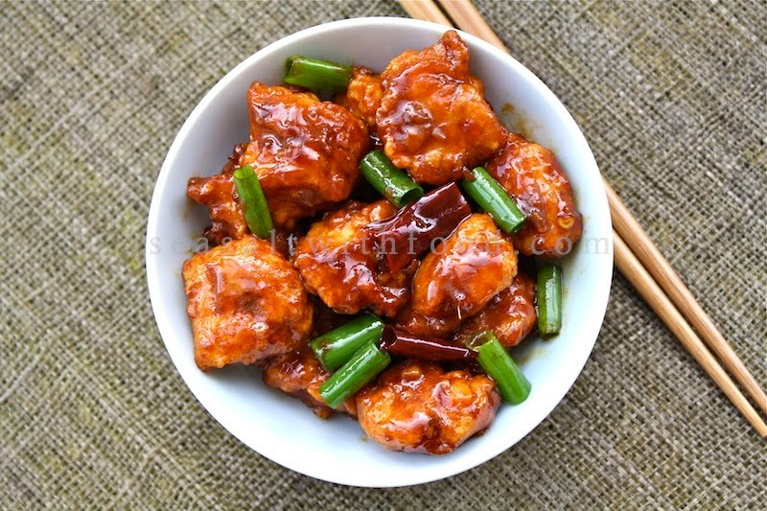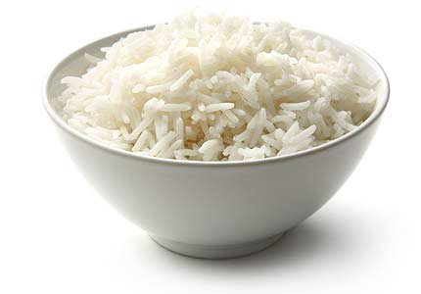 | 5) WG Chicken Tenders  Potato Wedges  Green Beans  Applesauce  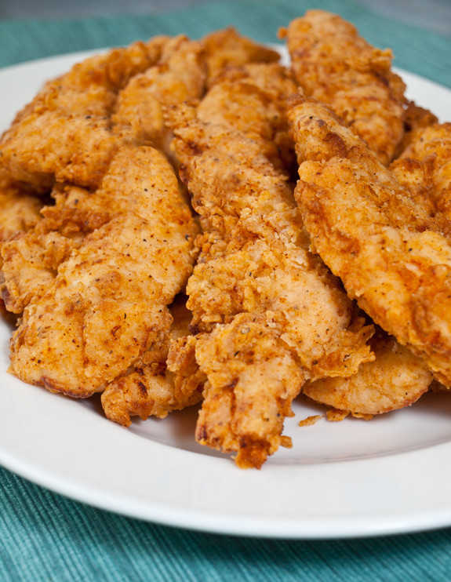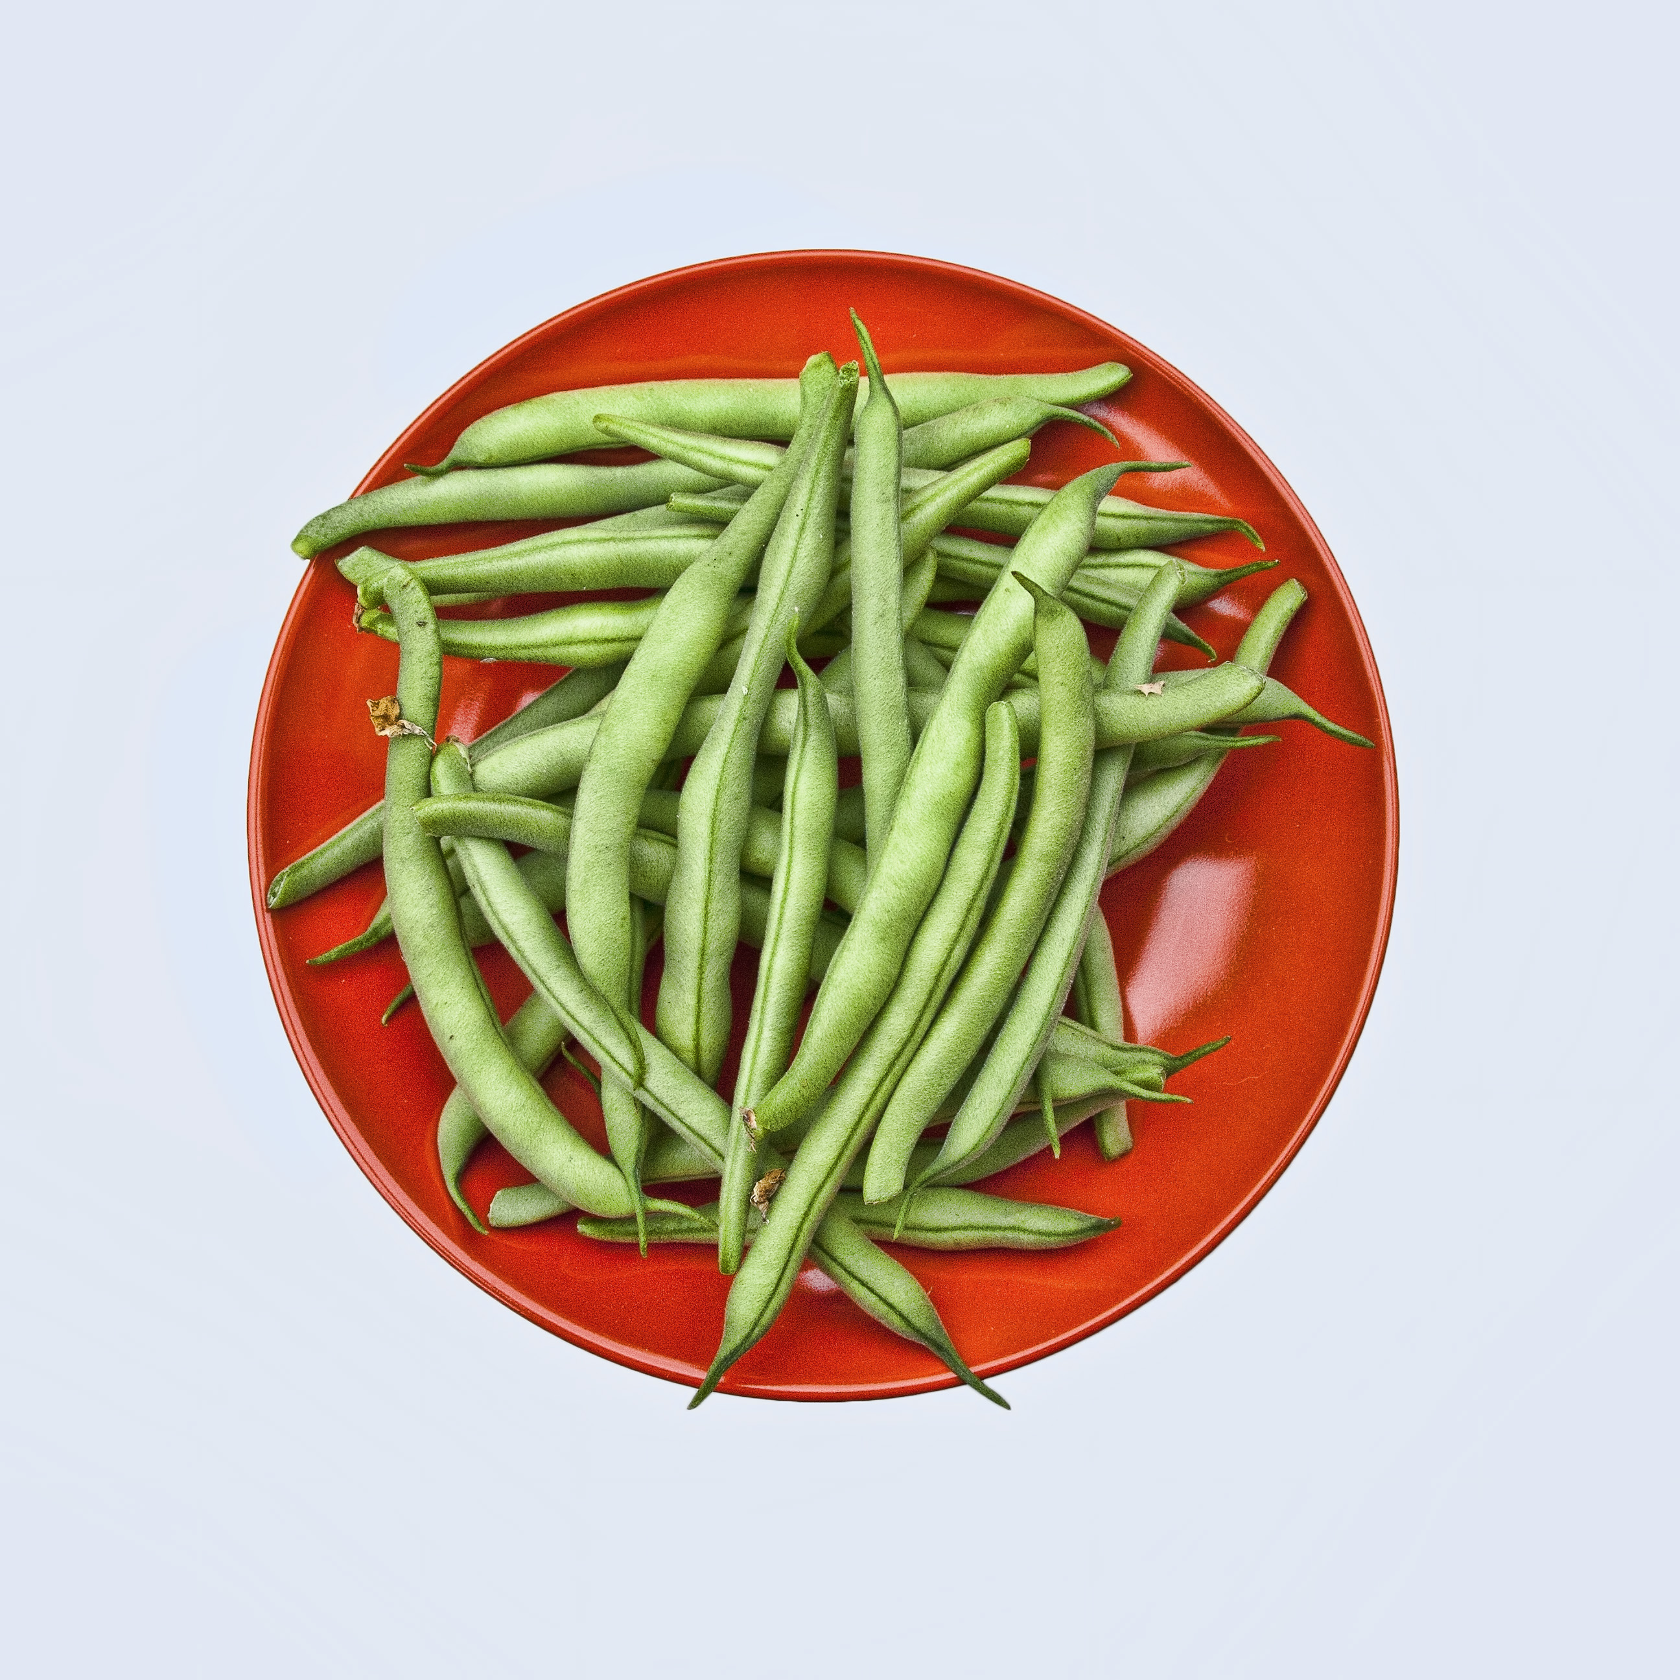 | 6) Steak & Cheese  WG Bun  Baked Beans  Pineapple Chunks  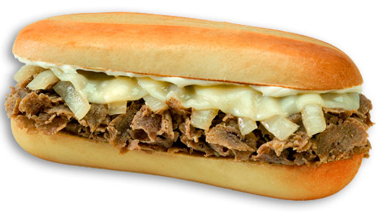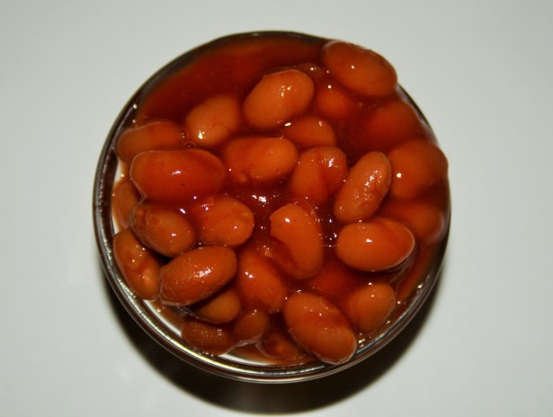
9) WG Corn Dog stick  Sweet Potatoes  Applesauce  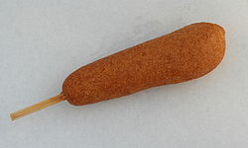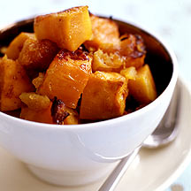 | 10) Pizza Pepperoni-WG  Green Beans  Mixed Fruit   | 11) WG Baked Spaghetti  Broccoli  Pears  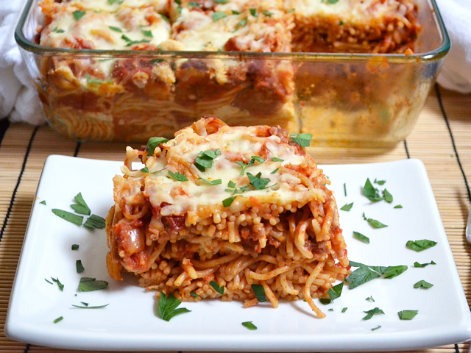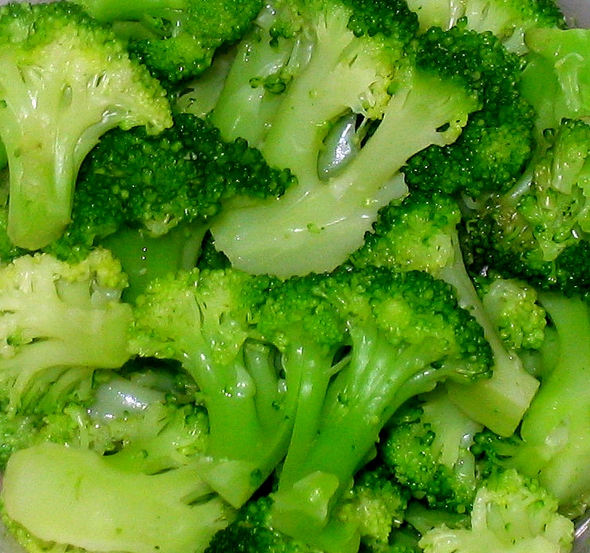 | 12) Chicken Patty  WG Bun  Potato Tots  Peaches  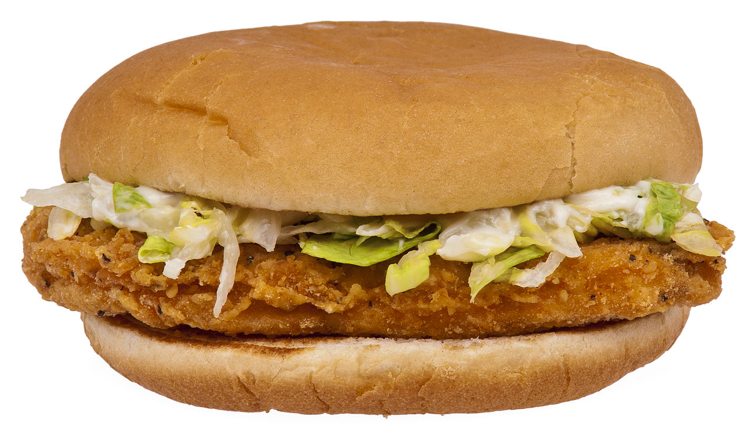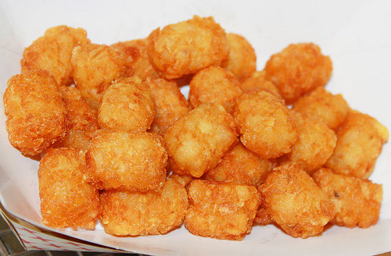 | 13) Cheeseburger on a  WG Bun  Baked Beans  Sliced Apples  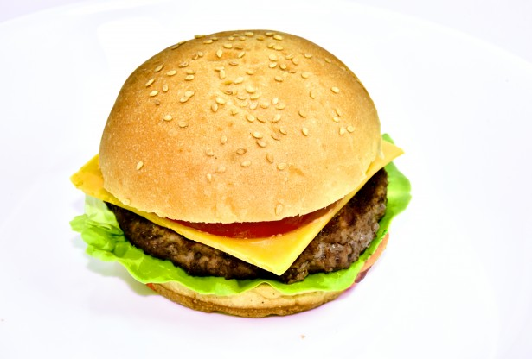
16) Beef Hot Dog, WG Bun  Chili & Cheese  Sweet Potato Wedges  Sliced Apples  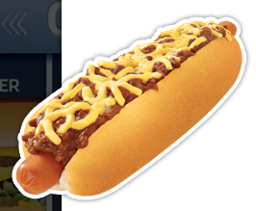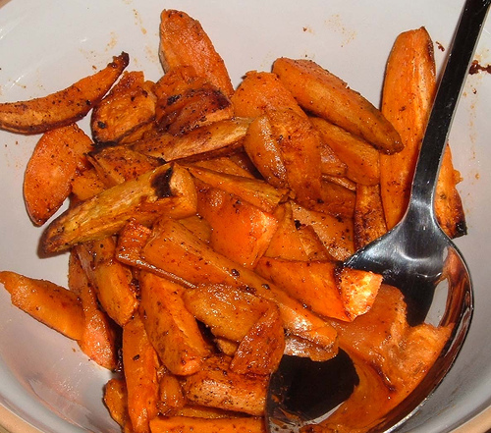 | 17) Turkey Taco  WG Tortilla Chips  Corn  Pears | 18) Asian Chicken  WG Rice  Broccoli  Applesauce  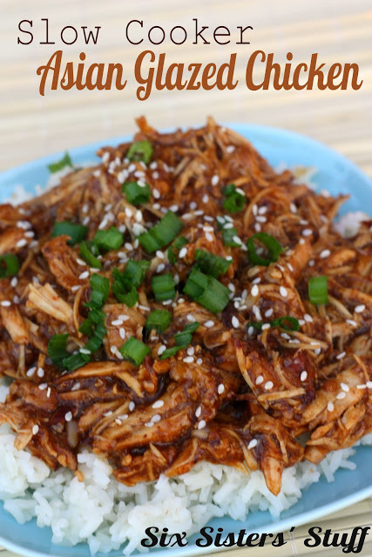 | 19) WG Chicken Nuggets  Side Salad  Mixed Fruit  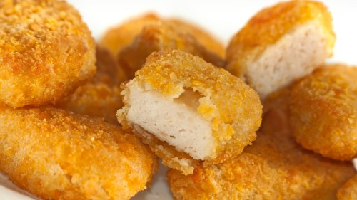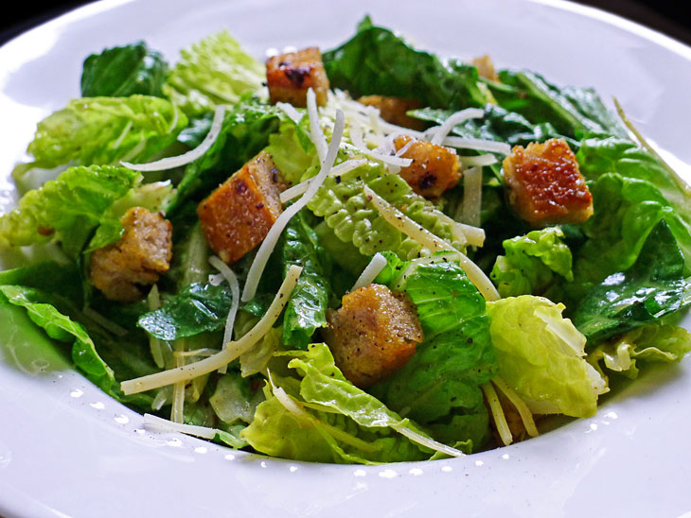 | 20) Steak & Cheese  WG Bun  Baked Beans  Pineapple Chunks
23) WG Corn Dog Nuggets  Sweet Potato Fries  Sliced Apples  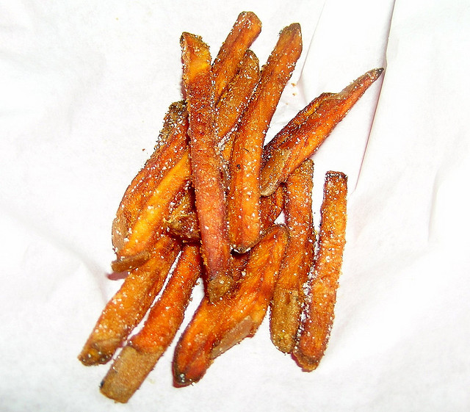 | 24) Pizza Cheese-WG  Side Salad  Applesauce  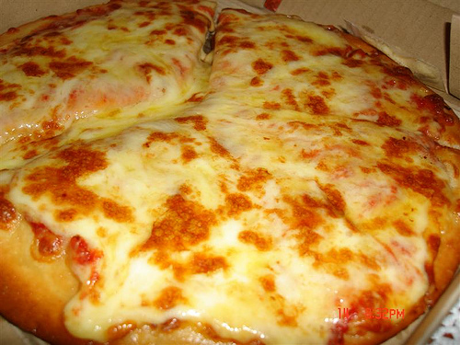 | 25) WG Beef-A-Roni  Broccoli  Peaches  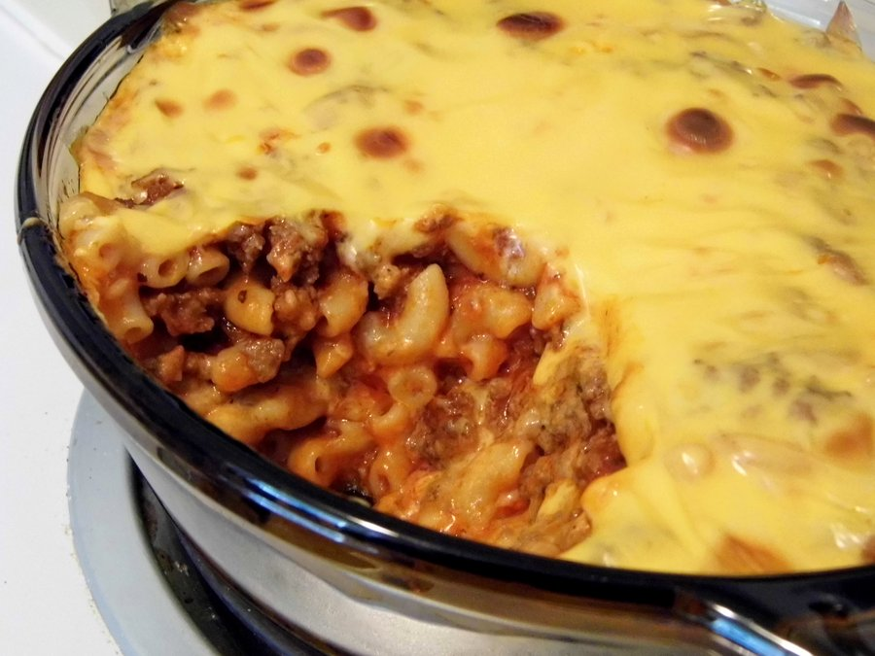 | 26) Rotisserie Chicken  Mashed Potatoes  Mixed Fruit  WG Roll  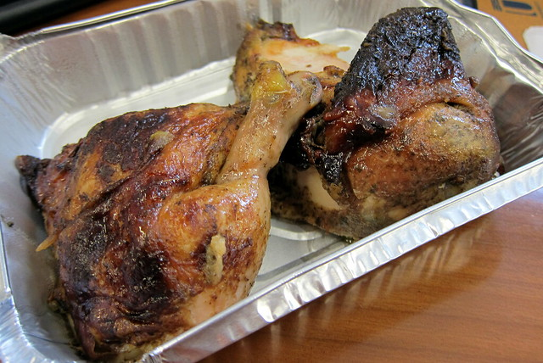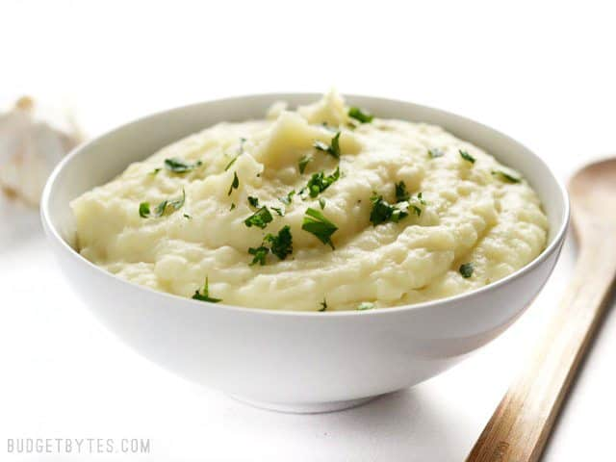 | 27) Cheeseburger/ WG bun  Baked Beans  Pears
30) Hot Dog on a WG bun  Sweet Potato Waffle  Applesauce  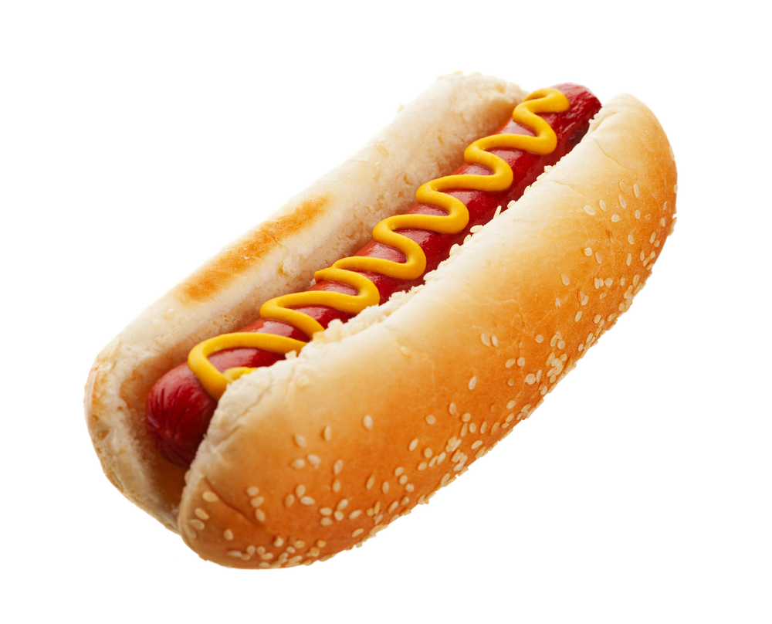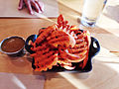 |  | *HEADSTART & PRE-K  STUDENTS ARE NOT UNDER OFFER SERVE, THEY GET WHAT IS ON THE MENU, FOR LUNCH; MEAT/MEAT ALTERNATE, GAIN, ½ CUP OF FRUIT, ½ CUP OF VEGETABLE & 1% FF WHITE MILK
WHAT IS OFFER V SERVE, & REIMBURSEABLE MEALS?
*WE OFFER FIVE COMPONENTS FOR LUNCH; A MEAT/MEAT ALTERNATE, A VEGETABLE, A FRUIT, A WG BREAD/GRAIN, AND MILK.
STUDENT CAN CHOOSE ALL FIVE, OR THEY CAN CHOOSE 4, OR 3 COMPONENTS, BUT 1 MUST BE A FRUIT, AND OR VEGETABLE.
A REIMBURSEABLE MEAL IS THREE, OR MORE OF THESE COMPONENTS, ONE OF THEM MUST BE A FRUIT AND OR VEGETABLE. PRIMARY & MIDDLE SCHOOL STUDENTS MAY REQUEST ¾ CUPS OF VEGETABLES DAILY; HIGH SCHOOL STUDENTS MAY REQUEST 1 CUP OF VEGETABLES DAILY. PRIMARY & MIDDLE MAY REQUEST ½ OR 1 CUP OF FRUIT, HIGH SCHOOL MAY REQUEST 1 CUP.
AN EXAMPLE OF A REIMBURSEABLE MEAL: (A CHEESEBURGER, ½ or 1cup of BROCCOLI IS A REIMBURSEABLE MEAL).
ANOTHER EXAMPLE IS; (CHICKEN TENDERS 1/2 or 1 cup of MIXED FRUIT, and MILK IS A REIMBURSEABLE MEAL).
ANOTHER EXAMPLE: (A SLICE OF PEPPERONI PIZZA, 1 cup of ROMINE, SPINACH SALAD IS A REIMBURSEABLE MEAL).
ANOTHER EXAMPLE: (CHICKEN NUGGETS, A WG ROLL 3/4 or 1 cup of CORN, and MILK, IS A REIMBURSEABLE MEAL).
ANOTHER EXAMPLE :( HOT DOG on a WG BUN, ¾ or 11/4 cup of CARROTS, & ½ or 1 cup of APPLESAUCE, IS A REIMBURSEABLE MEAL)
*THE LARGER PORTIONS ARE REQUIRED AT THE HIGH SCHOOL LEVEL.*
(***Condiments for lunch; Catsup, Mayonnaise, Honey Mustard, Barbeque sauce, Mustard & Dressing***)
NOTE:
Due to the menu being done in advance, product shortages, or items being out of stock at the warehouse;
***THE MENU IS SUBJECT TO CHANGE WITHOUT NOTICE***


